## Copy

### Site title

Flower Power

### Site tagline

Lovingly crafted bouquets

### Home Page

#### Intro to home page

Welcome to Flower Power

We sell hand-picked flower bouquets and arrangements. Whether you’re looking for flowers for a special occasion like a wedding, or just to brighten your home, we have what you need.

#### Quotation for Home Page

I have been using Flower Power for over two years and always love their fresh ideas and unique style. Their passion for good quality flowers shines through. – Maggie

#### Wedding Section Home Page

Let us help you plan your big day and ensure your personalities shine through. We offer bespoke solutions to make sure you get the most out of your wedding day.

#### Template

For MA1, your home page should look like this.

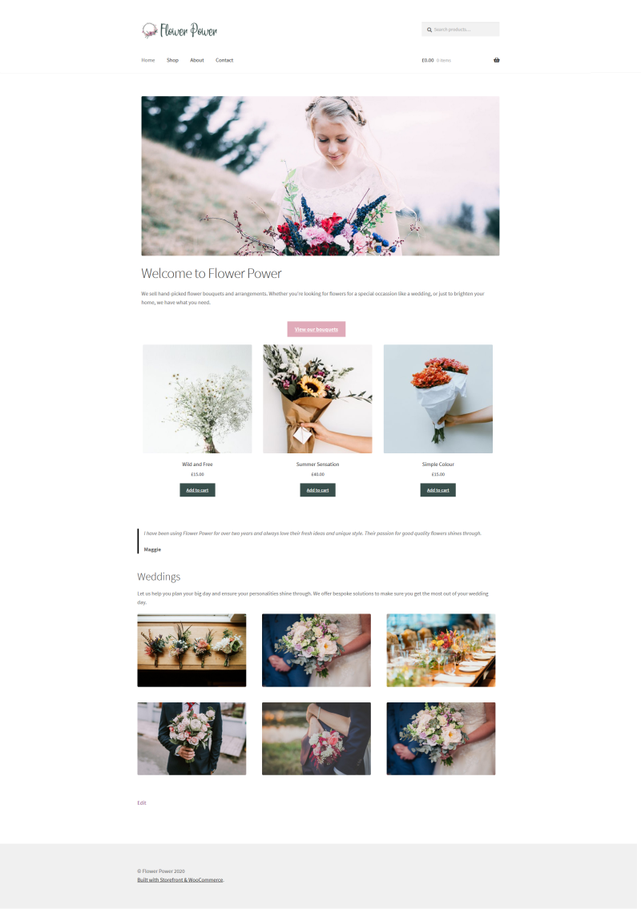

### About page

Flower Power started in 2007 as the passion project of Maggie Halls. Since then the team has grown to 5 staff who each bring their own unique angle and abilities.

Our philosophy is based on the right flower, picked at the right time, for the right occasion. We only sell locally sourced flowers which means that you’re getting good quality flowers that are stronger and will last longer.

## Colours

### Call-to-action button on home page

#e0aab9

### Buttons

Background color #394f4c

Text color #FFFFFF

Alternative button background color #e0aab9