SELECT * FROM sys.all_columns

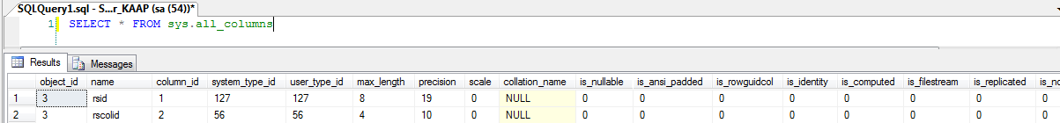

Shows the union of all columns belonging to user-defined objects and system objects.

|  |  |  |
| --- | --- | --- |
| **Column name** | **Data type** | **Description** |
| object_id | **int** | ID of the object to which this column belongs. |
| name | **sysname** | Name of the column. Is unique within the object. |
| column_id | **int** | ID of the column. Is unique within the object. |
| Column IDs might not be sequential. |
| system_type_id | **tinyint** | ID of the system-type of the column. |
| user_type_id | **int** | ID of the type of the column as defined by the user. |
| max_length | **smallint** | Maximum length (in bytes) of the column. |
| -1 = Column data type is **varchar(max)**, **nvarchar(max)**, **varbinary(max)**, or **xml**. |
| For **text** columns, the max_length value will be 16 or the value set by sp_tableoption 'text in row'. |
| precision | **tinyint** | Precision of the column if numeric-based; otherwise, 0. |
| scale | **tinyint** | Scale of the column if numeric-based; otherwise, 0. |
| collation_name | **sysname** | Name of the collation of the column if character-based; otherwise, NULL. |
| is_nullable | **bit** | 1 = Column is nullable. |
| is_ansi_padded | **bit** | 1 = Column uses ANSI_PADDING ON behavior if character, binary, or variant. |
| 0 = Column is not character, binary, or variant. |
| is_rowguidcol | **bit** | 1 = Column is a declared ROWGUIDCOL. |
| is_identity | **bit** | 1 = Column has identity values |
| is_computed | **bit** | 1 = Column is a computed column. |
| is_filestream | **bit** | 1 = Column is declared to use filestream storage. |
| is_replicated | **bit** | 1 = Column is replicated. |
| is_non_sql_subscribed | **bit** | 1 = Column has a non-SQL Server subscriber. |
| is_merge_published | **bit** | 1 = Column is merge-published. |
| is_dts_replicated | **bit** | 1 = Column is replicated by using SSIS. |
| is_xml_document | **bit** | 1 = Content is a complete XML document. |
| 0 = Content is a document fragment, or the column data type is not XML. |
| xml_collection_id | **int** | Non-zero if the column's data type is **xml** and the XML is typed. The value will be the ID of the collection containing the column's validating XML schema namespace |
| 0 = no XML schema collection. |
| default_object_id | **int** | 0 = No default. |
| rule_object_id | **int** | ID of the stand-alone rule bound to the column by using sys.sp_bindrule. |
| 0 = No stand-alone rule. |
| is_sparse | **bit** | 1 = Column is a sparse column. |
| is_column_set | **bit** | 1 = Column is a column set. |
| generated_always_type | **tinyint** | **Applies to**: SQL Server 2016 (13.x) through SQL Server 2017. |
| The numeric value representing the type of column: |
| 0 = NOT_APPLICABLE |
| 1 = AS_ROW_START |
| 2 = AS_ROW_END |
| generated_always_type_desc | **nvarchar(60)** | **Applies to**: SQL Server 2016 (13.x) through SQL Server 2017. |
| The text description of the type of column: |
| NOT_APPLICABLE |
| AS_ROW_START |
| AS_ROW_END |