SELECT * FROM sys.all_parameters

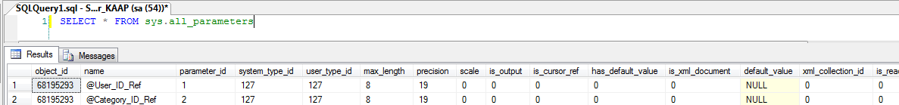

Shows the union of all parameters that belong to user-defined or system objects.

|  |  |  |
| --- | --- | --- |
| **Column name** | **Data type** | **Description** |
| object_id | **int** | ID of the object to which this parameter belongs. |
| name | **sysname** | Name of parameter. Is unique within the object. If the object is a scalar function, the parameter name is an empty string in the row representing the return value. |
| parameter_id | **int** | ID of parameter. Is unique within the object. If the object is a scalar function, **parameter_id** = 0 represents the return value. |
| system_type_id | **tinyint** | ID of the system type of the parameter. |
| user_type_id | **int** | ID of the type of the parameter as defined by the user. |
| To return the name of the type, join to the sys.types catalog view on this column. |
| max_length | **smallint** | Maximum length of the parameter, in bytes. |
| -1 = Column data type is **varchar(max)**, **nvarchar(max)**, **varbinary(max)**, or **xml**. |
| precision | **tinyint** | Precision of the parameter if it is numeric-based; otherwise, 0. |
| scale | **tinyint** | Scale of the parameter if it is numeric-based; otherwise, 0. |
| is_output | **bit** | 1 = Parameter is output (or return); otherwise, 0. |
| is_cursor_ref | **bit** | 1 = Parameter is a cursor reference parameter. |
| has_default_value | **bit** | 1 = Parameter has a default value. |
| SQL Server only maintains default values for CLR objects in this catalog view; therefore, this column will always have a value of 0 for Transact-SQL objects. To view the default value of a parameter in a Transact-SQL object, query the **definition** column of the sys.sql_modules catalog view, or use the OBJECT_DEFINITION system function. |
| is_xml_document | **bit** | 1 = Content is a complete XML document. |
| 0 = Content is a document fragment or the data type of the column is not **xml**. |
| default_value | **sql_variant** | If **has_default_value** is 1, the value of this column is the value of the default for the parameter; otherwise, NULL. |
| xml_collection_id | **int** | Is the ID of the XML schema collection used to validate the parameter. |
| Nonzero if the data type of the parameter is **xml** and the XML is typed. |
| 0 = There is no XML schema collection, or the parameter is not XML. |