SELECT * FROM sys.all_sql_modules

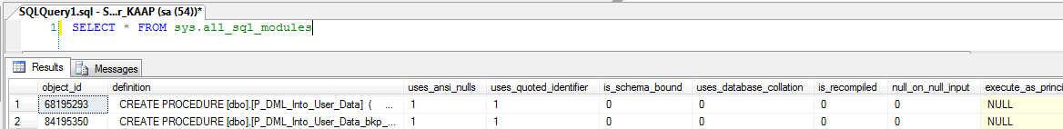

Returns the union of sys.sql_modules and sys.system_sql_modules.

|  |  |  |
| --- | --- | --- |
| **Column name** | **Data type** | **Description** |
| object_id | **int** | ID of the object of the containing object. Is unique within a database. |
| definition | **nvarchar(max)** | SQL text that defines this module. |
| NULL = Encrypted |
| uses_ansi_nulls | **bit** | Module was created with SET ANSI_NULLS ON. |
| uses_quoted_identifier | **bit** | Module was created with SET QUOTED_IDENTIFIER ON. |
| is_schema_bound | **bit** | Module was created with the SCHEMABINDING option. |
| uses_database_collation | **bit** | 1 = Schema-bound module definition depends on the default-collation of the database for correct evaluation; otherwise, 0. Such a dependency prevents changing the default collation of the database. |
| is_recompiled | **bit** | Procedure was created using the WITH RECOMPILE option. |
| null_on_null_input | **bit** | Module was declared to produce a NULL output on any NULL input. |
| execute_as_principal_id | **int** | ID of the EXECUTE AS database principal. |
| NULL by default or if EXECUTE AS CALLER. |
| ID of the specified principal if EXECUTE AS SELF or EXECUTE AS <principal>. |
| -2 = EXECUTE AS OWNER. |
| uses_native_compilation | **bit** | **Applies to**: SQL Server 2014 (12.x) through SQL Server 2017. |
| 0 = not natively compiled |
| 1 = is natively compiled |
| The default value is 0. |