SELECT * FROM sys.all_views

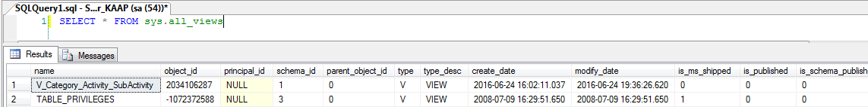

Shows the UNION of all user-defined and system views.

|  |  |  |
| --- | --- | --- |
| **Column name** | **Data type** | **Description** |
| is_replicated | bit | 1 = View is replicated. |
| has_replication_filter | bit | 1 = View has a replication filter. |
| has_opaque_metadata | bit | 1 = VIEW_METADATA option specified for view. |
| has_unchecked_assembly_data | bit | 1 = Table contains persisted data that depends on an assembly whose definition changed during the last ALTER ASSEMBLY. Resets to 0 after the next successful DBCC CHECKDB or DBCC CHECKTABLE. |
| with_check_option | bit | 1 = WITH CHECK OPTION was specified in the view definition. |
| is_date_correlation_view | bit | 1 = View was created automatically by the system to store correlation information between datetime columns. Creation of this view was enabled by setting DATE_CORRELATION_OPTIMIZATION to **ON**. |