SELECT * FROM sys.allocation_units

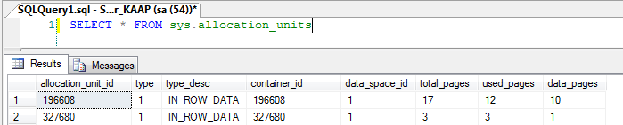

Contains a row for each allocation unit in the database.

|  |  |  |
| --- | --- | --- |
| **Column name** | **Data type** | **Description** |
| allocation_unit_id | **bigint** | ID of the allocation unit. Is unique within a database. |
| type | **tinyint** | Type of allocation unit: |
| 0 = Dropped |
| 1 = In-row data (all data types, except LOB data types) |
| 2 = Large object (LOB) data (**text**, **ntext**, **image**, **xml**, large value types, and CLR user-defined types) |
| 3 = Row-overflow data |
| type_desc | **nvarchar(60)** | Description of the allocation unit type: |
| **DROPPED** |
| **IN_ROW_DATA** |
| **LOB_DATA** |
| **ROW_OVERFLOW_DATA** |
| container_id | **bigint** | ID of the storage container associated with the allocation unit. |
| If type = 1 or 3, container_id = sys.partitions.hobt_id. |
| If type is 2, then container_id = sys.partitions.partition_id. |
| 0 = Allocation unit marked for deferred drop |
| data_space_id | **int** | ID of the filegroup in which this allocation unit resides. |
| total_pages | **bigint** | Total number of pages allocated or reserved by this allocation unit. |
| used_pages | **bigint** | Number of total pages actually in use. |
| data_pages | **bigint** | Number of used pages that have: |
| In-row data |
| LOB data |
| Row-overflow data |
|  |
| Note that the value returned excludes internal index pages and allocation-management pages. |