SELECT * FROM sys.assembly_modules

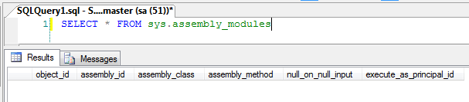

This catalog view maps CLR stored procedures, CLR triggers, or CLR functions to their underlying implementation.

|  |  |  |
| --- | --- | --- |
| **Column name** | **Data type** | **Description** |
| object_id | int | Object identification number of the SQL object. Is unique within a database. |
| assembly_id | int | ID of the assembly from which this module was created. |
| assembly_class | sysname | Name of the class within the assembly that defines this module. |
| assembly_method | sysname | Name of the method within the **assembly_class** that defines this module. |
| NULL for aggregate functions (AF). |
| null_on_null_input | bit | Module was declared to produce a NULL output for any NULL input. |
| execute_as_principal_id | int | ID of the database principal under which the context execution occurs, as specified by the EXECUTE AS clause of the CLR function, stored procedure, or trigger. |
| NULL = EXECUTE AS CALLER. This is the default. |
| ID of the specified database principal = EXECUTE AS SELF, EXECUTE AS *user_name*, or EXECUTE AS *login_name*. |
| -2 = EXECUTE AS OWNER. |