SELECT * FROM sys.check_constraints

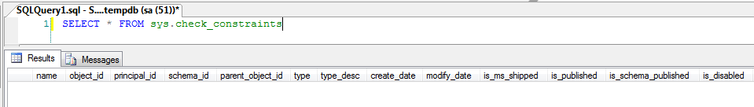

Contains a row for each object that is a CHECK constraint, with sys.objects.type = 'C'.

|  |  |  |
| --- | --- | --- |
| **Column name** | **Data type** | **Description** |
| is_disabled | bit | CHECK constraint is disabled. |
| is_not_for_replication | bit | CHECK constraint was created with the NOT FOR REPLICATION option. |
| is_not_trusted | bit | CHECK constraint has not been verified by the system for all rows. |
| parent_column_id | int | 0 indicates a table-level CHECK constraint. |
| Non-zero value indicates that this is a column-level CHECK constraint defined on the column with the specified ID value. |
| definition | nvarchar(max) | SQL expression that defines this CHECK constraint. |
| uses_database_collation | bit | 1 = The constraint definition depends on the default collation of the database for correct evaluation; otherwise, 0. Such a dependency prevents changing the database default collation. |
| is_system_named | bit | 1 = Name was generated by system. |
| 0 = Name was supplied by the user. |