WebDriver Installation and Integration in Eclipse ?

This whole process is for chrome users only :-

1. First download Chrome Driver [Link :- <https://chromedriver.chromium.org/downloads>]
2. You have to download chrome drive exe file ,from above file ,according to your current chrome browser version.
3. After download ,copy your chrome driver path ,because it required to initialize the path of chrome driver ,it get automatically tracked.
4. Code :-

System.*setProperty*("webdriver.chrome.driver", "C:\\Users\\User\\Downloads\\chromedriver_win32\\chromedriver.exe");

WebDriver wd = **new** ChromeDriver();

Locating Web Page Elements .?

ID :-

WebElement emailIdRef = wd.findElement(By.*id*("n3"));

Class :-

WebElement emailIdRef = wd.findElement(By.*class*("n3"));

Locator :-

WebElement emailIdRef = wd.findElement(By.*name*("n3"));

Locating Elements through CSS and XPath. ?

CSS :-

Inner Text :-

WebElement emailIdRef = wd.findElement(By.*cssSelector*(font:contains(“hello”));

Tag and ID :-

WebElement emailIdRef = wd.findElement(By.*cssSelector*("input#n1"));

Tag and Class :-

WebElement emailIdRef = wd.findElement(By.*className*("input.n1"));

Xpath :-

Relative Path :-

WebElement emailIdRef = wd.findElement(By.*xpath*("//*[@class=’relativexpath’]"));

Absolute Xpath :-

wd.findElement(By.*xpath*("html/body/input"));

Handling Various Web Elements. ?

Submit :-

submitRef.click();

Alert :-

Alert alertRef = wd.switchTo().alert();

Frame :-

wd.switchTo().frame(“frame1”);

Switchinh Tabs :-

wd.switchTo().window(tabs2.get(1));

Working with External Elements. ?

Opening new Window :-

WebDriver wd = **new** ChromeDriver();

WebElement passwordRef = wd.findElement(By.*id*("n2"));

passwordRef.sendKeys(Keys.Control+”w”);

Screenshots ?

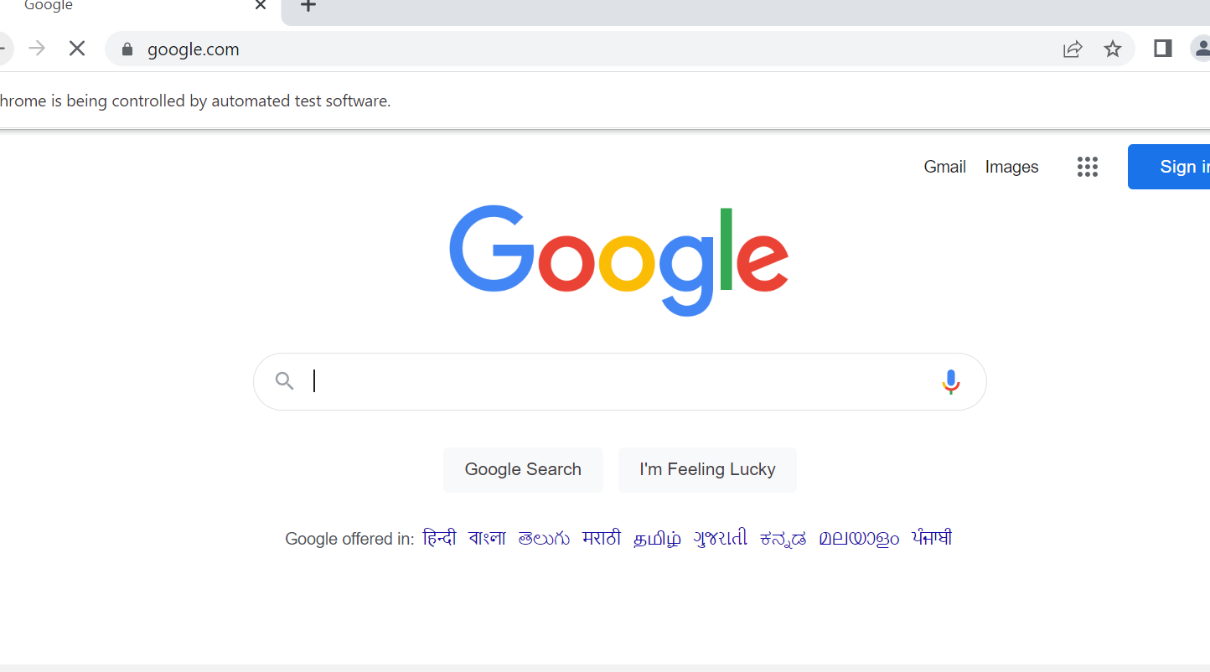

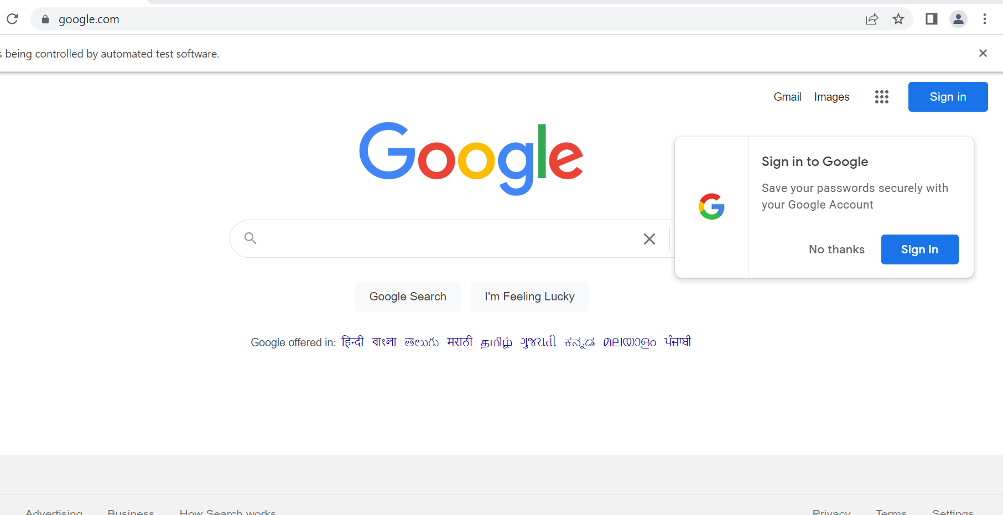

Handling File Uploads ?

WebElement browse =driver.findElement(By.id("uploadfile"));

browse.sendKeys("D:\\SoftwareTestingMaterial\\UploadFile.txt");

**import** java.io.IOException;

**import** java.util.concurrent.TimeUnit;

**import** org.openqa.selenium.By;

**import** org.openqa.selenium.WebDriver;

**import** org.openqa.selenium.firefox.FirefoxDriver;

**public** **class** AutoIt {

**private** **static** WebDriver driver = **null**;

**public** **static** void main(**String**[] args) **throws** **IOException**, **InterruptedException** {

driver = new ChromeDriver();

//driver = **new** FirefoxDriver();

driver.manage().timeouts().implicitlyWait(10, **TimeUnit**.SECONDS);

driver.get("http://toolsqa.com/automation-practice-form");

driver.findElement(By.id("photo")).click();

**Runtime**.getRuntime().exec("D:\AutoIt\AutoItTest.exe");

**Thread**.sleep(5000);

driver.close();

Perform All Test Annotations . ?

package com.testing;

import org.testng.annotations.Test;

import org.testng.annotations.BeforeMethod;

import static org.testng.Assert.assertEquals;

import org.openqa.selenium.Alert;

import org.openqa.selenium.By;

import org.openqa.selenium.WebDriver;

import org.openqa.selenium.WebElement;

import org.openqa.selenium.chrome.ChromeDriver;

import org.testng.annotations.AfterMethod;

public class LoginPageTest {

WebDriver wd;

@BeforeMethod

public void beforeMethod() {

System.setProperty("webdriver.chrome.driver", "C:\\Users\\User\\Downloads\\chromedriver_win32\\chromedriver.exe");

wd = new ChromeDriver();

}

@Test

public void loginPageTest() {

wd.get("http://127.0.0.1:5500/login.html");

WebElement emailIdRef = wd.findElement(By.id("n1"));

WebElement passwordRef = wd.findElement(By.id("n2"));

emailIdRef.sendKeys("man@abc.com");

passwordRef.sendKeys("111");

WebElement submitRef = wd.findElement(By.id("b1"));

submitRef.click();

Alert alertRef = wd.switchTo().alert();

//System.out.println(alertRef.getText());

String result = alertRef.getText();

alertRef.accept();

assertEquals(result, "Successfully Login");

wd.close();

}

@AfterMethod

public void afterMethod() {

}

}

Group Test Cases and Parallel Test Execution ?

package com.testing;

import org.testng.annotations.Test;

import org.testng.annotations.BeforeMethod;

import static org.testng.Assert.assertEquals;

import org.openqa.selenium.Alert;

import org.openqa.selenium.By;

import org.openqa.selenium.WebDriver;

import org.openqa.selenium.WebElement;

import org.openqa.selenium.chrome.ChromeDriver;

import org.testng.annotations.AfterMethod;

public class LoginPageTest {

WebDriver wd;

@BeforeMethod

public void beforeMethod() {

System.setProperty("webdriver.chrome.driver", "C:\\Users\\User\\Downloads\\chromedriver_win32\\chromedriver.exe");

wd = new ChromeDriver();

}

@Test

public void loginPageTest() {

wd.get("http://127.0.0.1:5500/login.html");

WebElement emailIdRef = wd.findElement(By.id("n1"));

WebElement passwordRef = wd.findElement(By.id("n2"));

emailIdRef.sendKeys("man@abc.com");

passwordRef.sendKeys("111");

WebElement submitRef = wd.findElement(By.id("b1"));

submitRef.click();

Alert alertRef = wd.switchTo().alert();

//System.out.println(alertRef.getText());

String result = alertRef.getText();

alertRef.accept();

assertEquals(result, "Successfully Login");

wd.close();

}

@AfterMethod

public void afterMethod() {

}

}

Evaluating Test Cases .?

package com.testing;

import org.testng.annotations.Test;

import org.testng.annotations.BeforeMethod;

import static org.testng.Assert.assertEquals;

import org.openqa.selenium.Alert;

import org.openqa.selenium.By;

import org.openqa.selenium.WebDriver;

import org.openqa.selenium.WebElement;

import org.openqa.selenium.chrome.ChromeDriver;

import org.testng.annotations.AfterMethod;

public class LoginPageTest {

WebDriver wd;

@BeforeMethod

public void beforeMethod() {

System.setProperty("webdriver.chrome.driver", "C:\\Users\\User\\Downloads\\chromedriver_win32\\chromedriver.exe");

wd = new ChromeDriver();

}

@Test

public void loginPageTest() {

wd.get("http://127.0.0.1:5500/login.html");

WebElement emailIdRef = wd.findElement(By.id("n1"));

WebElement passwordRef = wd.findElement(By.id("n2"));

emailIdRef.sendKeys("man@abc.com");

passwordRef.sendKeys("111");

WebElement submitRef = wd.findElement(By.id("b1"));

submitRef.click();

Alert alertRef = wd.switchTo().alert();

//System.out.println(alertRef.getText());

String result = alertRef.getText();

alertRef.accept();

assertEquals(result, "Successfully Login");

wd.close();

}

@AfterMethod

public void afterMethod() {

}

}

Selenium Integration with Jenkins . ?

NewTest.java :-

package com.example;

import org.openqa.selenium.WebDriver;

import org.openqa.selenium.chrome.ChromeDriver;

import org.openqa.selenium.firefox.FirefoxDriver;

import org.testng.annotations.AfterTest;

import org.testng.annotations.BeforeTest;

import org.testng.annotations.Test;

import org.testng.asserts.SoftAssert;

public class NewTest {

private WebDriver driver;

SoftAssert soft=new SoftAssert();

@Test

public void testEasy() {

System.setProperty("webdriver.chrome.driver", "./Resources/chromedriver.exe");

driver=new ChromeDriver();

driver.get("https://www.facebook.com");

String title = driver.getTitle();

soft.assertEquals("FB Login",title);

}

@BeforeTest

public void beforeTest() {

driver = new FirefoxDriver();

}

@AfterTest

public void afterTest() {

driver.quit();

}

}

Set Up Selenium Grid ?

1. Download Selenium standalone Server jar file from <https://www.seleniumhq.org/download/>link

2. 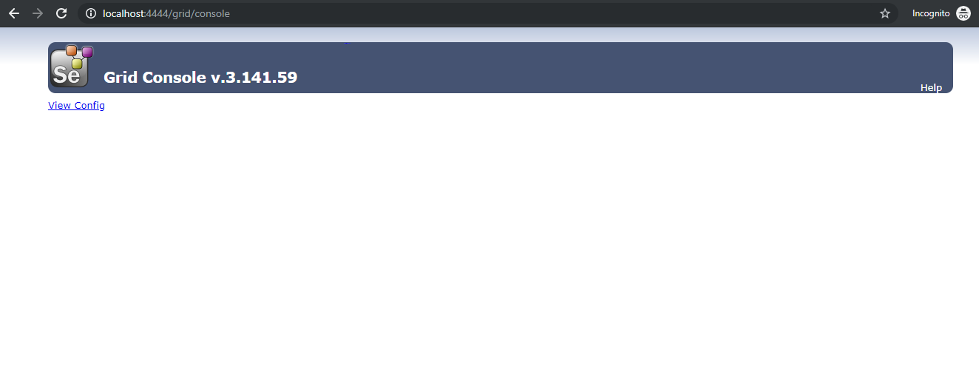

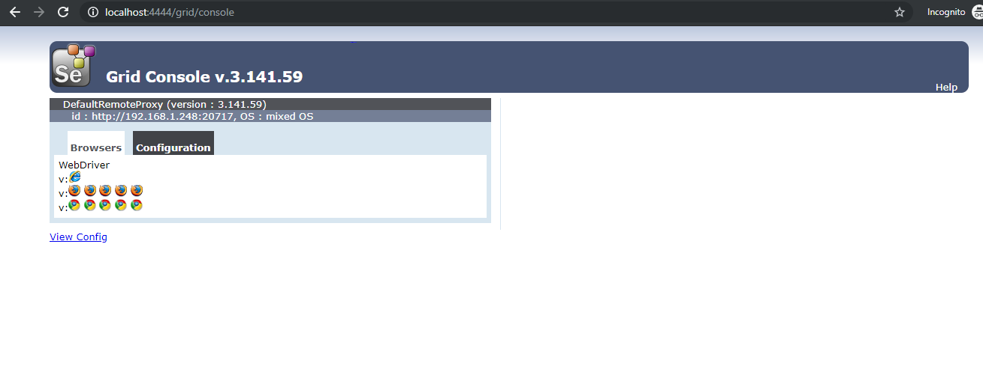

Grid Configuration Using JSON ?

JSON file :-

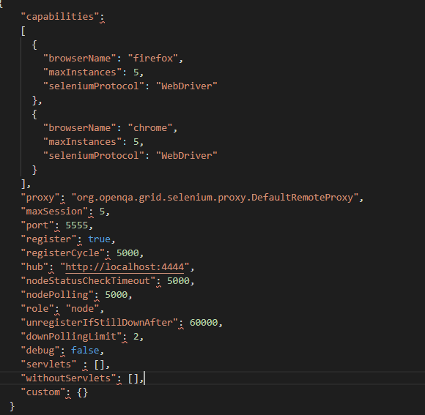

Running Tests on Selenium Grid . ?

Selenium Test :-

