**THE CONVEYOR BELT PROJECT REPORT**

**INSY-5373-001-PROJECT MANAGEMENT**

**Addressed to:**

**The Vice President of Operations**

Dr. Michel E. Whittenberg – Project Sponsor

**From:**

**Team 32**

Bonke Chaitali– Business Analyst

Chavan Kartik– Technical Lead

Murali Sathyendrasaran – Project Manager

Thapliyal Vikalp – Solution Architect

**Table of Contents**

1-Project Overview: 5

1.1- Project Objective: 5

1.2- Project Life Cycle Overview: 5

2-Summary: 6

3-Defining Phase: 7

3.1-Goals: 7

3.2- Specifications: 7

3.3- Tasks: 8

3.4-Responsibilities: 8

4-Planning Phase: 9

4.1 Schedules: 9

4.2 Budget: 10

4.2.2 Management Reserves: 11

4.3 Resources: 11

4.4 Risks: 12

5-Execution Phase: 13

5.1 Status Report: 13

5.1.1 Quarter 1: 13

5.1.2 Quarter 2: 13

5.1.3 Quarter 3: 14

5.1.4 Quarter 4: 14

5.1.5 Revised Quarter 4 15

5.2 Changes: 15

5.2.1 Adding of 2 extra Development teams: 15

5.2.2 External Development team: 15

5.3 Quality: 16

5.4 Forecast: 16

5.5- Management Issues: 16

5.6- Look out points: 16

6-Project Closure: 17

6.1- Customer Training and Transfer of Documents: 17

6.2 Release Resources: 17

6.3 Evaluation: 17

6.4 Lessons Learned: 17

6.5 - Project Audit: 17

6.6- Wrap-up Closure Checklist: 18

6.7- Keys to Success: 19

7-References: 20

Appendix- A (Base Line Cost) 1

Appendix-B (Gantt Entry Chart) 2

Appendix-C (EV Table) 3

Appendix-D (EV-Chart) 4

Appendix-E (Tracking Gantt Chart) 5

**Table of Tables**

Table 1: Project Priority Matrix 7

Table 2: Initial Work Breakdown Structure 7

Table 3: Project Priority Matrix 9

Table 4: Budget Reserve Contingency Matrix 10

Table 5: Organization Matrix 11

Table 6: Risk Assessment Matrix 11

Table 7: Risk Response Matrix 12

Table 8: Earned Values Figures 12

Table 9: Earned Values Figures 13

Table 10: Earned Values Figures 13

Table 11: Earned Values Figures 14

Table 11: Earned Values Figures 14

Table 12: Wrap up Closure Activities Checklist 19

1-Project Overview:

1.1- Project Objective:

To develop a computer-controlled conveyor belt that moves and positions items on the conveyor belt within <1 millimeter, with a tentative budget of 1.6 Million within 2 years. The new conveyor belt being updateable with future technologies, will replace the existing system, which has potential to be a critical unit in 30 percent of the systems installed in factories.

1.2- Project Life Cycle Overview:

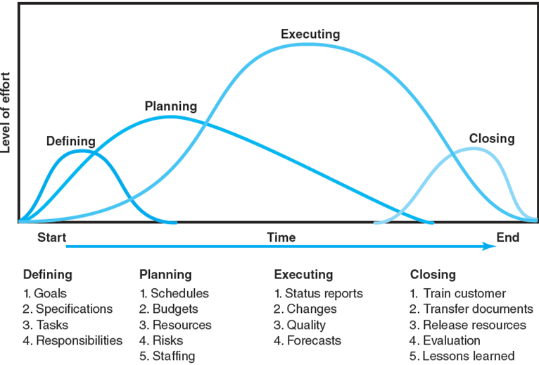

*Figure 1: Project Life Cycle*

2-Summary:

The Conveyor Belt Project was estimated to be completed within 530 days using a budget of approximately $1.6 Million. We used Microsoft Office Project for the analysis of the project and completed five project deliverables that gives the interim activities along the duration of the project with the guidance from the VP of Operations, Dr. Michel E. Whittenberg.

Depending on the information shared by the project sponsor, we created a work-breakdown structure and a Project Responsibility Matrix. We then generated a schedule by outlining order of the activities and including the duration for each activity in the project. We observed the critical path and calculated the Early or Late start and finish times. The resources were used as per the schedule to determine the project budget. We resolved the overallocated resources like Design, Documentation and Development by Levelling Outside Slack. This led to the increase in project duration from 530 to 560 days. A risk assessment was performed to determine the risks involved and how each risk should be dealt with.

In the fourth quarter, the project was 19 days behind schedule. The estimate date of completion was February 28, 2018. The project had a Cost Variance of -$29510.50. The project is 56.99% complete in term of the budget (PCIB) and 56.99% complete in terms of expected costs (PCIC). Since the last report, Estimated cost at Completion changed from $1,254,572.19 to $ 1,262,496.48 with the change Cost Variance from - $ 22,080.00 to -$29,510.50. EACf is estimated to be $1262496.48. The CPI of 0.96 causes the forecast to be greater than VAC of -51,783.40. The To-Complete Performance Index (TCPI) is 1.06 which indicates that we need to earn 1.06dollars for each dollar we will spend in the future to complete the project within budget.

The key project priority is time as the project is time constrained. The project is 19 days behind the schedule and it will require extra resources and cost to complete the project. So, the project is over budget and behind schedule. So overall the project is not performing up to our expectations. Delay in project will lead to allocation of more resources. This is not a big problem as the project is already time constrained with a budget that will lead to an increase in order to follow the project timeline.

3-Defining Phase:

3.1-Goals:To develop a computer-controlled conveyor belt with a tentative budget of 1.6 Million within 2 years.

3.2- Specifications:

By communicating with stakeholders, project sponsor, and executive management, we gathered specific requirements for the project as follows-

**Technical Requirements**

1. Conveyor belt should move and position items on the belt within less than 1 mm.
2. Conveyor belt should be able to operate at Temperature between 10 °C and 80 °C.
3. The belt should pass the ISO 703:2017 standard test.
4. The width of the belt should be about 1200 mm.
5. The belt speed should range between 100 m/min and 300 m/min.
6. Conveyor belt system parts should be inter-changeable and should be easily available in the market.
7. The system should be easier to update with future technologies.
8. The workplace will be cleaned by the company custodial contract.

**Limits and Exclusions:**

1. The Project Team will require approval from VP of Operations to work more than 40 hrs/week.
2. Usage of any Budget Reserves will require approval of VP of Operations.
3. There should be sufficient space to fit in the hardware in the installation site.
4. Operating personnel will be responsible for installing, maintaining and upgrading the system.
5. Project team will be responsible for sub-contract works.
6. The Project Team will not work on U.S National Holidays.

Considering on these, we formed a Project Priority matrix as shown in table 1 below-

|  |  |  |  |
| --- | --- | --- | --- |
|  | Time | Scope | Cost |
| Constrain | X |  |  |
| Enhance |  | X |  |
| Accept |  |  | X |

*Table 1: Project Priority Matrix*

3.3- Tasks:

After we finished defining goal, specification with limitations, we defined 4 milestones as follows-

1. Start Hardware Development by- 02/08/2016
2. Complete Development of Operating System by- 12/28/2017
3. Start Utilities Production by- 02/05/2016
4. Complete System Integration and Testing by- 03/15/2018

Furthermore, we prepared detailed Work Breakdown Structure (WBS) as shown in the following table 3-

|  |  |  |  |
| --- | --- | --- | --- |
| **1.1 Hardware** | **1.2 Operating system** | **1.3 Utilities** | **1.4 System integration** |
| 1.1.1 Hardware specifications | 1.2.1 Kernel specifications | 1.3.1 Utilities specifications | 1.4.1 Architectural decisions |
| 1.1.2 Hardware design | 1.2.2 Drivers | 1.3.2 Routine utilities | 1.4.2 Integration first phase |
| 1.1.3 Hardware documentation | 1.2.2.1 Disk drivers | 1.3.3 Complex utilities | 1.4.3 System hard/software test |
| 1.1.4 Prototypes | 1.2.2.2 Serial I/O drivers | 1.3.4 Utilities documentation | 1.4.4 Project documentation |
| 1.1.5 Order circuit boards | 1.2.3 Memory management | 1.3.4 Shell | 1.4.5 Integration acceptance testing |
| 1.1.6 Assemble preproduction models | 1.2.4 Operating system documentation |  |  |
|  | 1.2.5 Network interface |  |  |

*Table 2: Initial Work Breakdown Structure*

3.4-Responsibilities:

The project performance is mainly dependent on three groups: Project Sponsor, Project Manager, & Project Resources. Dr. Whittenberg, the project sponsor/ VP of Operations evaluates the project statuses and deliverables to give more insights on them. Group 32, the Project Managers, plan and prepare status reports, along with other managing project activities. Resource team works on activities to bring the project closer to its completion. The project manager can create Responsibility Matrix to get the outline as shown below-

|  |  |  |  |  |
| --- | --- | --- | --- | --- |
| **Task Name** | **Chaitali** | **Sathyendrasaran** | **Kartik** | **Vikalp** |
| Hardware specifications |  |  |  | R |
| Hardware design |  |  |  | R |
| Hardware documentation |  |  |  | R |
| Prototypes |  | S | S | R |
| Order circuit boards | R |  |  |  |
| Assemble preproduction models |  | R |  |  |
| Kernel specifications |  | R | S |  |
| Disk drivers | R |  | S |  |
| Serial I/O drivers | R |  | S |  |
| Memory management | S | R |  |  |
| Operating system documentation | R |  |  |  |
| Network interface |  | S | R |  |
| Utilities specifications | S |  |  | R |
| Routine utilities | S |  |  | R |
| Complex utilities | S |  |  | R |
| Utilities documentation | R |  |  | S |
| Shell |  |  | R |  |
| Architectural decisions |  | S | R |  |
| Integration first phase |  | S | R |  |
| System hard/software test | R |  | S |  |
| Project documentation | R |  | S |  |
| Integration acceptance testing |  | R |  | S |

*Table 3: Project Priority Matrix*

4-Planning Phase:

4.1 Schedules:

Conveyor Belt project is time-constrained, and every activity needs to be determined. We determined the schedule of each task in this phase. Dependencies between tasks are difficult to determine in Gantt chart that emphasizes more on the time management of the tasks while it is easier to verify in a Network diagram that emphasizes more on the sequence of tasks. The project is estimated to be completed within 530 days. The critical path is

Architectural Decisions 🡪 Hardware Specifications 🡪 Hardware Design 🡪 Hardware Documentation 🡪 Integration First Phase 🡪 Serial I/O Drivers 🡪 System Hard/Software Test 🡪 Network Interface 🡪 Integration Acceptance Testing

4.2 Budget:

The table 4 below gives the Budget Reserve Contingency Matrix that describes the Risks involved in the project along with the Work Package, Probability, Cost Impact and Budget Reserve.

|  |  |  |  |  |
| --- | --- | --- | --- | --- |
| Risk | Work Package | Probability | Cost Impact | Budget Reserve |
| Equipment Failures | Assemble pre-production models | 40% | $ 22,530 | $ 9,012 |
| Delay in Delivery of Circuit Board | Assemble pre-production models | 25% | $ 20,945 | $ 5,236.25 |
| Increase of Material Cost | Order Circuit Boards | 35% | $ 36,220 | $ 12,677 |
| Operational Complexity | Integration Acceptance testing | 20% | $ 8,500 | $ 1,700 |
| System Integration Failure | Integration First Phase | 55% | $ 37,860 | $ 20,823 |
| Total Budget Reserve | | | | $ 49,448.25 |
| Total Project Cost | | | | $ 1,051,200 |

*Table 4: Budget Reserve Contingency Matrix*

Work packages we identified are Equipment Failures, Delay in Delivery of Circuit Board, Increase in material cost, Operational Cost and System Integration Failure. We assumed the budget reserves to be $ 9,012 for Equipment Failures, $ 5,236.25 for Delay in Delivery of Circuit Board, $ 12,677 for Increase in material cost, $1700 for Operational Cost and $ 20,823 for System Integration Failure. The Total Budget Reserve sums to $49,448.25 and the Total Project Management Reserve of $ 1,051,200.

**4.2.1 Budget Reserves:**

Total Budget Reserve is identified as $49,448.25 using the factors identified risk and probability

Budget Reserves = Probability of the risk * Cost impact if occurred.

4.2.2 Management Reserves:

The management reserves is identified by taking 10% from the sum of project cost and budget reserve.

Total Project Cost + Budget Reserve = 1,051,200+ 49,448.25 = 1,100,648.25

Management Reserve = 10% of (1,100,648.25) = 110,064.825

4.3 Resources:

Table 5 below contains the teams involved, resource types and cost per hour applied in this project.

|  |  |  |
| --- | --- | --- |
| Team | Group | Cost in $/hr. |
| Design | R&D (2Teams) | 100 |
| Development | R&D (2 Teams) | 70 |
| Documentation | R&D (1 Team) | 60 |
| Assembly/Test | R&D (1 Team) | 70 |
| Purchasing | Procurement (1 Team) | 40 |

*Table 5: Organization Matrix*

Overallocated resources are Design, Documentation and Development. After Levelling within Slack, it tries to resolve, but cannot resolve completely. After reducing slack, it increases the sensitivity of the network and increases the number of critical paths. Overallocation is resolved, but at an expense of a very large increase in schedule. This increases the cost of the project, as well as the ‘time to market’/delay in further successor projects based on this project. Here we are left with 2 options- more resources, or more time.

4.4 Risks:

We did the Risk Assessment as shown in the table 6 below-

|  |  |  |  |
| --- | --- | --- | --- |
| **Risk Event** | **Likelihood** | **Impact** | **When** |
| **Equipment Failures** | 2 | 3 | In Operation |
| **Delay in Delivery of Circuit Board** | 1 | 4 | Order Circuit Board |
| **Increase of Material Cost** | 1 | 2 | Procurement |
| **Operational Complexity** | 2 | 3 | After Installation |
| **System Integration Failure** | 2 | 4 | Integration |

*Table 6: Risk Assessment Matrix*

When the Risk Responses are determined, the risk response matrix demonstrates what needs to be done depending on the occurrence of a risk.

|  |  |  |  |  |
| --- | --- | --- | --- | --- |
| **Risk Event** | **Response** | **Contingency Plan** | **Trigger** | **Who is Responsible** |
| Equipment Failures | Mitigate | Pick extra equipment from inventory | Equipment Fails | Purchasing Team |
| Delay in Delivery of Circuit Board | Avoid | Order from reliable vendor | Ordering Circuit Board | Purchasing Team |
| Increase of Material Cost | Transfer | Contract to a supplier | Increase in market price | Purchasing Team |
| Operational Complexity | Mitigate | Detailed Training Manual & Support | When Operator cannot use Equipment | Support Team |
| System Integration Failure | Avoid | Continually Revise the Design | Quarterly | Development Team |

*Table 7: Risk Response Matrix*

5-Execution Phase:

5.1 Status Report:

5.1.1 Quarter 1:

|  |  |  |  |  |  |
| --- | --- | --- | --- | --- | --- |
| **PV** | **EV** | **AC** | **SV** | **CV** | **BAC** |
| $140,800.00 | $155,980.72 | $151,680.00 | $15,180.72 | $4,300.72 | $1,210,713.08 |
| **EACf** | **VAC** | **CPI** | **PCIB** | **PCIC** | **TCPI** |
| $1,177,335.04 | $33,378.04 | 1.03 | 0.128834 | 0.128833 | 1 |
| **SPI** | **MRI** |
| 1.11 | 0.039074 |

*Table 8: Earned Values Figures*

The above table shows status report of the project at 1st quarter dated on April 1, 2016. The project is under budget with a cost variance of $4300.72 and ahead of schedule with a schedule variance of $ 15,180.72.  The CPI is 1.03, which implies the project is earning 1.03 dollars for every dollar spent.

In terms of budget the project is 12.89% complete. In terms of expected cost, the project is 12.89% complete. The forecasted estimate at completion EACf is $ 1,177,335.04 which is less than BAC of the project

5.1.2 Quarter 2:

|  |  |  |  |  |  |
| --- | --- | --- | --- | --- | --- |
| **PV** | **EV** | **AC** | **SV** | **CV** | **BAC** |
| $448,560.00 | $454,431.13 | $470,720.00 | $5,871.13 | ($16,288.87) | $1,210,713.08 |
| **EACf** | **VAC** | **CPI** | **PCIB** | **PCIC** | **TCPI** |
| $1,254,115.26 | ($43,402.18) | 0.97 | 0.375342 | 0.37534 | 1.02 |
| **SPI** | **MRI** |
| 1.01 | 0.14799 |

*Table 9: Earned Values Figures*

The above table shows status report of the project at 2nd quarter dated on July 1, 2016. The project is over budget with a cost variance of -$16,288.87 and ahead of schedule with a schedule variance of $ 5,871.13.  The CPI is 0.97, which implies the project is earning 0.97 dollars for every dollar spent

In terms of budget the project is 37.53% complete. In terms of expected cost, the project is 37.53% complete. The forecasted estimate at completion EACf is $ 1,254,115.26 which is more than BAC of the project

5.1.3 Quarter 3:

|  |  |  |  |  |  |
| --- | --- | --- | --- | --- | --- |
| **PV** | **EV** | **AC** | **SV** | **CV** | **BAC** |
| $599,440.00 | $609,520.00 | $631,600.00 | $10,080.00 | ($22,080) | $1,210,713.08 |
| **EACf** | **VAC** | **CPI** | **PCIB** | **PCIC** | **TCPI** |
| $1,254,572.19 | ($43,859.11) | 0.97 | 0.503439 | 0.503439 | 1.04 |
| **SPI** | **MRI** |
| 1.02 | 0.20061 |

*Table 10: Earned Values Figures*

The above table shows status report of the project at 3rd quarter dated on October 1, 2016. The project is over budget with a cost variance of -$22,080 and ahead of schedule with a schedule variance of $ 10,080.  The CPI is 0.97, which implies the project is earning 0.97 dollars for every dollar spent.

In terms of budget the project is 50.344% complete. In terms of expected cost, the project is 50.344% complete. The forecasted estimate at completion EACf is $1,254,572.19 which is more than BAC of the project

5.1.4 Quarter 4:

|  |  |  |  |  |  |
| --- | --- | --- | --- | --- | --- |
| **PV** | **EV** | **AC** | **SV** | **CV** | **BAC** |
| $685,120.00 | $690,009.50 | $719,520.00 | $4,889.50 | ($29,510.50) | $1,210,713.08 |
| **EACf** | **VAC** | **CPI** | **PCIB** | **PCIC** | **TCPI** |
| $1,262,496.48 | ($51,783.40) | 0.96 | 0.56992 | 0.569918 | 1.06 |
| **SPI** | **MRI** |
| 1.01 | 0.26812 |

*Table 11: Earned Values Figures*

The above table shows status report of the project at 4th quarter dated on January 1, 2017. The project is over budget with a cost variance of -$29,510.5 and ahead of schedule with a schedule variance of $4,889.5.  The CPI is 0.96, which implies the project is earning 0.96 dollars for every dollar spent.

In terms of budget the project is 56.99% complete. In terms of expected cost, the project is 56.99% complete. The forecasted estimate at completion EACf is $1,262,496.48 which is more than BAC of the project.

5.1.5 Revised Quarter 4

|  |  |  |  |  |  |
| --- | --- | --- | --- | --- | --- |
| **PV** | **EV** | **AC** | **SV** | **CV** | **BAC** |
| $685,120.00 | $688,281.67 | $719,520.00 | $3,161.67 | ($31,238.33) | $1,210,713.08 |
| **EACf** | **VAC** | **CPI** | **PCIB** | **PCIC** | **TCPI** |
| $1,265,665.03 | ($54,951.95) | 0.96 | 0.568493 | 0.568492 | 1.06 |
| **SPI** | **MRI** |
| 1 | 0.28382 |

*Table 11: Earned Values Figures*

The above table shows status report of the project at revised 4th quarter. The project is under budget with a cost variance of -$31,238.33 and on schedule with a schedule variance of $ 3,161.67.  The CPI is 0.96, which implies the project is earning 0.96 dollars for every dollar spent.

In terms of budget the project is 56.85% complete. In terms of expected cost, the project is 56.85% complete. The forecasted estimate at completion EACf is $ 1,265,665.03 which is less than BAC of the project

5.2 Changes:

The project was not performing well in terms of schedule and without adding additional resources, the project would take well beyond the 530 days to complete. According to priority matrix time is a major constraint and to keep the project within schedule we implemented the following the changes.

5.2.1 Adding of 2 extra Development teams:

We added 2 additional development teams increasing the resource percent from 200% to 400%. This caused the number of days to complete to reduce to 550 days to keep the project duration under 530 days.

5.2.2 External Development team:

Adding external development team is costly and to minimize the communication gap and other disadvantages, we assigned the routine utilities to external development team. The task takes 60 days and it is least connected to other tasks making it the most appropriate one.

Implementing the above changes reduced the project duration keeping it under 530 days

5.3 Quality:

Quality is one of the foremost requirement or this project as it is necessary in term of safety standards and meeting customer expectations

1. Conveyor belt should move and position items on the belt within less than 1 mm.
2. Conveyor belt should be able to operate at Temperature between 10 °C and 80 °C.
3. The belt should pass the ISO 703:2017 standard test.
4. The width of the belt should be about 1200 mm.
5. The belt speed should range between 100 m/min and 300 m/min.
6. Conveyor belt system parts should be interchangeable and should be easily available in

the market.

1. The system should be easier to update with future technologies.

5.4 Forecast:

The TCPI is 1.06 at the end of revised fourth quarter which indicates that we need to spend 1.06 worth of work for every dollar we will spend in future. The forecast estimate at completion is $ 1,265,665.03 and variance at completion implies that we are $52,440.64 over budget. The SPI suggests that the project is on schedule.

5.5- Management Issues:

1. There is a delay in project as the total completion time increased to 549 days which exceeds the estimated 530 days.
2. Delay in project will lead to allocation of more resources.
3. Project may go over budget due to increase in time and resources.
4. Increasing the workload for existing employees might make the employees to lose focus and demotivate them.
5. Over Budget and behind the schedule might give rise to new conflicts.

5.6- Look out points:

1. Distribution of tasks in accordance to the job description, ability and performance.
2. Keep the risk assessment updated and build up the contingency plans for each risk.
3. Conflict resolution through mediation
4. Separating people from problems
5. Creating a thriving environment encouraging mutual growth, aimed at successful project completion.
6. Make sure that the resources are available at each activity when required.

6-Project Closure:

6.1- Customer Training and Transfer of Documents:

Training will be provided to the customers as per the provided schedule. The customer is provided training on how to operate the hardware and system components. They will also be trained to maintain the system, assemble spare-parts and to conduct trial-runs.

6.2 Release Resources:

Resources are released so that they can be used for other projects depending on the project priority. Project team members are reassigned.

Accounts are closed after making sure all the bills are paid and a final report is generated.

6.3 Evaluation:

The Project Manager keeps track of the performance evaluations throughout the project and customer feedback. The evaluation also includes group and individual evaluation and the need for appraisal depending on the contributions done by individuals.

6.4 Lessons Learned:

1. Duration estimating methods needs improvisation.
2. Effective communication within the team is necessary.
3. Weekly meetings to keep track and communicate the project priorities and progress.
4. Cost Control methods needs improvisation.
5. Project Manager should closely monitor the tasks and activities of the project.
6. Create a strong work ethic by keeping all team members engaged and motivation.
7. Multi-tasking kills Productivity.
8. Training for increasing the productivity needs to be given.

6.5 - Project Audit:

1. Comments about individuals or groups participating in the project should be minimized. Keep to project issues, not what happened or by whom.
2. The attitude toward a project audit and its aftermath depends on the modus operandi of the audit leadership and group. The objective is not to prosecute. The objective is to learn and conserve valuable organization resources where mistakes have been made. Friendliness, empathy, and objectivity encourage cooperation and reduce anxiety.
3. Audit activities should be intensely sensitive to human emotions and reactions. The inherent threat to those being evaluated should be reduced as much as possible.
4. Develop a checklist that includes questions regarding the success criteria.
5. Focus on their viewpoints regarding the project’s successes, failures, missed opportunities and challenges.
6. Organize a meeting with the team to discuss their thoughts and ideas regarding the project’s current state.
7. Discuss and try to address major project issues, concerns and challenges during the meeting.
8. Identify and agree on best practices of teamwork and collaboration.

**Step-1: Initiation & staffing:**

In small organizations and projects where face-to-face contact at all levels is prevalent, an audit may be informal and only represent another staff meeting. In these environments the content of a formal project audit should be examined and covered with notes made of the lessons learned. The audit is likely to be conducted by someone from management with project management experience.

**Step-2: Data Collection & Analysis:**

1. Was the organizational culture supportive and correct for this type of project? Why? Why not?
2. Was senior management’s support adequate?
3. Did the project accomplish its intended purpose?
4. Were the project planning and control systems appropriate for this type of project? Should all similar size and type of projects use these systems? Why/why not?
5. Did the project conform to plan? Is the project over or under budget and schedule? Why?
6. Were interfaces and communications with project stakeholders adequate and effective?
7. Did the team have adequate access to organizational resources—people, budget, support groups, equipment? Were there resource conflicts with other ongoing projects?

**Step-3: Reporting**

To improvise the way of managing the future projects & to avoid reworks, we report and recommend corrective actions in the methods of the organization, based on the analysis.

6.6- Wrap-up Closure Checklist:

|  |  |  |
| --- | --- | --- |
|  | Task | Completed? Yes/No |
|  | *Team* |  |
| 1 | Has a schedule for reducing project staff been developed and accepted? |  |
| 2 | Has staff been released or notified of new assignments? |  |
| 3 | Have performance reviews for team members been conducted? |  |
| 4 | Has staff been offered outplacement services and career counseling activities? |  |
|  | *Vendors/contractors* |  |
| 5 | Have performance reviews for all vendors been conducted? |  |
| 6 | Have project accounts been finalized and all billing closed? |  |
|  | *Customer/Users* |  |
| 7 | Has the customer signed-off on the delivered product? |  |
| 8 | Has an in-depth project review and evaluation interview with the customer been conducted? |  |
| 9 | Have the users been interviewed to assess their satisfaction with the deliverables? With the project team? With vendors? With training? With support? With maintenance? |  |
|  | *Equipment and facilities* |  |
| 10 | Have project resources been transferred to other projects? |  |
| 11 | Have rental or lease equipment agreements been closed out? |  |
| 12 | Has the date for the closure review been set and stakeholders notified? |  |
|  | *Attach comments or links on any tasks you feel need explanation.* |  |

*Table 12: Wrap up Closure Activities Checklist*

6.7- Keys to Success:

1. Effective communication within the team.  
2. Weekly meetings to keep track and communicate the project priorities and progress  
3. Project Manager should closely monitor the tasks and activities of the project.  
4. Create a strong work ethic by keeping all team members engaged and motivation.

7-References:

· Erik W. Larson and Gray, Clifford F. Project Management: The Managerial Process. 7th edition. New York: McGraw Hill Education.

· Vice President of Operations- Dr. Michel E. Whittenberg.

Appendix- A (Base Line Cost)

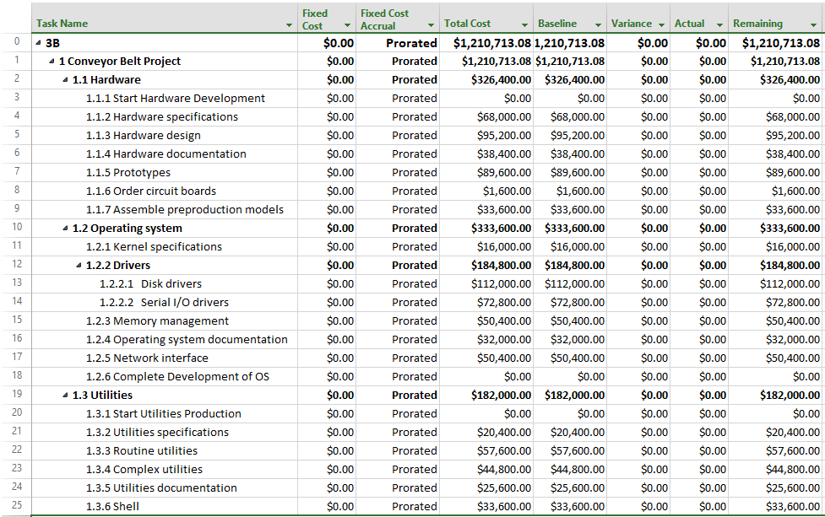

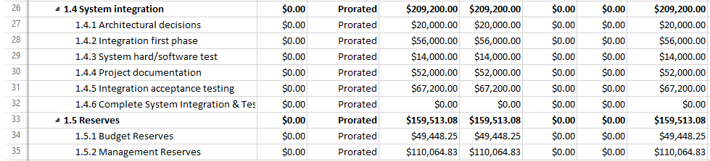

Appendix-B (Gantt Entry Chart)

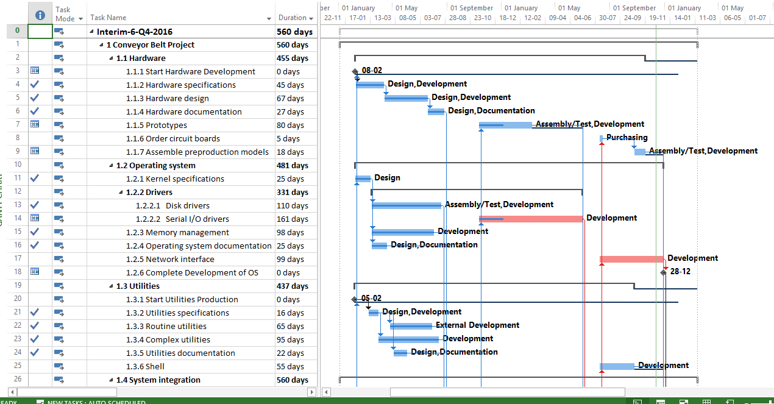

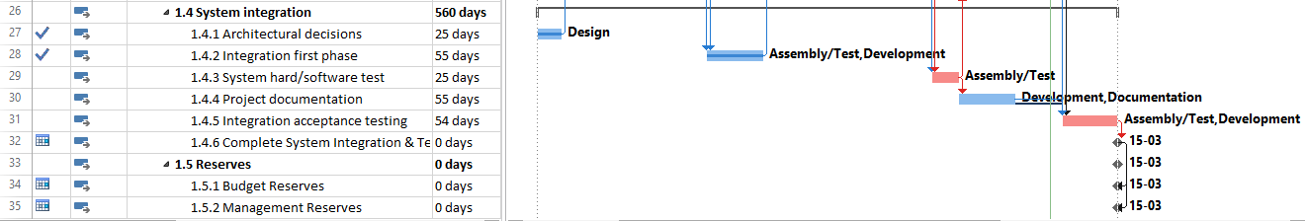

Appendix-C (EV Table)

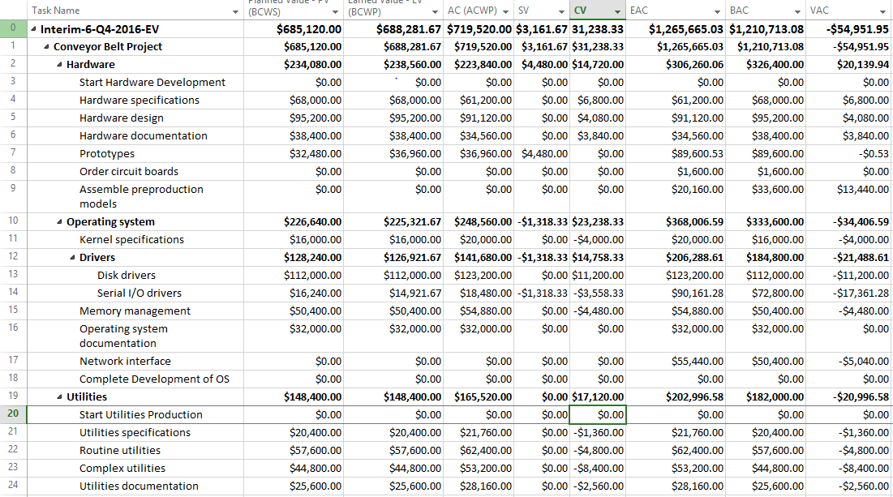

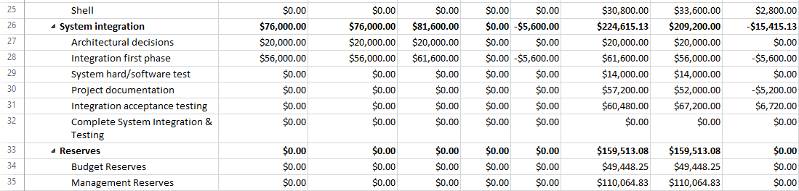

Appendix-D (EV-Chart)

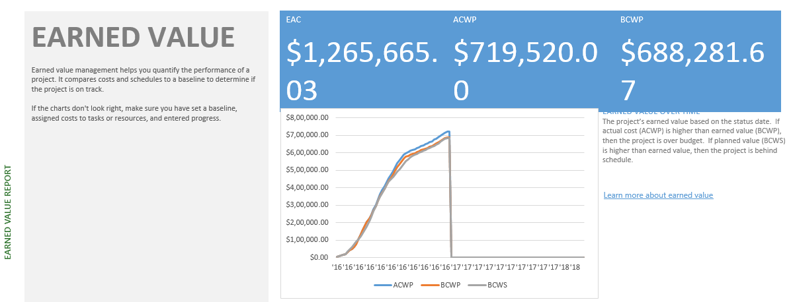

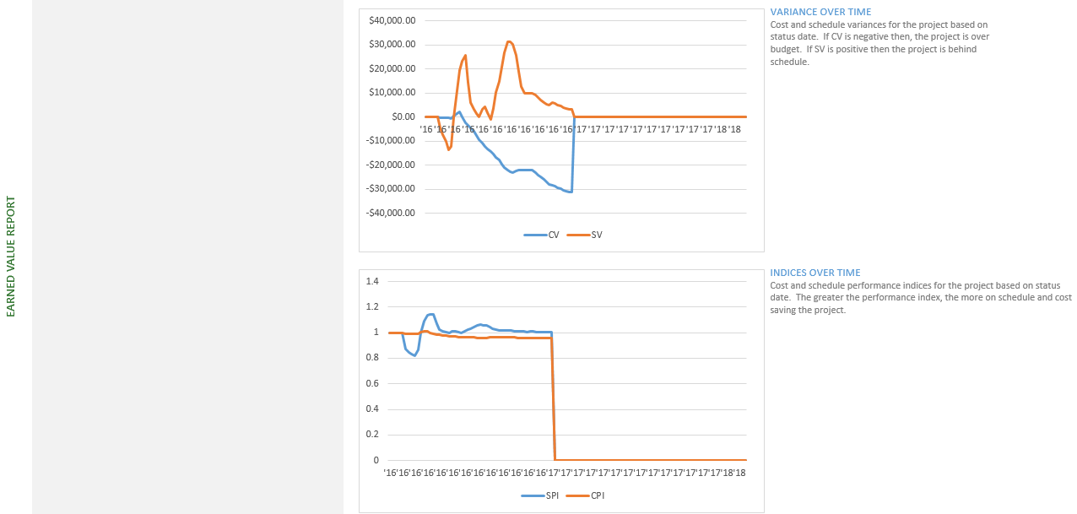

Appendix-E (Tracking Gantt Chart)

