電通二乙微處理器實驗 實驗結報

實驗名稱 | Lab 06 –音樂教室
組別 | 03 | 組員 | 04050626林晉丞/04050254 游景勝

- 實驗目的
如何使Arduino發出特定旋律的聲音?
1.Arduino接喇叭如何接線?
2.如何使用tone library?
3.如何演奏一段音樂?
4.如何使用4x4 鍵盤演奏音樂?
- 實驗步驟\
*Arduino演奏一段特定的音樂, 旋律不得是小蜜蜂
*使用4x4 鍵盤演奏音樂
- 程式碼
音階
void playTone(int tone, int duration)
{
for (long i = 0; i < duration * 1000L; i += tone * 2) {
digitalWrite(speakerPin, HIGH);
delayMicroseconds(tone);
digitalWrite(speakerPin, LOW);
delayMicroseconds(tone);
}
}
節拍
void playNote(char note, int duration)
{
char names[] = { 'c', 'd', 'e', 'f', 'g', 'a', 'b', 'C' };
int tones[] = { 1915, 1700, 1519, 1432, 1275, 1136, 1014, 956 };
if (names[i] == note)
playTone(tones[i], duration);
}
}

- 電路圖
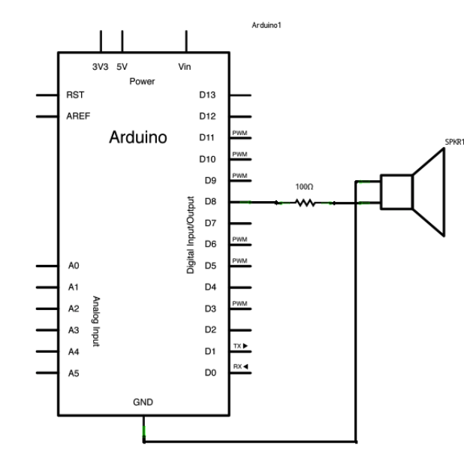

修改程式碼

(1)
#define NOTE_ 0
#define NOTE_B0 31
#define NOTE_C1 33
#define NOTE_CS1 35
#define NOTE_D1 37
#define NOTE_DS1 39
#define NOTE_E1 41
#define NOTE_F1 44
#define NOTE_FS1 46
#define NOTE_G1 49
#define NOTE_GS1 52
#define NOTE_A1 55
#define NOTE_AS1 58
#define NOTE_B1 62
#define NOTE_C2 65
#define NOTE_CS2 69
#define NOTE_D2 73
#define NOTE_DS2 78
#define NOTE_E2 82
#define NOTE_F2 87
#define NOTE_FS2 93
#define NOTE_G2 98
#define NOTE_GS2 104
#define NOTE_A2 110
#define NOTE_AS2 117
#define NOTE_B2 123
#define NOTE_C3 131
#define NOTE_CS3 139
#define NOTE_D3 147
#define NOTE_DS3 156
#define NOTE_E3 165
#define NOTE_F3 175
#define NOTE_FS3 185
#define NOTE_G3 196
#define NOTE_GS3 208
#define NOTE_A3 220
#define NOTE_AS3 233
#define NOTE_B3 247
#define NOTE_C4 262
#define NOTE_CS4 277
#define NOTE_D4 294
#define NOTE_DS4 311
#define NOTE_E4 330
#define NOTE_F4 349
#define NOTE_FS4 370
#define NOTE_G4 392
#define NOTE_GS4 415
#define NOTE_A4 440
#define NOTE_AS4 466
#define NOTE_B4 494
#define NOTE_C5 523
#define NOTE_CS5 554
#define NOTE_D5 587
#define NOTE_DS5 622
#define NOTE_E5 659
#define NOTE_F5 698
#define NOTE_FS5 740
#define NOTE_G5 784
#define NOTE_GS5 831
#define NOTE_A5 880
#define NOTE_AS5 932
#define NOTE_B5 988
#define NOTE_C6 1047
#define NOTE_CS6 1109
#define NOTE_D6 1175
#define NOTE_DS6 1245
#define NOTE_E6 1319
#define NOTE_F6 1397
#define NOTE_FS6 1480
#define NOTE_G6 1568
#define NOTE_GS6 1661
#define NOTE_A6 1760
#define NOTE_AS6 1865
#define NOTE_B6 1976
#define NOTE_C7 2093
#define NOTE_CS7 2217
#define NOTE_D7 2349
#define NOTE_DS7 2489
#define NOTE_E7 2637
#define NOTE_F7 2794
#define NOTE_FS7 2960
#define NOTE_G7 3136
#define NOTE_GS7 3322
#define NOTE_A7 3520
#define NOTE_AS7 3729
#define NOTE_B7 3951
#define NOTE_C8 4186
#define NOTE_CS8 4435
#define NOTE_D8 4699
#define NOTE_DS8 4978
int melody[] = {
NOTE_G4, NOTE_G4, NOTE_E4, NOTE_D4, NOTE_E4, NOTE_D4, NOTE_C4,
NOTE_E4, NOTE_D4, NOTE_C4, NOTE_A3, NOTE_G3, NOTE_A3, NOTE_G3,
NOTE_A3, NOTE_A3, NOTE_C4, NOTE_A3, NOTE_C4, NOTE_D4, NOTE_E4,
NOTE_D4, NOTE_D4, NOTE_G4, NOTE_G4, NOTE_E4, NOTE_D4, NOTE_C4,
};

int noteDurations[] = {
6, 16, 8, 8, 8, 8, 4,
6, 16, 8, 8, 8, 8, 4,
6, 16, 8, 8, 8, 8, 4,
6, 16, 8, 8, 8, 8, 4,
};
void play(int *melody, int *noteDurations, int num){
for(int note = 0; note < num; note++){
int noteDuration = 3000 / noteDurations[note];
tone(8, melody[note], noteDuration);

delay(noteDuration * 1.30);
}
}

void setup(){
}

void loop(){
play(melody, noteDurations, sizeof(melody) / sizeof(int));

delay(2000);
}

(2)

#include <Keypad.h>
const byte ROWS = 4;
const byte COLS = 4;
char keys[ROWS][COLS]={
{'F','B','A','0'},
{'E','3','2','1'},
{'D','6','5','4'},
{'C','9','8','7'}
};
byte rowPins[ROWS] ={9, 10, 11, 12};
byte colPins[COLS]={A0, A1, A2, A3};

Keypad keypad = Keypad( makeKeymap(keys), rowPins, colPins, ROWS, COLS );
#define NOTE_C3 131
#define NOTE_CS3 139
#define NOTE_D3 147
#define NOTE_DS3 156
#define NOTE_E3 165
#define NOTE_F3 175
#define NOTE_FS3 185
#define NOTE_G3 196
#define NOTE_GS3 208
#define NOTE_A3 220
#define NOTE_AS3 233
#define NOTE_B3 247
#define NOTE_C4 262
#define NOTE_CS4 277
#define NOTE_D4 294
#define NOTE_DS4 311
#define NOTE_E4 330
#define NOTE_F4 349
#define NOTE_FS4 370
#define NOTE_G4 392
#define NOTE_GS4 415
#define NOTE_A4 440
#define NOTE_AS4 466
#define NOTE_B4 494
#define WHOLE 1 //全分符
#define HALF 0.5 //半分符
#define QUARTER 0.25
#define EIGHTH 0.125
#define SIXTEENTH 0.0625

//int tune[] = {NOTE_C3,NOTE_B4,NOTE_A4,NOTE_G4 };

void setup() {
pinMode(8, OUTPUT);
//sizeof(tune[0]);
}
void loop() {
char key = keypad.getKey();
switch(key)
{
case '1': {
tone(8,523);
delay(250);
noTone(8);
break;
}
case '2': {
tone(8,587);
delay(250);
noTone(8);
break;
}
case '3' : {
tone(8,659);
delay(250);
noTone(8);
break;
}
case '4': {
tone(8,698);
delay(250);
noTone(8);
break;
}
case '5': {
tone(8,784);
delay(250);
noTone(8);
break;
}
case '6': {
tone(8,880);
delay(250);
noTone(8);
break;
}
case '7': {
tone(8,988);
delay(250);
noTone(8);
break;
}

}
//noTone(8);

}

(3)

char *morse[]={ "01","1000","1010","100",
"0","0010","110","0000",
"00","0111","101","0100",
"11","10","111","0110",
"1101","010","000","1",
"001","0001","11","1001",
"1011","1100"};
const byte Buzzer = 10;
char chr,index;
char *ptr;

void setup()
{
pinMode(Buzzer,OUTPUT);
Serial.begin(9600);
}
void loop()
{
if(Serial.available())
{
chr = Serial.read();
Serial.println(chr);
if((chr-'A')>=0 && (chr-'Z')<=0)
{ index=chr-'A';
ptr=morse[index];
while(*ptr!='\0')
{
if(*ptr=='0')
{
tone(Buzzer,440,100);
delay(100);
}
else
{
tone(Buzzer,440,300);
delay(300);
}
ptr++;
delay(100);
}
delay(300);
}
if(chr==' ')
{
delay(700);
}
}
}

