1) IMPORTANT NOTE
Within the user manual, text written in Italics generally represents words and phrases contained in the Glossary.

2) INTRODUCTION
The applications were developed to illustrate a few basic principles of evolution. To demonstrate these principles, two applications have been produced – the “text evolution program” and the “graphic evolution program”.
The text evolution program illustrates natural selection through text, either entered on the keyboard or loaded from a file off disk. When the evolution process is commenced, the program generates a random character for each character within the text the user has entered. For example, if the user entered a sentence containing 30 characters, the program will then generate 30 characters randomly, one character for each position in the original text. The program’s next task is to go through this random text and compare each character with those in the original text, by position. That is, the program compares the first random character with the first character in the sentence the user entered. It then compares the second random character it generated with the second character in the sequence the user entered, and so forth. In each case, if the random character generated matches the character in the original text (in the same position), then that character is said to have evolved successfully and is locked. If, however, the characters do not match, a new random character is chosen. The process continues through all the characters in the original text until the end is reached. Each pass through the text is referred to as a generation, or sometimes as an iteration. The process then repeats continually until all the characters in the evolving text match the characters in the original text precisely – their case and positions the same. The program gives the user some control over the evolution process, including the ability to set a generation limit (where evolution is considered complete when a certain number of generations have passed – the evolving text may not necessarily match the original text entered by the user). A report detailing the evolutionary process is available after evolution is complete, which may also be saved to disk if the user wishes.
The graphic evolution program demonstrates evolution, natural selection and the accumulation of small change, by using small graphical line drawings, referred to as Biomorphs. A biomorph is a small graphical “creature” which has several genes represented by an array of numbers. Each gene (or number) governs some aspect of the way the biomorph is drawn onto the screen. By altering these values, the shape, size and various other aspects of the biomorph can be changed. The program begins by giving the user a display of a number of biomorphs. To determine which biomorph will “survive”, the user clicks on it with the mouse pointer (natural selection here is governed by the user). The surviving biomorph then produces a number of offspring. Each offspring copies the genetic make-up of its parent (the numbers used to draw the biomorph) and then randomly alters one of those gene values. It may alter its length, the angle at which the lines are drawn and so forth. As a result, the new parent biomorph selected by the user will have generated a number of offspring (the number of offspring in itself is governed by a gene) each of which will differ from the parent in just one aspect of its genetic code. The process is then repeated as the user selects a new parent from these offspring. This differs from the text evolution program in that there is no definite end goal, the evolution process may continue indefinitely. The program also demonstrates the accumulation of small change, in that over a large number of generations, the small genetic mutations result in a biomorph which in no way resembles its ancestors. The program allows for the direct editing of gene values, saving and loading of “parents”, and also comes with two utility applications – one allowing the evolution process to be shown as a simple animation (animator), the other allowing saved biomorphs to be view independently of the program itself (Bio view).

3) SYSTEM REQUIREMENTS
Before installing the software to your local or network drive, check that you have the following:

- At least a 486DX or higher.
- At least 8MB of memory (16MB or more is recommended)
- Microsoft Windows95 or Microsoft NT4.0 32-bit operating systems.
- A 3.5” high-density floppy disk drive for installation of the software
- At least 2MB of free disk space to install the applications
- An SVGA screen with 256 colours (16 million colours is preferred for the full colour mutation effect in the graphic evolution program)
.

4) INSTALLING THE SOFTWARE
This chapter will guide you through the installation process.
To install the text evolution and graphic evolution programs from disk, in Windows:

- Insert the installation disk into the floppy disk drive.
- Double click on “My Computer”.
- Open the floppy drive which contains the installation disk
(E.G: 3½ Floppy (A:))
- Right click on the folder labelled “Natural” and select “Copy”. Alternatively you can go to the “Edit” menu and select “copy”.
- Go back to “My Computer”
- Right click on the drive you wish to install the software to (E.G: C:), and select “Paste”. Alternatively you can left click once on the drive you wish to install to, then go to the “Edit” menu and select “Paste”.
- The files should now be copied across to your system.

If you have any problems or encounter them while copying the files across, consult your Windows manuals.

You should now have a folder labelled “Natural”. This folder should contain two other folders labelled “part_a” and “part_b”.

The “part_a” directory should contain the following:
- A folder labelled “Source” with the source codes to the text evolution program
- Part_a.exe (note that the .exe extension may not necessarily be displayed)

The “part_b” directory should contain the following:
- A folder labelled “Source” with the source codes to the graphic evolution program
- Part_b.exe (note that the .exe extension may not necessarily be displayed)
- Bio_view.exe (note that the .exe extension may not necessarily be displayed)
- Animator.exe (note that the .exe extension may not necessarily be displayed)

4.1) Setting up the file extensions.
The utilities that come with the graphical evolution program require that the correct file extensions be setup.

In Windows:
- Start Windows Explorer.
- Open the VIEW menu and select OPTIONS.
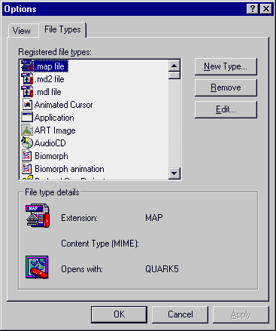

- Select FILE TYPES. A dialog box similar to the one shown above should be displayed. Click on the NEW TYPE” button.
- A dialog labeled “Add New File Type” should be displayed. Enter the following information in the appropriate fields:
DESCRIPTION OF TYPE: Biomorph Animation Log
ASSOCIATED EXTENSION: BAN

- Click on the NEW button. A dialog labeled “New Action” should be displayed, similar to the one shown below. In the box labelled “Action” enter OPEN.
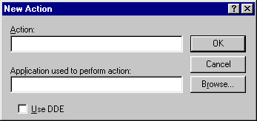
- In the box labelled “Application used to perform action” enter the full filename and path for the animator file, animator.exe. This file is located inside of your NATURAL/PART_B folder. Alternatively you can click the BROWSE button and locate the animator.exe file manually. When done, click on the OK button.
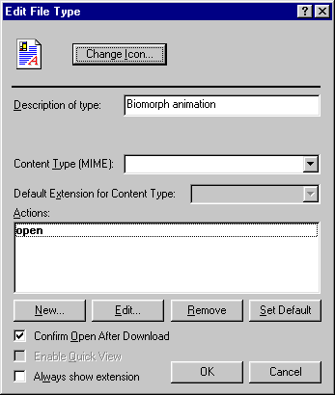
- The information you have entered for the animator files should look like that shown above.You should return to the “Add New File Type” dialog. Click OK again.
- The “Options” dialog should be displayed again. Click the NEW TYPE button.
- A dialog labelled “Add new file type” should be displayed. Enter the following information in the appropriate fields:
DESCRIPTION OF TYPE: Biomorph file
ASSOCIATED EXTENSION: BMF
- Click on the NEW button. A dialog labeled “New Action” should be displayed. In the box labelled “Action” enter OPEN.
- In the box labelled “Application used to perform action” enter the full filename and path for the bio view file, bio_view.exe. This file is located inside of your NATURAL/PART_B folder. Alternatively you can click the BROWSE button and locate the bio_view.exe file manually.
- Click the OK button. You should return to the “Add New File Type” dialog. Click OK again.
- Exit Windows Explorer.

If you have any problems setting up a new file association, consult your Windows manuals.

5) ADDING A SHORTCUT TO THE START MENU
This section will illustrate how to add the two programs to your start menu and how to configure your system to run all the applications correctly.

In Windows:
- Click on the “Start” button.

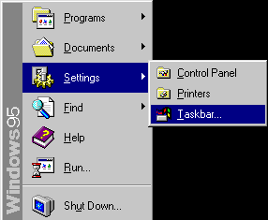
- Select “Settings” from the menu, then “Taskbar”.
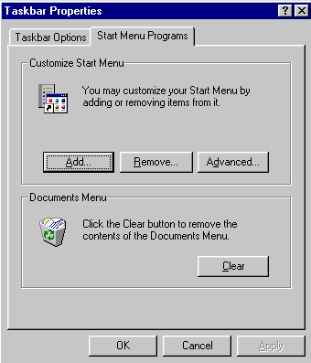
- From the “Taskbar properties”, select “Start menu programs”.

- Click “Add” from “Customize start menu”.

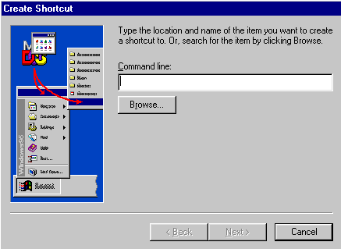
- In the space marked “Command line”, enter the full filename and path for the file part_a.exe and click “Next”, or click “Browse” and navigate through your local and/or network drives until you locate the file part_a.exe. This file is located under the NATURAL/PART_A folder that you copied under the “installation” chapter.

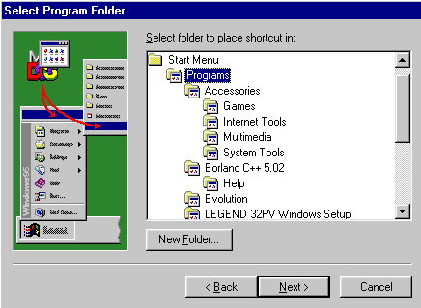
- Click “New folder” from the “Select program folder” window. Label the new folder “Evolution” and click “next”.

- In the box labelled “Select a name for the shortcut”, enter “Text evolver” and click “Finish”.

- Click on “add” from the “Customise start menu”.

- In the space marked “Command line”, enter the full filename and path for the file part_b.exe and click “Next”, or click “Browse” and navigate through your local and/or network drives until you locate the file part_b.exe. This file is located under the NATURAL/PART_B folder that you copied under the “installation” chapter.

- Under “Select a program folder”, highlight the folder labelled “Evolution” and click “next”.

11. In the box labelled “Select a name for the shortcut”, enter “Graphic evolver” and click “Finish”.

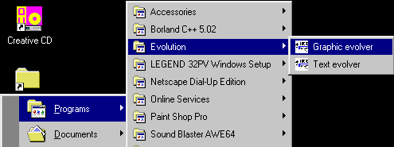
To test your shortcut, go to the Windows START button, select PROGRAMS and you should find a folder there labelled “Evolution” (similar to the display shown above). Select this folder and the applications should be listed there.

If you have difficulty adding a shortcut to your START menu, consult your Windows manuals.

6) RUNNING THE PROGRAMS
The applications must be run from Windows. You may run them using shortcuts, from a DOS prompt from within Windows or through the RUN option from the Windows START menu.

6.1) Running from a DOS prompt.
- From within the DOS prompt, navigate your directories to find the folder that contains the application you wish to run. For the text evolution program, this will be the folder NATURAL/PART_A. For the graphic evolution program, this will be the folder NATURAL/PART_B.
- Enter the name of the application you wish to run. For the text evolution program, this will be the file PART_A.EXE. For the graphic evolution program, this will be the file PART_B.EXE.
- The application you wish to run should now run in Windows normally.
6.2) Viewing animation logs or saved biomorphs from a DOS prompt.
It should be noted that achieving this is much easier if you save your animation logs and biomorphs to the same folder that the BIO VIEW and ANIMATOR utilities are stored. Typically, this would be within your NATURAL/PART_B folder. Alternatively, you may wish to copy the BIO VIEW and ANIMATOR utilities across to your WINDOWS/COMMAND folder. You may also wish to add the folder NATURAL/PART_B to your DOS path. Consult your Microsoft DOS manuals for information on how to do this.
- Navigate your directories to find the folder NATURAL/PART_B. For this example, we will assume you have saved your animation logs and biomoprhs to the same folder that the applications themselves are in.
- To view animation logs, enter the following on the DOS command line:
ANIMATOR <animation log filename>
You must include the BAN file extension for animation log files.
To view a saved biomorph, enter the following on the DOS command line:
BIO_VIEW <saved biomorph filename>
You must include the BMF extension for saved biomorph files.

6.3) Using RUN from the START menu.
To run the applications using the RUN option:
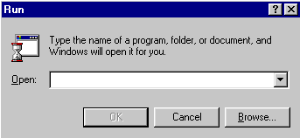
- Select RUN from under the Windows START menu. A dialog box similar to the one shown above should be displayed

- Enter the full filename and path of the application you wish to run. For the text evolution program, this will be the file PART_A.EXE from inside your NATURAL/PART_A folder. For the graphic evolution program, this will be the file PART_B.EXE from inside your NATURAL/PART_B folder. Alternatively, you can click the BROWSE buttons and locate the applications manually.
7) TEXT EVOLUTION OVERVIEW
7.1) The application screen.
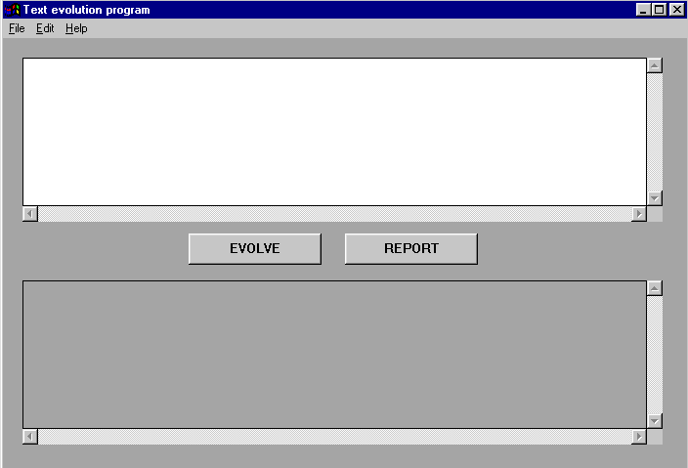
This image shows the text evolution program as it looks when it is started. The important features are detailed here:

The ORIGINAL TEXT box
The original text box is the large, white text box located at the top of the application. This box is where you enter the text you wish to evolve, or where the text you wish to load in from disk is stored. You may edit any text that this box contains, making full use of the usual Windows editing commands (such as copy, paste, cut etc).

The EVOLVING TEXT box
The evolving text box is the large grey text box located at the bottom of the application. This is where the text that is currently being evolved will be displayed. You cannot edit any text that is displayed inside of this box.

The EVOLVE button
By clicking this button, you will begin the evolution process on the text that is displayed in the original text box.

The REPORT button
When evolution is complete, you can click on this button to view a report on the process.

7.2) The menu.

Each of the pulldown menus and their associated options are explained below.

The FILE menu
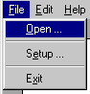

Open
This option allows you to load in text from a file on disk. Selecting this will bring up a file dialog similar to those you find in most Windows applications. If you select a file to be loaded, the text from this file will then be displayed in the original text box.

Setup
This option will bring up the settings dialog. This allows you to alter some of the evolution parameters. Each of the settings options are explained in the following section.

Exit
This option will allow you to exit the program.

The EDIT menu
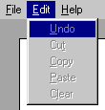
The edit menu offers standard Windows editing options such as cut and paste, copy and clear. It allows you to edit the text in the original text window, the same way you could with a word processor.

The HELP menu
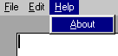

About
The about option will display information about the program.

7.3) Settings.
The settings for how evolution is performed can be found by selecting “Setup” from within the “file” menu.
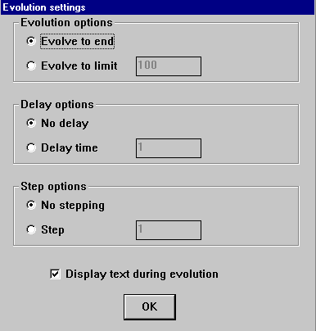
Evolution settings.
This setting determines when the evolutionary process is stopped. If you select “evolve to end”, the evolution process is continued until the text being evolved matches the original text exactly. If you select a “generation limit”, then evolution will be performed over a set number of generations where it will stop, regardless of whether or not the evolving text matches the original text.

Delay options.
This setting determines whether or not there is a delay between generations. If you select “no delay”, there will be no delay between generations and the program will simply continue processing without pausing. If you select a delay time, the time entered is the length of time in seconds between each generation.

Step options.
This determines whether or not the program will step through evolution. If “no stepping” is selected, the program will continue evolution without pausing. If a step value is selected, the program will perform a certain number of generations before pausing and displaying a “step complete” message. By clicking “ok”, the evolutionary process will continue on until the next step is complete. Entering a number in the box next to “step” can change the number of generations taken by a “step”.

Display text during evolution.
This option determines whether or not text being evolved will be displayed during the evolutionary process. It should be noted that this option doesn’t have an effect due to an internal program bug. However, the program will run a little faster if this option is NOT selected. For more information on this problem, read the TROUBLESHOOTING chapter.

7.4) Reports.
As you perform the evolutionary process on any piece of text, the program will generate a report. A typical report dialog is shown here.

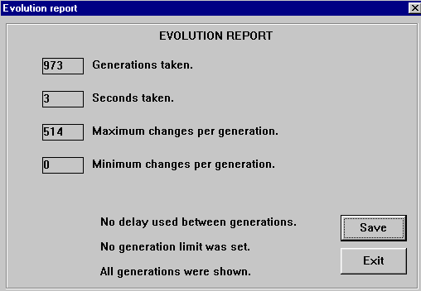

The following sections detail what each part of the report dialog shows.

Generations taken
This number shows how many generations were taken for the evolutionary process.

Seconds taken
This number shows how many seconds the evolutionary process has taken. This number is rounded BACK, so it will frequently be 0 for smaller amounts of text.

Maximum changes per generation
This number shows the maximum number of times in any generation that the evolution process replaced a character. This value is a measure of the “hit” rate of the process. A high value means that in one particular generation, a large number of characters were replaced in the evolving text as not having matched in the original text.

Minimum changes per generation
This number shows the minimum number of times in any generation that the evolution process replaced a character. This value is also a measure of the “hit” rate of the process. A lower value means in that in one particular generation, few characters needed to be replaced in the evolving text as not having matched in the original text.
8) TEXT EVOLUTION TUTORIAL
This chapter will step you through the program and demonstrate some of its basics.
- The application screen. The original text box at the top of the application is where the text you wish to evolve should be entered. Click on the text box and enter some text. Write a few sentences, perhaps a small paragraph.

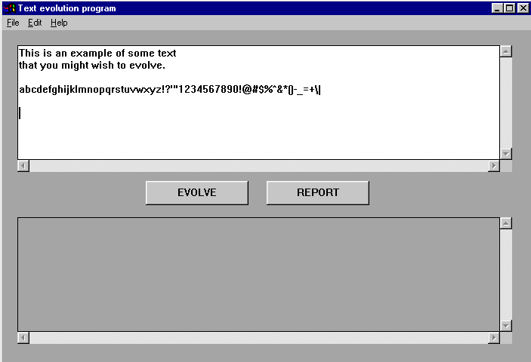
- The application screen with some text in the original text box should be shown, similar to the image shown above. From the FILE menu, select SETUP.

- The SETUP dialog. This dialog allows you to alter some of the evolution parameters. From the group box entitled “evolution options”, click on the EVOLVE TO LIMIT option. By selecting this option, you are limiting the evolutionary process to just 100 generations (indicated by the number in the box next to this option), rather than allowing it to be performed through to completion (where the original text would match the evolving text). When you have selected the EVOLVE TO LIMIT option, click on the OK button.

- You should now have been returned to the application window. Click on the EVOLVE button in the middle of the screen.

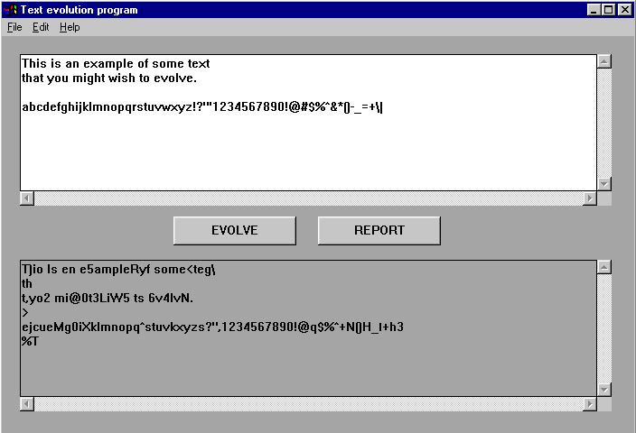
- The application window with the text in the original text box and the evolving text box with the resulting text. The text that has evolved may not necessarily match the original text, since we have imposed a GENERATION LIMIT for this text. To view a report on how the process ran, click the REPORT button.

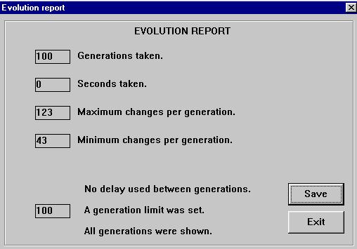
- The evolution report. This report details the settings you used for this process and some of the statistical information relating to it.

9) TEXT EVOLUTION ERROR MESSAGES

“You must have stepped or completed evolution to see a report!”

This error message is returned when you have attempted to view a report, but has not yet performed any evolution on any text. You must first perform a step or a complete evolution cycle before a report can be generated and displayed.
10) GRAPHIC EVOLUTION OVERVIEW
10.1) Biomorphs.
A biomorph is a small, graphical “creature”. How a biomorph will look and how it is drawn on the screen, depends on a list of “values”, known as it’s genetic makeup. By altering any of these values, you can alter how the biomorph will look. The following table outlines the purpose of each of these gene values. For more information about how biomorphs are drawn, read the DRAWING BIOMORPHS chapter.

Gene number: | Purpose:
0 | Number of offspring.
1 | Number of iterations.
2 | Length of first line.
3 | Length of second line.
4 | Offshoot point.
5 | Angle of first line.
6 | Angle of second line.
7 | Length of trunk.
8 | Red colour value.
9 | Green colour value.
10 | Blue colour value.

Gene 0 – Number of offspring.
This gene determines how many offspring this biomorph would generate. If this biomorph were to survive, this gene holds the number of new “offspring” this biomorph will generate.

Gene 1 – Number of iterations.
This gene controls how many new branches are drawn when the biomorph is displayed. Essentially, this means how many lines are drawn. As each line that makes up the biomorph is drawn, two new lines will branch off from it. From each of those new lines, two others will branch. The extent to which this process continues is handled by this gene.

Gene 2 – Length of first line.
This gene determines the length of the line for each even iteration.

Gene 3 – Length of second line.
This gene determines the length of the line for each odd iteration.

Gene 4 – Offshoot point.
When a line is drawn, two new lines will branch off from it, a process that is repeated until the biomorph is fully displayed. This gene determines at what point along a new line each of the two new branches will extend from.

Gene 5 – First angle.
When a line is drawn, two new lines will branch from it, a process that is repeated until the biomorph is fully displayed. From each line, two new branches will be drawn. If the line being drawn falls during an even iteration, this gene determines at what angle the two new branches will be drawn.

Gene 6 – Second angle.
When a line is drawn, two new lines will branch from it, a process that is repeated until the biomorph is fully displayed. From each line, two new branches will be drawn. If the line being drawn falls during an odd iteration, this gene determines at what angle the two new branches will be drawn.

Gene 7 – Length of trunk.
The “trunk” is the initial line drawn when displaying the biomorph. It forms the base or “body” of the biomorph. This gene determines the length of its trunk.

Gene 8 – Red colour value.
The colour of each biomorph is determined by combining red, green and blue colours together. This gene holds the value for the red pigment.

Gene 9 – Green colour value.
The colour of each biomorph is determined by combining red, green and blue colours together. This gene holds the value for the green pigment.

Gene 10 – Blue colour value.
The colour of each biomorph is determined by combining red, green and blue colours together. This gene holds the value for the blue pigment.

10.2) Drawing biomorphs.
Using its gene values, the biomorph is drawn onto the screen. Biomorphs are drawn using what is referred to as “recursion”. When a line is drawn, two new lines will branch out from it. From each of these new branches, two other lines will be drawn. This process continues a certain number of times, governed by gene 1. The line drawing process is illustrated in the following diagram.

First iteration
Second iteration
Third iteration
Fourth iteration
10.3) The application screen.
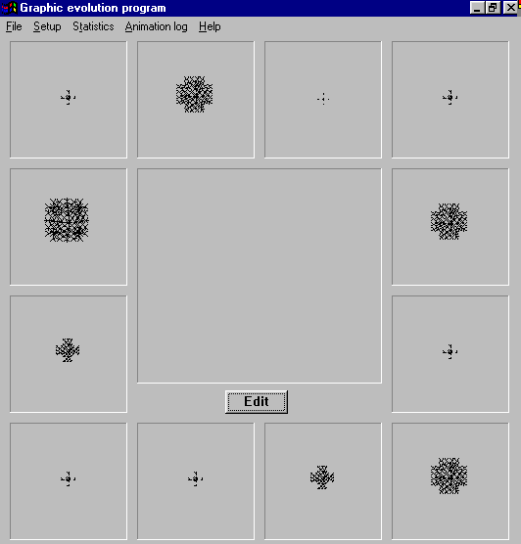
This image shows the graphic evolution program as it looks when it is started. The important features are detailed here:

The OFFSPRING boxes
The offspring boxes the smaller squares that are around the border of the application. Each of these smaller boxes may contain an offspring biomorph when the application is started. You select a new parent biomorph by clicking on one of these boxes. You should note that after a few generations, it is not necessary that each of the offspring boxes be active.

The PARENT box
The parent box is located in the centre of the application. It is the large square, directly above the EDIT button. This box displays the current parent biomorph. When the application starts, this box will be empty.

The EDIT button
This button allows you to edit the gene values of the current parent directly. For more information on this feature, see the chapter entitled EDITING A PARENT.

10.4) The menu.

Each of the pulldown menus and their associated options are explained below.

The FILE menu

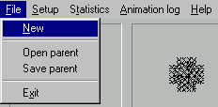

New
This option allows you to reset the program and start afresh. Selecting this option will clear all the statistical information, clear any biomorphs stored in the animation log and reset all biomorphs to start all over again.

Open parent
This option allows you to load in a biomorph file (a file with a .BMF extension) from off a disk. Selecting this will bring up a file dialog similar to those you find in most Windows applications. If you chose to load a biomorph, it will be loaded into the parent box and a new generation of offspring will be created.

Save parent
This option allows you to save the current biomorph to a file (a file with a .BMF extension). Selecting this option will bring up a file dialog similar to those you find in most Windows applications.

Exit
This option allows you to exit the program.

The SETUP menu

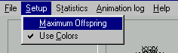

Maximum offspring
Selecting this option will toggle the “maximum offspring” option. With this option selected, there will always be 12 offspring in each generation. The effect of gene 0 - the gene governing the number of new offspring a given biomorph would generate if selected - is negated.

Use colours
Selecting this option will toggle the “use colours” option. With this option selected, the evolution manager will allow the use of colour by your biomorphs. This means that the colours evolve along with the normal gene values. If this option is NOT selected, all the biomorphs will appear black and you will not be permitted to edit the genes relating to colour.

The STATISTICS menu
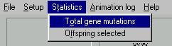
Total gene mutations
Selecting this option will bring up the “total gene mutations” dialog.

Offspring selected
Selecting this option will bring up the “offspring selection count” dialog.

The ANIMATION LOG menu
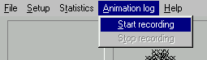
The animation log menu allows you to control when recording of biomorphs is stopped or started.

Start recording
By selecting this option, the program will begin to record the gene values for each new parent you select. This information can be played back later using the ANIMATOR utility.

Stop recording
By selecting this option, the program will finish recording an animation log and invite you to save it to disk for viewing using the ANIMATOR utility. When complete, the animation array will be emptied and you will be able to start a new animation log from scratch.

The HELP menu

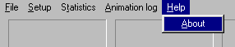

About
The about option will display information about the program.

10.5) Animation logs.
Animation logs allow you to store the gene values for each new parent you select. These values can be stored in a file, and played back sequentially using the supplied ANIMATOR utility. By doing this, you can view the changes that each new generation has brought.
To begin recording a new animation log, select START RECORDING from under the ANIMATION LOG menu. Each time you chose a new parent, the values for it are added to the log. When you have chosen a number of generations, select STOP RECORDING from under the ANIMATION LOG menu. A standard Windows save file dialog will be displayed, allowing you to save the log to disk. An animation log file has a .BAN file extension.
To view the animation, use Windows Explorer to locate the file on disk and OPEN it. If you have the file associations already set up, the file should open and the animator utility will be displayed (similar to the image shown below). To begin the animation, click the ANIMATE button.
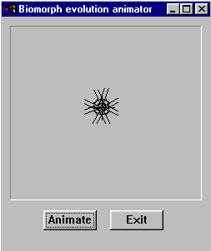
If the file associations have not been set up, Windows will prompt you to identify a program it can use to open that file. If this is the case, select BROWSE and locate the file “ANIMATOR.EXE” from within your NATURAL/PART_B folder. Doing this should set up the file association permanently and you should not be prompted to locate the animator program again.

10.6) Viewing saved biomorphs.
Another utility supplied with the Graphic evolution program is called “bio view”. This application allows you to view biomorphs outside of the application, in the same way you would view normal image files.
To save a parent to disk and view it later, select SAVE PARENT from under the FILE menu. Using Windows Explorer, locate the saved biomorph file on disk. It will have a .BMF file extension. When you locate the file, OPEN it. If you already have the file association set up, the saved biomorph should be displayed in a box on the screen.
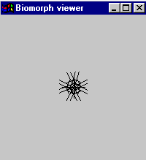
If not, Windows will prompt you to identify a program it can use to open that file. If this is the case, select BROWSE and locate the file “BIO_VIEW.EXE” from within your NATURAL/PART_B folder. Doing this should set up the file association permanently and you should not be prompted to locate the animator program again.

10.7) Editing a parent.
The program allows you to edit each of the gene values for a parent manually. Editing is performed on any biomorph which is current a parent. No editing of gene values can be done on offspring.
To begin editing the values for a parent biomorph, click on the EDIT button beneath it. This will open the EDITING PARENT dialog.
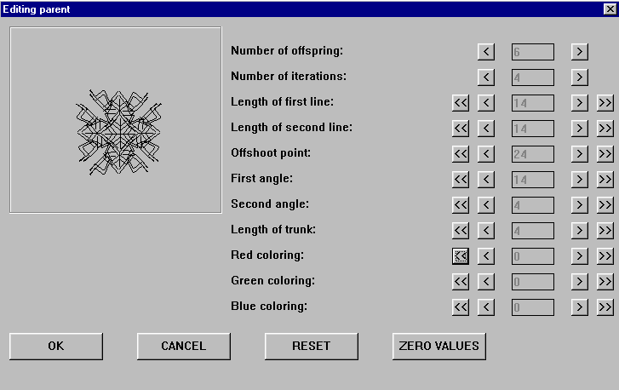
The genes and each of their functions are listed down the right side of the application. A box that will display how the edited biomorph looks is displayed to the upper left corner. Due to a program bug, when you edit Biomorphs the gene values will all appear to be zero and no biomorph will be shown. When you start up the EDIT dialog, click the RESET button to update the display correctly. For more information, see the section entitled TROUBLESHOOTING – GRAPHIC EVOLUTION.

The OK button
Clicking this button will return you to the application window, copying all the new gene change values into the parent. Doing this will automatically create a new generation of offspring biomorphs.

The CANCEL button
Clicking the CANCEL button allows you to exit the edit dialog without any changes being made to the parent.

The RESET button
The RESET button resets all the gene values to how they were for the biomorph you originally started editing. Essentially, this works like an “undo” option.

The ZERO VALUES button
This button sets all the genes to zero, with the exception of the “number of offspring” gene, which will reset to 1. This button allows you to start with a clean biomorph, without having to manually reset all the values yourself.

The GENE MODIFIDER buttons
These buttons are located alongside each of the boxes that display the value of each gene.
Decrease gene value by 1.
Decrease gene value by 10.
Increase gene value by 1.
Increase gene value by 10.

10.8) Statistics.
Some statistical information is available to you. This information can be obtained through the options under the STATISTICS menu.

Total gene mutations
Selecting this will bring up the “total gene mutations” dialog with the buttons OK and SHOW. TO display the graph, click the SHOW button.
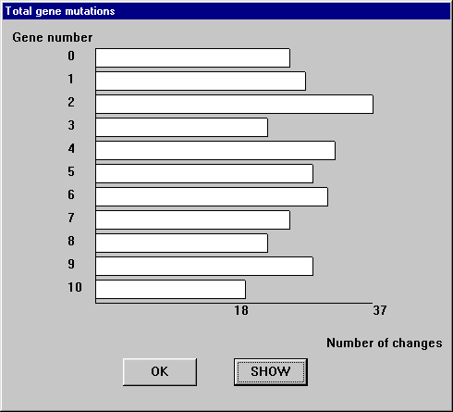

This is a graph of how many times each gene has mutated, from all of the new offspring that have been generated. For each new offspring biomorph, the program maintains a count of how many times each gene is mutated. These tallies continue on with each new generation. The graph shows which genes mutate more often than the others. All the gene mutation tallies are reset to 0 when you select NEW from the FILE menu.
To exit the “total gene mutations” dialog, click on the OK button.

Offspring selected
Selecting this will bring up the “offspring selection count” chart.
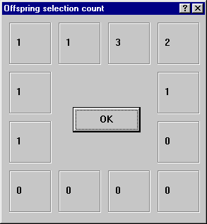

This shows the number of times each offspring box on the screen has been chosen as containing the biomorph that will made a new parent. Each time you select a new parent biomorph, the “hit” count for that box is increased by one. The “hit” counts for each box are reset to 0 when you select NEW from the FILE menu.
To exit the “offspring selection count” chart, click on the OK button.

11) GRAPHIC EVOLUTION TUTORIAL

The purpose of this chapter is to guide you through some of the basic functions.

- Start up the graphic evolution program. The application should appear on screen, similar to that shown here. It should be noted that each time the application is run, each of the 12 initial biomorphs are generated randomly. You are now ready to begin selecting new parent biomorphs from the available offspring. To chose which offspring biomorph will become a new parent, click on the box that contains it with the LEFT mouse button.

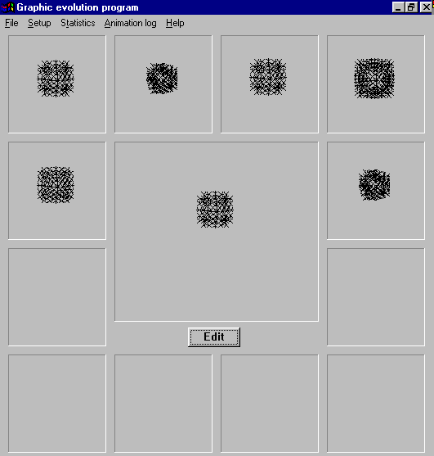
- The application window should change. The biomorph you clicked on should now be displayed in the centre of the screen, with a new generation of offspring surrounding it. Repeat this by choosing another new parent from the offspring available to you, by clicking with the LEFT mouse button.

- The application window should change again, with another new generation of offspring. This process of choosing a new parent may be repeated many times. Continue selecting a few new parents from each generation that you are presented with.

- You have the option of viewing the gene values that make up each of the current offspring at any time. To see this, choose an offspring and click on it with the RIGHT mouse button.

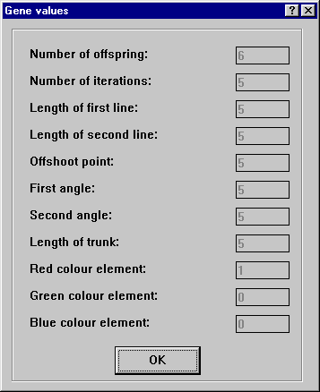
- A dialog listing each of the genes and its value for this offspring should be displayed. You should note that the numbers representing the structure of your biomorph may not necessarily match those displayed. When you have finished looking over these gene values, click the OK button.

- Continue choosing a few new parent biomorphs by click on the offspring boxes with the LEFT mouse button. When done, select the STATISTICS menu and choose the option “total gene mutations”.

- A dialog box should appear with the buttons OK and SHOW.

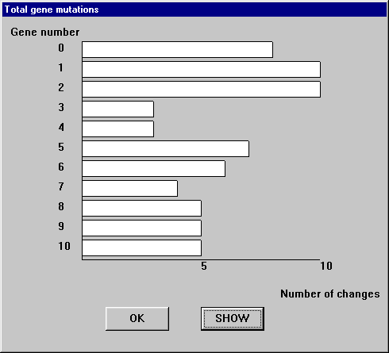
- A bar graph similar to the one shown above should be displayed. This bar graph shows the total number of times each of the 11 genes has been mutated, through all of your offspring. By viewing this graph, you can determine which genes have shown a greater tendency to mutate. When finished viewing the graph, click the OK button.

- Select the STATISTICS menu again and choose the option “offspring selected”.

- A chart similar to the one displayed above should be shown. You should note that the numbers displayed in each box might not necessarily match those in yours. This chart shows which offspring box is being selected most frequently as containing the new parent. When you have finished viewing this chart, click on the OK button.

- From the SETUP menu, select the MAXIMUM OFFSPRING option. Continue selecting new generations by clicking on the offspring boxes with the LEFT mouse button. You should now notice that each new generation will always have 12 new offspring. The MAXIMUM OFFSPRING option allows you to force the application to give you 12 biomorphs to choose from, in each generation. This gives you a greater choice of new parents. Select the MAXIMIUM OFFSPRING option from the SETUP menu once again to turn this option back off.

- From the SETUP menu, select the “Use colours” option. Continue choosing new generations by clicking on the offspring boxes with the LEFT mouse button. All the new offspring should be black, without any of the colours mutating. By toggling the USE COLOURS option, you can change between the offspring being black or their colours mutating.

- Continue selecting a few more new parents by clicking on the offspring boxes with the LEFT mouse button. Now, click on the EDIT button beneath the parent in the middle of the application window.

- An “editing parent” dialog box should be displayed on the screen. Click on the RESET button. You should bow have a display similar to the one shown above. You should note that the biomorph shown in the upper left and each of its gene values may not necessarily match yours. Try altering some of the gene values for this parent and click OK.

- The application screen should change again. Your new parent should be displayed in the centre of the application with a new generation of offspring surrounding it.

- Continue the process of selecting new parents. Unlike the text evolution program, the graphic evolution program does not have an ultimate goal. You can continue to evolve your biomorphs until you find one that you feel is finished, or simply continue indefinitely.

12) GRAPHIC EVOLUTION ERROR MESSAGES

“All biomorphs stored for animation have been lost”

This message is intended as a warning, not as an error report. This message is displayed when you chosen NEW from the under the FILE menu, while you had been recording an animation log. Any animation data you had stored will be lost and the recording options will all be re-initialised when you select NEW.

“AN I/O ERROR HAS OCCURRED!”

This error message is returned when the program has attempted to load in a new parent biomorph, yet disk access has failed. This could indicate a faulty disk, a faulty file or an incorrect file type.

“No frames to save!”
You have attempted to stop recording an animation log and save it to disk, but no frames were added to the array. The recording state will be reset and no animation data will be saved to disk.

13) TROUBLESHOOTING – TEXT EVOLUTION

The end of the text I have entered or loaded into the evolving text edit box is lost when I attempt to evolve it.

Unfortunately, there is a limit on the amount of text that can be stored within the text edit boxes. The evolution process should be continued normally with the text that is stored. There is no solution for this problem.

If I switch tasks and return to the evolution program, the application window has had all the buttons and edit boxes cleared leaving just grey or what areas.

This is due to an internal programming bug with the application. If you minimise the application or switch processes while the evolution program is running, the interface will not be able to “re-draw” itself on the screen correctly until the evolution process is completed OR a “step” has been finished. The program should continue running normally.

If I load in non-text files such as images or word documents, the evolution process completes but the resulting text doesn’t look like the text I’ve entered or loaded.

The application will only evolve characters that are considered part of the “normal” character set – upper and lower case letters, number, punctuation symbols, etc. The evolution program will ignore any other characters, even though they may appear in the text that is to be evolved. Most files such as wave audio or images contain codes for characters that cannot be displayed normally.

The option to “display text during evolution” does not appear to have any effect. I do not see any text being displayed as evolution is performed, unless I chose a step number.

This problem is related to an internal programming bug with the application. The effect this option will have is to alter the speed at which evolution will be performed. If you chose to display text during evolution, the program will run a little slower than if you chose not to. The problem stems from the windows inability to “draw” itself after each generation of text. By choosing a step number, the window WILL be “drawn” and you do get to view the text. There is no solution for this problem.

14) TROUBLESHOOTING – GRAPHIC EVOLUTION

When I edit a biomorph, all the gene values displayed are zero and no biomorph is displayed. As soon as I alter a gene value using one of the gene change buttons, all the values change suddenly and the biomorph appears.

This problem is due to an internal programming bug within the application. Since the dialog box is not “drawn” onto the screen correctly, you will only see the correct values for each of the biomorph’s genes and in fact see the biomorph displayed, AFTER you have clicked either the RESET button or one of the gene modifier buttons. There is no solution to this problem.

15) GLOSSARY
Accumulation of small change
The effect that small changes in a gene value can have, when such small changes are repeated over many generations.

Animation log
A file storing the gene values of each new parent biomorph the user selects. This file can then be played back later using the ANIMATOR utility.

Animator
The utility allowing the user to view animation logs that have been saved as part of the Graphic Evolution Program.

Application
An executable program.

ASCII
The American Standard Code for Information Interchange. This is a numeric code used to represent the character set.

Biomorphs
Graphical “creatures” which are drawn using a set of numbers.

C++
A programming language with object orientated extensions.

Evolving text
The text which is undergoing evolution. It is randomly generated by the text evolution program.

Evolving text box
The grey text box in the text evolution program which contains the text the application is currently evolving, or has completed the evolution process on.

Executable
A file on disk that the computers operating system may run.

Generation
In the text evolution program: The end result of the application making a complete pass through the evolving text, replacing any characters in it that don’t match the characters in the same position within the original text.
In the graphical evolution program: The current offspring biomorphs generated by selecting a new parent.

Genetic make-up
The gene values that determine how a biomorph is drawn.

Graphic(al) evolution program
The program that demonstrates the accumulation of small change by using small graphical creatures known as biomorphs.

Group box
A box displayed on the screen that contains a variety of interface components. Typically, radio buttons or checkboxes.

Iteration
When drawing biomorphs: The current series of lines being drawn onto the screen by the graphic evolution program. Each iteration can be made up of many lines. See also: Generation

MB
A megabyte – 1,024,000 bytes of memory, each capable of storing one character.

Natural selection
The rules determining which species survive, due to many factors such as environment.

Offspring
See Offspring biomorph.

Offspring biomorph
A biomorph which has been created using the gene values of a parent biomorph. Offspring biomorphs are displayed around the edges of the graphic evolution program and any of them may be selected to become a new parent.

Original text
The text entered by the user in the white text area in the text evolution program. It is the text that the evolution process will be performed on.

Original text box
The white text area in the text evolution program where there user enters the text they wish to evolve.

Parent
See Parent biomorph

Parent biomorph
The current parent biomorph, whose gene values have been used to generate a new number of offspring biomorphs.

Shortcut
Icons in windows that provide a shortcut to a program or a file.

Text evolution program
The program that demonstrates cumulative selection over the idea of the random variation.
16) SUGGESTED READING.
To further understand all the applications and their purpose, the following reading material is suggested.

Dawkins, R. (1991) Blind Watchmaker, The. England: Penguin Books Ltd.

