System Introduction

The Biomorph (text) application demonstrates the basic idea of evolution with natural selection. It simulates this by applying natural selection to evolving (randomly chosen) text. It achieves this by taking any given text and continuously choosing a random character for each character within this text until it obtains a random character that matches the original. When this happens, that character is said to have “evolved” and no longer changes. The process will continue until either all the characters evolve or a final evolution limit has been reached (a set number of “generations” – iterations of randomly selected characters – has been reached). The program will accept text from the keyboard or any standard text file may be loaded from disk.

Two versions of this program are available, one application written using Java 1.1 (platform independent) and another written with Borland C++ V5.02 (for the Windows95™/WindowsNT4.0™ operating systems).

Getting started

Entering text from the keyboard

Fig1.1 – The application once loaded
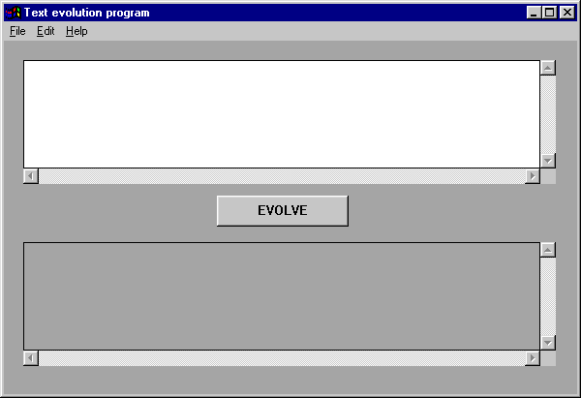
Once the application has loaded, make sure the original text edit box is selected. The edit box is selected if the flashing cursor can be seen. You may enter any text inside this edit box that you wish to perform the evolution process on. You may use multiple lines and your text may run off the edge of the edit box. If you enter more text on one line than can be shown by the edit box, you can scroll horizontally through your text using the horizontal scroll bar. Should you need to enter more lines than the text edit box can display, you can scroll vertically through the text using the vertical scroll bar (see fig1.2).

Once you have entered your text, click the evolve button to start the
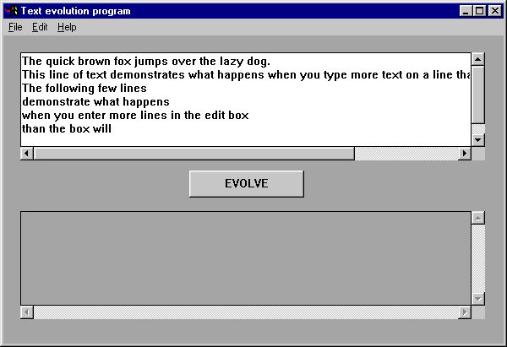evolution process. This process may take some time, depending on the amount of text you have entered. Once complete, a report will be displayed detailing the results of your text being evolved. An example of what a typical report may look like is shown in figure 1.3. The numbers displayed in a report box will probably be different from those shown.

Generations taken: This is the total number of generations the program needed to create in order to reach a match with the text you entered.

Seconds taken: This is the total amount of time in seconds that the program required to complete the evolution process.

Maximum changes per generation: This is the maximum number of new random characters the program needed to create for any of the generations it required.

Minimum changes per generation: This is the minimum number of new random characters the program needed to create for any of the generations it required. As the text you entered was evolved right through to a complete match, the final generation required no changes at all, hence this number will usually be 0.
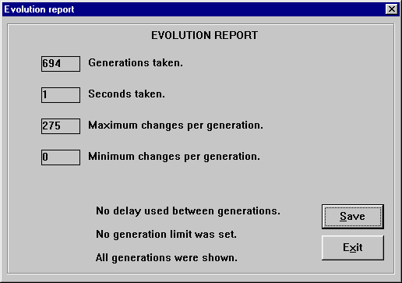

Troubleshooting

Windows95™ version

The end of the text I have entered or loaded into the text edit box is lost when I attempt to evolve it.

Unfortunately, there is a limit on the amount of text you may enter or load into the text box. This is no solution for this problem, although the remaining text left behind after the end is lost will still evolve just fine.

If I load in non-text files such as Word documents or image files, the evolved text has a lot of characters missing or comes out with a final match that does not look like the original.

The application will only evolve normal characters, punctuation marks and numbers. Many other file formats such as executables, image or word files contain characters outside this displayable range. Although such characters may appear inside the text edit box, once evolution is commenced these are ignored by the program. The resulting evolved text is a match of all the normal display characters your original text contained.

