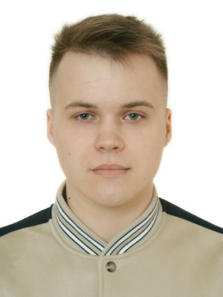**Kartash Dmitry Olegovich**

Kiev, st. Makeevska 7, 149 • +380509018361 • kartaschdim@gmail.com

|  |  |  |
| --- | --- | --- |
| Objective | To get position of Front End developer. | |
| SUMMARY | **Background** – One year of freelance work. A couple of commercial projects  **Skills** – I already know and can use main instruments for Web-development such as HTML5, CSS3, JavaScript, Vue.js  **Personality** – I am honest, organized and flexible. I concentrate on tasks to achieve results. | |
|  |  | |
| Experience | **Computer courses Streamline**, Kiev 2018 - 2019  **IT Trainer**   * HTML, CSS course * Javascript course   **GS4B marketing agency**, Kiev Aug.2019 – Dec.2019  **FrontEnd developer**   * Yii2 CMS Experience * Nuxt.js Experience | |
| Education | **Program Engineering Magistracy**, KNUTE, Kiev Present  **Program Engineering Bachelor**, KNUTE, Kiev 2019  **Program Engineering**, TEK KNUTE, Kiev 2016  Junior Information Systems Specialist | |
| Computer Skills | * JavaScript, HTML5, CSS3 * SASS, jQuery, Vue.js * MySQL * Gulp/ Webpack * Adobe Photoshop, Illustrator * Git | |
| Languages | **Ukrainian**: Native language  **Russian:** Native language  **English**: Pre-Intermediate Listener, Novice Speaker, Advanced Reading and Pre-Intermediate Writing |  |
| Activities and Interests | Web development, Board Games(D&D), Volleyball, Table Tennis, Chess, Drawing, Cycling, Active Rest | |
|  |  | |