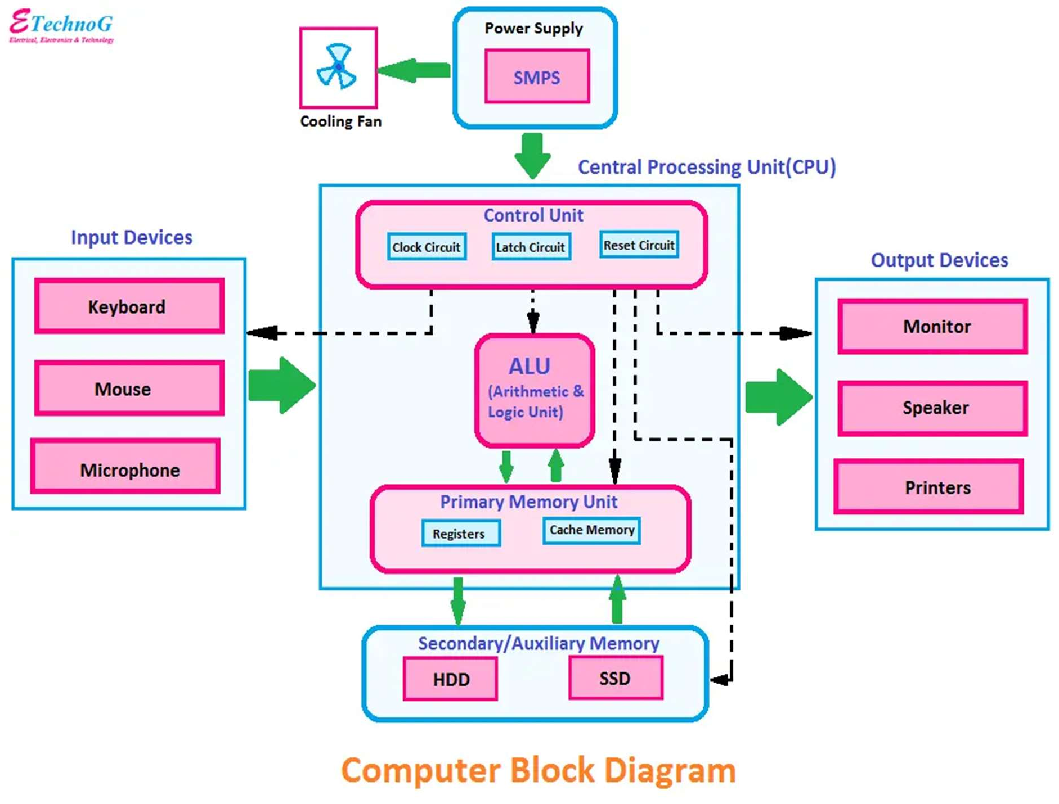

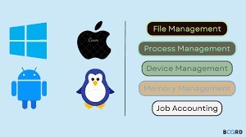**Operating System Functions:**

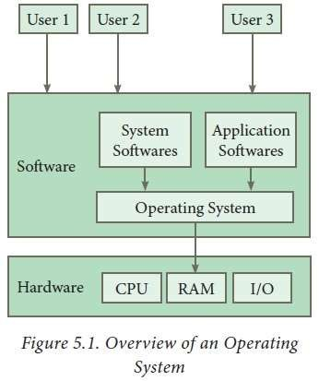

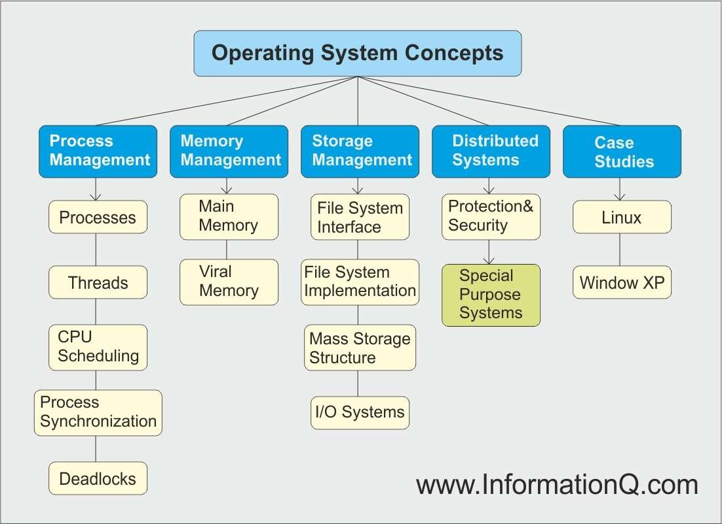

# History of Linux:

* In 1991, Linus Torvalds, a Finnish computer science student, developed the Linux kernel.
* Linus released the kernel as free software under the GNU General Public License (GPL).
* The kernel's development was open and collaborative, allowing contributors worldwide to enhance and extend it.
* Over time, a vibrant Linux community evolved, resulting in numerous distributions and applications.

# Linux Foundation:

* The Linux Foundation is a consortium founded to support and promote Linux and open- source technologies.
* It sponsors the development of the Linux kernel and other important open-source projects.
* The Linux Foundation provides training, certification, and collaboration opportunities for developers and organizations.
* It hosts events, including the Linux Plumbers Conference and the Open Source Summit.

# Hardware Requirements:

* Hardware requirements for Linux can vary significantly based on the distribution and usage scenario.
* Server installations may require more memory and processing power compared to desktop systems.
* Lightweight distributions, like Puppy Linux, can run on older hardware with minimal resources.
* Embedded systems might have specialized hardware requirements depending on the target platform.

# Linux Components:

* Linux is a popular operating system that is known for its open-source nature and ﬂexibility.
* It consists of several key components that work together to provide a fully functional computing environment.

Here are the major components of a typical Linux operating system:

**Linux Kernel:**

* The core of the Linux operating system is the Linux kernel.
* It is responsible for managing hardware resources, scheduling processes, and handling essential system functions.
* The kernel is the bridge between the hardware and software.

**Shell:**

* The shell is the user interface that allows users to interact with the Linux system.
* Common shells include Bash (Bourne-Again Shell), Zsh, and others.
* The shell interprets user commands and provides a command-line interface for running programs and managing the system.

**System Libraries:**

* Linux includes a set of system libraries that provide essential functions and services to applications.
* These libraries contain reusable code for tasks like file I/O, memory management, and network communication.
* The GNU C Library (glibc) is a critical system library used in most Linux distributions.

**File System:**

* Linux supports various file systems, including ext4, XFS, and Btrfs.
* The file system manages files, directories, and storage devices.
* It handles file creation, reading, writing, and organization.

**Device Drivers:**

* Device drivers are essential software components that enable the kernel to communicate with hardware devices, such as graphics cards, network adapters, and printers.
* Linux supports a wide range of hardware through its extensive collection of device drivers.

**Process Management:**

* Linux manages processes, which are running programs or tasks.
* This includes process creation, scheduling, termination, and resource allocation.
* The kernel ensures efficient utilization of the CPU and memory.

**Memory Management:**

* Memory management is responsible for allocating and managing system memory, including physical and virtual memory.
* It ensures that processes can access and use memory resources efficiently.

**Networking Stack:**

* Linux oﬀers a robust networking stack with support for various protocols, such as TCP/IP.
* It enables network communication, including network configuration, socket management, and data transmission.

**User Space Utilities:**

* Linux includes a wide range of command-line utilities and system tools to perform tasks like file manipulation, process management, and system administration.
* Some common utilities include ls, cp, mv, ps, and top.

**Graphical User Interface (Optional):**

* Many Linux distributions include a graphical user interface, such as GNOME, KDE, or Xfce, to provide a user-friendly desktop environment.
* Users can interact with the system using a mouse and graphical applications in addition to the command-line interface.

**Package Management:**

* Linux distributions often come with package management systems (e.g., APT, YUM, or DNF) to simplify software installation, updates, and removal.
* Users can easily install and update software packages from repositories maintained by the distribution.

**Security and Authorization:**

* Linux includes security features, such as user authentication, access control, and firewalls.
* It oﬀers robust user and group management to control access to system resources.

**Error Handling:**

* Linux provides mechanisms for logging and handling system errors and exceptions to maintain system stability.

**Printing Services:**

* Linux supports printing services that enable users to configure and manage printers and print documents.

**Desktop Environment (Optional):**

* In addition to the graphical user interface, many Linux distributions oﬀer complete desktop environments that provide a consistent look and feel and additional features for desktop users.
* The specific components and their configurations can vary between diﬀerent Linux distributions.
* Examples of popular Linux distributions include Ubuntu, Fedora, CentOS, Debian, and many others, each with its own package management system, default software selection, and system administration tools.

# Linux Distributions (Distros):

* Linux distributions come in various ﬂavors, each tailored for specific purposes and preferences.

**Ubuntu:** User-friendly, suitable for desktops and servers.

**Debian**: Known for stability and a large package repository.

**CentOS**: Designed for enterprise use and known for long-term support.

**Fedora**: Features the latest software and technologies.

**Arch Linux**: Oﬀers a minimalist, rolling-release system for advanced users.

**Red Hat Enterprise Linux (RHEL):** Enterprise-grade distribution with paid support.

# Features of Linux:

**Open Source:** Linux is open-source, allowing users to access, modify, and distribute the source code.

**Stability:** It's known for its reliability and long uptimes, making it suitable for critical tasks.

**Security:**  Strong security features, including user permissions, SE Linux, and a robust firewall system.

**Multitasking:** Linux handles multitasking efficiently, supporting multiple processes and users concurrently.

**Networking:** Excellent networking capabilities, making it the foundation for many network devices and servers.

**Flexibility**: It's highly customizable and can be tailored to specific needs and preferences.

# Choosing a Suitable Linux Distribution:

**Use Case:** Determine if you need a distribution for a desktop, server, embedded system, or a specific purpose like ethical hacking or multimedia production.

**Package Management:** Choose between distributions with diﬀerent package management systems (e.g., Debian-based, RPM-based, source-based).

**Community or Enterprise:** Decide if you require community-driven support or enterprise- level support and maintenance.

**User-Friendliness:**

* Consider the ease of use for both you and the intended end-users.
* Some distributions are more user-friendly than others.

**Hardware Requirements:**

Ensure the distribution matches your hardware capabilities, whether you're running it on a high-end server or an old laptop.

**Release Cycle:**

* Some distributions have fixed release cycles, while others follow rolling releases.
* Choose based on your preference and need for stability.

**Support and Documentation:**

Assess the availability of community support, official documentation, and forums for troubleshooting and assistance.

**Software Ecosystem:**

Evaluate the software available in the distribution's repositories and ensure it meets your requirements.

**Security:**

Consider the distribution's security features, patching frequency, and overall reputation for security.

**Personal Preference:**

* Finally, personal preference plays a role in selecting a distribution.
* Experiment with a few to find one that suits your workﬂow and preferences.

Conclusion:

* Linux is a diverse and robust operating system with a rich history, a wide range of distributions, and a multitude of features.
* To choose the right distribution, assess your specific needs and preferences, and consider factors such as use case, package management, support, hardware, release cycle, and personal comfort with the system.

Reference:

Geeks for geeks Javatpoint