# Linux Architecture: Kernel

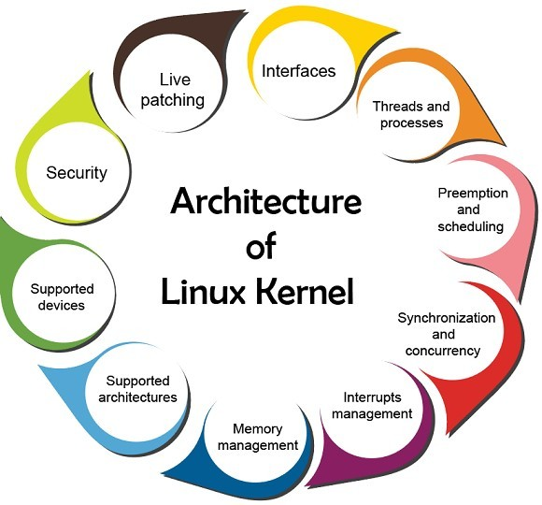

1. **Monolithic Kernel**:

* The Linux kernel is a monolithic kernel, which means that it contains most of the operating system's core functionalities within a single, unified structure.
* This design choice oﬀers efficiency but reduces modularity.

1. **Process Management:**

* The kernel handles process creation, scheduling, and termination.
* It maintains a process table, which contains essential information about running processes.

1. **Memory Management:**

* The kernel manages physical and virtual memory, ensuring memory protection, paging, and swapping.
* The Memory Management Unit (MMU) plays a critical role in this process.

1. **Device Drivers:**

* Device drivers are integrated directly into the kernel or provided as loadable modules.
* These drivers enable communication between the hardware and software.

1. **File System Management:**

* The kernel provides access to the file system, which includes file I/O operations, file permissions, and maintaining file metadata.
* (e.g., ownership, timestamps).

1. **Networking:**

* The kernel handles network protocols and supports various network devices and configurations.
* It is responsible for routing, packet handling, and network stack management.

1. **Security:**

* The kernel enforces security policies, such as user and group permissions, Access Control Lists (ACLs), and firewall rules.
* It ensures process isolation and data protection.

1. **Inter-Process Communication (IPC):**

* The kernel provides mechanisms for processes to communicate, including pipes, sockets, and message queues.
* These IPC methods facilitate collaboration between applications.

# Architectural Diﬀerences between Windows and Linux :

1. **Kernel Type:**

* Windows uses a hybrid kernel, which combines features of both monolithic and microkernel architectures, resulting in complex interactions between components.
* Linux employs a pure monolithic kernel, oﬀering more straightforward communication between kernel modules.

1. **Licensing Model:**

* Windows is a proprietary operating system, requiring users to purchase licenses for most versions.
* Linux is open-source, making it freely available, with various distributions to choose from.

1. **GUI and Desktop Environment:**

* Windows includes a tightly integrated graphical user interface (GUI), and the GUI is a fundamental part of the OS.
* Linux separates the GUI from the core OS, allowing users to choose from various desktop environments (e.g., GNOME, KDE, Xfce).

1. **Software Installation and Package Management:**

* Windows primarily relies on executable installers (e.g., MSI, EXE) for software installation.
* Linux uses package managers (e.g., APT, Yum, DNF) to install and manage software, simplifying updates and dependencies.

1. **File System:**

* Windows predominantly uses the NTFS file system, which is optimized for its platform.
* Linux supports multiple file systems (e.g., ext4, Btrfs, XFS), allowing users to choose the one that best suits their needs.

1. **User Permissions and Security Model:**

* Windows uses access control lists (ACLs) and a user-based permission model, which can sometimes be complex.
* Linux employs a more straightforward user and group permission model, making it easier to manage access and control.

1. **Command Line Interface (CLI):**

* Windows oﬀers a command-line interface through PowerShell and Command Prompt, which are not as extensive as the Linux Terminal.
* Linux provides a robust command-line environment with a vast array of tools and scripting capabilities.

# Conﬁguration & Customizations of Linux :

1. **Package Management:**

* Use package managers like `apt`, `yum`, or `pacman` to install, update, and remove software.
* Customize software sources and repositories to control where packages are fetched from.

1. **Shell Customization:**

* Modify shell profiles (e.g., `.bashrc`, `.zshrc`) to tailor the command-line environment.
* Personalize the shell prompt, set environment variables, and create aliases for frequently used commands.

1. **Kernel Configuration:**

* Adjust kernel parameters using configuration files in `/etc/sysctl.conf` or by directly editing the `/proc` filesystem.
* Recompile the kernel or load/unload kernel modules to optimize performance or enable specific features.

1. **User and Group Management:**

* Create, modify, and manage user accounts and groups using commands like `useradd`, `usermod`, and `groupadd`.
* Set user permissions, create home directories, and manage group memberships.

1. **Network Configuration:**

* Configure network settings through files in `/etc/network/` or `/etc/sysconfig/network-scripts/` depending on the distribution.
* Adjust network interfaces, set IP addresses, and create custom routing rules.

1. **File System Customization:**

* Mount and manage file systems, specifying mount options and file system types in `/etc/fstab`.
* Create custom partitions, format disks, and configure quotas.

1. **Security Hardening:**

* Enhance system security by configuring firewalls (e.g., `iptables` or `ufw`) and intrusion detection systems (e.g., `Fail2ban`).
* Regularly update the system using the package manager to patch security vulnerabilities.

# Linux Structure and Installation :

1. **Filesystem Hierarchy:**

* Linux follows a well-defined hierarchy with key directories, including `/bin`, `/etc`, `/home`, and `/var`.
* `/bin` contains essential binaries, `/etc` holds configuration files, `/home` hosts user home directories, and `/var` stores variable data.

1. **Boot Process:**

* The boot process begins with BIOS/UEFI firmware, which loads a bootloader (e.g., GRUB).
* The bootloader loads the Linux kernel, which initializes the system and launches essential services and daemons.

1. **Installation:**

* The Linux installation process can vary between distributions but usually involves booting from installation media (USB, CD/DVD).
* During installation, users select partitions, specify file systems, choose software packages, and create user accounts as needed.

1. **Package Management:**

* After installation, package managers such as `apt`, `yum`, or `pacman` are used to update, install, or remove software packages.

1. **Configuration:**

* Post-installation configuration includes setting up user accounts, network settings, and other system-specific configurations.

1. **Updates:**

* Regularly update the system using the package manager to ensure the latest security patches and software updates are applied.

Reference

https://[www.geeksforgeeks.org/introduction-to-linux-operating-system/](http://www.geeksforgeeks.org/introduction-to-linux-operating-system/)

https://[www.geeksforgeeks.org/the-linux-kernel/](http://www.geeksforgeeks.org/the-linux-kernel/)