**Difference b/w linux and windows**

|  |  |  |
| --- | --- | --- |
| **S.NO** | **Linux** | **Windows** |
| 1. | Open source operating system. | Non open source OS |
| 2. | It is free of cost. | While it is costly. |
| 3. | ﬁle name case-sensitive. | ﬁle name is Non case sensitive |
| 4. | Monolithic kernel is used. | Hybrid kernel is used. |
| 5. | More efﬁcient | Less efﬁcient. |

|  |  |  |
| --- | --- | --- |
| 6. | forward slash is used for Separating the directories. | back slash is used for Separating the directories. |
| 7. | More secure than windows. | Less secure than linux. |
| 8. | It is widely used in hacking purpose based systems. | It does not provide much efﬁciency in hacking. |
| 9. | 3 types of user account:  (1) Regular  (2) Root (3) Service account | 4 types of user account:  (1) Administrator (2) Standard (3) Child (4) Guest |
| 10. | Root user is the super user and has all administrative privileges. | Administrator user has all administrative privileges of computers. |

|  |  |  |
| --- | --- | --- |
| 11. | Linux ﬁle naming convention is non-case sensitive. Thus, sample and SAMPLE are 2 different ﬁles in Linux/Unix OS. | In Windows, you cannot have 2 ﬁles with the same name in the same folder. |

Choosing a Linux Distro

|  |  |  |
| --- | --- | --- |
| **Distribution** | | **Why To Use** |
| UBuntu | | It works like Mac OS and easy to use. |
| Linux mint | | It works like windows and should be use by new comers. |
| Debian | | It provides stability but not recommended to a new user. |
| Fedora | | If you want to use red hat and latest software. |
| Red  enterprise | hat | To be used commercially. |
| CentOS | | If you want to use red hat but without its trademark. |
| OpenSUSE | | It works same as Fedora but slightly older and more stable. |
| Arch Linux | | It is not for the beginners because every package has to be installed by yourself. |

Dual Boot :

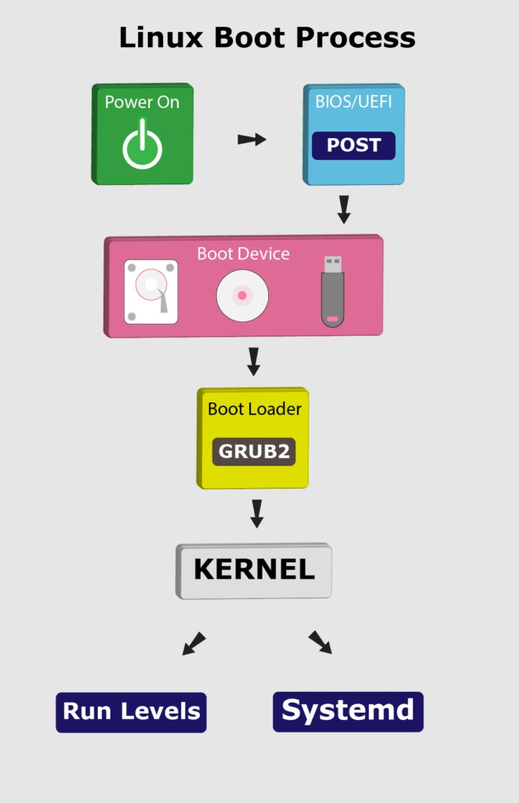

1. **BIOS and UEFI**

* First, the BIOS (Basic Input/Output System) or UEFI (Unified Extensible Firmware Interface) program kicks in once the system powers up.
* Usually, the BIOS contains all the code to gain initial access to the main machine devices:

keyboard display screen disk drives

serial communications

* Most of these devices will have dedicated device drivers taking over once the system boots fully.
* BIOS and UEFI are firmware interfaces that computers use to boot up the operating system (OS).
* Yet, the two programs differ in how they store metadata on and about the drive:
* BIOS uses the Master Boot Record (MBR)
* UEFI uses the GUID Partition Table (GPT)

Next, the BIOS or UEFI runs the power-on self-test (POST).

The POST does a series of tasks:

* verify the hardware components and peripherals.
* carry out tests to ensure that the computer is in proper working condition.
* Further, if this test finds any error, it commonly shows an error message on the screen.
* In case the test fails to detect the RAM, POST triggers a beeping sound.
* Finally, if the system passes the POST, it signals the start-up process to the next stage.

1. **Boot Loader**

* Now, the BIOS or UEFI has run the POST to check the state of the machine.
* Moving on, the BIOS/UEFI selects a boot device depending on the system configuration.
* Usually, there’s a default boot order:

Hard drives USB drives CD drives

* Of course, we can configure the BIOS or UEFI to choose the boot device in any order.
* Whatever their order, the computer looks for the boot loader in these devices one by one.

In fact, a BIOS system has the boot loader located in the first sector of the boot device; this is the MBR. It takes up the first 512 bytes on the disk. On the other hand, a UEFI system stores all startup data in an .efi file. The file is on the EFI System Partition, which contains the boot loader.

Notably, the boot loader is a small program that loads the operating system. The main job of the boot loader is to perform three actions with the kernel: locate on the disk, insert into memory, and execute with the supplied options.

The following are some of the available boot loaders for a Linux system:

LILO SYSILINUX GRUB2

In general, once the computer finds the boot loader on a device, it will run it. Consequently, this loads a larger and more complex program which eventually starts our operating system.

Let’s highlight some of the boot loaders in use with Linux.

* 1. LILO

Initially, LILO (Linux Loader) was one of the most widely used Linux boot loaders. However, it has lost favor because it has no support for multi-boot environments and for UEFI. Also, it has limited support for new filesystems.

Officially, the developers of LILO halted its development and support in December 2015. Hence, the Linux Loader is old and mostly obsolete.

* 1. SYSLINUX

Equally, SYSLINUX is a boot loader for the Linux operating system, which runs on a FAT filesystem, typical for a Windows system. In short, its goal is to ease the process of installing Linux for the first time.

Further, SYSLINUX supports several major filesystems:

FAT

ext2 ext3 ext4

In addition, SYSLINUX can support Btrfs and XFS filesystems with some constraints.

* 1. GRUB2

Despite the many choices, almost all (non-embedded) modern Linux distributions use GRUB (GRand Unified Boot Loader) because it’s very feature-rich:

ability to boot multiple operating systems

boots both a graphical and a text-based interface allows ease of use over a serial cable

strong command line interface for interactive configuration network-based diskless booting

Presently, GRUB2 has replaced its past version (GRUB), which is now known as GRUB Legacy. Importantly, we can check for the GRUB version in our system using the following command:

sudo grub-install -V

1. Kernel

After going through BIOS or UEFI, POST, and using a boot loader to initiate the kernel, the operating system now controls access to our computer resources.

Here, the Linux kernel follows a predefined procedure:

decompress itself in place perform hardware checks

gain access to vital peripheral hardware run the init process

Next, the init process continues the system startup by running init scripts for the parent process. Also, the init process inserts more kernel modules (like device drivers).

1. Systemd

To reiterate, the kernel initiates the init process, which starts the parent process. Here, the parent of all Linux processes is Systemd, which replaces the old SysVinit process. Following the booting steps, Systemd performs a range of tasks:

probe all remaining hardware mount filesystems

initiate and terminate services

manage essential system processes like user login run a desktop environment

Indeed, these and other tasks allow users to interact with the system. Lastly, Systemd uses the

/etc/systemd/system/default.target file to decide the state or target the Linux system boots into.

1. Run Levels

In Linux, the run level stands for the current state of the operating system. Run levels define which system services are running. Previously, SysVinit identified run levels by number.

However, .target files now replace run levels in Systemd.

Further, Systemd activates the default.target unit by default when the system boots. Let’s check our default target:

# systemctl get-default graphical.target

Copy

Now, let’s see the link between run level numbers and targets:

poweroff.target, run level 0: turn off (shut down) the computer rescue.target, run level 1: initiate a rescue shell process

multi-user.target, run level 3: configure the system as a non-graphical (console) multi-user environment

graphical.target, run level 5: establish a graphical multi-user interface with network services

reboot.target, run level 6: restart the machine emergency.target: emergency run level

For instance, the target value for a desktop workstation with a graphical user interface (GUI) is

5. This value stands for run level 5 which is graphical.target. Also, the run level for a server without a GUI is 3 because the default target is multi-user.target.

In addition, we can change the target (run level) while the system runs. This change entails that only services and other units defined under that target will now run on the system.

For example, to switch to run level 3 from run level 5, we can run the following command:

$ sudo systemctl isolate multi-**user.target** Copy

Then, to take the system to run level 5, let’s run the command:

$ sudo systemctl isolate **graphical.target** Copy

This command returns the run level to graphical.target, equivalent to level 5 for GUI.

**Shell:**

* Outer layer of UNIX operating System.
* It reads our command, verify syntax and check whether the corresponding command related application is available or not.
* If everything is proper, then shell interprets our command into kernal understandable form and handover to the kernal.
* It acts as interface between user and kernal.

**Kernal:**

* Core component of UNIX operating system.
* Responsible to execute our commands.
* Responsible to interact with hardware components.
* (Memory and processor) allocation will takes care by kernal

