**free :-**

* The free command gives information about used and unused memory

usage and swap memory of a system.

* By default, it displays memory in kb (kilobytes).
* Memory mainly consists of RAM (random access memory) and swap memory.
* Swap memory is a part of hard disk drive that acts like a virtual RAM.

free **-b** > display information in Bytes

free **-m** ------> display information in Megabytes free **-g** ---> display information in Gigabytes

free -**h** > human readable form

free **-t** > It adds an additional line in the output showing the column totals. free -sh

**df :-**

* The df command stands for disk free, and it shows you the amount of

space taken up by different drives.

* By default, df displays values in 1-kilobyte blocks.

df -h > human readable form df -Bg > block size in gb

df -Bm > block size in mb

**du :-**

* Command du stands for Disk Usage.
* It is used to check the information of disk usage of files and directories on a system.
* Command du display a list of all the files along with their respective sizes.
* By default, size given is in kilobytes.
* File names are used as arguments to get the file size.
* du ---> show disk usage of current directory.
* du file/directory ---> show disk usage of particular file or folder.
* du -a--> for all files and directory.
* du -h--> human readable form.
* du -Bg > block size in gb.
* du -Bm> block size in mb.
* 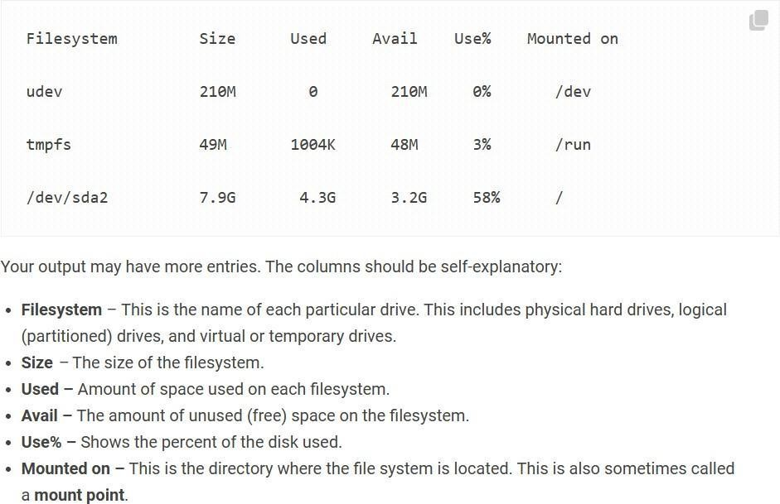du -h --exclude=excluded_directory /path/to/directory du -h /path/to/directory | sort -rh

**fdisk :-**

* fdisk is used for view, create, delete, change , resize, copy and move partitions on a hard drive.
* A partition is a logical division of a hard disk that is treated as a separate unit by operating systems (OSes) and file systems.
* The OSes and file systems can manage information on each partition as if it were a distinct hard drive.

**-l:** Lists the partition table of the specified device(s) without making any changes.

**-n:** Creates a new partition.

**-d:** Deletes a partition.

**-p:** Prints the partition table of the specified device(s).

**-t:** Changes the system ID (type) of a partition.

**-u:** Changes the display units to sectors.

**-v:** Shows the version of the fdisk command.

-**h or --help:** Shows the help message.

1. sudo fdisk -l sudo fdisk (path) → Gives an interactive output
2. What is the primary function of the **Linux kernel** in an operating system?
   1. Managing user applications Handling input/output devices
   2. Running graphical user interfaces Providing web browsing capabilities
3. Which component of the Linux kernel is responsible for process scheduling and memory management?
   1. Kernel modules System libraries
   2. Kernel scheduler Process scheduler
4. The Linux kernel can be classified as a operating system kernel, which means it allows **multiple processes to run simultaneously**.
   1. Monolithic Microkernel
   2. Hybrid Nano
5. Which part of the Linux kernel is responsible **for handling device drivers and hardware interaction**?
   1. System libraries Userspace applications
   2. Kernel space Kernel modules
6. What is the role of the **init process** in the Linux kernel architecture?
   1. Handling user interface components
   2. Initializing system hardware
   3. Managing memory allocation
   4. Bootstrapping the system and starting user-level processes
7. What is the first program that runs during the boot process of a Linux system?
   1. Init BIOS
   2. Grub Kernel
8. In the Linux boot process, which component is responsible for **loading the kernel into memory from the disk**?
   1. User BIOS
   2. Init Bootloader
9. In the Linux boot process, what is the last step after all necessary components have been loaded and services started?
   1. Loading the graphical user interface (GUI)
   2. Displaying the login prompt
   3. Running the first user-level application Shutting down the system
10. In the context of Linux booting, what does "**GRUB" stand for**?
    1. Grand Unified Bootloader
    2. General Resource Utilization Bootloader
    3. Global Runtime Universal Bootloader Graphical User Bootloader
11. During the Linux boot process, which component is responsible for loading the Linux kernel into memory?
    1. BIOS GRUB
    2. Init systemd
       1. Which Linux command is used to create a new directory?
          1. `dir` `make`
          2. `create` `mkdir`
       2. What is the purpose of the `-p` option in the `mkdir` command?
          1. Print the directory's contents
          2. Remove the directory and its contents
          3. Create parent directories if they don't exist
          4. Provide permission for the directory
       3. Which command is used to remove an empty directory in Linux?
          1. `delete` `rmdir`
          2. `remove` `rm`
       4. What happens if you attempt to use `rmdir` to delete a directory that

contains files or subdirectories?

* + - 1. The directory is deleted along with its contents.
      2. The command generates an error and does not delete the directory.
      3. Only empty subdirectories are removed.
      4. The directory is moved to the Trash for later recovery.
    1. Which of the following commands can be used to remove a directory and

its contents, including subdirectories?

* + - 1. `rmdir -f` rmdir -R`
      2. `rm -r` `delete -d`