Γράφος:

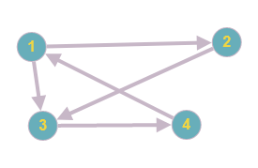

**(Α εκτέλεση)** Dfs spanning tree starting from node 1

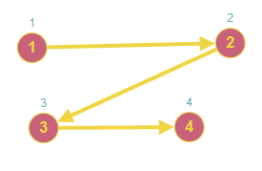

**Tree edges:** (1-2), (2-3), (3-4) **Back edge:** (4-1) **Forward edge:** (1-3)

**(Β εκτέλεση)** Dfs spanning tree starting from node 2

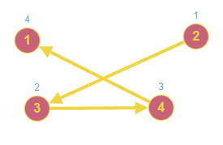

**Tree edges:** (2-3), (3-4), (4-1) **Back edges:** (1, 2), (1,3)