Γράφος:



**(Α εκτέλεση)** Dfs spanning tree starting from node 1

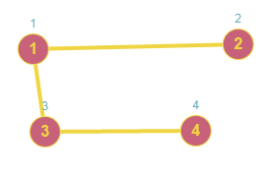

**Tree edges:** (1-2), (1-3), (3-4) **Back edge:** (1-4)

**(B εκτέλεση)** Dfs spanning tree starting from node 3

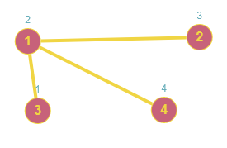

**Tree edges:** (3-1), (1-2), (1-4) **Back edge:** (3-4)