AGRISENSE: AN ML-BASED AGRICULTURAL DECISION SUPPORT SYSTEM FOR SMALL-SCALE FARMERS
A PROJECT BASED LEARNING (PBL) REPORT
Submitted by
B NISHANTH
KARTHEEBAN C
Submitted in partial fulfilment of the requirements
for the Project-Based Learning component of Machine Learning
BACHELOR OF ENGINEERING
in
COMPUTER SCIENCE AND ENGINEERING
CHENNAI INSTITUTE OF TECHNOLOGY, CHENNAI
Affiliated to Anna University, Chennai
(Autonomous)
OCTOBER 2026

BONAFIDE CERTIFICATE
This is to certify that the Project–Based Learning report titled “AGRISENSE: AN ML-BASED AGRICULTURAL DECISION SUPPORT SYSTEM FOR SMALL-SCALE FARMERS” is a Bonafide record of work carried out by B NISHANTH ([Reg. No.]) and KARTHEEBAN C ([Reg. No.]) of the Department of Computer Science and Engineering, Chennai Institute of Technology, as part of the continuous, mentor–guided Project-Based Learning (PBL) component of the Machine Learning course during the academic year 2026–2027 under my supervision.

SIGNATURE | SIGNATURE
Dr. S. Pavithra, M.E., Ph.D.  Professor and Head,  Dept. of Computer Science and Engineering  Chennai Institute of Technology, Chennai – 69. | <<Name>>  MENTOR  <<Designation>>  Dept. of Computer Science and Engineering  Chennai Institute of Technology, Chennai – 69.

Submitted for the final review held on ……………………

Internal Examiner External Examiner

DECLARATION
We jointly declare that the PBL report on “AGRISENSE: AN ML-BASED AGRICULTURAL DECISION SUPPORT SYSTEM FOR SMALL-SCALE FARMERS” is the result of original work done by us and best of our knowledge, similar work has not been submitted to “ANNA UNIVERSITY, CHENNAI” for the requirement of Degree of BACHELOR OF ENGINEERING. This PBL report is submitted on the partial fulfilment of the requirement of the award of Degree of COMPUTER SCIENCE AND ENGINEERING.

Signature

B NISHANTH ([Reg. No.])
KARTHEEBAN C ([Reg. No.])

Place: Chennai
Date:

ACKNOWLEDGEMENT
We wish to express our sincere gratitude to our honorable Chairman SHRI. P. SRIRAM for providing immense facilities at our institution.
We are very proudly rendering our thanks to our Principal Dr. A. RAMESH M.E., Ph.D., for the facilities and the encouragement given by him to the progress and completion of our project.
We would like to express special thanks of gratitude to our Dean Dr. V. SRINIVASA RAO, M.E., Ph.D., who has been the key spring of motivation to us throughout the completion of our course and project work.
We proudly render our immense gratitude to the Head of the Department Dr. S. PAVITHRA M.E., Ph.D., for her effective leadership, encouragement and guidance in the project.
We would like to extend our thanks to the Project Co-ordinator <NAME, DESIGNATION>, and to our class advisors <NAME, DESIGNATION>, Department of Computer Science and Engineering, for their valuable suggestions throughout this project.

B NISHANTH ([REG.NO])
KARTHEEBAN C ([REG.NO])

ABSTRACT
Small-scale farmers choose what to sow and estimate what they will harvest largely from experience, with little quantitative support. This project builds AgriSense, a machine-learning decision support system that addresses both decisions and delivers them through a mobile application. Two supervised tasks were framed: a 22-class classification problem recommending a crop from seven soil and weather variables over 2,200 balanced records, and a regression problem estimating yield, derived as production divided by area, from 49,999 district-level Indian agriculture records reduced to 48,681 after removing invalid rows and clipping to the 1st–99th percentile. Three models were compared for each task. For classification a tuned Random Forest reached 99.55% test accuracy and 0.9927 ± 0.0039 cross-validated accuracy, against a 97.27% logistic-regression baseline. For regression a tuned XGBoost regressor reached R² 0.7403, RMSE 5.0247 and MAE 1.6527, against a linear baseline of R² 0.0726 — a gap showing the relationship is strongly non-linear. A third iteration exposed the models through a FastAPI service and a React Native client, with a parity test asserting endpoint output matches direct model output. The system answers both questions from a phone in under a second.

Keywords: Crop Recommendation, Yield Estimation, Random Forest, XGBoost, Decision Support System

TABLE OF CONTENTS

(Right-click the table above in Word and choose “Update Field” to populate page numbers.)

LIST OF FIGURES
Figure | Title
4.1 | AgriSense three-layer system architecture
4.2 | Feature correlation heatmap
5.1 | Code — yield derivation and outlier handling
5.2 | Code — model comparison, selection and tuning
5.3 | Code — parity test between API and model
5.4 | Mobile app — onboarding, home and analyze hub
5.5 | Mobile app — the two analysis flows and their results
5.6 | Mobile app — history and profile
5.7 | Streamlit prototype
6.1 | Confusion matrix — tuned Random Forest
6.2 | Predicted vs actual yield — tuned XGBoost
6.3 | Feature importance — both final models

LIST OF TABLES
Table | Title
2.1 | Summary of explored approaches
3.1 | Weekly PBL progress log
3.2 | Hardware and software requirements
4.1 | Model comparison across iterations
4.2 | Final hyperparameters
6.1 | Classification results
6.2 | Regression results
6.3 | Defects found during integration testing
7.1 | Course outcome evidence
A.1 | Self and peer assessment

LIST OF ABBREVIATIONS
Abbr. | Expansion | Abbr. | Expansion
ML | Machine Learning | RMSE | Root Mean Squared Error
PBL | Project-Based Learning | MAE | Mean Absolute Error
API | Application Programming Interface | R² | Coefficient of Determination
REST | Representational State Transfer | CV | Cross-Validation
RF | Random Forest | EDA | Exploratory Data Analysis
XGBoost | Extreme Gradient Boosting | N, P, K | Nitrogen, Phosphorus, Potassium

CHAPTER 1
INTRODUCTION

1.1 Background
Agriculture supports a large share of rural livelihoods in India, and most holdings are small or marginal. Two decisions dominate the start of every season: which crop to sow on a given plot, and how much that plot is likely to produce. Both are usually made from inherited experience, which works while conditions stay familiar but degrades when rainfall patterns shift, when soil nutrient balance changes after repeated cropping, or when an unfamiliar crop is considered.
Soil testing services exist, but their output is a sheet of nutrient values rather than an actionable recommendation. The gap is not measurement — it is interpretation. A farmer holding a report of nitrogen, phosphorus, potassium and pH values still has to translate those into a sowing decision. Machine learning is well suited to that translation, provided labelled historical records are available. The contribution here is not a new algorithm; it is the end-to-end path from a public dataset to a tool a farmer can open on a phone.

1.2 Driving Question
“Can soil and weather measurements that a small-scale farmer can realistically obtain be used to reliably recommend a crop and estimate its yield, and can that capability be delivered in a form a farmer would actually use?”
This was narrowed into two supervised tasks. The first is multi-class classification: given N, P, K, temperature, humidity, pH and rainfall, predict which of 22 crops is best suited. The second is regression: given temperature, humidity, soil moisture, area, season and crop, predict yield as production per hectare. The final clause — delivery — drove a third iteration in which the models were exposed through a REST API and consumed by a mobile application.

1.3 Objectives
- To collect and preprocess two public agricultural datasets, deriving yield and removing invalid and extreme records.
- To build and iteratively refine classification and regression models, comparing a baseline against ensemble methods at each stage.
- To evaluate using accuracy, precision, recall and F1 for classification and RMSE, MAE and R² for regression, and justify design choices against those results.
- To deploy the models behind a REST API and a mobile client, so the work is usable rather than only measurable.
- To document weekly progress and mentor feedback through the PBL cycle, and reflect on the team’s process.

1.4 Scope and Limitations
The project covers model development, evaluation, and delivery through a REST API and an Android-oriented client. It is not a production deployment: the backend runs on a development server, authentication is absent, and cross-origin policy is permissive to allow testing from a physical device. Three data limitations bound the results. The classification dataset is perfectly balanced and separates cleanly, so its accuracy should not be read as field accuracy. The yield dataset records weather as coarse integers — temperature spans only 25–37 — capping what a weather-driven model can extract. Yield is expressed in the source data’s own production units, which differ by crop, so estimates are comparable within a crop only; the application states this rather than hiding it.

CHAPTER 2
CONCEPT EXPLORATION

2.1 Related Approaches
Random Forest [1] builds many decision trees on bootstrap samples, each split considering a random feature subset, and aggregates their votes. The randomisation decorrelates the trees so averaging reduces variance. It handles multi-class targets natively, needs no feature scaling, and exposes feature importances — all suited to a 22-class problem over seven heterogeneous variables.
Gradient boosting [9] instead adds trees sequentially, each fitted to the residual error of the ensemble so far. XGBoost [2] is a regularised, second-order implementation. Because boosting reduces bias rather than variance, it tends to suit irregular target surfaces — which is the case for yield, where the dominant predictors are categorical.
Logistic regression and ordinary least squares were included as controls, not contenders. A baseline that nearly matches an ensemble shows the problem is close to linearly separable and the extra complexity is unjustified; a baseline that collapses shows genuine non-linear structure. Both outcomes are informative, and the two tasks here gave opposite answers (Section 6.3). scikit-learn [3] provided the estimators, splitting, grid search and cross-validation; FastAPI [6] the service layer, since it derives validation and OpenAPI documentation from type annotations; and Expo Router [7] the client.

2.2 Summary Table
Ref. | Approach / Model | Role in this project
[1] | Random Forest | Selected for crop recommendation
[2], [9] | Gradient boosting / XGBoost | Selected for yield estimation
[3] | scikit-learn estimators | Training, tuning and evaluation for both tasks
[4] | Crop recommendation dataset — 2,200 records, 22 classes | Task 1 training data
[5] | Indian crop production dataset — 49,999 records | Task 2 training data
[6], [7] | FastAPI, Expo Router | REST service and mobile client
Table 2.1 — Summary of explored approaches
[Team to complete: add the crop-prediction papers you actually read, with their datasets and reported accuracies, as further rows and as references [10] onward.]

2.3 What This Told Us
The exploration pointed to starting simple and escalating only if the data justified it. Iteration 1 was therefore planned around linear baselines to establish a floor, and Iteration 2 around Random Forest and XGBoost with tuning. Because the two tasks differ — one balanced and cleanly separable, the other dominated by categorical predictors — the team did not assume one model family would win both, and compared all three candidates independently for each.

CHAPTER 3
PROJECT PLANNING AND TEAM ORGANISATION

3.1 Weekly PBL Progress Log
[Team to complete from your mentor review records; replace the remarks with what was discussed at each review.]
Week | Milestone / Task | Work Done | Mentor Remarks
1–2 | Problem framing, dataset search | Selected the two public datasets; framed one classification and one regression task. | [remarks]
3–4 | Concept exploration | Reviewed ensemble and linear methods; agreed to benchmark three models per task. | [remarks]
5–7 | Iteration 1 — baselines | EDA, cleaning, yield derivation; logistic and linear baselines established. | [remarks]
8–10 | Iteration 2 — refinement | Random Forest and XGBoost trained, grid-searched, cross-validated and saved. | [remarks]
11–12 | Iteration 3 — delivery | FastAPI service and React Native client built; integration defects fixed; report prepared. | [remarks]
Table 3.1 — Weekly PBL progress log

3.2 Requirements
Dataset 1 [4]: 2,200 rows, 7 numeric features, 22 balanced classes at exactly 100 records each. Dataset 2 [5]: 49,999 rows covering location, year, season, crop and the weather, area and production columns; 75 crops and 6 seasons survive cleaning.
Category | Requirement
Processor / RAM | Intel i5 or equivalent / 8 GB RAM minimum. No GPU required.
Languages | Python 3.11 or newer; TypeScript for the mobile client
ML libraries | scikit-learn 1.9.0, XGBoost 3.2.0, pandas 3.0.5, NumPy 2.4.6, joblib 1.6.0, matplotlib 3.11.1, seaborn 0.13.2
Backend / Mobile | FastAPI, Uvicorn, Pydantic 2.x · Node.js 22, Expo SDK 57, React Native 0.86
Environment / Testing | VS Code; Android emulator or Expo Go · pytest 9.1.1 (22 tests), TypeScript compiler
Version control | https://github.com/kartheeban-chelladurai/agri-decision-support-ml
Table 3.2 — Hardware and software requirements

3.3 Feasibility
The project was achievable within the PBL timeframe because every heavy dependency was avoided by design. Both datasets are public and train on a laptop CPU in roughly one and two minutes respectively; no GPU, cloud account or paid service is needed. The delivery layer reuses the trained models rather than retraining, and the roughly 3 MB of saved artefacts is committed, so anyone can clone the project and run the tests without reproducing the training.

CHAPTER 4
ITERATIVE DESIGN AND DEVELOPMENT

4.1 System Architecture
AgriSense is organised in three layers, with the machine learning layer as the single source of truth; the layers above wrap it rather than reimplementing any part of it.
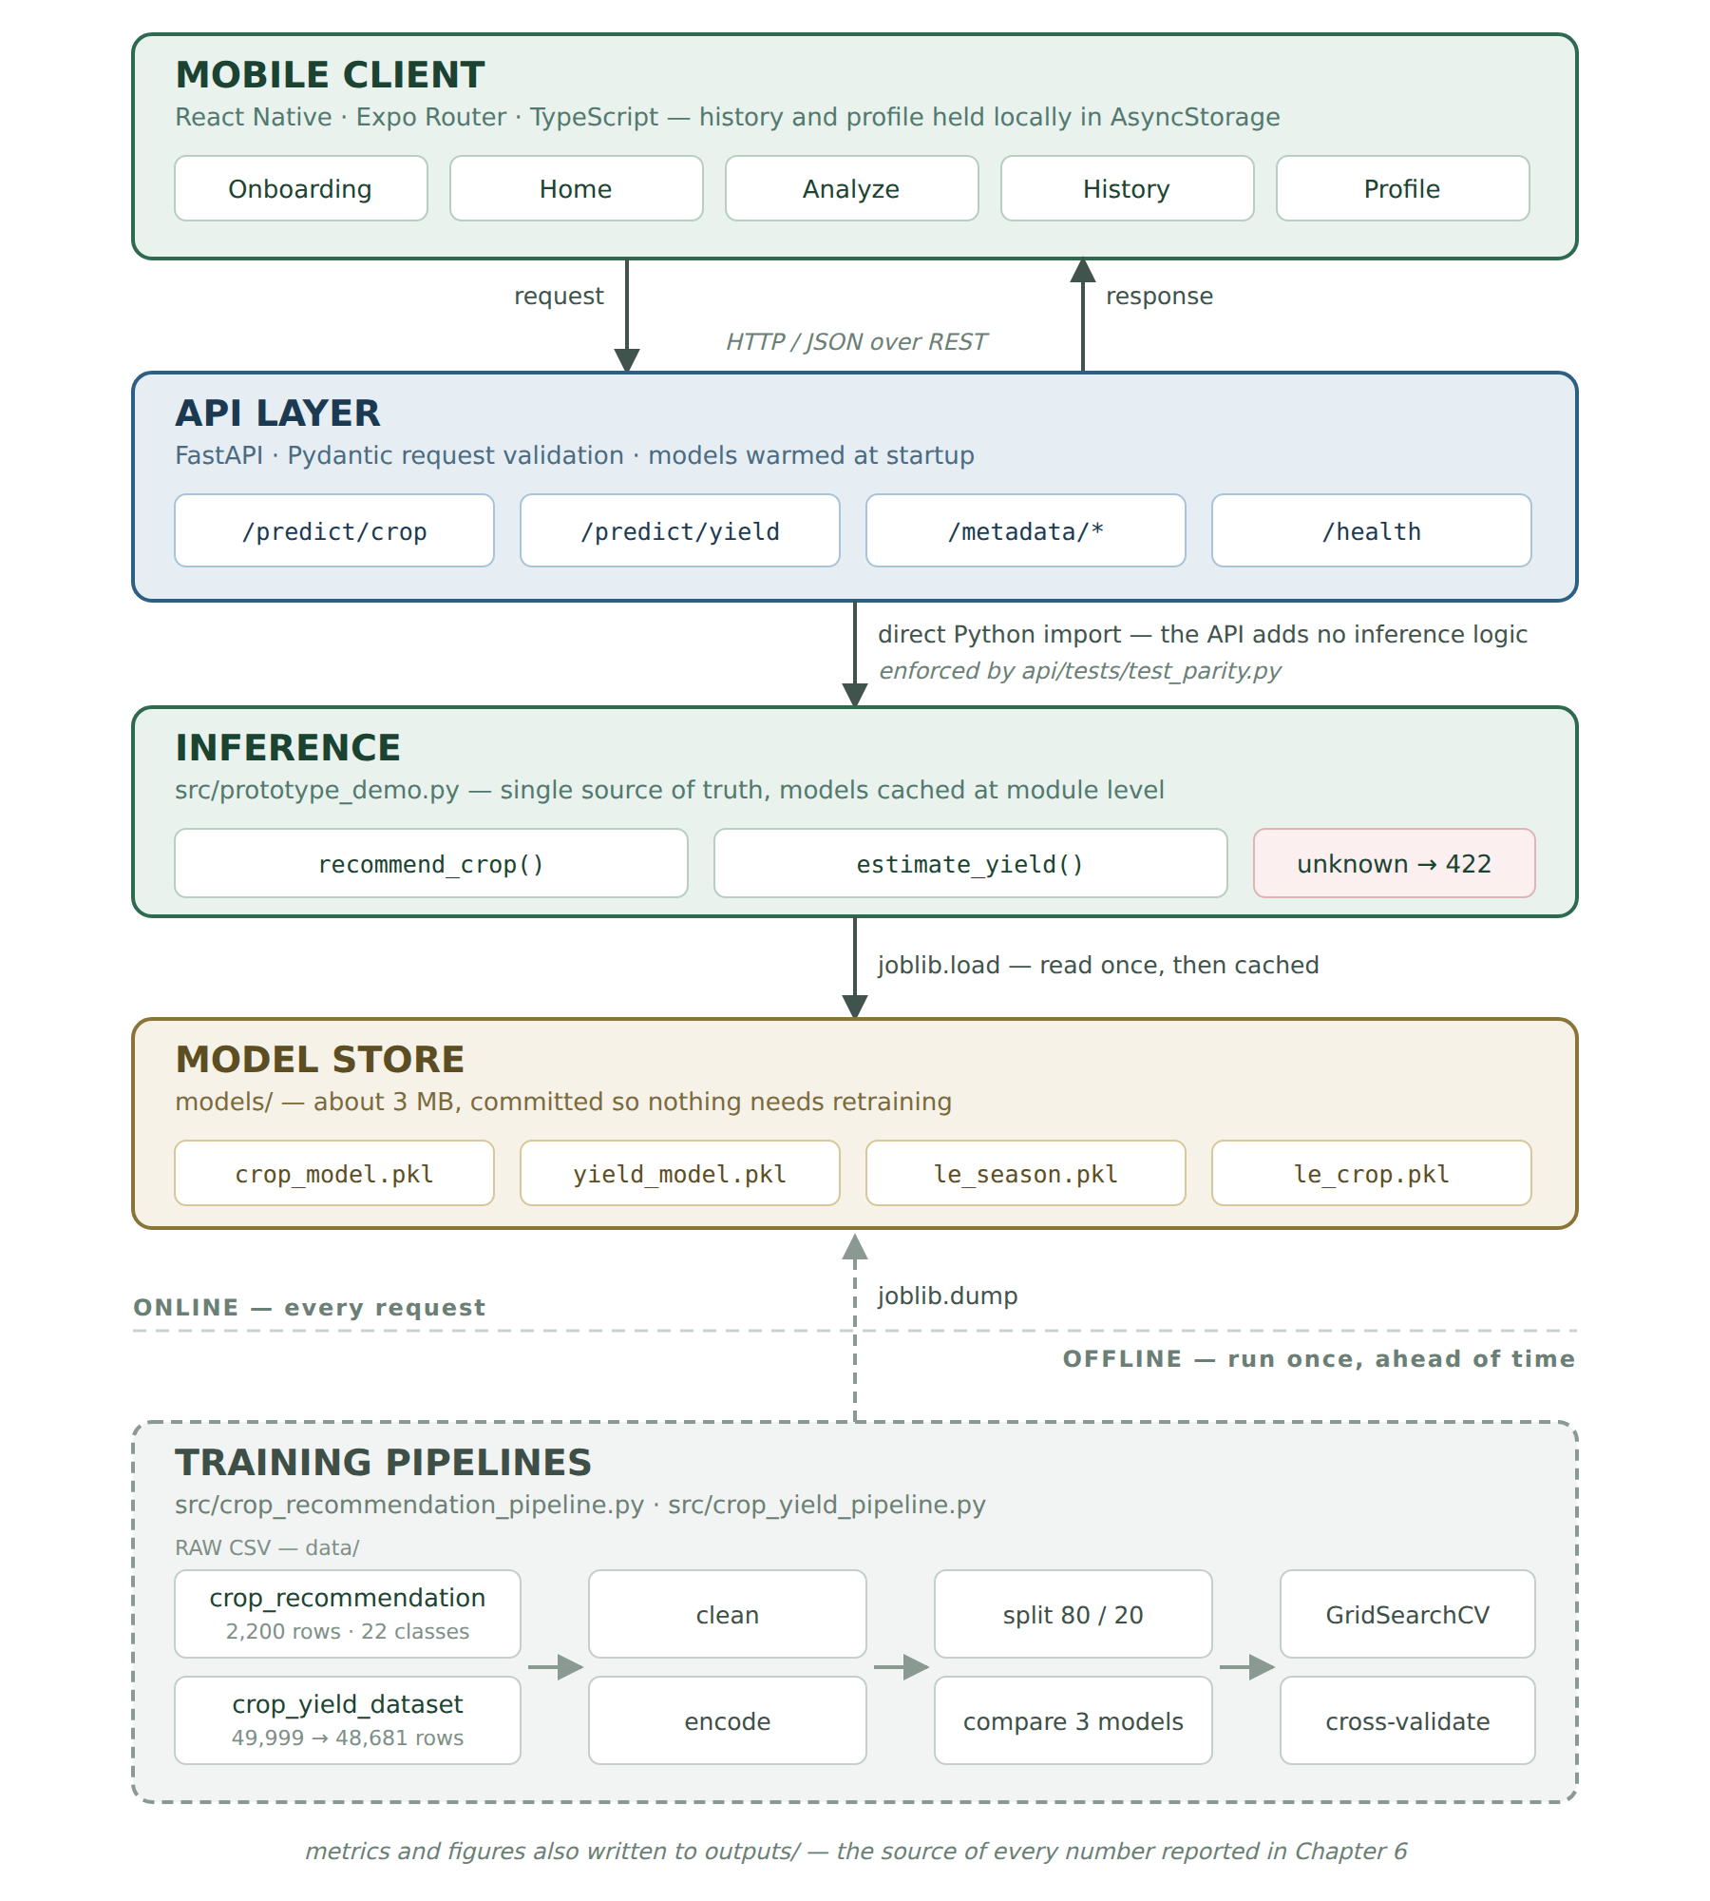
Figure 4.1 — AgriSense three-layer system architecture
The training pipelines read the raw CSVs, clean and encode them, compare candidate models, tune the winner and serialise it. The model store holds those artefacts, committed so no consumer retrains. The inference module loads them once, caches them, and exposes two plain functions. The API layer validates incoming JSON against Pydantic schemas, calls those functions and wraps the outcome in a consistent envelope. The client renders forms, posts them and stores results locally. The layering is enforced by a test rather than by convention: api/tests/test_parity.py asserts endpoint output equals direct function output.

4.2 Iteration 1 — Baseline
The first version established a floor with the simplest reasonable models: a standardised logistic regression on a stratified 80/20 split (1,760 train, 440 test), and ordinary least squares for yield. The regression data required real cleaning first — column names and string values carry trailing whitespace in the source file (seasons appear as “Kharif ”), 215 rows have no production value, and yield once derived ranged from 0.0005 to 33,089. Rows with missing or non-positive area or production were dropped and yield clipped to the 1st–99th percentile, taking 49,999 rows to 48,681 and the range to 0.168–129.2.
The two baselines pointed in opposite directions, and that shaped the next iteration. Classification was already strong at 97.27%, so the open question was whether the remaining error was reducible at all. Regression explained only 7% of variance, which said clearly that yield is not a linear function of label-encoded categorical inputs and that a different model family was needed rather than better linear features.
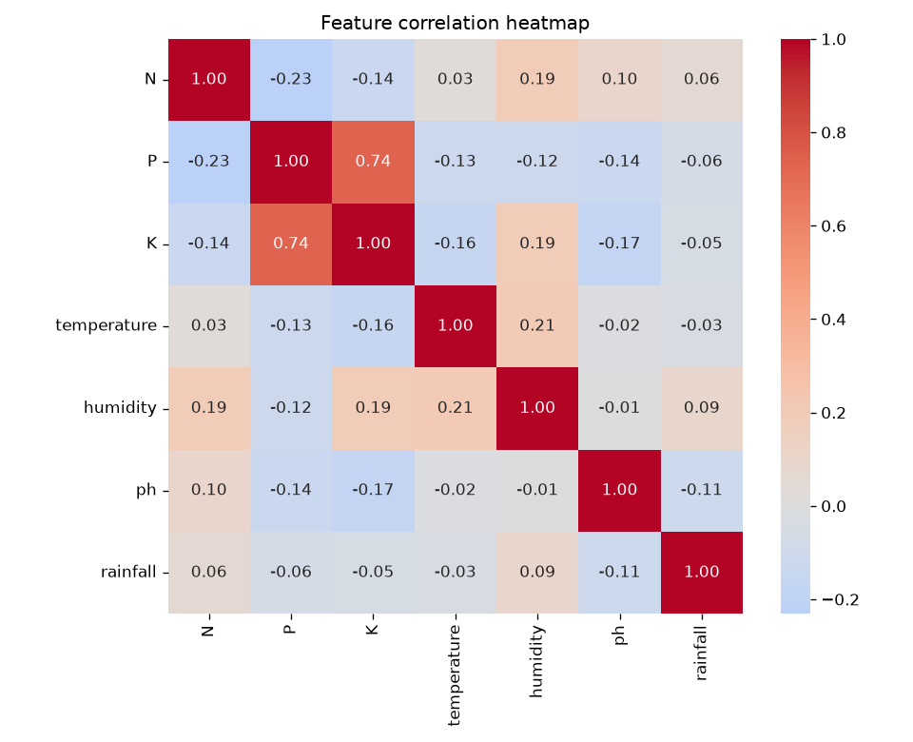
Figure 4.2 — Feature correlation heatmap. Inter-feature correlation is low, so all seven features were retained.

4.3 Iteration 2 — Refinement
Iteration 2 added two ensemble methods per task on identical splits, then tuned the winner by exhaustive grid search — 27 candidates over n_estimators, max_depth and min_samples_split for the forest, and 12 over n_estimators, max_depth and learning_rate for the boosted regressor.
Task | Model | Key metric
Classification | Logistic Regression (baseline) | Accuracy 0.9727
Classification | Random Forest | Accuracy 0.9955
Classification | XGBoost | Accuracy 0.9886
Regression | Linear Regression (baseline) | R² 0.0726
Regression | Random Forest | R² 0.6719
Regression | XGBoost | R² 0.6946
Table 4.1 — Model comparison across iterations
Random Forest won classification and XGBoost regression, confirming the decision in Section 2.3 not to assume one family suits both. Tuning had asymmetric effect, which is itself a result. The classifier did not improve — 0.9955 before and after — because at 440 test records it was already missing only two. The regressor improved materially, from R² 0.6946 to 0.7403, with RMSE falling from 5.4483 to 5.0247. Notably the selected depth was 4, shallower than the untuned 6: the search found the model had been overfitting and that constraining it generalised better.

4.4 Final Approach and Training Procedure
For crop recommendation the final model is a Random Forest of 100 trees, maximum depth 10, minimum 5 samples to split. The approach fits because the 22 classes are separated by threshold-like conditions on rainfall and humidity rather than linear boundaries — a tree expresses “rainfall above 200 mm and humidity above 80%” directly. For yield the final model is an XGBoost regressor with 200 rounds, depth 4 and learning rate 0.1; trees are added sequentially against residual error, with the learning rate shrinking each contribution. This fits a target driven mainly by crop and season — a step-like surface over categorical inputs a linear model cannot represent at all, as its R² of 0.07 demonstrated.
Model | n_estimators | max_depth | other | random_state
Random Forest (classification) | 100 | 10 | min_samples_split = 5 | 42
XGBoost (regression) | 200 | 4 | learning_rate = 0.1 | 42
Table 4.2 — Final hyperparameters selected by grid search
Classification used a stratified 80/20 split preserving 100 records per class, grid search with 5-fold cross-validation on accuracy, then an independent 5-fold cross_val_score giving 0.9927 ± 0.0039. Regression sampled 15,000 of the 48,681 cleaned rows, split 12,000/3,000, label-encoded season and crop with the fitted encoders serialised alongside the model so the API and client validate input against exactly the categories seen in training, used 3-fold grid search on R², and an independent 5-fold cross_val_score giving 0.7428 ± 0.0254. Both pipelines fix random_state at 42, so every figure in Chapter 6 is reproducible at the precision shown.

CHAPTER 5
IMPLEMENTATION

5.1 Module Description
Two pipeline scripts own all data handling. The classification pipeline loads its CSV, prints shape, summary statistics and missing-value counts, and produces the EDA figures. The regression pipeline additionally strips whitespace from column names and values, coerces area and production to numeric, drops rows where either is missing or non-positive, derives yield and clips to the 1st–99th percentile, printing row counts before and after each step so the effect of cleaning is visible in the logs rather than asserted in prose.
Each pipeline builds three candidate models, fits them on an identical split, selects the winner programmatically — by weighted F1 for classification, R² for regression — then tunes it and cross-validates. Every metric is written to JSON under outputs/, which is what makes the numbers in this report auditable rather than transcribed by hand. src/prototype_demo.py exposes recommend_crop() and estimate_yield(), loading the models once and caching them; estimate_yield validates season and crop against the saved encoders before predicting, raising a descriptive ValueError rather than letting a raw scikit-learn error escape.
The FastAPI application exposes /predict/crop, /predict/yield, /metadata/* and /health under /api/v1, validating bodies against Pydantic schemas with physical bounds — pH between 0 and 14, area strictly positive — and warming the models at startup. The metadata endpoints let the client populate its dropdowns from the encoders themselves, so the app can never offer a crop the model does not know. The Expo Router client provides onboarding, a home dashboard, an analyze hub with both forms, result screens, a locally stored history and a profile section, built from reusable components driven by a shared design-token layer.

5.2 Key Code Snippets
Yield derivation and outlier handling — the step that makes the regression target usable:
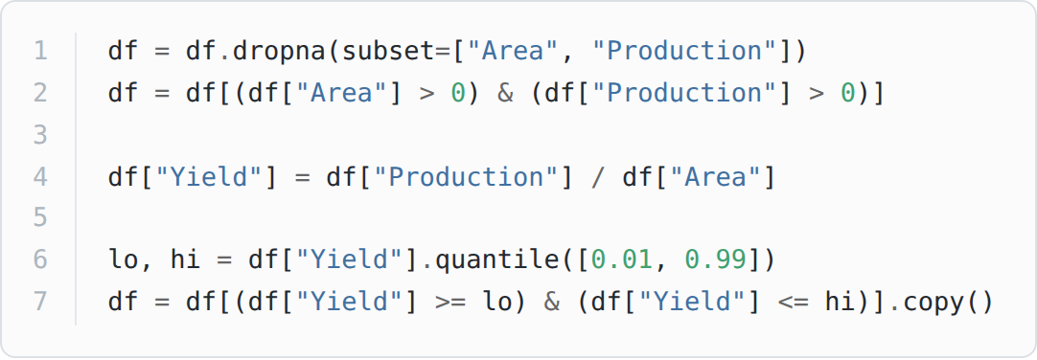
Figure 5.1 — Yield derivation and outlier handling (src/crop_yield_pipeline.py)
Model selection and tuning — the winner is chosen from measured results, not assumed:
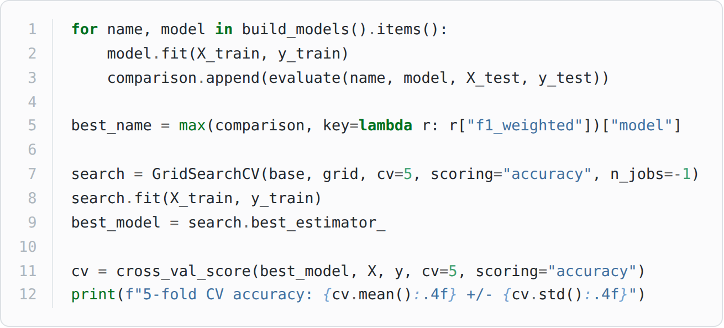
Figure 5.2 — Model comparison, selection and tuning (src/crop_recommendation_pipeline.py)
The parity test that keeps the API honest. Input validation at the inference boundary follows the same pattern: an unknown crop raises a readable ValueError, which the API maps to HTTP 422 rather than a 500.
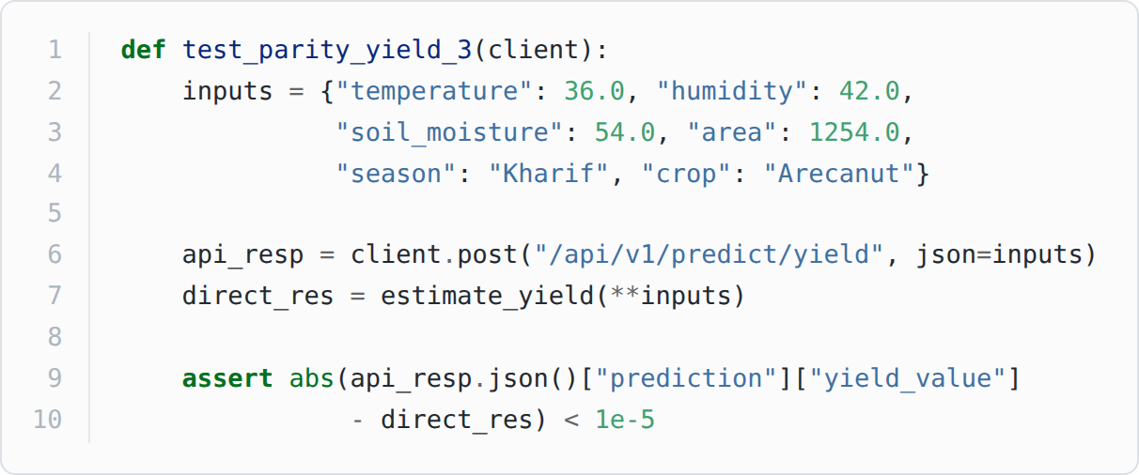
Figure 5.3 — Parity test between endpoint and model (api/tests/test_parity.py)

5.3 User Interface
All screenshots below were captured from the running application against a live backend — the values shown are genuine model output, not mock-ups.
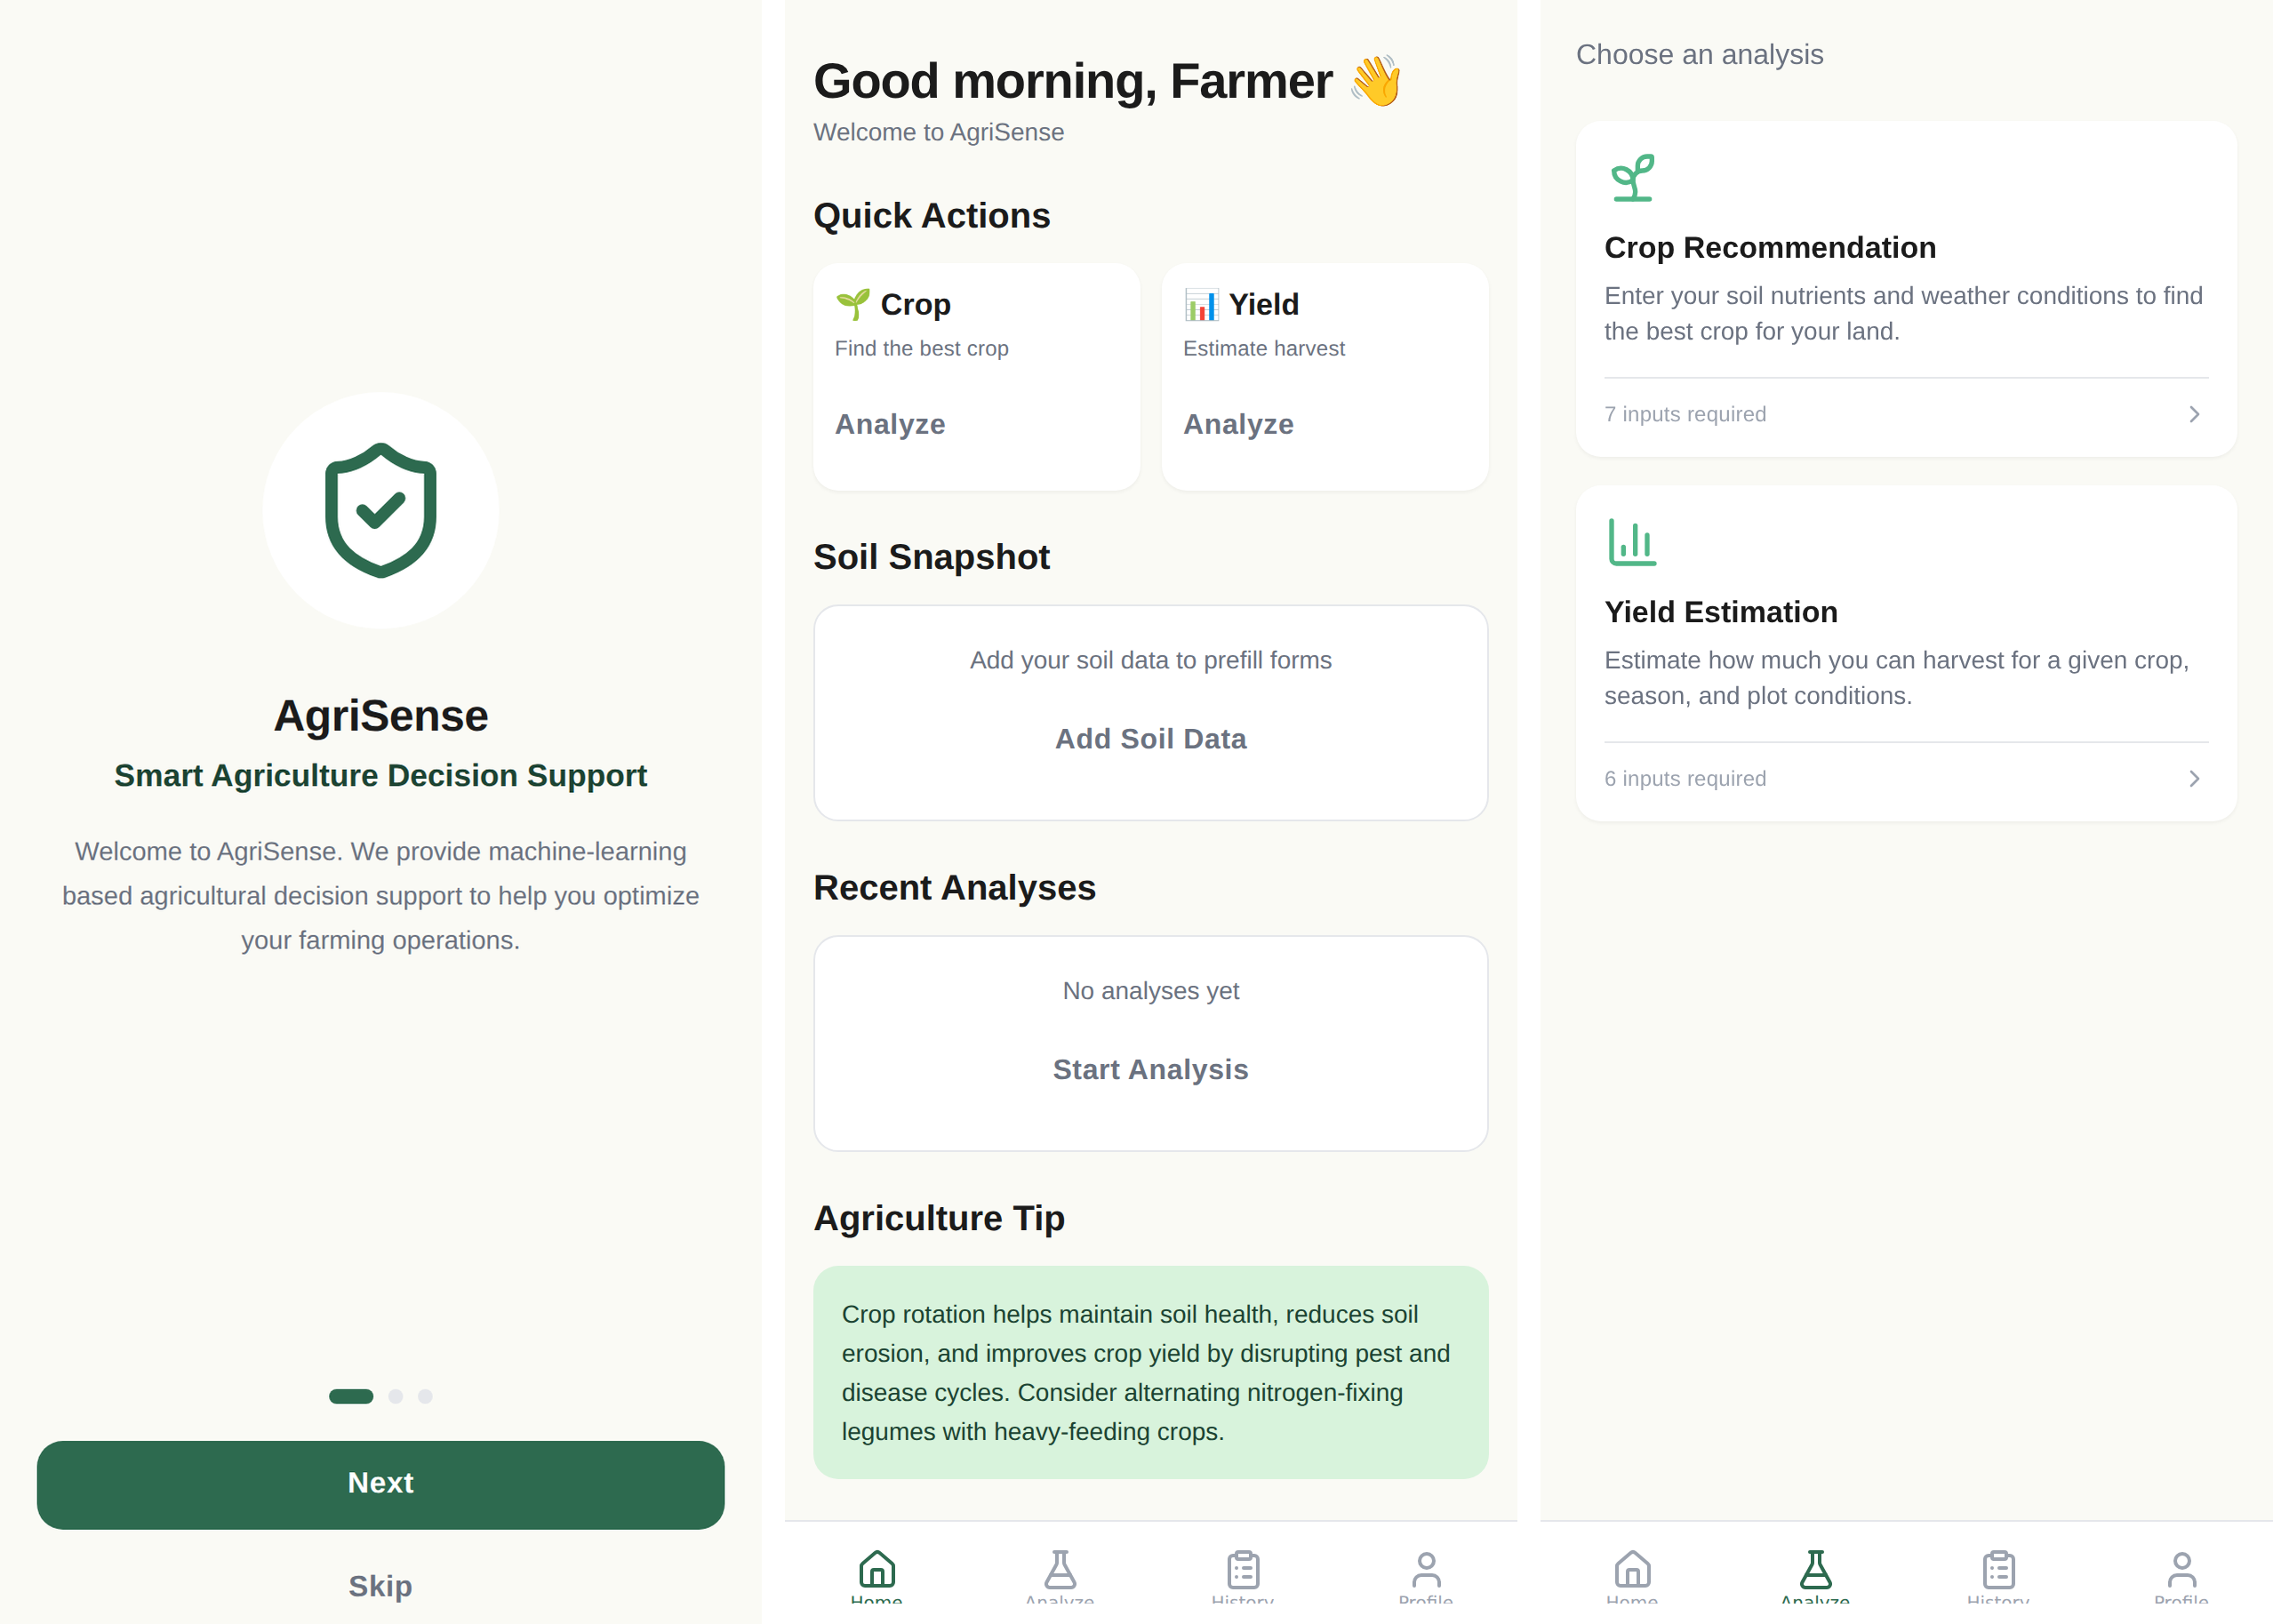
Figure 5.4 — Onboarding, home dashboard and analyze hub
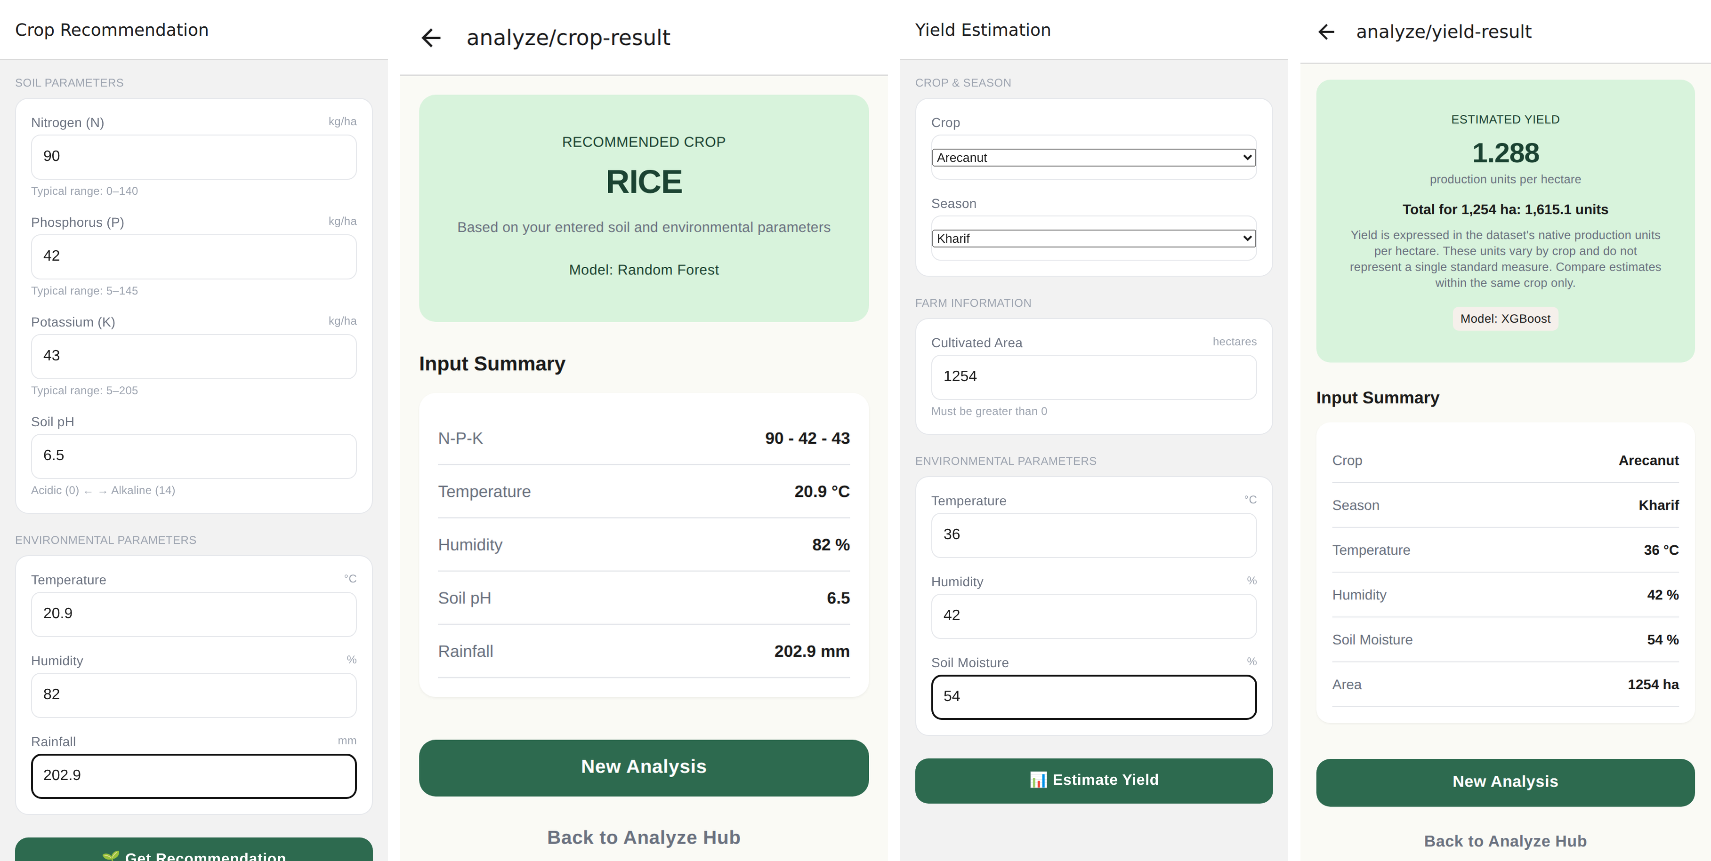
Figure 5.5 — Both analysis flows. N-P-K 90-42-43 at 20.9 °C, 82% humidity, pH 6.5 and 202.9 mm returns “RICE”; Arecanut in Kharif over 1,254 ha returns 1.288 units per hectare, matching direct model output exactly. Crop and season dropdowns are populated from the saved encoders via /metadata.
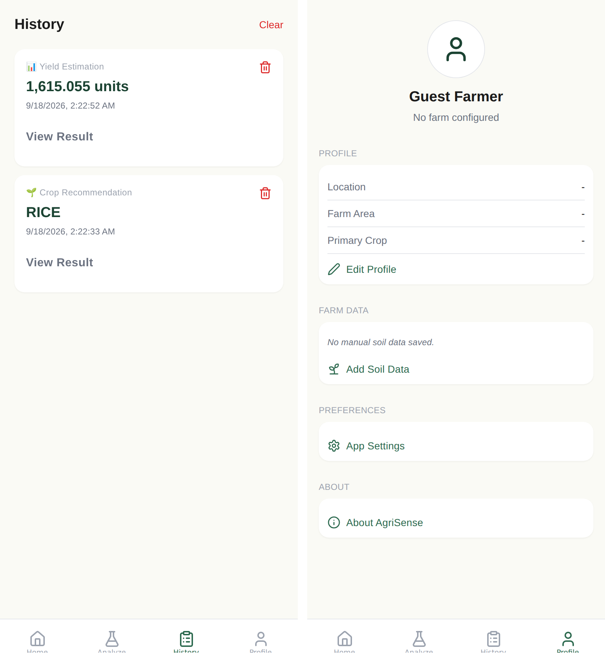
Figure 5.6 — Locally stored prediction history and profile section
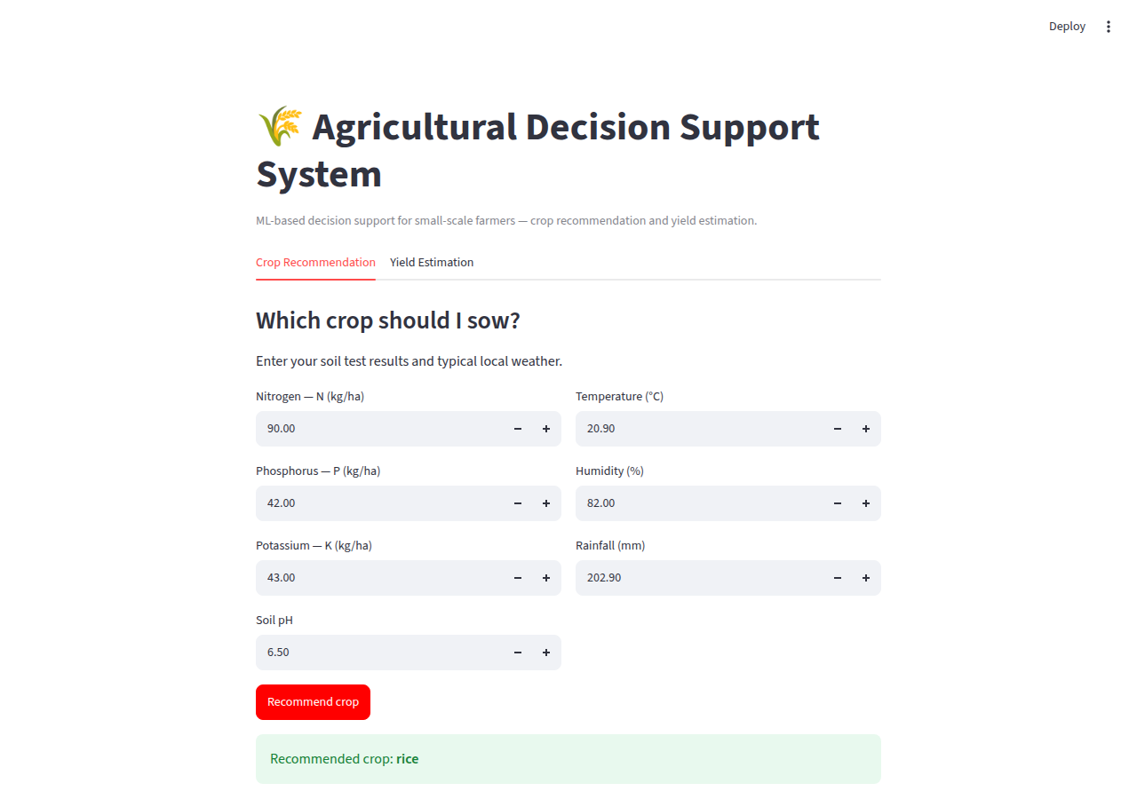
Figure 5.7 — Streamlit prototype, which preceded the mobile client and is retained for desktop testing

CHAPTER 6
RESULTS AND DISCUSSION

6.1 Evaluation Metrics
Classification was evaluated with accuracy, precision, recall and F1. Because the dataset is exactly balanced, accuracy is not misleading and is reported as the headline; precision, recall and F1 are weighted averages, and F1 was the selection criterion because it penalises a model that achieves accuracy by favouring easy classes. Regression used RMSE, MAE and R². RMSE is in the units of yield and penalises large errors quadratically, which matters because an overestimate on a large plot is costly; MAE gives typical error magnitude and is less sensitive to remaining outliers; R² is scale-free and so comparable across models. Reporting all three matters here — Random Forest achieved the better MAE (1.6607 against 1.7289) while XGBoost achieved the better RMSE and R², meaning the forest was typically closer but the boosted model made fewer large errors.

6.2 Results Across Iterations
Version | Accuracy | Precision (w) | Recall (w) | F1 (w)
Iteration 1 — Logistic Regression | 0.9727 | 0.9740 | 0.9727 | 0.9725
Iteration 2 — XGBoost | 0.9886 | 0.9894 | 0.9886 | 0.9885
Iteration 2 — Random Forest | 0.9955 | 0.9957 | 0.9955 | 0.9955
Final — Random Forest (tuned) | 0.9955 | 0.9957 | 0.9955 | 0.9955
Final — 5-fold cross-validation | 0.9927 ± 0.0039 | — | — | —
Table 6.1 — Classification results
Version | RMSE | MAE | R²
Iteration 1 — Linear Regression | 9.4949 | 4.6019 | 0.0726
Iteration 2 — Random Forest | 5.6473 | 1.6607 | 0.6719
Iteration 2 — XGBoost | 5.4483 | 1.7289 | 0.6946
Final — XGBoost (tuned) | 5.0247 | 1.6527 | 0.7403
Final — 5-fold cross-validation | — | — | 0.7428 ± 0.0254
Table 6.2 — Regression results
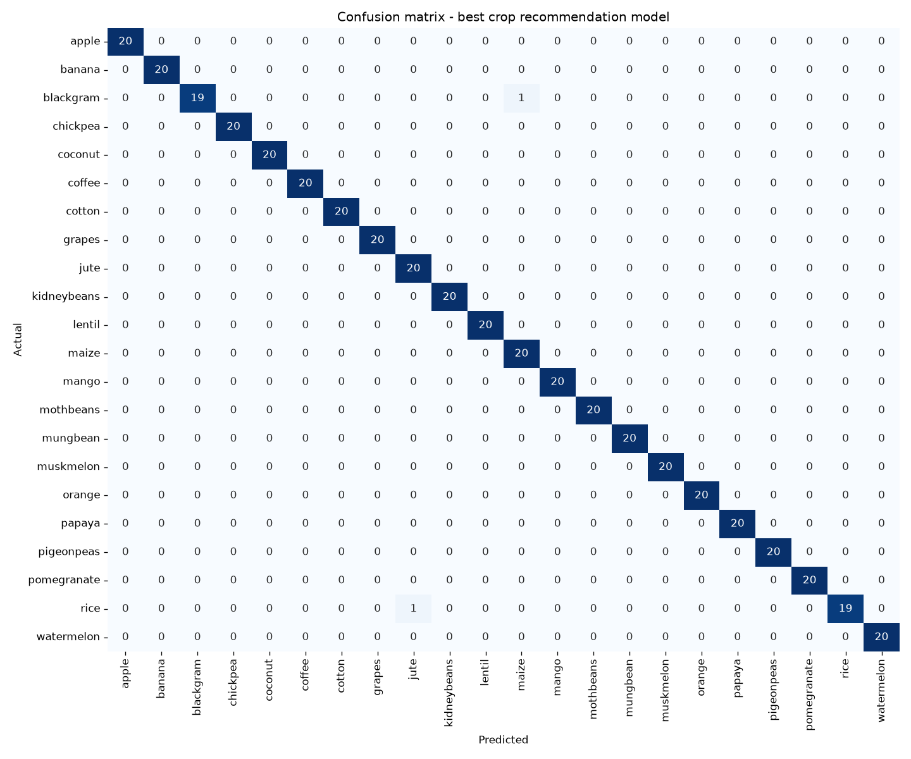
Figure 6.1 — Confusion matrix, tuned Random Forest. 438 of 440 test records lie on the diagonal.
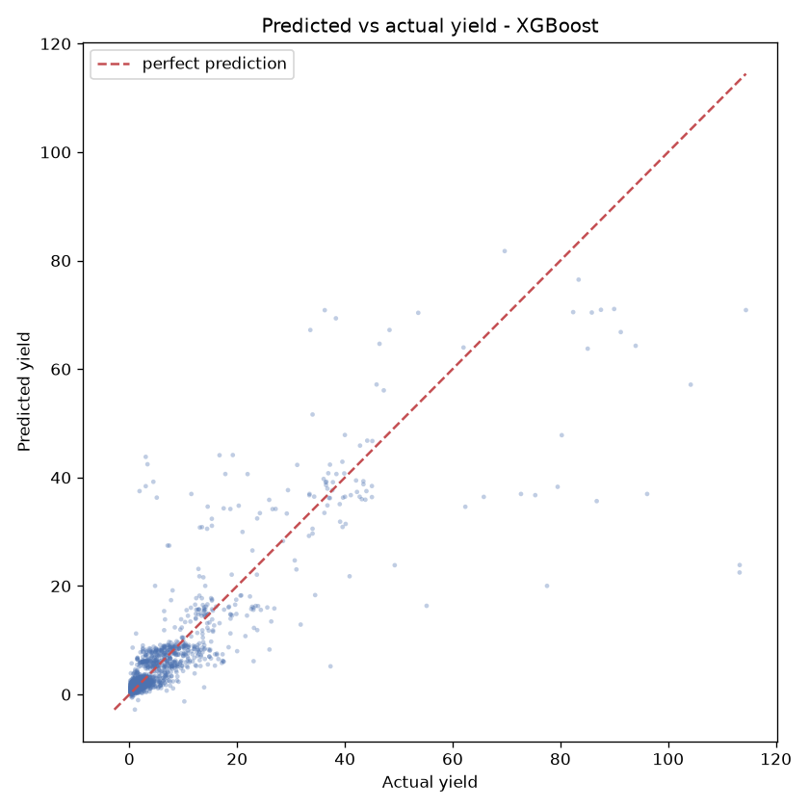
Figure 6.2 — Predicted vs actual yield, tuned XGBoost
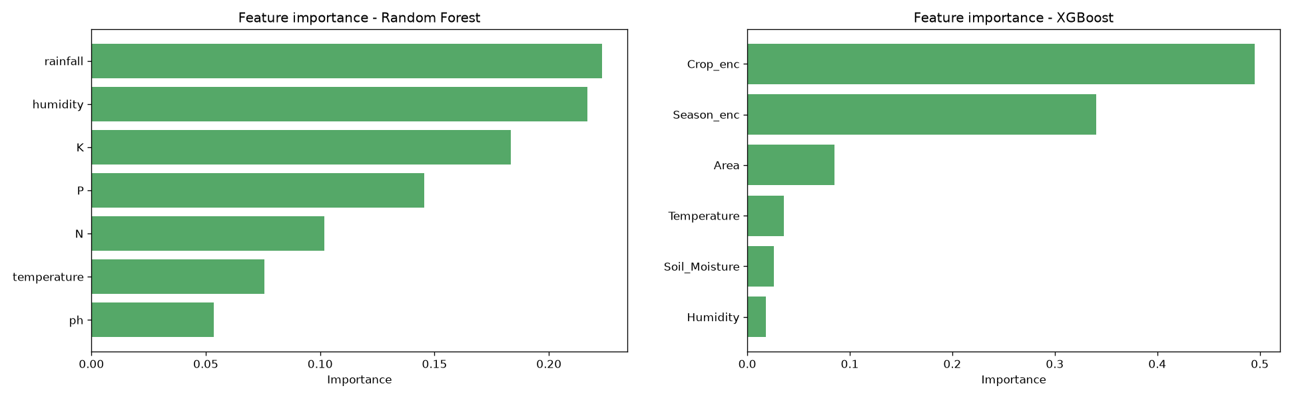
Figure 6.3 — Feature importance for both final models: rainfall and humidity dominate crop recommendation, while crop and season dominate yield

6.3 Discussion
The most informative result is the contrast between the two baselines. Logistic regression reached 97.27% while linear regression reached R² 0.0726 — the same class of model was near-sufficient for one problem and almost useless for the other, and the reason is visible in the feature importances. Crop recommendation is driven by continuous variables, with rainfall (0.2231) and humidity (0.2169) together accounting for 44% of the signal, and the 22 crops separate along water requirement in a way a linear boundary can largely capture. Yield is driven by which crop is grown (0.4949) and in which season (0.3404), together 84% of the signal, and those are categorical. Once label-encoded their integer values carry no meaningful order: crop 12 is not “more” than crop 11. A linear model fitted to such a column is fitting noise, which is exactly what R² 0.07 reports. Tree ensembles are unaffected because they split on category membership rather than magnitude.
Tuning outcomes were similarly asymmetric. Grid search left the classifier unchanged because only two of 440 test records were misclassified — the model had reached the dataset’s ceiling, and the cross-validated 0.9927 ± 0.0039 confirms this is stable rather than a lucky split. For the regressor, tuning moved R² from 0.6946 to 0.7403 and selected depth 4 over 6; the shallower tree generalising better is direct evidence the untuned model was overfitting. Where the yield model does poorly is visible in Figure 6.2: the scatter is tight at low yields, where most data lies, and fans out at high yields. With a median near 1.06 and a clipped maximum of 129.2, high-yield records are sparse, so the model regresses them toward the mean.
The third iteration produced a different kind of result. Integration testing — driving the real application against a live backend rather than reading code — exposed defects that neither the 22 automated tests nor TypeScript compilation caught. They are recorded because a PBL report is assessed on process, and finding them is part of what the process produced.
Defect | Effect | Root cause and resolution
Missing peer dependency | App could not bundle at all | react-native-svg is required by the icon library but was never declared; the documented --legacy-peer-deps flag suppressed the warning. Declared at the version Expo SDK 57 pins.
Metadata response shape | Yield estimation unusable — dropdowns never populated | Client assumed every endpoint returns the {success, prediction} envelope, but metadata endpoints return their payload directly. Added a separate accessor for unwrapped endpoints.
Onboarding redirect loop | Onboarding could not be completed on a device | The route guard compared against a flag captured once at mount, reading a stale value after completion. The guard now re-reads the persisted flag.
Malformed timestamp | Invalid RFC 3339; parsed as Invalid Date | isoformat() already emits the offset and “Z” was appended. Replaced with a single correct format.
Mislabelled result | Screen headed “Estimated yield” showed total production | The result screen rendered the wrong field. It now shows yield per hectare with total production on its own line.
Table 6.3 — Defects found during integration testing
The common thread is that all five were invisible to the checks in place. The automated tests exercised the Python layers, which were correct; the type checker verified the client’s types were internally consistent, which they were. What none verified was whether the client’s assumptions matched the server’s actual behaviour. That gap closed only when the application was run.

6.4 Limitations
- The classification dataset is perfectly balanced and separates cleanly; 99.55% reflects that dataset, not field conditions.
- Yield is expressed in the source data’s own production units, which differ by crop, so estimates are comparable within a crop only.
- The yield model explains about 74% of variance; the rest is attributable to coarse weather columns and sparse high-yield records.
- Training used 15,000 of 48,681 cleaned rows, sampled for speed.
- The system is a development build — no authentication, permissive CORS, backend bound to the local network — and the models are static.

CHAPTER 7
TEAM REFLECTION AND LEARNING OUTCOMES

7.1 Individual Reflections
[2–4 sentences each: what you personally worked on, one thing you learned, one challenge. Mentors read this closely and generic reflection is obvious — refer to specific decisions, such as why the linear baseline was kept once it scored R² 0.07, or what the defects in Table 6.3 taught you about testing assumptions rather than code.]
B NISHANTH: [reflection]
KARTHEEBAN C: [reflection]

7.2 Team Learning
[Worth addressing, from what the project record shows: (i) benchmarking three models per task rather than committing early, and whether that was worth the time; (ii) keeping the failing linear baseline in the report instead of removing it; (iii) how ML work was divided from application work in Iteration 3; (iv) any mentor feedback that changed direction.]

7.3 Course Outcomes — Evidence Summary
Course Outcome | Evidence from this project
Apply ML techniques to a real problem | Two supervised tasks; final models reach 99.55% accuracy and R² 0.7403 (Tables 6.1, 6.2)
Evaluate and justify model selection | Three models compared per task on identical splits; winners selected by measured F1 and R², then tuned (Sections 4.3–4.4)
Interpret and communicate results | Feature importances used to explain why the linear baseline fails on regression but nearly suffices for classification (Section 6.3)
Design and build a working system | Three-layer architecture with REST API and mobile client, enforced by an automated parity test (Section 4.1)
Test and validate | 22 automated tests, static type checking, and integration testing that exposed five defects (Table 6.3)
Teamwork and process | [Cite your weekly log in Table 3.1 — task rotation across iterations, mentor reviews that changed direction]
Table 7.1 — Course outcome evidence
[Replace the left column with the exact CO statements from your course handbook.]

CHAPTER 8
CONCLUSION AND FUTURE SCOPE

8.1 Conclusion
This project built AgriSense, a machine-learning decision support system that recommends a crop from soil and weather measurements and estimates the yield of a planned cultivation. A tuned Random Forest classifies among 22 crops with 99.55% test accuracy and 0.9927 ± 0.0039 cross-validated accuracy, and a tuned XGBoost regressor estimates yield with R² 0.7403 and RMSE 5.0247. Both are delivered through a REST API and a mobile application, with parity between application output and direct model output asserted by an automated test.
Both parts of the driving question were addressed. Soil and weather measurements a farmer can realistically obtain are sufficient to recommend a crop reliably and to estimate yield with useful though bounded accuracy, and that capability was delivered in a form a farmer could use. The honest qualification is that the classification figure reflects a clean, balanced dataset rather than field conditions, and the yield figure is bounded by the coarseness of the available weather data. All objectives set out in Section 1.3 were met.

8.2 Future Scope
- Train on the full 48,681 cleaned rows rather than a 15,000-row sample, and test whether that improves the high-yield region where Figure 6.2 shows the model is weakest.
- Add finer-grained weather data from a meteorological API in place of the coarse integer columns, which the feature importances suggest is the binding constraint.
- Return a confidence measure with each prediction — class probabilities and a prediction interval — so a farmer can tell a firm recommendation from a marginal one.
- Deploy the backend with authentication and a restricted cross-origin policy, and add offline support and regional language options.

REFERENCES
[1] L. Breiman, “Random forests,” Machine Learning, vol. 45, no. 1, pp. 5–32, 2001.
[2] T. Chen and C. Guestrin, “XGBoost: A scalable tree boosting system,” in Proc. 22nd ACM SIGKDD Int. Conf. Knowledge Discovery and Data Mining, 2016, pp. 785–794.
[3] F. Pedregosa et al., “Scikit-learn: Machine learning in Python,” Journal of Machine Learning Research, vol. 12, pp. 2825–2830, 2011.
[4] Harvestify, “Crop recommendation dataset,” GitHub repository. [Online]. Available: https://raw.githubusercontent.com/Gladiator07/Harvestify/master/Data-processed/crop_recommendation.csv
[5] A. Kandoi, “Crop prediction dataset based on Indian agriculture,” GitHub repository. [Online]. Available: https://github.com/AbhishekKandoi/Crop-Yield-Prediction-based-on-Indian-Agriculture
[6] S. Ramírez, “FastAPI documentation.” [Online]. Available: https://fastapi.tiangolo.com
[7] Expo, “Expo Router documentation.” [Online]. Available: https://docs.expo.dev/router/introduction/
[8] Streamlit Inc., “Streamlit documentation.” [Online]. Available: https://docs.streamlit.io
[9] J. H. Friedman, “Greedy function approximation: A gradient boosting machine,” Annals of Statistics, vol. 29, no. 5, pp. 1189–1232, 2001.
[10] onward — add the crop-prediction papers your team read for Chapter 2, in IEEE format, in order of first citation.

APPENDIX

A.1 Full Source Code
Complete source code, datasets, trained models, generated figures and result files: https://github.com/kartheeban-chelladurai/agri-decision-support-ml
The repository contains the two training pipelines and the inference module under src/, the FastAPI service under api/, the React Native client under mobile/, all 22 automated tests under tests/ and api/tests/, and the raw metric files under outputs/ from which every number in Chapter 6 was taken.

A.2 Reproducing the Results
git clone \
https://github.com/kartheeban-chelladurai/agri-decision-support-ml
cd agri-decision-support-ml
python -m venv .venv
.venv\Scripts\activate # Windows
source .venv/bin/activate # macOS / Linux
pip install -r requirements.txt
pytest # 9 ML tests
python src/crop_recommendation_pipeline.py # ~1 min
python src/crop_yield_pipeline.py # ~2 min
pip install -r api/requirements.txt
python -m uvicorn api.main:app --port 8000 --reload
pytest tests/ api/tests/ # 22 tests
cd mobile && npm install --legacy-peer-deps
npx expo start
Requires Python 3.11 or newer. Trained models are committed, so tests and the API run without retraining.

A.3 Self and Peer Assessment
Team Member | Self-Rated (%) | Peer-Rated (%) | Remarks
B NISHANTH | [%] | [%] | [remarks]
KARTHEEBAN C | [%] | [%] | [remarks]
Table A.1 — Self and peer assessment

