AGRISENSE: AN ML-BASED AGRICULTURAL DECISION SUPPORT SYSTEM FOR SMALL-SCALE FARMERS
A PROJECT BASED LEARNING (PBL) REPORT
Submitted by
STUDENT 1 NAME (REGISTER NO.)
STUDENT 2 NAME (REGISTER NO.)
Submitted in partial fulfilment of the requirements
for the Project-Based Learning component of Machine Learning
BACHELOR OF ENGINEERING
in
COMPUTER SCIENCE AND ENGINEERING
CHENNAI INSTITUTE OF TECHNOLOGY, CHENNAI
Affiliated to Anna University, Chennai
(Autonomous)
MONTH YEAR

BONAFIDE CERTIFICATE
This is to certify that the Project–Based Learning report titled “AGRISENSE: AN ML-BASED AGRICULTURAL DECISION SUPPORT SYSTEM FOR SMALL-SCALE FARMERS” is a Bonafide record of work carried out by [Student Name(s), Register No(s).] of the Department of Computer Science and Engineering, Chennai Institute of Technology, as part of the continuous, mentor–guided Project-Based Learning (PBL) component of the Machine Learning course during the academic year [2026–2027] under my supervision.
SIGNATURE | SIGNATURE
Dr. S. Pavithra, M.E., Ph.D.  Professor and Head,  Dept. of Computer Science and Engineering  Chennai Institute of Technology, Chennai – 69. | <<Name>>  MENTOR  <<Designation>>  Dept. of Computer Science and Engineering  Chennai Institute of Technology, Chennai – 69.

Submitted for the final review held on ……………………

Internal Examiner External Examiner

DECLARATION
I/We jointly declare that the PBL report on “AGRISENSE: AN ML-BASED AGRICULTURAL DECISION SUPPORT SYSTEM FOR SMALL-SCALE FARMERS” is the result of original work done by us and best of our knowledge, similar work has not been submitted to “ANNA UNIVERSITY, CHENNAI” for the requirement of Degree of BACHELOR OF ENGINEERING. This PBL report is submitted on the partial fulfilment of the requirement of the award of Degree of COMPUTER SCIENCE AND ENGINEERING.
Signature
STUDENT NAME
STUDENT NAME

Place: Chennai
Date:

ACKNOWLEDGEMENT
We wish to express our sincere gratitude to our honorable Chairman SHRI. P. SRIRAM for providing immense facilities at our institution.
We are very proudly rendering our thanks to our Principal Dr. A. RAMESH M.E., Ph.D., for the facilities and the encouragement given by him to the progress and completion of our project.
We would like to express special thanks of gratitude to our Dean Dr. V. SRINIVASA RAO, M.E., Ph.D., who has been the key spring of motivation to us throughout the completion of our course and project work.
We proudly render our immense gratitude to the Head of the Department Dr. S. PAVITHRA M.E., Ph.D., for her effective leadership, encouragement and guidance in the project.
We would like to extend our thanks to the Project Co-ordinator <NAME, DESIGNATION>, Department of Computer Science and Engineering, for their valuable suggestions throughout this project.
We wish to acknowledge the help received from the class advisors <NAME, DESIGNATION>, of the Department of Computer Science and Engineering and others for providing valuable suggestions and for the successful completion of the project.
NAME 1 (REG.NO)
NAME 2 (REG.NO)

ABSTRACT
Small-scale farmers choose what to sow and estimate what they will harvest largely from experience, with little quantitative support. This project builds AgriSense, a machine-learning decision support system that addresses both decisions and delivers them through a mobile application. Two supervised learning tasks were framed. The first is a 22-class classification problem that recommends a crop from seven soil and weather variables, trained on 2,200 balanced records. The second is a regression problem that estimates yield, derived as production divided by area, from 49,999 district-level Indian agriculture records reduced to 48,681 after removing invalid rows and clipping to the 1st–99th percentile. Three models were compared for each task across two iterations. For classification, a tuned Random Forest reached 99.55% test accuracy and 0.9927 ± 0.0039 five-fold cross-validated accuracy, against a 97.27% logistic-regression baseline. For regression, a tuned XGBoost regressor reached R² 0.7403, RMSE 5.0247 and MAE 1.6527, against a linear baseline of R² 0.0726 — a gap that shows the relationship is strongly non-linear. A third iteration exposed the trained models through a FastAPI REST service and a React Native client, with a parity test asserting that endpoint output matches direct model output. The completed system answers both questions from a phone in under a second.

Keywords: Crop Recommendation, Yield Estimation, Random Forest, XGBoost, Decision Support System

TABLE OF CONTENTS

(Right-click the table above in Word and choose “Update Field” to populate page numbers.)

LIST OF FIGURES
Figure | Title
Figure 4.1 | AgriSense three-layer system architecture
Figure 4.2 | Feature distributions of the crop recommendation dataset
Figure 4.3 | Feature correlation heatmap
Figure 5.1 | Mobile app — onboarding, home and analyze hub
Figure 5.2 | Mobile app — crop recommendation input and result
Figure 5.3 | Mobile app — yield estimation input and result
Figure 5.4 | Mobile app — history and profile screens
Figure 5.5 | Streamlit prototype interface
Figure 6.1 | Confusion matrix — tuned Random Forest
Figure 6.2 | Feature importance — tuned Random Forest
Figure 6.3 | Predicted vs actual yield — tuned XGBoost
Figure 6.4 | Feature importance — tuned XGBoost

LIST OF TABLES
Table | Title
Table 2.1 | Summary of explored approaches
Table 3.1 | Weekly PBL progress log
Table 3.2 | Hardware and software requirements
Table 4.1 | Iteration 1 — baseline results
Table 4.2 | Iteration 2 — model comparison
Table 4.3 | Final hyperparameters
Table 6.1 | Classification results across iterations
Table 6.2 | Regression results across iterations
Table 6.3 | Feature importance values
Table 6.4 | Defects found and fixed during integration testing
Table 7.1 | Course outcome evidence
Table A.1 | Self and peer assessment

LIST OF ABBREVIATIONS
Abbreviation | Expansion
ML | Machine Learning
PBL | Project-Based Learning
API | Application Programming Interface
REST | Representational State Transfer
RF | Random Forest
XGBoost | Extreme Gradient Boosting
RMSE | Root Mean Squared Error
MAE | Mean Absolute Error
R² | Coefficient of Determination
CV | Cross-Validation
EDA | Exploratory Data Analysis
JSON | JavaScript Object Notation
N, P, K | Nitrogen, Phosphorus, Potassium
CO | Course Outcome

CHAPTER 1
INTRODUCTION

1.1 Background
Agriculture supports a large share of rural livelihoods in India, and the majority of holdings are small or marginal. Two decisions dominate the start of every season: which crop to sow on a given plot, and how much that plot is likely to produce. Both are usually made from inherited experience and local convention. That works while conditions stay familiar, but it degrades when rainfall patterns shift, when soil nutrient balance changes after repeated cropping, or when a farmer considers an unfamiliar crop.
Soil testing services and agricultural extension programmes exist, but their output is typically a sheet of nutrient values rather than an actionable recommendation. The gap is not measurement — it is interpretation. A farmer holding a soil report with nitrogen, phosphorus, potassium and pH values still has to translate those into a sowing decision.
Machine learning is well suited to exactly this translation step. Supervised models can learn the mapping from measured soil and weather conditions to a suitable crop, and from cultivation conditions to expected output, provided labelled historical records are available. The contribution of this project is not a new algorithm; it is the end-to-end path from a public dataset to a working tool that a farmer can actually open on a phone.

1.2 Driving Question
The question the team set out to answer was:
“Can soil and weather measurements that a small-scale farmer can realistically obtain be used to reliably recommend a crop and estimate its yield, and can that capability be delivered in a form a farmer would actually use?”
This was narrowed into two concrete supervised learning tasks. The first is a multi-class classification task: given nitrogen, phosphorus, potassium, temperature, humidity, pH and rainfall, predict which of 22 crops is best suited. The second is a regression task: given temperature, humidity, soil moisture, cultivated area, season and crop, predict yield expressed as production per hectare. The final clause of the question — delivery — drove a third iteration in which the trained models were exposed through a REST API and consumed by a mobile application.

1.3 Objectives
- To collect and preprocess two public agricultural datasets, deriving yield as production divided by area and removing invalid and extreme records.
- To design, build and iteratively refine classification and regression models, comparing a simple baseline against ensemble methods at each stage.
- To evaluate performance using accuracy, precision, recall and F1 for classification, and RMSE, MAE and R² for regression, and to justify design choices against those results.
- To deploy the trained models behind a REST API and a mobile client, so the work is usable rather than only measurable.
- To document weekly progress and mentor feedback through the PBL cycle.
- To reflect on the team’s approach, division of work, and what the process taught each member.

1.4 Scope and Limitations
The project covers model development, evaluation, and delivery through a REST API and an Android-oriented mobile client. It does not cover a production deployment: the backend runs on a development server on the local network, authentication is absent, and cross-origin policy is deliberately permissive to allow testing from a physical device.
Three data limitations bound what the results can claim. The crop recommendation dataset is perfectly balanced at 100 records per class and its classes separate cleanly, so the reported accuracy should not be read as field accuracy on raw soil reports. The yield dataset records weather as coarse integers — temperature spans only 25–37 and humidity 35–55 — which caps how much a weather-driven model can extract. Finally, yield is expressed in the source data’s own production units, which differ by crop, so estimates are comparable within a crop and not across crops. This constraint is surfaced to the user in the application itself rather than hidden.

CHAPTER 2
CONCEPT EXPLORATION

2.1 Related Approaches

2.1.1 Classical ensemble methods
Random Forest [1] builds many decision trees on bootstrap samples of the training data, with each split considering a random subset of features, and aggregates their votes. The randomisation decorrelates the trees so that averaging reduces variance without the bias increase that pruning a single tree would cause. It handles multi-class targets natively, needs no feature scaling, and exposes feature importances directly — all of which suited a 22-class problem over seven heterogeneous soil and weather variables.
Gradient boosting [9] takes the opposite approach: trees are added sequentially, each fitted to the residual error of the ensemble so far. XGBoost [2] is a regularised, second-order implementation of that idea with efficient handling of sparse data. Because boosting reduces bias rather than variance, it tends to perform well where the target surface is irregular — which is the case for yield, where the dominant predictors are categorical.

2.1.2 Linear baselines
Logistic regression and ordinary least squares were included not because they were expected to win, but as controls. A baseline that performs nearly as well as an ensemble indicates the problem is close to linearly separable and the added complexity is unjustified; a baseline that collapses indicates genuine non-linear structure. Both outcomes are informative, and in this project the two tasks produced opposite answers — see Section 6.3.

2.1.3 Tooling
scikit-learn [3] provided the estimators, the stratified splitting, the grid search and the cross-validation used throughout. FastAPI [6] was chosen for the service layer because it derives request validation and OpenAPI documentation from Python type annotations, and Expo Router [7] for the client because it allows a single TypeScript codebase to target Android without native build tooling during development.

2.2 Summary Table
Ref. | Approach / Model | Applied to | Role in this project
[1] | Random Forest | Multi-class classification | Selected for crop recommendation
[2], [9] | Gradient boosting / XGBoost | Regression and classification | Selected for yield estimation
[3] | scikit-learn estimators | Both tasks | Training, tuning and evaluation
[4] | Crop recommendation dataset | 2,200 records, 22 classes | Task 1 training data
[5] | Indian crop production dataset | 49,999 records | Task 2 training data
[6], [7] | FastAPI, Expo Router | Delivery layer | REST service and mobile client

Table 2.1 — Summary of explored approaches
[Team to complete: add the crop-prediction papers your team actually read, with their datasets and reported accuracies, as additional rows and as references [10] onward. Do not cite work you have not read — examiners routinely ask about specific rows in this table.]

2.3 What This Told Us
The exploration pointed to starting simple and escalating only if the data justified it. The team therefore planned Iteration 1 around linear baselines to establish a floor, and Iteration 2 around Random Forest and XGBoost with hyperparameter tuning. Because the two tasks differ — one balanced and cleanly separable, the other dominated by categorical predictors over noisy weather — the team deliberately did not assume the same model family would win both, and compared all three candidates independently for each task.

CHAPTER 3
PROJECT PLANNING AND TEAM ORGANISATION

3.1 Weekly PBL Progress Log
[Team to complete from your actual mentor review records. The milestones below reflect the order in which the repository was built, from its commit history, and are offered as a starting point — replace the summaries and remarks with what was really discussed at each review.]
Week | Milestone / Task | Work Done | Mentor Remarks
1–2 | Problem framing, dataset search | Selected the two public datasets; framed one classification and one regression task. | [remarks]
3–4 | Concept exploration, baseline plan | Reviewed ensemble and linear methods; agreed to benchmark three models per task. | [remarks]
5–7 | Iteration 1 — baseline models | EDA, cleaning, yield derivation; logistic and linear regression baselines established. | [remarks]
8–10 | Iteration 2 — refinement | Random Forest and XGBoost trained, grid-searched and cross-validated; models saved. | [remarks]
11–12 | Iteration 3 — delivery and evaluation | FastAPI service and React Native client built; integration defects found and fixed; report prepared. | [remarks]

Table 3.1 — Weekly PBL progress log

3.2 Requirements
Dataset 1 — crop recommendation [4]: 2,200 rows, 7 numeric features, 22 balanced classes at exactly 100 records each. Dataset 2 — Indian crop production [5]: 49,999 rows and 10 columns covering state, district, year, season, crop, temperature, humidity, soil moisture, area and production; 75 crops and 6 seasons survive cleaning.
Category | Requirement
Processor / RAM | Intel i5 or equivalent / 8 GB RAM (minimum). No GPU required.
Programming language | Python 3.11 or newer (pandas, NumPy, scikit-learn and matplotlib all require it); TypeScript for the mobile client
ML libraries | scikit-learn 1.9.0, XGBoost 3.2.0, pandas 3.0.5, NumPy 2.4.6, joblib 1.6.0
Visualisation | matplotlib 3.11.1, seaborn 0.13.2
Backend | FastAPI, Uvicorn, Pydantic 2.x
Mobile | Node.js 22, Expo SDK 57, React Native 0.86, Expo Router, React 19
Development environment | VS Code; Android Studio emulator or a physical Android device running Expo Go
Testing | pytest 9.1.1 (22 tests), TypeScript compiler for static checking
Version control | https://github.com/kartheeban-chelladurai/agri-decision-support-ml

Table 3.2 — Hardware and software requirements

3.3 Feasibility
The project was achievable within the PBL timeframe because every heavy dependency was avoided by design. Both datasets are public and small enough to train on a laptop CPU — the classification pipeline completes in about one minute and the regression pipeline in about two, the latter after sampling 15,000 rows from the cleaned set. No GPU, cloud account or paid service is required at any stage. The delivery layer reuses the trained models rather than retraining, so the API starts in seconds, and the mobile client runs through Expo Go without a native build. The trained model files total roughly 3 MB and are committed to the repository, which means any team member — or an examiner — can clone the project and run the tests without first reproducing the training.

CHAPTER 4
ITERATIVE DESIGN AND DEVELOPMENT

4.1 System Architecture
AgriSense is organised in three layers, with the machine learning layer as the single source of truth. The layers above it wrap that layer rather than reimplementing any part of it.
┌───────────────────────────────────────────────────┐
│ MOBILE CLIENT (React Native / Expo Router) │
│ Onboarding · Home · Analyze · History · Profile │
└───────────────────────┬───────────────────────────┘
│ HTTP / JSON (REST)
┌───────────────────────▼───────────────────────────┐
│ API LAYER (FastAPI + Pydantic) │
│ /predict/crop /predict/yield │
│ /metadata/* /health │
└───────────────────────┬───────────────────────────┘
│ direct Python import
┌───────────────────────▼───────────────────────────┐
│ INFERENCE (src/prototype_demo.py) │
│ recommend_crop() estimate_yield() │
└───────────────────────┬───────────────────────────┘
│ joblib.load (cached)
┌───────────────────────▼───────────────────────────┐
│ MODELS crop_model.pkl · yield_model.pkl │
│ le_season.pkl · le_crop.pkl │
└───────────────────────▲───────────────────────────┘
│ produced by
┌───────────────────────┴───────────────────────────┐
│ TRAINING PIPELINES │
│ raw CSV → clean → encode → split → compare → │
│ GridSearchCV → cross-validate → save │
└───────────────────────────────────────────────────┘
Figure 4.1 — AgriSense three-layer system architecture
Each block has a single responsibility. The training pipelines read the raw CSVs, clean and encode them, compare candidate models, tune the winner and serialise it. The model store holds those serialised artefacts, which are committed to the repository so no consumer needs to retrain. The inference module loads them once, caches them in module-level state, and exposes two plain Python functions. The API layer validates incoming JSON against Pydantic schemas, calls those two functions, and wraps the outcome in a consistent response envelope. The mobile client renders forms, posts them, stores results locally and displays history.
This layering is enforced by a test rather than by convention. api/tests/test_parity.py calls each endpoint and the underlying function with the same inputs and asserts the answers match, so the API cannot silently drift into reimplementing inference.

4.2 Iteration 1 — Baseline
The first working version established a floor with the simplest reasonable models. For classification, features were standardised and a logistic regression fitted on a stratified 80/20 split — 1,760 training and 440 test records. For regression, the raw data required real cleaning first: column names and string values carry trailing whitespace in the source file (seasons appear as “Kharif ”), 215 rows have no production value, and yield, once derived as production divided by area, ranged from 0.0005 to 33,089. Rows with missing or non-positive area or production were dropped and the derived yield clipped to the 1st–99th percentile, taking 49,999 rows to 48,681 and the yield range to 0.168–129.2.
Task | Baseline model | Result
Crop recommendation | Logistic Regression | Accuracy 0.9727, F1 (weighted) 0.9725
Yield estimation | Linear Regression | R² 0.0726, RMSE 9.4949, MAE 4.6019

Table 4.1 — Iteration 1 baseline results
The two baselines pointed in opposite directions, and that is what shaped the next iteration. The classification baseline was already strong at 97.27%, so the open question was whether the remaining error was reducible at all. The regression baseline explained only 7% of variance, which said clearly that yield is not a linear function of label-encoded categorical inputs and that a fundamentally different model family was needed rather than better linear features.
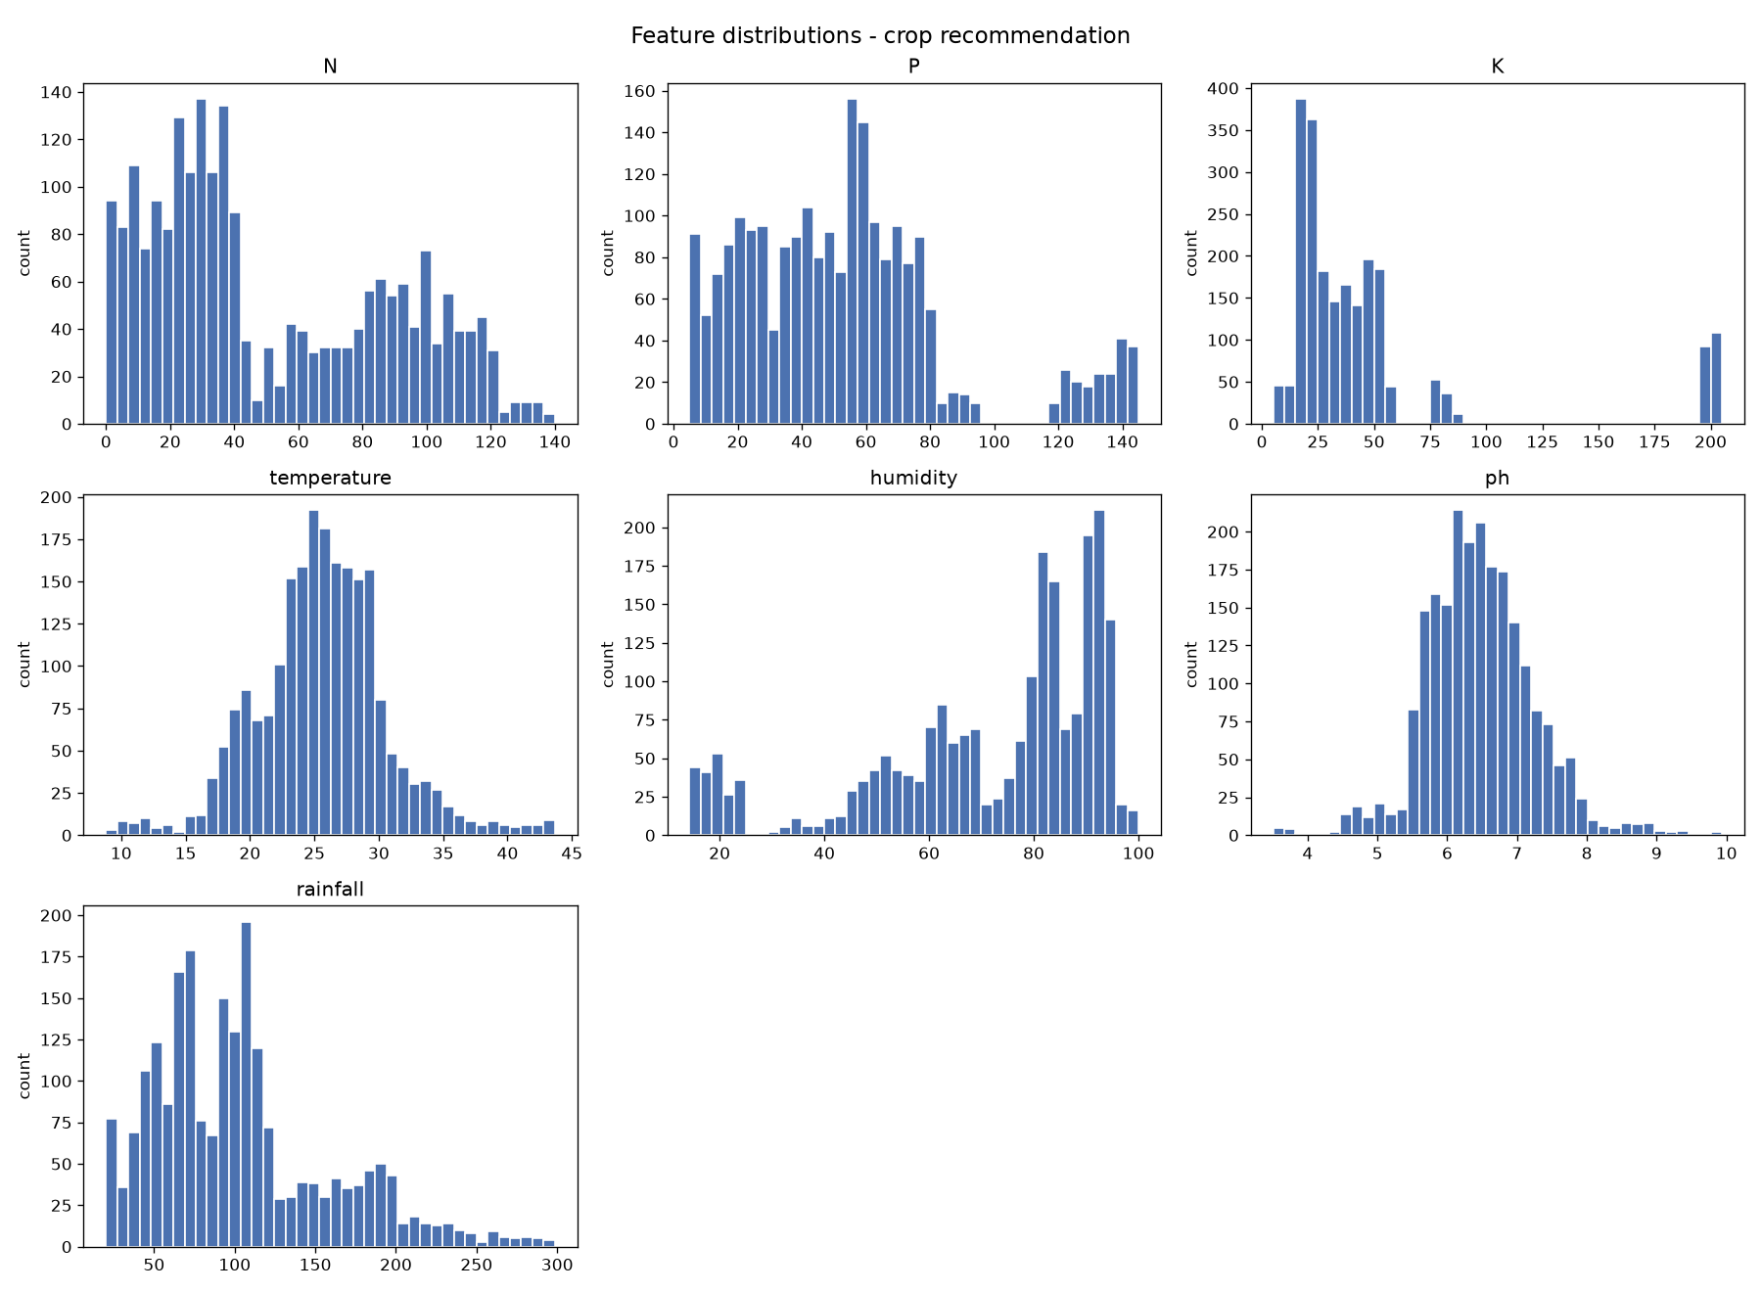
Figure 4.2 — Feature distributions of the crop recommendation dataset
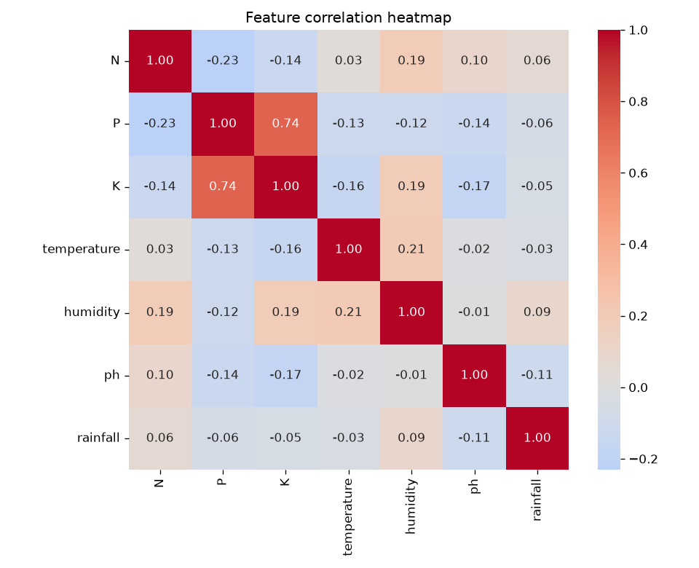
Figure 4.3 — Feature correlation heatmap. Inter-feature correlation is low, so all seven features were retained.

4.3 Iteration 2 — Refinement
Iteration 2 introduced two ensemble methods per task and tuned the winner. Random Forest and XGBoost were trained on identical splits to the baseline so results stayed comparable.
Task | Model | Key metric
Classification | Logistic Regression (baseline) | Accuracy 0.9727
Classification | Random Forest | Accuracy 0.9955
Classification | XGBoost | Accuracy 0.9886
Regression | Linear Regression (baseline) | R² 0.0726
Regression | Random Forest | R² 0.6719
Regression | XGBoost | R² 0.6946

Table 4.2 — Iteration 2 model comparison
Random Forest won the classification task and XGBoost the regression task — confirming the team’s decision in Section 2.3 not to assume one family would suit both. Each winner was then tuned with an exhaustive grid search: 27 candidates over n_estimators, max_depth and min_samples_split for the forest, and 12 candidates over n_estimators, max_depth and learning_rate for the boosted regressor.
Tuning had asymmetric effect, which is itself a result. The classifier did not improve — 0.9955 before and after — because at 440 test records it was already missing only two, and no hyperparameter setting recovers those. The regressor improved materially, from R² 0.6946 to 0.7403, with RMSE falling from 5.4483 to 5.0247. Notably the selected depth was 4, shallower than the untuned 6: the grid search found that the model had been overfitting and that constraining it generalised better.

4.4 Final Approach
For crop recommendation the final model is a Random Forest of 100 trees with maximum depth 10 and a minimum of 5 samples required to split. Each tree is trained on a bootstrap sample and considers a random feature subset at each split; the ensemble predicts by majority vote. The approach fits this problem because the 22 classes are separated by threshold-like conditions on rainfall and humidity rather than by linear boundaries — a tree expresses “rainfall above 200 mm and humidity above 80%” directly, whereas a linear model must approximate it.
For yield estimation the final model is an XGBoost regressor with 200 boosting rounds, maximum depth 4 and learning rate 0.1. Trees are added sequentially, each fitted to the residual error of those before it, with the learning rate shrinking each contribution so that no single tree dominates. This fits a target driven mainly by which crop and which season — a step-like surface over categorical inputs that a linear model cannot represent at all, as its R² of 0.07 demonstrated.
Model | Hyperparameter | Final value
Random Forest (classification) | n_estimators | 100
 | max_depth | 10
 | min_samples_split | 5
 | random_state | 42
XGBoost (regression) | n_estimators | 200
 | max_depth | 4
 | learning_rate | 0.1
 | random_state | 42

Table 4.3 — Final hyperparameters selected by grid search

4.5 Training Procedure
Classification. The 2,200 records were split 80/20 with stratification on the label, preserving 100 records per class across the split and yielding 1,760 training and 440 test records. Class labels were integer-encoded. Grid search used 5-fold cross-validation over 27 candidates scored on accuracy, and the selected model was then validated with an independent 5-fold cross_val_score over the full dataset, giving 0.9927 ± 0.0039.
Regression. After cleaning, 15,000 rows were sampled from the 48,681 available to keep training time within a couple of minutes, then split 80/20 into 12,000 training and 3,000 test records. Season and crop were integer-encoded with LabelEncoder and the fitted encoders serialised alongside the model, so that the API and the client validate user input against exactly the categories the model was trained on. Grid search used 3-fold cross-validation over 12 candidates scored on R², and the selected model was validated with 5-fold cross_val_score, giving 0.7428 ± 0.0254.
Both pipelines fix random_state at 42 throughout, so every figure reported in Chapter 6 is reproducible at the precision shown. The loss functions are those of the respective estimators — Gini impurity for the forest’s splits, squared error for the boosted regressor.

CHAPTER 5
IMPLEMENTATION

5.1 Module Description

Data ingestion and preprocessing
Two pipeline scripts own all data handling. The classification pipeline loads the CSV, prints shape, summary statistics and missing-value counts, and produces the EDA figures. The regression pipeline additionally strips whitespace from column names and string values, coerces area and production to numeric, drops rows where either is missing or non-positive, derives yield, and clips to the 1st–99th percentile. Row counts are printed before and after each step so the effect of cleaning is visible in the logs rather than asserted in prose.

Model training and evaluation
Each pipeline builds three candidate models, fits them on an identical split, and reports metrics per model. The winner is selected programmatically — by weighted F1 for classification, by R² for regression — then passed to GridSearchCV and an independent cross_val_score. Every metric is written to a JSON file under outputs/, which is what makes the numbers in this report auditable: they were not transcribed by hand.

Inference
src/prototype_demo.py exposes recommend_crop() and estimate_yield(). Models are loaded once and cached in module-level variables, so repeated calls do not re-read the disk. estimate_yield validates season and crop against the saved encoders before calling the model, raising a descriptive ValueError rather than allowing a raw scikit-learn “previously unseen label” error to escape.

API layer
The FastAPI application exposes /predict/crop, /predict/yield, /metadata/crops, /metadata/seasons, /metadata/model-info and /health under /api/v1. Request bodies are validated by Pydantic schemas with physical bounds — pH between 0 and 14, area strictly positive. Models are warmed at startup through a lifespan hook. The metadata endpoints are what allow the client to populate its dropdowns from the encoders themselves, so the app can never offer a crop the model does not know.

Mobile client
The Expo Router application provides onboarding, a home dashboard, an analyze hub with the two input forms, result screens, a locally stored prediction history and a profile section. Reusable components (AppButton, AppCard, InputField, SelectField, StatusBadge) are driven by a shared design-token layer, and history, profile, soil and settings are persisted with AsyncStorage.

5.2 Key Code Snippets
Yield derivation and outlier handling — the step that makes the regression target usable:
df = df.dropna(subset=["Area", "Production"])
df = df[(df["Area"] > 0) & (df["Production"] > 0)]

df["Yield"] = df["Production"] / df["Area"]

lo, hi = df["Yield"].quantile([0.01, 0.99])
df = df[(df["Yield"] >= lo) & (df["Yield"] <= hi)].copy()

Model selection and tuning — the winner is chosen from measured results, not assumed:
for name, model in build_models().items():
model.fit(X_train, y_train)
comparison.append(evaluate(name, model, X_test, y_test))

best_name = max(comparison, key=lambda r: r["f1_weighted"])["model"]

search = GridSearchCV(base, grid, cv=5, scoring="accuracy", n_jobs=-1)
search.fit(X_train, y_train)
best_model = search.best_estimator_

cv = cross_val_score(best_model, X, y, cv=5, scoring="accuracy")
print(f"5-fold CV accuracy: {cv.mean():.4f} +/- {cv.std():.4f}")

Input validation at the inference boundary — an unknown crop produces a readable message, which the API maps to HTTP 422:
if crop_clean not in set(le_crop.classes_):
raise ValueError(
f"Unknown crop {crop_clean!r}. This crop was not in the "
f"training data ({len(le_crop.classes_)} crops known, e.g. "
f"{', '.join(list(le_crop.classes_)[:5])})."
)

The parity test that keeps the API honest:
def test_parity_yield_3(client):
inputs = {"temperature": 36.0, "humidity": 42.0,
"soil_moisture": 54.0, "area": 1254.0,
"season": "Kharif", "crop": "Arecanut"}
api_resp = client.post("/api/v1/predict/yield", json=inputs)
direct_res = estimate_yield(**inputs)
assert abs(api_resp.json()["prediction"]["yield_value"]
- direct_res) < 1e-5

5.3 User Interface / Demo
All screenshots below were captured from the running application against a live backend — the values shown are genuine model output, not mock-ups.
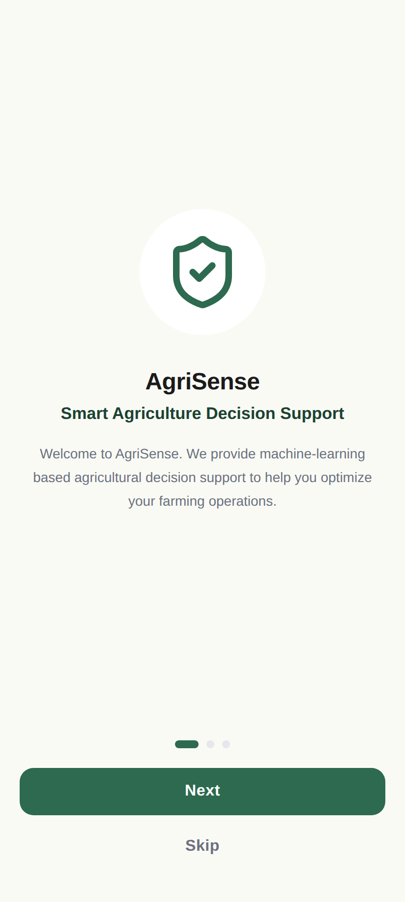
Figure 5.1(a) — Onboarding, first launch
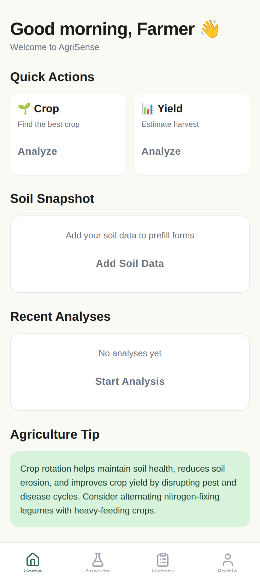
Figure 5.1(b) — Home dashboard after onboarding
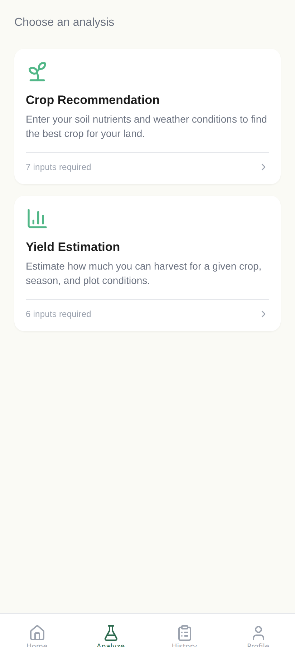
Figure 5.1(c) — Analyze hub, the entry point to both tasks
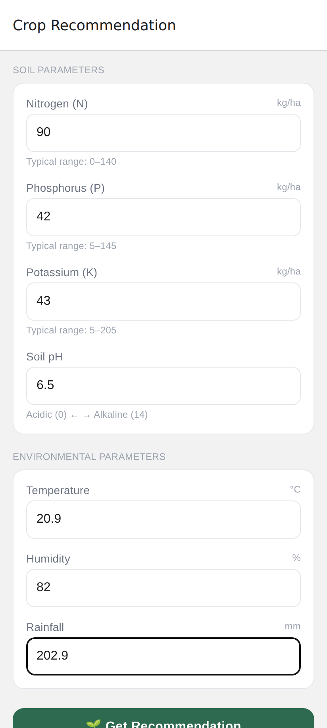
Figure 5.2(a) — Crop recommendation input form
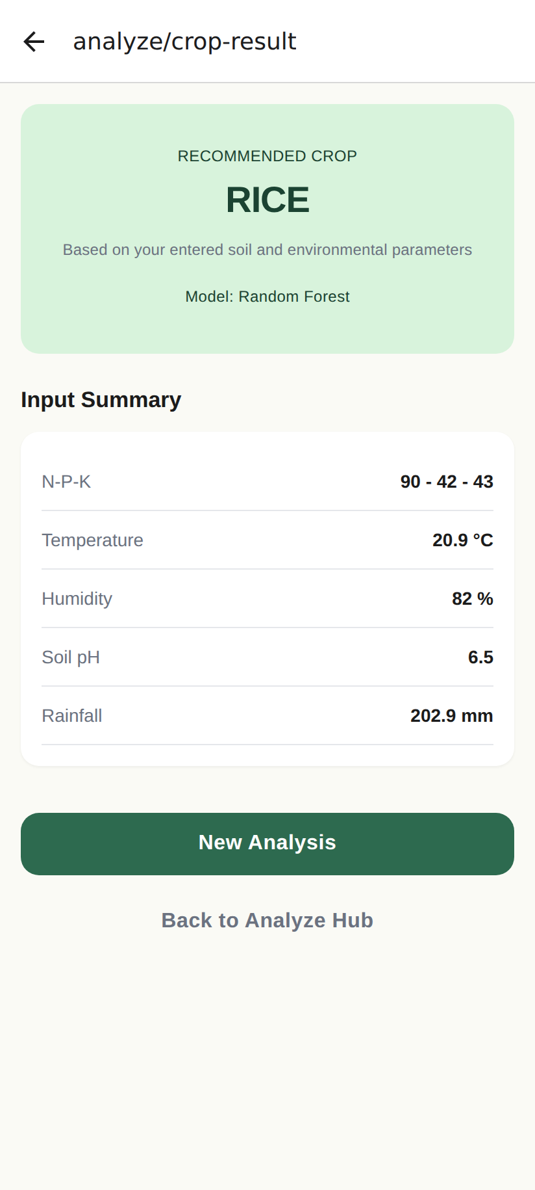
Figure 5.2(b) — Result: N-P-K 90-42-43 at 20.9 °C, 82% humidity, pH 6.5, 202.9 mm rainfall returns “RICE”
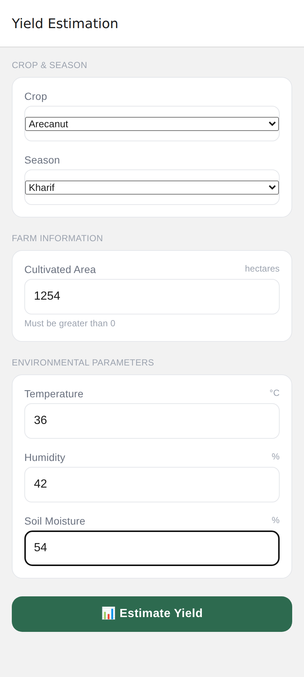
Figure 5.3(a) — Yield estimation form. Crop and season dropdowns are populated from the saved encoders via /metadata.
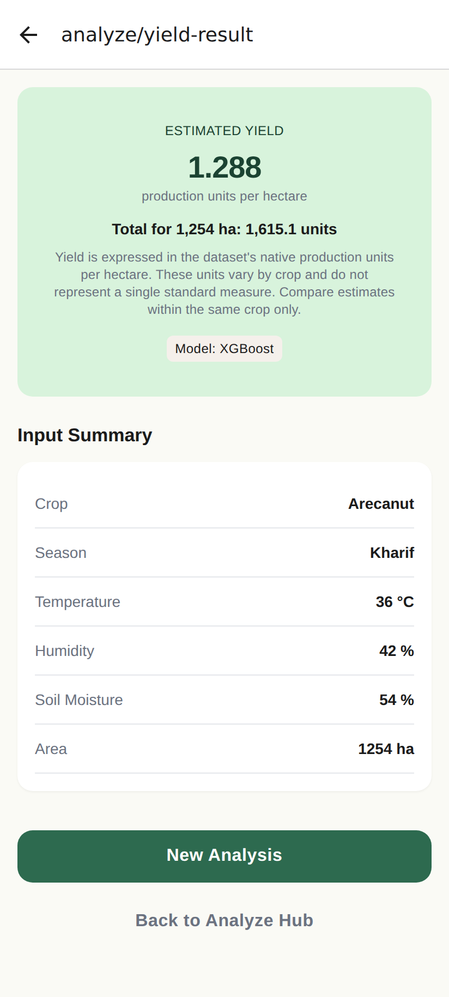
Figure 5.3(b) — Result: Arecanut, Kharif, 1,254 ha returns 1.288 units per hectare, matching direct model output exactly

Figure 5.4(a) — Locally stored prediction history
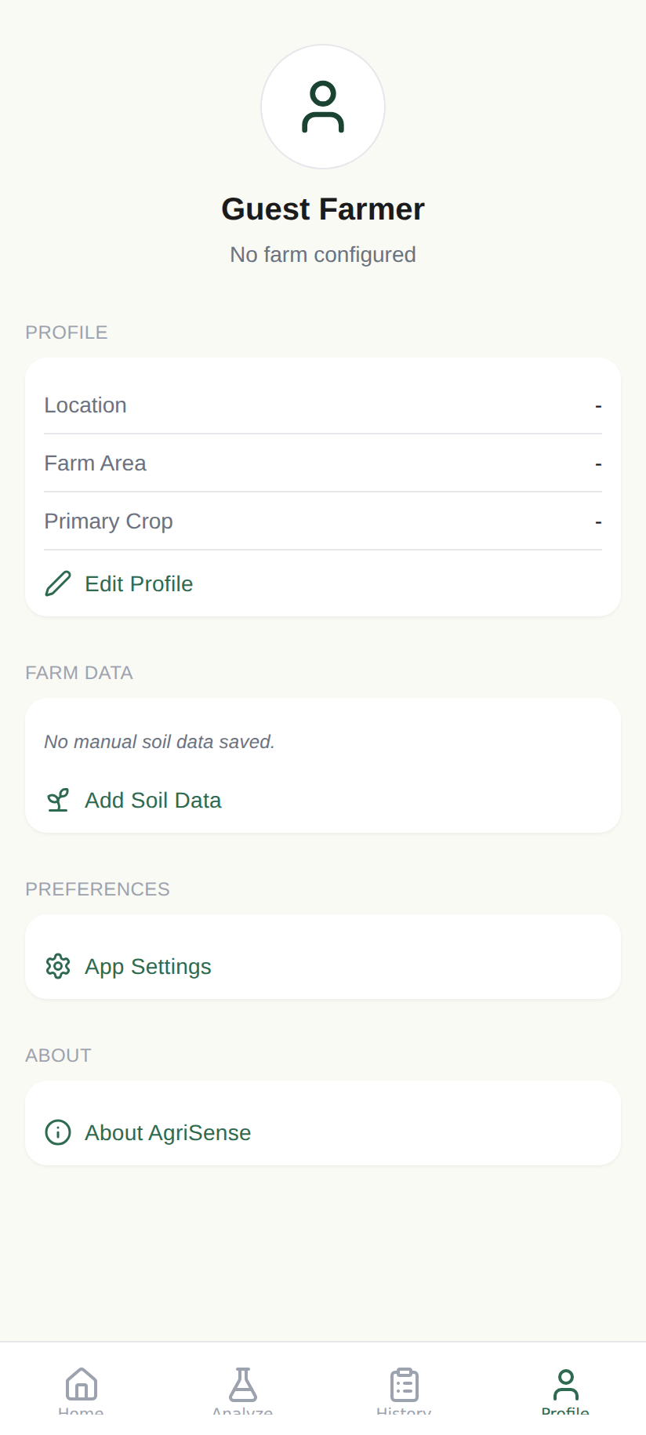
Figure 5.4(b) — Profile section
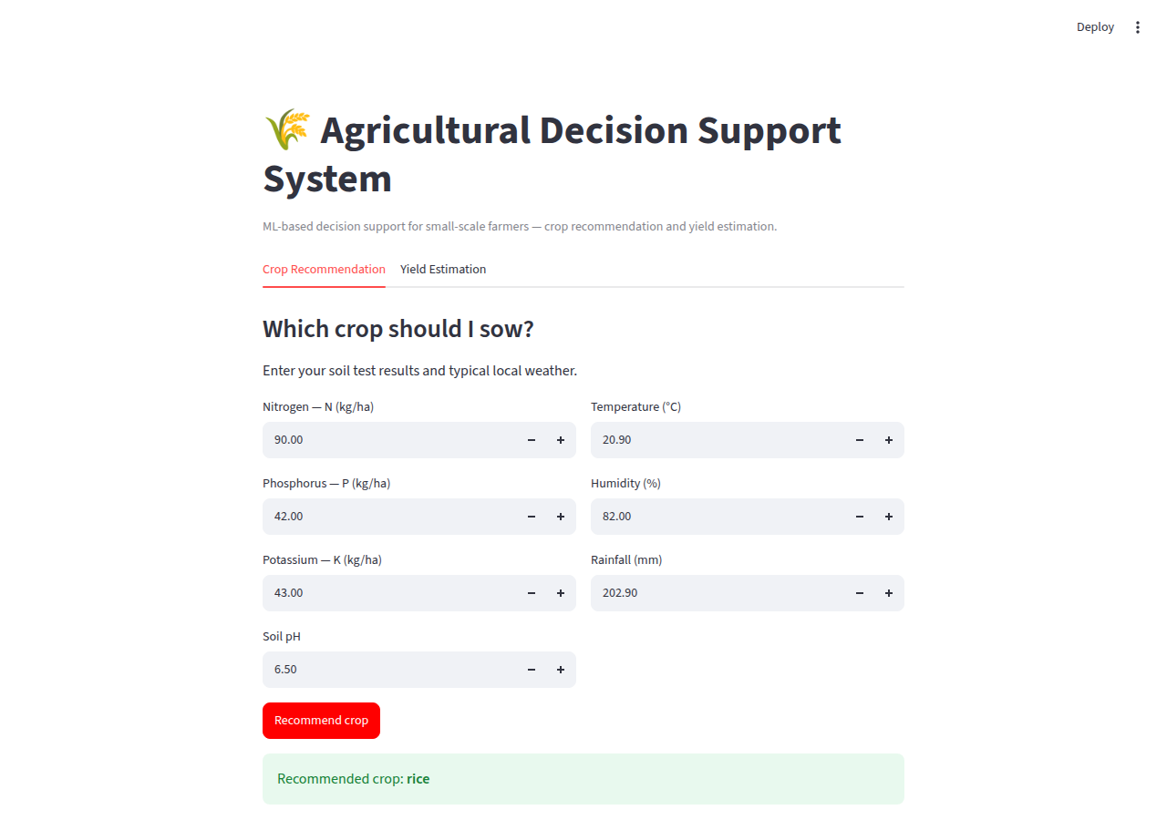
Figure 5.5(a) — Streamlit prototype, crop recommendation. This interface preceded the mobile client and is retained for desktop testing.
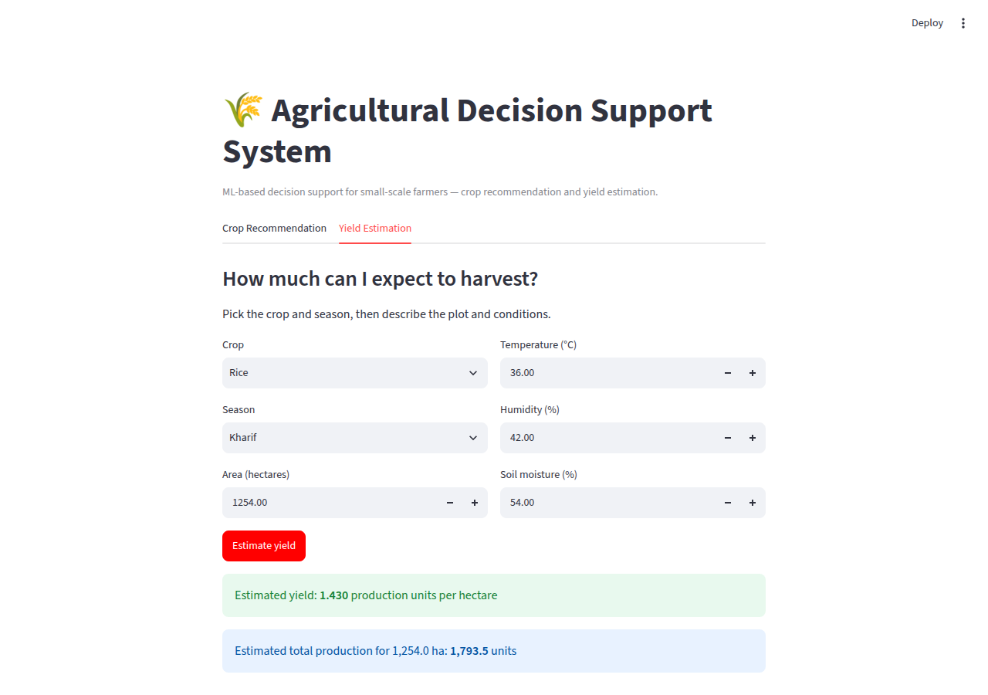
Figure 5.5(b) — Streamlit prototype, yield estimation

CHAPTER 6
RESULTS AND DISCUSSION

6.1 Evaluation Metrics
Classification was evaluated with accuracy, precision, recall and F1. Because the dataset is exactly balanced at 100 records per class, accuracy is not misleading here and is reported as the headline figure. Precision, recall and F1 are reported as weighted averages so that every class contributes; F1 was used as the selection criterion because it penalises a model that achieves accuracy by favouring easy classes.
Regression was evaluated with RMSE, MAE and R². RMSE is in the units of yield and penalises large errors quadratically, which matters because an overestimate on a large plot is costly. MAE gives the typical error magnitude and is far less sensitive to the remaining outliers. R² was used for selection because it is scale-free and therefore comparable across models. Reporting all three matters here: Random Forest achieved the better MAE (1.6607 against 1.7289) while XGBoost achieved the better RMSE and R², meaning the forest was typically closer but the boosted model made fewer large errors.

6.2 Results Across Iterations
Version | Accuracy | Precision (w) | Recall (w) | F1 (w)
Iteration 1 — Logistic Regression | 0.9727 | 0.9740 | 0.9727 | 0.9725
Iteration 2 — XGBoost | 0.9886 | 0.9894 | 0.9886 | 0.9885
Iteration 2 — Random Forest | 0.9955 | 0.9957 | 0.9955 | 0.9955
Final — Random Forest (tuned) | 0.9955 | 0.9957 | 0.9955 | 0.9955
Final — 5-fold cross-validation | 0.9927 ± 0.0039 | — | — | —

Table 6.1 — Classification results across iterations
Version | RMSE | MAE | R²
Iteration 1 — Linear Regression | 9.4949 | 4.6019 | 0.0726
Iteration 2 — Random Forest | 5.6473 | 1.6607 | 0.6719
Iteration 2 — XGBoost | 5.4483 | 1.7289 | 0.6946
Final — XGBoost (tuned) | 5.0247 | 1.6527 | 0.7403
Final — 5-fold cross-validation | — | — | 0.7428 ± 0.0254

Table 6.2 — Regression results across iterations
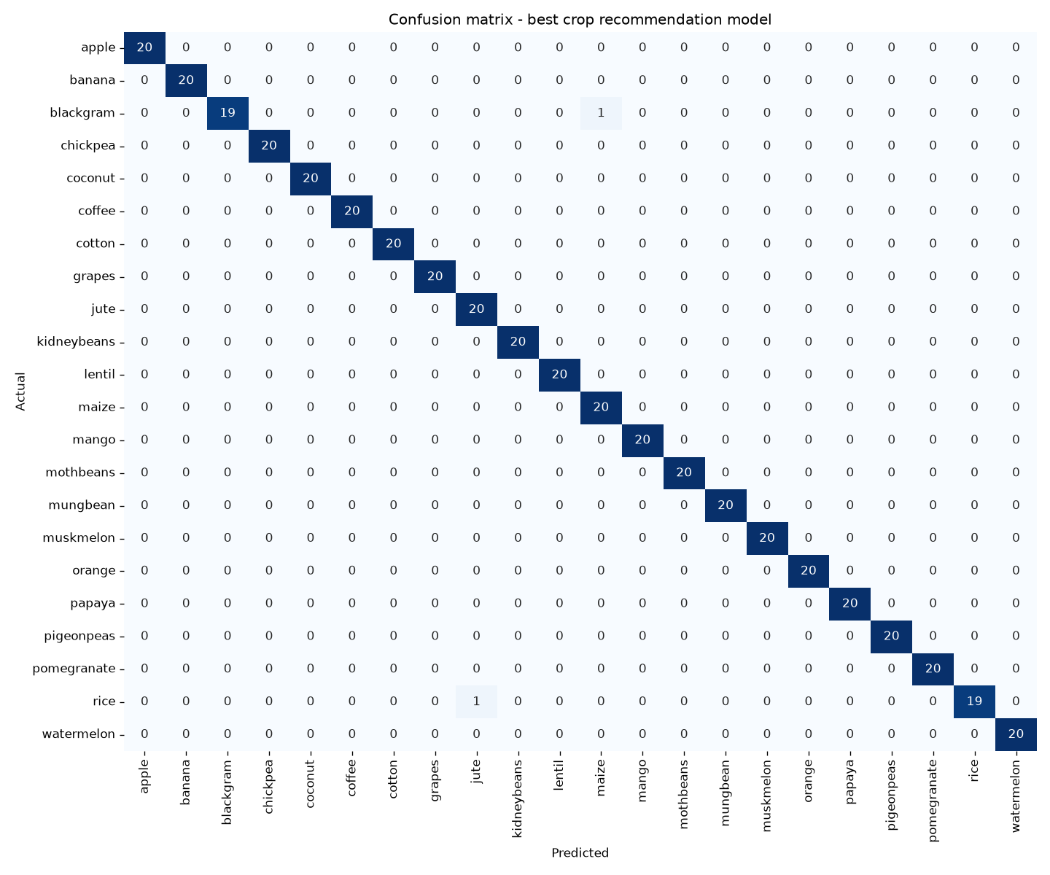
Figure 6.1 — Confusion matrix, tuned Random Forest. 438 of 440 test records are on the diagonal.
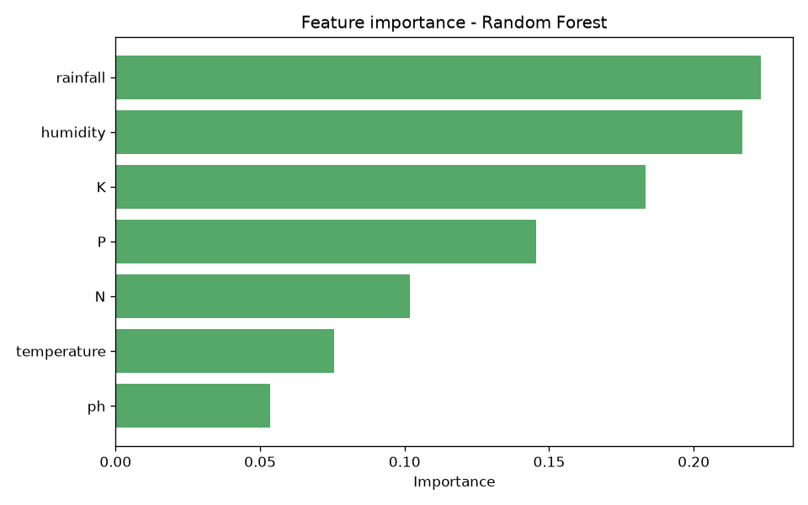
Figure 6.2 — Feature importance, tuned Random Forest
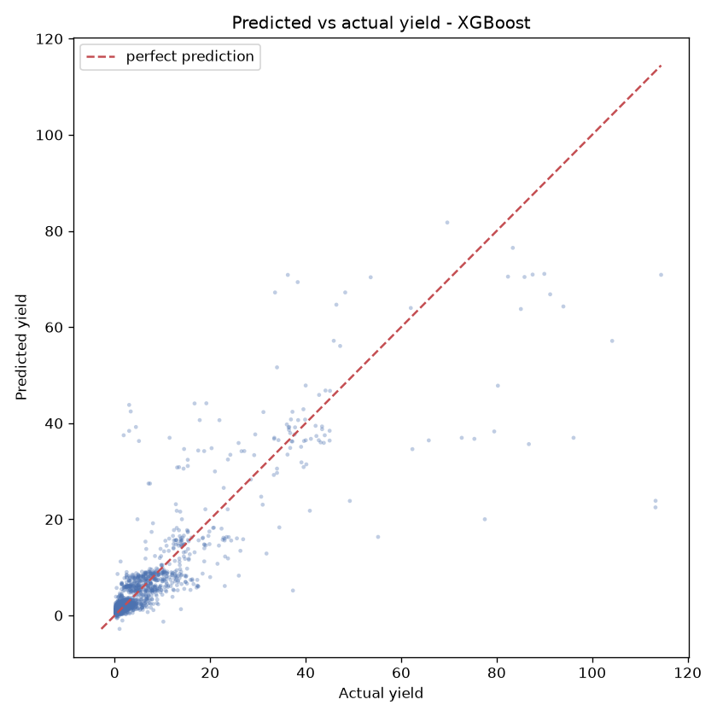
Figure 6.3 — Predicted vs actual yield, tuned XGBoost
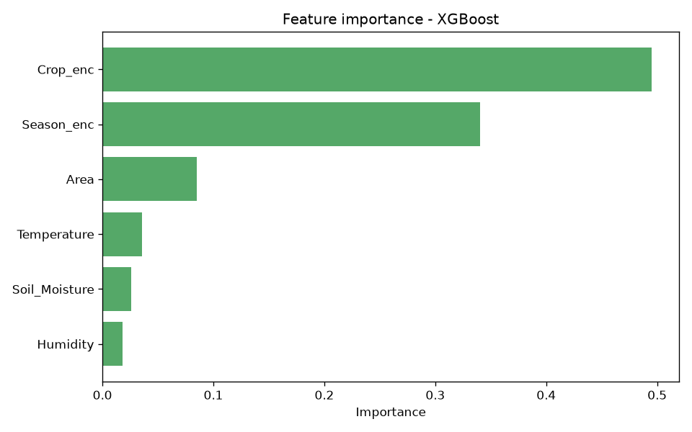
Figure 6.4 — Feature importance, tuned XGBoost
Crop recommendation | Importance | Yield estimation | Importance
rainfall | 0.2231 | Crop (encoded) | 0.4949
humidity | 0.2169 | Season (encoded) | 0.3404
K | 0.1834 | Area | 0.0850
P | 0.1456 | Temperature | 0.0354
N | 0.1020 | Soil moisture | 0.0258
temperature | 0.0755 | Humidity | 0.0185
ph | 0.0535 | — | —

Table 6.3 — Feature importance values for both final models

6.3 Discussion
The most informative result in this project is the contrast between the two baselines. Logistic regression reached 97.27% on the classification task, while linear regression reached R² 0.0726 on the regression task. The same class of model was near-sufficient for one problem and almost useless for the other, and the reason is visible in the feature importances. Crop recommendation is driven by continuous variables — rainfall at 0.2231 and humidity at 0.2169 together account for 44% of the signal — and the 22 crops separate along water requirement in a way a linear boundary can largely capture. Yield is driven by which crop is grown (0.4949) and in which season (0.3404), together 84% of the signal, and those are categorical. Once label-encoded, their integer values carry no meaningful order: crop 12 is not “more” than crop 11. A linear model fitted to such a column is fitting noise, which is exactly what R² 0.07 reports. Tree ensembles are unaffected because they split on category membership rather than magnitude.
The tuning outcomes are similarly asymmetric. Grid search left the classifier unchanged at 0.9955 because only two of 440 test records were misclassified — the model had reached the dataset’s ceiling, and the 5-fold cross-validated 0.9927 ± 0.0039 confirms the result is stable rather than a lucky split. For the regressor, tuning moved R² from 0.6946 to 0.7403 and selected depth 4 over the untuned 6; the shallower tree generalising better is direct evidence that the untuned model was overfitting.
Where the yield model does poorly is visible in Figure 6.3: the scatter is tight at low yields, where most of the data lies, and fans out at high yields. With a median yield near 1.06 and a clipped maximum of 129.2, high-yield records are sparse, so the model has little to learn from and regresses them toward the mean. The weather columns compound this — temperature spans only 25–37 as integers — so there is little variance for the model to exploit even where it would help.
The third iteration produced a different kind of result. Integration testing, performed by driving the real application against a live backend rather than by reading code, exposed three defects that neither the 22 automated tests nor TypeScript compilation had caught. They are recorded below because a PBL report is assessed on process, and finding them is part of what the process produced.
Defect | Effect | Root cause | Resolution
Missing peer dependency | App could not bundle at all | react-native-svg is required by the icon library but was never declared; the documented --legacy-peer-deps install flag suppressed the warning | Declared at the version Expo SDK 57 pins
Metadata response shape | Yield estimation unusable — crop and season dropdowns never populated | Client assumed every endpoint returns the {success, prediction} envelope; metadata endpoints return their payload directly | Added a separate accessor for unwrapped endpoints
Onboarding redirect loop | Onboarding could never be completed on a device | The route guard compared against a flag captured once at mount, so it read a stale value after completion and redirected back | Guard now re-reads the persisted flag on entry
Malformed timestamp | API returned invalid RFC 3339; JavaScript parsed it as Invalid Date | isoformat() already emits the +00:00 offset and "Z" was appended, giving two designators | Replaced with a single correct format
Mislabelled result | Screen headed “Estimated yield” displayed total production — 1,615 where the yield is 1.288 | Result screen rendered the wrong field; yield_value was never displayed anywhere | Headline now shows yield per hectare, with total production on its own line

Table 6.4 — Defects found during integration testing and their resolution
The common thread is that all five were invisible to the checks in place. The automated tests exercised the Python layers, which were correct; the type checker verified that the client’s types were internally consistent, which they were. What none of them verified was whether the client’s assumptions matched the server’s actual behaviour. That gap only closed when the application was run.

6.4 Limitations
- The crop recommendation dataset is perfectly balanced with 100 records per class and separates cleanly. 99.55% accuracy reflects that dataset, not field conditions, and should not be presented as expected real-world accuracy.
- Yield is expressed in the source data’s own production units, which differ by crop — tonnes, bales, nuts. Estimates are comparable within a crop only. The application states this on the result screen rather than hiding it.
- The yield model explains about 74% of variance; the remainder is attributable to the coarse weather columns and to the sparsity of high-yield records visible in Figure 6.3.
- Training used 15,000 of the 48,681 cleaned rows, sampled for speed. Using the full set may change results modestly.
- The system is a development build: no authentication, permissive cross-origin policy, and a backend bound to the local network. It is not deployed.
- The models are static. They do not learn from user corrections and were trained on historical records that predate current conditions.

CHAPTER 7
TEAM REFLECTION AND LEARNING OUTCOMES

7.1 Individual Reflections
[Each member to write 2–4 sentences: what you personally worked on, one thing you learned, and one challenge you faced. Mentors read this section closely and generic reflection is obvious — refer to specific decisions, for example why the linear baseline was kept once it scored R² 0.07, or what the integration defects in Table 6.4 taught you about testing assumptions rather than code.]
[Name 1]: [reflection]
[Name 2]: [reflection]

7.2 Team Learning
[Team to complete. Points worth addressing, drawn from what the project record actually shows: (i) the decision to benchmark three models per task rather than committing to one early, and whether that was worth the time; (ii) the choice to keep the failing linear baseline in the report instead of removing it; (iii) how the team divided ML work from application work in Iteration 3; (iv) any mentor feedback that changed direction.]

7.3 Course Outcomes — Evidence Summary
Course Outcome | Evidence from this project
Apply ML techniques to a real problem | Two supervised tasks trained on public datasets; final models reach 99.55% accuracy and R² 0.7403 (Tables 6.1, 6.2)
Evaluate and justify model selection | Three models compared per task on identical splits; winners selected by measured F1 and R², then tuned by grid search (Sections 4.2–4.4)
Interpret and communicate results | Feature importances analysed to explain why the linear baseline fails on regression but nearly suffices for classification (Section 6.3)
Design and build a working system | Three-layer architecture with a REST API and mobile client; layering enforced by an automated parity test (Section 4.1)
Test and validate | 22 automated tests, static type checking, and integration testing that exposed five defects (Table 6.4)
Teamwork and process | [Cite your weekly log in Table 3.1 — e.g. task rotation across iterations, mentor reviews that changed direction]

Table 7.1 — Course outcome evidence
[Replace the outcome names in the left column with the exact CO statements from your course handbook.]

CHAPTER 8
CONCLUSION AND FUTURE SCOPE

8.1 Conclusion
This project built AgriSense, a machine-learning decision support system that recommends a crop from soil and weather measurements and estimates the yield of a planned cultivation. A tuned Random Forest classifies among 22 crops with 99.55% test accuracy and 0.9927 ± 0.0039 cross-validated accuracy, and a tuned XGBoost regressor estimates yield with R² 0.7403 and RMSE 5.0247. Both models are delivered through a REST API and a mobile application, and the parity between application output and direct model output is asserted by an automated test.
Both parts of the driving question were addressed. Soil and weather measurements a farmer can realistically obtain are sufficient to recommend a crop reliably and to estimate yield with useful though bounded accuracy; and that capability was delivered in a form a farmer could use, with a phone-based interface reached in three taps. The honest qualification is that the classification figure reflects a clean, balanced dataset rather than field conditions, and the yield figure is bounded by the coarseness of the weather data available. All six objectives set out in Section 1.3 were met.

8.2 Future Scope
- Train on the full 48,681 cleaned rows rather than a 15,000-row sample, and test whether the additional data improves the high-yield region where Figure 6.3 shows the model is weakest.
- Add finer-grained weather data from a meteorological API in place of the dataset’s coarse integer columns, which the feature importances suggest is the binding constraint on regression accuracy.
- Return a confidence measure alongside each prediction — class probabilities for the recommendation and a prediction interval for the yield — so a farmer can tell a firm recommendation from a marginal one.
- Deploy the backend to a hosted environment with authentication and a restricted cross-origin policy, replacing the current local-network development build.
- Add offline support so a prediction can be requested without connectivity, which matters for the intended users.
- Support regional languages in the interface.

REFERENCES
[1] L. Breiman, “Random forests,” Machine Learning, vol. 45, no. 1, pp. 5–32, 2001.
[2] T. Chen and C. Guestrin, “XGBoost: A scalable tree boosting system,” in Proc. 22nd ACM SIGKDD Int. Conf. Knowledge Discovery and Data Mining, San Francisco, CA, USA, 2016, pp. 785–794.
[3] F. Pedregosa et al., “Scikit-learn: Machine learning in Python,” Journal of Machine Learning Research, vol. 12, pp. 2825–2830, 2011.
[4] Harvestify, “Crop recommendation dataset,” GitHub repository. [Online]. Available: https://raw.githubusercontent.com/Gladiator07/Harvestify/master/Data-processed/crop_recommendation.csv
[5] A. Kandoi, “Crop prediction dataset based on Indian agriculture,” GitHub repository. [Online]. Available: https://github.com/AbhishekKandoi/Crop-Yield-Prediction-based-on-Indian-Agriculture
[6] S. Ramírez, “FastAPI documentation.” [Online]. Available: https://fastapi.tiangolo.com
[7] Expo, “Expo Router documentation.” [Online]. Available: https://docs.expo.dev/router/introduction/
[8] Streamlit Inc., “Streamlit documentation.” [Online]. Available: https://docs.streamlit.io
[9] J. H. Friedman, “Greedy function approximation: A gradient boosting machine,” Annals of Statistics, vol. 29, no. 5, pp. 1189–1232, 2001.
[10] onward — add the crop-prediction papers your team read for Chapter 2, in IEEE format, in order of first citation.

APPENDIX

A.1 Full Source Code
Complete source code, datasets, trained models, generated figures and result files: https://github.com/kartheeban-chelladurai/agri-decision-support-ml
The repository contains the two training pipelines and the inference module under src/, the FastAPI service under api/, the React Native client under mobile/, all 22 automated tests under tests/ and api/tests/, and the raw metric files under outputs/ from which every number in Chapter 6 was taken.

A.2 Complete Weekly PBL Log and Mentor Sign-offs
[Attach the full weekly log and mentor sign-off sheets here if longer than Table 3.1.]

A.3 Self and Peer Assessment
Team Member | Self-Rated Contribution (%) | Peer-Rated Contribution (%) | Remarks
[Name 1] | [%] | [%] | [remarks]
[Name 2] | [%] | [%] | [remarks]

Table A.1 — Self and peer assessment

A.4 Reproducing the Results
git clone https://github.com/kartheeban-chelladurai/agri-decision-support-ml
cd agri-decision-support-ml
python -m venv .venv
.venv\Scripts\activate # Windows
source .venv/bin/activate # macOS / Linux
pip install -r requirements.txt

pytest # 9 ML tests
python src/crop_recommendation_pipeline.py # ~1 min
python src/crop_yield_pipeline.py # ~2 min

pip install -r api/requirements.txt
python -m uvicorn api.main:app --port 8000 --reload
pytest tests/ api/tests/ # 22 tests

cd mobile && npm install --legacy-peer-deps
npx expo start

Requires Python 3.11 or newer. Trained models are committed, so the tests and the API run without retraining.

