Project plan

COURSE CODE: PA2534

Version 1 – February 6, 2015

|  |  |  |
| --- | --- | --- |
| Thesis | Tentative title | Usage of Third Party Components and Their Effects in  Testing of Heterogeneous Systems |
| Classification | Computer Systems Organization, Other Architecture Styles, Heterogeneous (hybrid) systems |
| Student 1 | Name | Jaya krishna Raavi |
| e-Mail | [jara14@student.bth.se](mailto:jara14@student.bth.se) |
| Social security nr | 9307055492 |
| Visa expiration date |  |
| Supervisor | Name and title | Nauman Ghazi |
| e-Mail | nauman.ghazi@bth.se |
| Department | DIPT |
| External | Name and title |  |
| e-Mail |  |
| Company/HEI |  |

# Introduction and Background

**Heterogeneous systems:**

Software is evolving with the passage of time and its size is also increasing exponentially. Immensely colossal systems that are evolving are mainly the system of systems. System of systems have different components developed and have single authority which exhibit heterogeneity [1]. The main characteristics of system of systems are degree of centralization, operational independence of participating system and independent evolution of participating systems [1]. These sub-systems exhibit heterogeneity in terms of both hardware and software [1].

Heterogeneous systems consist of functionally independent *n* subsystems where at least one subsystem exhibits heterogeneity with respect to other subsystems [2]. This heterogeneity may occur in different dimensions such as system complexities [3], platforms [4], type of systems [5], system supply (third party software) [6], development process and distribution sites [7].

**Third party system supply:**

Third party system supply is one of the heterogeneity dimensions in heterogeneous systems [6], which we intend to investigate in this thesis. The main third party components are Commercial Of The Shelf (COTS)[8], Open Source Systems (OSS)[9] and in-house developed software [10]. “COTS is the software that is sold, licensed or leased to customers without giving the source code” [11]. Gosh and Schmid [12] studied about the robustness of the COTS to the operating system errors. Haddox and Kapfhammer provided an approach in their article [13] to test COTS and has provided developers an improved understanding of the COTS component’s behavior within the system.

**Testing of Heterogeneous systems involving third party systems:**

Testing of heterogeneous systems has been a challenge for the testers due to sub-system interaction [14]. Testing in heterogeneous systems is mainly done by reusing the artefacts [15]. Otani et al. [16] proposed a framework on UML artefacts which are used in other similar testing projects. Otani et al. extended his work and introduced goal-driven reuse of artefacts for testing heterogeneous systems [15]. One of the main challenges posed to heterogeneous systems is related to interoperability. Xia et al.[4] Proposed a test method to interoperability testing for e-business specification languages. Piel et al.[17] Present a virtual component testing technique and further implemented and evaluated it in industrial setting. Quality assurance for heterogeneous systems has become challenge due to the involvement of different sub-systems. Prioritization of test cases is also a challenge due to the growth in the regression test suits [18]. Kropp et al. has described the Ballista methodology for scalable, portable, automated robustness testing of commercial of the shelf (COTS) software [19]. Reza et al. proposed a hybrid method based on software fault tree analysis and UML communication diagram to test commercial off the shelf (COTS) software in safety critical systems [20]. So far there is lack of empirical studies to investigate the effect of third party system software on testing of heterogeneous systems.

In this thesis we will investigate about different types of third party components and their effects on testing of heterogeneous systems.

# Aim and objectives

The aim of this study is, “Usage of third party components and their effects on testing of heterogeneous systems”. In order to accomplish this aim the following are the goals that are to be followed:

* Identify different types of third party components.
* Investigate the difference in test design of different third party components
* Identify what the practitioners learn from different third party components

# Research questions

**RQ1:** What are the different types of third party component used in heterogeneous systems?

**RQ2:** How does test design differ between different types of third party components?

**RQ2.1:** Why do they differ?

**RQ3:** What practitioner learn from each other by following different types of third party components?

# Method

The research method used is a mixed approach. The data collected from the research methods are qualitative and quantitative. To answer RQ1 literature review is used. Interviews are conducted to answer RQ2, RQ2.1 and RQ3. Further the data obtained from the interviews will be validated through survey with more industry practitioners.

**Literature review:**

Literature review chosen as the way to answer the research question RQ1. Literature review provides qualitative evidence on a topic using informal or subjective methods to collect and interpret studies [21]. The main steps in literature review are identification of keywords and then select database and start searching the literature relevant to the topic [21]. Snow ball sampling strategy is used to conduct literature review. The choice of selecting snow ball sampling is that the density of articles is reduced in this approach. It is carried out by selecting the papers in google scholar and searching for the cited articles and references. The summary of the most relevant articles are done to answer RQ1.

**Interviews:**

Interviews are used to answer RQ2, RQ2.1 and RQ3. A semi structured interviews are followed to answer the research questions. Semi structured interviews has both open ended and close ended questions[22]. The questions for the interviews are framed from the literature review. A fixed set of questions are formulated and pilot interviews are conducted to understand how well the questions are formulated and understandable to the interviewee. We use Time glass model[22] to conduct an interview session. In this model open questions are posed at the beginning and strengthens the structure in the middle and opens up again towards the end of interview [22]. Interview are mainly carried out through communication channels such as skype, team viewer and face to face meetings. The subjects used are the employees who are developing heterogeneous systems comprising of third party components. The data from the interviews will be recorded and transcribed into text. These transcripts data are reviewed by the interview subjects which helps us for clarification and expansion of answers.

**Survey:**

Survey method is used to validate the data collected from interviews to answer research questions RQ2, RQ2.1 and RQ3. Surveys will be designed using the information gathered from the interviews to further validate the finding from the practitioners. The motivation for selecting survey is that it describes the characteristics of large population. Survey allows “the collection of a large amount of data from a sizable population in a highly economical way”[23]. Case study is not chosen as research method to validate the finding because the data collected suits only to a single organization or single case. The data collection method used is closed ended questionnaire. An online survey will be dispersed and shared with contacts in industry as well as in testing forums, LinkedIn and focus groups.

The following diagram shows the research design for this thesis:

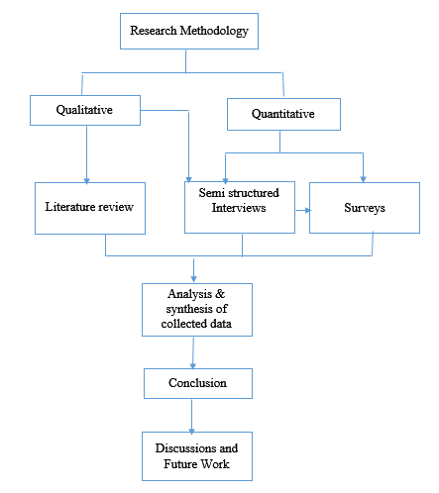

Figure Research Design:

# Expected outcomes

The expected outcomes from the research are as follows:

* Different types of third party components
* Differences between different types of third party components and the rationale for why a specific type of third party component is used in specific scenarios by the practitioners.
* Pros and Cons of using third party components in development of heterogeneous systems and its effects on test activities.

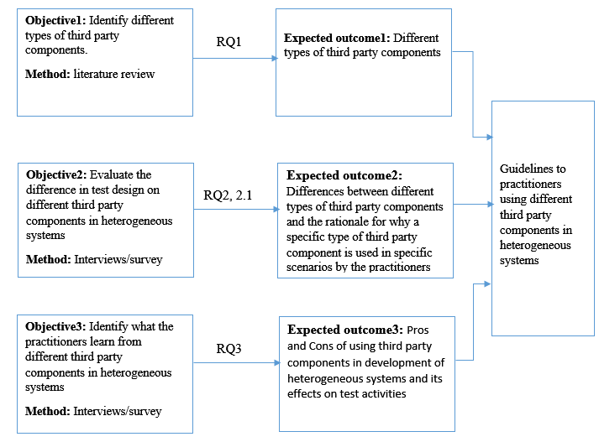

Figure Expected outcomes

# Time and activity plan

The following is the time activity plan for accomplishing the thesis. These are the scheduled milestones as follows:

* 20150117: Start writing Proposal
* 20150126: First draft of proposal to supervisor
* 20150206: Final draft of proposal to supervisor
* 20150207: Start date for literature review
* 20150228: End date for literature review
* 20150301: Start of interview process
* Search for Industrial contacts
* Preparation of Questionnaires
* Interviewing selected candidates
* 20150412: Analysis and Extraction of Data
* 20150415: Start Drafting Thesis report
* 20150426: Draft sent to Supervisor
* 20150513: Final Submission of report to supervisor
* 20150521: Supervisor tells OK to examiner for presentation
* 20150526: Document sent to opposition
* 20150601: Thesis Presentation
* 20150615: Updated report sent to examiner

# Risk management

In this section we discuss about the risks that may occur in the initial stage of research work. The following are the risks:

|  |  |
| --- | --- |
| **Strengths** | **Opportunities** |
| * Good communication and writing skills. * Dedicated and highly motivated * Good analytical skills. | * Good opportunity in contribution to the research area (Heterogeneous systems) * Opportunity to provide test process in third party components * Opportunity to provide guidelines to practitioners on third party components. |
| **Weaknesses** | **Contingency plan** |
| * Lack of industrial contacts * Lack of industrial experience | * Explore industrial contacts from the known contacts. |
| **Threats** | **Contingency plan** |
| * Short deadlines * Not getting data in time from survey method. * Unavailability of interview subjects. | * Provide buffer time * Posting survey questionnaire in different forums and focus groups. * Search for other industrial contacts. |

## References

[1] G. Lewis, E. Morris, P. Place, S. Simanta, D. Smith, and L. Wrage, “Engineering systems of systems,” in *Systems Conference, 2008 2nd Annual IEEE*, 2008, pp. 1–6.

[2] A. N. Ghazi, J. Andersson, R. Torkar, K. Petersen, and J. Börstler, “Information Sources and their Importance to Prioritize Test Cases in Heterogeneous Systems Context,” *Communications*.

[3] K. Petersen, K. Rönkkö, and C. Wohlin, “The impact of time controlled reading on software inspection effectiveness and efficiency: a controlled experiment,” in *Proceedings of the Second ACM-IEEE international symposium on Empirical software engineering and measurement*, 2008, pp. 139–148.

[4] Q.-M. Xia, T. Peng, B. Li, and Z. Feng, “Study on Automatic Interoperability Testing for E-Business,” in *Computational Intelligence and Software Engineering, 2009. CiSE 2009. International Conference on*, 2009, pp. 1–4.

[5] A. Forward and T. C. Lethbridge, “A taxonomy of software types to facilitate search and evidence-based software engineering,” in *Proceedings of the 2008 conference of the center for advanced studies on collaborative research: meeting of minds*, 2008, p. 14.

[6] J. Kontio, “A case study in applying a systematic method for COTS selection,” in *Software Engineering, 1996., Proceedings of the 18th International Conference on*, 1996, pp. 201–209.

[7] J. D. Herbsleb, “Global software engineering: The future of socio-technical coordination,” in *2007 Future of Software Engineering*, 2007, pp. 188–198.

[8] M. Morisio and N. Sunderhaft, “Commercial-off-the-shelf (cots): A survey,” *University of Maryland*, 2000.

[9] Ø. Hauge, C. Ayala, and R. Conradi, “Adoption of open source software in software-intensive organizations–A systematic literature review,” *Information and Software Technology*, vol. 52, no. 11, pp. 1133–1154, 2010.

[10] A. A. Ssaed, W. Kadir, and S. Z. M. Hashim, “Metaheuristic Search Approach Based on In-house/Out-sourced Strategy to Solve Redundancy Allocation Problem in Component-Based Software Systems,” *International Journal of Software Engineering and Its Applications*, vol. 6, no. 4, pp. 143–154, 2012.

[11] P. A. Oberndorf, “Facilitating component-based software engineering: COTS and open systems,” in *Assessment of Software Tools and Technologies, 1997., Proceedings Fifth International Symposium on*, 1997, pp. 143–148.

[12] A. K. Ghosh and M. Schmid, “An approach to testing COTS software for robustness to operating system exceptions and errors,” in *Software Reliability Engineering, 1999. Proceedings. 10th International Symposium on*, 1999, pp. 166–174.

[13] J. M. Haddox and G. M. Kapfhammer, “An approach for understanding and testing third party software components,” in *Reliability and Maintainability Symposium, 2002. Proceedings. Annual*, 2002, pp. 293–299.

[14] D. Wang, B. Barnwell, and M. B. Witt, “A cross platform test management system for the SUDAAN statistical software package,” in *Software Engineering Research, Management and Applications, 2009. SERA’09. 7th ACIS International Conference on*, 2009, pp. 237–244.

[15] T. W. Otani, J. B. Michael, and M.-T. Shing, “Goal-driven software reuse in the IV&V of system of systems,” in *System of Systems Engineering (SoSE), 2010 5th International Conference on*, 2010, pp. 1–6.

[16] T. W. Otani, J. B. Michael, and M.-T. Shing, “Software Reuse in the IV&V of System of Systems,” in *System of Systems Engineering, 2009. SoSE 2009. IEEE International Conference on*, 2009, pp. 1–5.

[17] É. Piel, A. Gonzalez-Sanchez, and H.-G. Gross, “Built-in data-flow integration testing in large-scale component-based systems,” in *Testing Software and Systems*, Springer, 2010, pp. 79–94.

[18] N. B. Ali, K. Petersen, and M. Mäntylä, “Testing highly complex system of systems: an industrial case study,” in *Proceedings of the ACM-IEEE international symposium on Empirical software engineering and measurement*, 2012, pp. 211–220.

[19] N. P. Kropp, P. J. Koopman, and D. P. Siewiorek, “Automated robustness testing of off-the-shelf software components,” in *Fault-Tolerant Computing, 1998. Digest of Papers. Twenty-Eighth Annual International Symposium on*, 1998, pp. 230–239.

[20] H. Reza, S. Buettner, and V. Krishna, “A method to test component off-the-shelf (COTS) used in safety critical systems,” in *Information Technology: New Generations, 2008. ITNG 2008. Fifth International Conference on*, 2008, pp. 189–194.

[21] J. W. Creswell, *Research design: Qualitative, quantitative, and mixed methods approaches*. Sage publications, 2013.

[22] C. Wohlin, P. Runeson, M. Höst, M. C. Ohlsson, B. Regnell, and A. Wesslén, *Experimentation in software engineering*. Springer Science & Business Media, 2012.

[23] C. W. Dawson, *Projects in computing and information systems: a student’s guide*. Pearson Education, 2005.