1. First the user must login to the application, or choose the Forgot Password option.

If chosen they are redirected to change the password where they get an email otp and then they can update the password

Link:

<https://online.visual-paradigm.com/community/share/kartheek-2110110292-1o5m82oe4n>

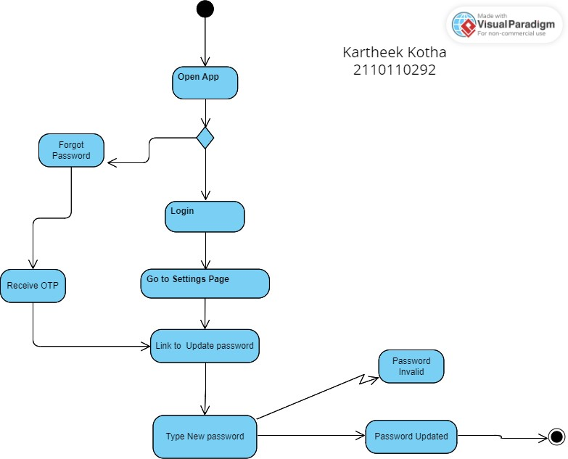

1. <https://online.visual-paradigm.com/community/share/kartheek-2110110292-1o5m82oe4n>

User must login if they have an account, or Sign up if they don’t. They must go to Home screen and they have two options whether taking a Photo or Uploading from Gallery. They can retake the photo if not satisfied, then edit the photo. Then the photo will be uploaded.

<https://online.visual-paradigm.com/community/share/feepaymentsystem-1nyrmjlgzv>

**Fee-Payment System Activity Diagram**

The activity diagram for the fee-payment system illustrates the sequence of actions performed in the process of fee payment.

