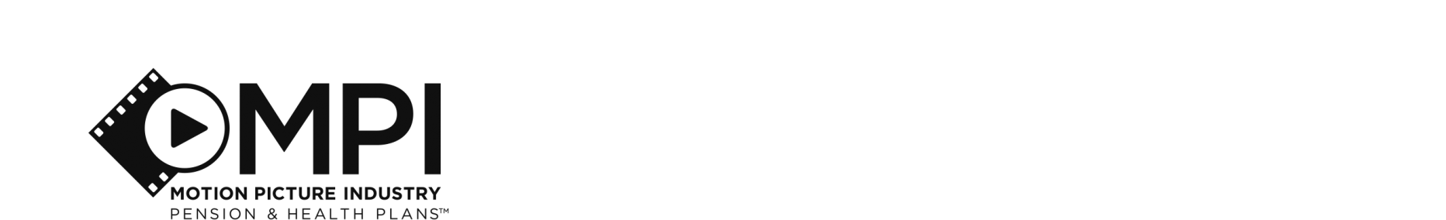{CurrentDate}

{stdMbrFullName}

{x stdMbrAdrCorStreet1}

{x stdMbrAdrCorStreet2}

{x if stdIsUSA = 1}

{x stdDomesticStateInternationalCountry}

{x else}

{x stdDomesticStateInternationalCountry}

{x stdMbrAdrCountryDesc}

{x endif}

Re: **13th and 14th Check for** **{BatchYear}**

Dear {stdTitle} {stdMbrLastName}:

This letter is to notify you that the Motion Picture Industry Pension Plan (the “Plan”) is preparing to issue a 13th and 14th pension check to qualified participants who retired on or prior to August 1, 2009 contingent on fulfillment of the following requirements:

1. Formal approval by the Plan’s Board of Directors.
2. Satisfaction of any other conditions required by the applicable Collective Bargaining Agreement and the Board of Directors.

Should both requirements be met as anticipated, you will be entitled to receive a payment of {GrossAmt} which equals the total of two monthly pension checks.

{x if ShowRollover = Y}

**Direct Rollover**

If the certification conditions are met, and since your 13th and 14th pension check amount is over $750, you may choose to roll the payment over into an IRA or other qualified retirement plan. If you would like to roll the payment over instead of receiving a direct payment, you must complete and return the enclosed Lump Sum Distribution Form to the MPI office by {CutOffDate}. An envelope has been enclosed for your convenience.

If you choose not to roll over the payment or the Plan office does not receive the completed Lump Sum Distribution Form by {CutOffDate} indicating your choice of payment, the payment will be processed as a lump sum payable to you directly. Please note such payment is subject to a mandatory 20% federal tax withholding.

The Plan will follow any current direct deposit instructions on file to process payments (if any) to the bank account indicated. If there are no direct deposit instructions, the payment will be made to you by check. A 13th and 14th check may still be rolled over into an IRA or eligible employer plan that will accept it within 60 days of receiving the payment from the Pension Plan.

{x else}

This amount is subject to the same tax withholding rules applicable to your regular monthly pension payments. The Plan will follow any current direct deposit instructions on file to process payments (if any) to the bank account indicated. If there are no direct deposit instructions, the payment will be made to you by check.

{x endif}

If you have any questions, please contact MPI’s Participant Services Center using the Contact Us tab at [www.mpiphp.org](http://www.mpiphp.org) or by telephone at (855) ASK-4MPI between 8 a.m. and 5 p.m. Pacific Time, Monday through Friday.

Sincerely,

Retirement Benefits

*See your Summary Plan Description for additional information about the Plans. Benefits are subject to final verification, review and adjustment. If applicable, these amounts may be subject to change in accordance with any divorce or Qualified Domestic Relations Order (QDRO), which may or may not be on file. In the event of any inconsistency between any communications and the provisions of the Plans, the provisions of the Plans shall govern.*

*{x if ShowRollover = Y}*

**LUMP SUM DISTRIBUTION FORM**

**Additional 13th and 14th Check for** **{BatchYear}**

***Pursuant to the provision of the Motion Picture Industry Pension (the ''Plan''), the Plan is authorized to distribute the funds in accordance with the Option I have selected below. I understand that if this form is not received by the Plan Office on or before*** ***{CutOffDate}, I will deem to have elected Option 1 under Section A.***

|  |  |
| --- | --- |
| **PARTICIPANT** | |
| Name: | **SS#:** |
| Address: | Birth Date: |
|  | Phone: |

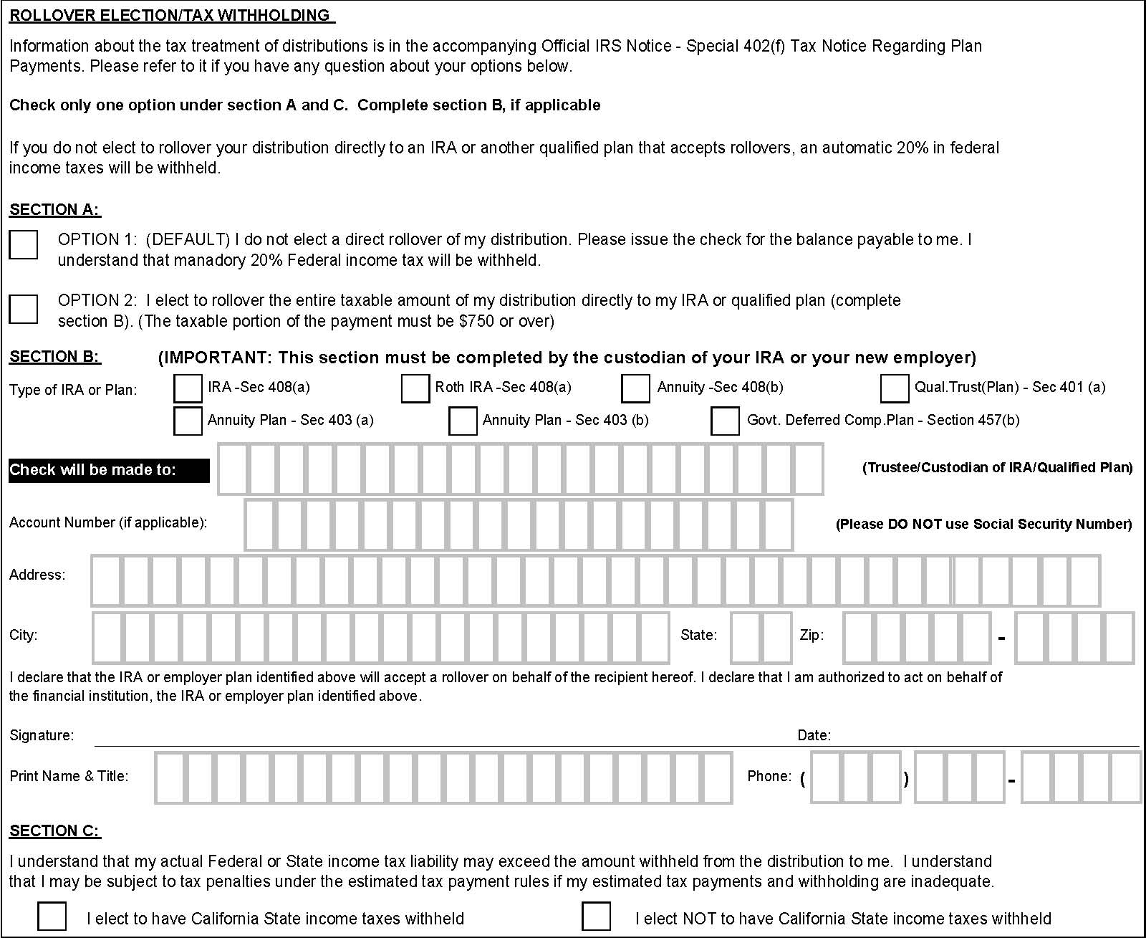

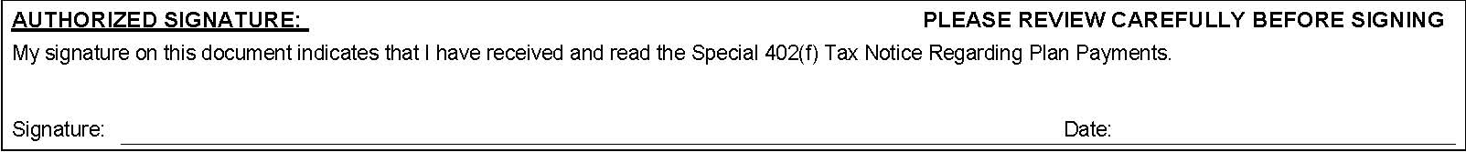

{x endif}