**58819-****{stdMbrPERSLinkID}**

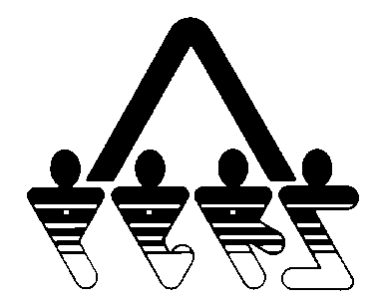

**WAIVER OF INSURANCE COVERAGE**

NORTH DAKOTA PUBLIC EMPLOYEES RETIREMENT SYSTEM

SFN 58819 (Rev. 01-2014)

**NDPERS • PO Box 1657 • Bismarck, • North Dakota 58502-1657**

**(701) 328- 3900 • 1-800-803-7377 • Fax 701-328-3920**

|  |  |
| --- | --- |
| PART A EMPLOYEE IDENTIFICATION | |
| Name (Last, First, Middle) {stdMbrFullNameLFM} | NDPERS Member ID {stdMbrPERSLinkID} |
| Last Four Digits of Social Security Number {stdMbrLastFourDigitsOfSSN} | Date of Birth {stdMbrDateOfBirth} |
| Organization Name {stdCurrentEmployerOrgName} | NDPERS Organization ID {stdCurrentEmployerOrgCodeID} |
| PART B WAIVER OF INSURANCE COVERAGE | |
| Check the applicable insurance plan: Health Insurance Dental Insurance Vision Insurance Life Insurance | |
| I have been informed that I am eligible to apply for insurance coverage under my employer’s Benefit Plan issued I do not wish coverage for: Myself Spouse Eligible Dependents Myself and Entire Family  Reason coverage is being waived: I have coverage through my spouse’s employer  I have other individual coverage  I have Medicare coverage  Other:____________________________________________ | |
| PARTC EMPLOYEE AUTHORIZATION | |
| I hereby forfeit insurance coverage at this time. I fully understand that if I or my Eligible Dependents desire to be covered under my employer's insurance Benefit Plan in the future, I and my Eligible Dependents may have a Waiting Period for Preexisting Conditions and one of the following must apply:  1. If at the time I am declining coverage, it is because:   1. I or my Eligible Dependents have other group insurance coverage, and that coverage is either terminated as a result of loss of eligibility (Including loss as a result of legal separation, divorce, death, termination of employment or reduction of hours) or employer contributions toward such coverage was terminated; or 2. Coverage was under COBRA at the time I declined coverage and that coverage has been exhausted.   Under (a.) and (b.) above, I must complete a membership application within 31 days after I lose my current coverage.  2. If I have a new dependent as a result of marriage, birth, adoption or placement for adoption, I may enroll myself and my  Eligible Dependents, provided that I request enrollment within 31 days of marriage, birth, adoption or placement for  adoption.  3. If I do not meet requirements under 1 or 2 above, I may apply as a Late Enrollee, Late Enrollees must request  enrollment during the Enrollment Period.  ________________________________________ ____________________  Employee's Signature Date | |

