**58886-****{stdMbrPERSLinkID}**

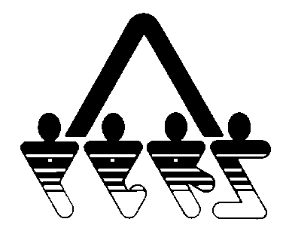

**PURCHASE REMITTANCE STATEMENT**

NORTH DAKOTA PUBLIC EMPLOYEES RETIREMENT SYSTEM

SFN 58886 (Rev.01-2014)

**NDPERS • PO Box 1657 • Bismarck, • North Dakota 58502-1657**

**(701) 328- 3900 • 1-800-803-7377 • Fax 701-328-3920**

|  |  |
| --- | --- |
| Billing Date: | {stdlongdate} |
| NDPERS Member ID: | **{stdMbrPERSLinkID}** |
| Due Date: | {DueDate} |
| Amount Due: | ${AmountDue} |

{stdMbrFullName}

{stdMbrAdrCorStreet1}

{x stdMbrAdrCorStreet2}

{stdMbrAdrCorCity} {stdMbrAdrCorState} {stdMbrAdrCorZip}

{Plan} Statement Details:

Service Amount Being Purchased: {ServiceAmtToBePurchased}

Type of Service Being Purchased: {TypeOfService}

Cost:

Retirement Portion: ${RetirementPortion}

Retiree Health Credit Portion: ${RHICPortion}

**Current Balance Due: $****{BalanceDue}**

***If you have already submitted payment, please disregard this statement.***

Page 1 of 2

**58886-****{stdMbrPERSLinkID}**

**PURCHASE REMITTANCE STATEMENT**



NORTH DAKOTA PUBLIC EMPLOYEES RETIREMENT SYSTEM

SFN 58886 (Rev.01-2014)

**NDPERS • PO Box 1657 • Bismarck, • North Dakota 58502-1657**

**(701) 328- 3900 • 1-800-803-7377 • Fax 701-328-3920**

**REMITTANCE COPY**

*To ensure proper credit, return this portion with your payment. Your check or money order needs to be payable to NDPERS and include your NDPERS Member ID.*

|  |  |
| --- | --- |
| NDPERS Member ID: | **{stdMbrPERSLinkID}** |
| Due Date: | {DueDate} |
| Amount Paid: | $ |

{stdMbrFullName}

{stdMbrAdrCorStreet1}

{x stdMbrAdrCorStreet2}

{stdMbrAdrCorCity} {stdMbrAdrCorState} {stdMbrAdrCorZip}

Page 2 of 2

