**59511-****{stdOrgCodeId}**

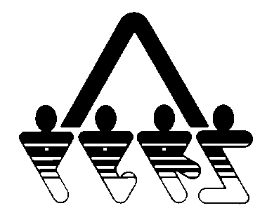

**ORGANIZATION AUTHORIZATION FOR ELECTRONIC PAYMENT**

NORTH DAKOTA PUBLIC EMPLOYEES RETIREMENT SYSTEM

SFN 59511 (Rev. 01-2014)

**NDPERS • PO Box 1657 • Bismarck, • North Dakota 58502-1657**

**(701) 328- 3900 • 1-800-803-7377 • Fax 701-328-3920**

|  |  |  |  |  |  |
| --- | --- | --- | --- | --- | --- |
| PART A ORGANIZATION IDENTIFICATION | | | | | |
| Organization Name: {stdOrgName} | | | Organization ID: {stdOrgCodeId} | | |
| **PART B ORGANIZATION AUTHORIZATION** | | | | | |
| I hereby authorize the North Dakota Public Employees Retirement System (NDPERS), to initiate debit entries to the account indicated below at the depository financial institution named below, and to debit the same to such account.  This authorization will remain in effect until the primary authorized agent notifies NDPERS in writing to cancel it in such time as to afford NDPERS a reasonable opportunity to act on it. The amounts authorized to be deducted from the bank account will be made on the next business day following the business day on which the debit authorization is received in good order.  I agree to the terms listed on this authorization.  _____________________________________ _________________  Primary Authorized Agent’s Signature Date | | | | | |
| **PART C FINANCIAL INSTITUTION** | | | | | |
| Name of Financial Institution | | | | | |
| Mailing Address | City | | | State | Zip Code |
| Account Number | | Type of Account  Checking  Savings | | | |
| Routing Number (9 Digits) | | | | | |



ORGANIZATION AUTHORIZATION FOR ELECTRONIC PAYMENT

SFN 59511 (Rev. 01-2014) Page 2

**IMPORTANT NOTICE** - This form is to be used only for North Dakota Public Employees Retirement System.

**THIS FORM ONLY AUTHORIZES DEDUCTIONS FROM YOUR ACCOUNT**

**INSTRUCTIONS AND CONDITIONS**

If you wish to have your electronic payments deducted from your savings or checking account, you must complete this form to authorize this action. The North Dakota Public Employees Retirement System will deduct payments to the point you authorize. The financial institution may be any bank, savings bank, savings and loan association or similar institution, or Federal or State chartered credit union.

**PART A ORGANIZATION IDENTIFICATION**

For organization identification, please provide all requested information.

**PART B ORGANIZATION AUTHORIZATION**

Sign and date the form to authorize electronic payment.

**PART C FINANCIAL INSTITUTION SECTION**

Complete the requested information for the financial institution for which you want electronic payments to be make. Upon completion, you should retain a photocopy for your records and return the original to NDPERS.

**CANCELLATION INSTRUCTIONS**

When entered in your record with the North Dakota Public Employees Retirement System, this authorization will remain in effect until canceled by written notice by you to the North Dakota Public Employees Retirement System. The financial organization should also be notified if you cancel this agreement.

The financial organization may cancel their agreement by providing you a written notice 30 days in advance of the cancellation date. You must advise the North Dakota Public Employees Retirement System if this authorization is canceled. The financial organization cannot cancel this authorization by advice to the North Dakota Public Employees Retirement System.

The form is due back in our office by the 15th of the month prior to the month you want to begin electronic payments.