|  |  |
| --- | --- |
| {SFNLogo} | **62523-****{stdMbrPERSLinkID}** |
| **DEFINED CONTRIBUTION RETIREMENT PLAN SPECIAL ELECTION** |
| NORTH DAKOTA PUBLIC EMPLOYEES RETIREMENT SYSTEM |
| SFN 62523 (Rev 01-2025)  **{SFNAddress}** |

|  |  |
| --- | --- |
| **PART A: MEMBER INFORMATION** | |
| Name (Last, First, Middle){stdMbrFullNameLFM} | NDPERS Member ID{stdMbrPERSLinkID} |
| Last Four Digits of Social Security Number  {stdMbrLastFourDigitsOfSSN} | Date of Birth (mm/dd/yyyy)  {stdMbrDateOfBirth} |
| Member email | Member phone number |
| **PART B: ELIGIBILITY AND ACKNOWLEDGEMENT** | |
| Per NDCC 4-52.6-02.2, eligible employee means a permanent state employee of a state employer who on December 31, 2024, is a participating member of the Public Employees Retirement System Main Defined Benefit Plan (see Tiers on page 3) under chapter 54-52, who has been a participating member under chapter 54-52 for no more than five years, and who is at least eighteen years of age.  For the purpose of identifying employer obligations under the provisions of NDCC 54-52-06(1)(a), NDCC 54-52.6-02.2, and NDCC 54-52.6-09.5, and determining employee eligibility under NDCC 54-52.6-02.2, per NDAC 71-08-11-08, “state governmental unit” and “state employer” are those state entities that receive budgetary approval from the state legislature.  I have been given the opportunity to elect to remain in the Main Defined Benefit retirement plan under NDCC 54-52 or terminate membership and become a participating member in the Defined Contribution Retirement Plan under NDCC 54-52.6 during the special election window of January 1, 2025 – March 31, 2025.  If I elect to terminate membership and participate in the Defined Contribution Plan, **I understand my election is irrevocable and permanent** and I will not be able to rejoin the Main Defined Benefit Plan in the future under any circumstance. Further, if I elect to transfer to the Defined Contribution Plan, I voluntarily waive all of my rights to a pension, annuity, retirement allowance, disability benefit, dual service or any other benefit under the NDCC 54-52 Main Defined Benefit Plan. I understand that if I terminate state employment before receiving the lump sum transfer, my election is invalid, and I will remain a member of Main Defined Benefit Plan.  I acknowledge that by electing the Defined Contribution Retirement Plan, I may be eligible for an additional annual contribution payment to my account in the Defined Contribution Retirement Plan for the prior year. The first payment will be $3,333.00 paid by my state employer in January 2026, with subsequent payments for up to two (2) remaining years each January, as long as I continue permanent employment with an eligible state employer. Annual contribution payments will extend no further than January 2028. I understand that if I terminate employment with an eligible state employer before receiving up to the three (3) allowable additional annual contribution payments, I will forfeit any subsequent payments.  I have had the opportunity to speak with an attorney and financial planner of my choosing at my own expense, and to review NDCC 54-52 and 54-52.6 and the information available from NDPERS, and to ask any questions I may have concerning this election. I further understand that under the NDCC 54-52.6 Defined Contribution Retirement Plan, I will be responsible for directing the investment of any transferred fund balance as well as future retirement contributions. I will be solely responsible for the investment results of my account. NDPERS and its governing board will not be liable for any election or investment decision I make or any default investment as a result of my failure to timely make an investment election.  I understand that my election to terminate membership and join the Defined Contribution Plan must be either:   * Hand delivered and date stamped by the NDPERS office at 1600 E Century Ave. Bismarck, ND between Wednesday, January 1, 2025 and Monday, March 31, 2025 at 5:00 PM CT. * Electronically received by the NDPERS info account at ndpers-info@nd.gov between Wednesday, January 1, 2025 and Monday, March 31, 2025 at 11:59 PM CT. * Deposited into the NDPERS drop box at 1600 E Century Ave. Bismarck, ND between Wednesday, January 1, 2025 and Monday, March 31, 2025. * Postmarked by a delivery service between January 1, 2025 and Monday, March 31, 2025.   If I fail to provide my election by the date and time for any of the methods above, I shall remain a member of the Main Defined Benefit Retirement Plan. | |
| DEFINED CONTRIBUTION RETIREMENT PLAN SPECIAL ELECTION  SFN 62523 (Rev 01-2025) Page 2 of 3 | |
| **PART C: EMPLOYEE ELECTION** | |
| I have reviewed and understand each of the above provisions, and I hereby elect to remain in the Main Defined Benefit Retirement Plan.  Remain | |
| Member’s Signature (Electronic Signatures will not be accepted) | Effective Date |
| I have reviewed and understand each of the above provisions, and I hereby elect to terminate my membership in the Main Defined Benefit Retirement Plan and transfer to the Defined Contribution Retirement Plan.  Terminate | |
| Member’s Signature (Electronic Signatures will not be accepted) | Termination Date |

DEFINED CONTRIBUTION RETIREMENT PLAN SPECIAL ELECTION

SFN 62523 (Rev 01-2025) Page 3 of 3

**INSTRUCTIONS**

**PART A: MEMBER INFORMATION**

For member identification, please provide all requested information.

**PART B: ELIGIBILITY AND ACKNOWLEDGEMENT**

Per NDCC 4-52.6-02.2, eligible employee means a permanent state employee of a state employer who on December 31, 2024, is a participating member of the NDPERS Main Defined Benefit Plan under NDCC 54-52, who has been a participating member under NDCC 54-52 for no more than five years, and who is at least eighteen years of age.

For the purpose of identifying employer obligations under the provisions of NDCC 54-52-06(1)(a), NDCC 54-52.6-02.2, and NDCC 54-52.6-09.5, and determining employee eligibility under NDCC 54-52.6-02.2, per NDAC **71-08-11-08,** “state governmental unit” and “state employer” are those state entities that receive budgetary approval from the state legislature.

**PART C: EMPLOYEE ELECTION**

Member must select which plan they elect to participate. Election is irrevocable. The Defined Contribution Retirement Plan Special Election Form must be executed properly and received on or before Monday, March 31, 2024 at 5:00 PM CT. The Main Defined Benefit Retirement Plan Tiers are outlined below based upon member “first enrolled” date at NDPERS. The arrow provides the applicable Defined Contribution Retirement Plan that you will move to if you elect to transfer your participation from the Main Defined Benefit Retirement Plan to the Defined Contribution Retirement Plan.

First enrolled in the Main Defined Benefit Retirement Plan prior to January 1, 2020.

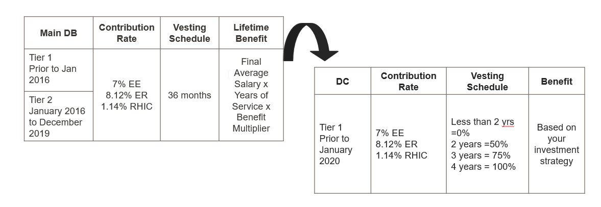

First enrolled in the Main Defined Benefit Retirement Plan on or after January 1, 2020.

