**53405-****{stdMbrPERSLinkID}**

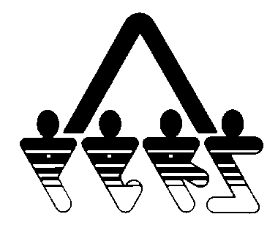

**WAIVER OF MEMBERSHIP FOR ELECTED OFFICIALS ONLY**

NORTH DAKOTA PUBLIC EMPLOYEES RETIREMENT SYSTEM

SFN 53405 (Rev. 01-2014)

**NDPERS • PO Box 1657 • Bismarck, • North Dakota 58502-1657**

**(701) 328- 3900 • 1-800-803-7377 • Fax 701-328-3920**

|  |  |
| --- | --- |
| **PART A ELECTED OFFICIAL** | |
| Name (Last, First, Middle) {stdMbrFullName} | NDPERS Member ID {stdMbrPERSLinkID} |
| Last Four Digits of Social Security Number {stdMbrLastFourDigitsOfSSN} | Date of Birth {stdMbrDateOfBirth} |
| Organization Name {stdCurrentEmployerOrgName} | NDPERS Organization ID {stdCurrentEmployerOrgCodeID} |
| I hereby acknowledge the following:   1. I am an ELECTED official of _____________________________, and my present term started __________________________. The title of the position I was elected to is __________________________________. 2. I am 18 years or older. 3. I understand that I can only elect to participate in the North Dakota Public Employees Retirement System within the first six months of my term. 4. I hereby waive my rights to participate in the North Dakota Public Employees Retirement System and understand I must enroll within the first six months of any new term if I wish to participate in the North Dakota Public Employees Retirement System in the future. 5. I understand if I join North Dakota Public Employees Retirement System in the future, I cannot draw benefits until I actually terminated my position with the employer.   Signature of Elected Official Signature of Authorized Agent  Date of Signature Date of Signature | |

