**58868-****{stdMbrPERSLinkID}**

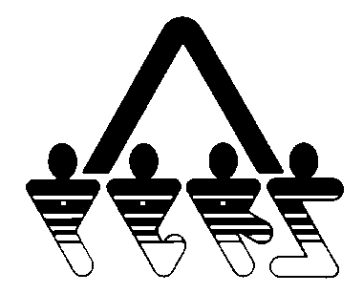

**WAIVER OF FEDERAL TAX NOTIFICATION**

NORTH DAKOTA PUBLIC EMPLOYEES RETIREMENT SYSTEM

SFN 58868 (Rev. 01-2014)

**NDPERS • PO Box 1657 • Bismarck, • North Dakota 58502-1657**

**(701) 328- 3900 • 1-800-803-7377 • Fax 701-328-3920**

|  |  |
| --- | --- |
| PART A PARTICIPANT IDENTIFICATION | |
| Name (Last, First, Middle) {stdMbrFullNameLFM} | NDPERS Member ID {stdMbrPERSLinkID} |
| Last Four Digits of Social Security Number {stdMbrLastFourDigitsOfSSN} | Date of Birth {stdMbrDateOfBirth} |
| Organization Name {stdCurrentEmployerOrgName} | NDPERS Organization ID {stdCurrentEmployerOrgCodeID} |
| PART B WAIVER OF FEDERAL TAX NOTIFICATION | |
| I have read the "Safe Harbor Tax Notice Regarding Plan Payments".  I understand that the North Dakota Public Employees Retirement System is required to send the "Safe Harbor Tax Notice Regarding Plan Payments" a minimum of 30 days prior to a distribution.  I hereby waive my rights to this minimum 30 day notice requirement.  ______________________________ ________________  Signature of Member Date | |



WAIVER OF FEDERAL TAX NOTIFICATION

SFN 58868 (Rev. 01-2014) Page 2

**PART A Participant Identification**

For member identification, please provide all requested information.

**PART B WAIVER OF TAX NOTICE**

You must sign and date this section for the form to be valid.