**59179-****{stdMbrPERSLinkID}**

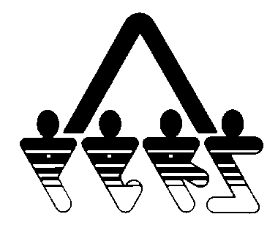

**BENEFIT OVERPAYMENT BILLING STATEMENT**

NORTH DAKOTA PUBLIC EMPLOYEES RETIREMENT SYSTEM

SFN 59179 (Rev. 01-2014)

**NDPERS • PO Box 1657 • Bismarck, • North Dakota 58502-1657**

**(701) 328- 3900 • 1-800-803-7377 • Fax 701-328-3920**

|  |  |
| --- | --- |
| Billing Date: | {BillDate} |
| NDPERS Member ID: | {stdMbrPERSLinkID} |
| Due Date: | {DueDate} |
| Amount Due: | {GrossReductionAmount} |

{stdMbrFullName}

{stdMbrAdrCorStreet1}

{x stdMbrAdrCorStreet2}

{stdMbrAdrCorCity} {stdMbrAdrCorState} {stdMbrAdrCorZip}

{x if pastdue = “Y”}

**Your account shows a past due balance, this must be paid the 15th**

**of this month in order to avoid interest penalty.**

{endblock}

Statement Details:

**Current Balance Due: $****{DueAmount}**

Page 1 of 2

**59179-****{stdMbrPERSLinkID}**



**BENEFIT OVERPAYMENT BILLING STATEMENT**

NORTH DAKOTA PUBLIC EMPLOYEES RETIREMENT SYSTEM

SFN 59179 (Rev. 01-2014)

**NDPERS • PO Box 1657 • Bismarck, • North Dakota 58502-1657**

**(701) 328- 3900 • 1-800-803-7377 • Fax 701-328-3920**

**REMITTANCE COPY**

*To ensure proper credit, return this portion with your payment. Your check or money order needs to be payable to NDPERS and include your NDPERS Member ID.*

|  |  |
| --- | --- |
| NDPERS Member ID: | {stdMbrPERSLinkID} |
| Due Date: | {DueDate} |
| Amount Paid: | $ |

{stdMbrFullName}

{stdMbrAdrCorStreet1}

{x stdMbrAdrCorStreet2}

{stdMbrAdrCorCity} {stdMbrAdrCorState} {stdMbrAdrCorZip}



Page 2 of 2