**60711-****{stdMbrPERSLinkID}**

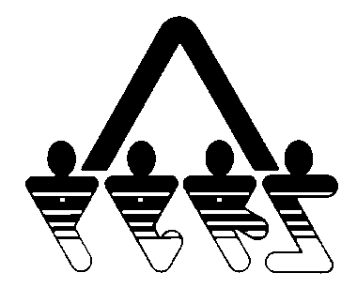

**DECLINE OFFER OF HEALTH INSURANCE COVERAGE**

NORTH DAKOTA PUBLIC EMPLOYEES RETIREMENT SYSTEM

SFN 60711 (Rev. 10-2014)

**NDPERS • PO Box 1657 • Bismarck, • North Dakota 58502-1657**

**(701) 328- 3900 • 1-800-803-7377 • Fax 701-328-3920**

|  |  |
| --- | --- |
| PART A EMPLOYEE IDENTIFICATION | |
| Name (Last, First, Middle) {stdMbrFullName} | NDPERS Member ID {stdMbrPERSLinkID} |
| Last Four Digits of Social Security Number {stdMbrLastFourDigitsOfSSN} | Date of Birth {stdMbrDateOfBirth} |
| Organization Name {stdOrgName} | NDPERS Organization ID {stdOrgCodeId} |
| PART B OFFER OF HEALTH INSURANCE COVERAGE | |
| I understand that I am offered adequate and affordable coverage as a “full-time” employee as defined by the Affordable Care Act. I understand that the coverage is offered to me and my Eligible Dependents.  *Please check the applicable box:*  I am already covered under the NDPERS health insurance through my spouse. I understand that my coverage will remain through my spouse unless my spouse terminates employment or ceases to be an Eligible Employee, at which time I will have the opportunity to apply for coverage within 31 days of the event as an Eligible Employee.    I decline for one of the following (check applicable) reasons:  I have coverage through my spouse’s employer (non-NDPERS)  I have Medicare coverage  I have other individual coverage (non-NDPERS)  Other:______________________ | |
| PARTC EMPLOYEE AUTHORIZATION | |
| I hereby decline health insurance coverage at this time. I understand that in declining this offer of health insurance coverage, I may not be eligible to apply for a federal tax subsidy through the Marketplace Exchanges. I fully understand that if I or my Eligible Dependents desire to be covered under my employer's insurance Benefit Plan in the future, I and my Eligible Dependents may have a Waiting Period for Preexisting Conditions and one of the following must apply:  1. If at the time I am declining coverage, it is because:   1. I or my Eligible Dependents have other group insurance coverage, and that coverage is either terminated as a result of loss of eligibility (Including loss as a result of legal separation, divorce, death, termination of employment or reduction of hours) or employer contributions toward such coverage was terminated; or 2. Coverage was under COBRA at the time I declined coverage and that coverage has been exhausted.   Under (a.) and (b.) above, I must complete a membership application within 31 days after I lose my current coverage.  2. If I have a new dependent as a result of marriage, birth, adoption or placement for adoption, I may enroll myself and my Eligible Dependents, provided that I request enrollment within 31 days of marriage, birth, adoption or placement for adoption.  3. If I do not meet requirements under 1 or 2 above, I may apply as a Late Enrollee, Late Enrollees must request enrollment during the Enrollment Period.  ________________________________________ ____________________  Employee's Signature Date | |