**19182-****{stdMbrPERSLinkID}**

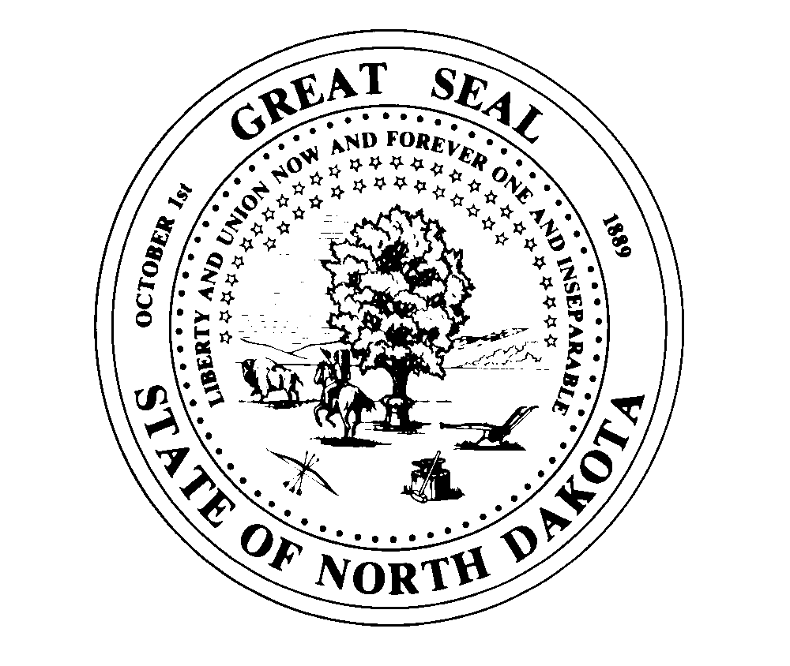

**PAYROLL DEDUCTION AUTHORIZATION (313)**

NORTH DAKOTA RETIREMENT AND INVESTMENT OFFICE

TEACHERS’ FUND FOR RETIREMENT DIVISION

SFN 19182 (4-08)

**Return To: NDPERS • PO Box 1657 • Bismarck, • North Dakota 58502-1657**

**(701) 328- 3900 • 1-800-803-7377 • Fax 701-328-3920**

|  |  |  |  |
| --- | --- | --- | --- |
| Name (Last, First, Middle) {stdMbrFullNameLFM} | TFFR Person ID | NDPERS Member ID {stdMbrPERSLinkID} | |
| Last Four Digits of Social Security Number {stdMbrLastFourDigitsOfSSN} | | Date of Birth {stdMbrDateOfBirth} | |
| Home Telephone {HomeTelePhone} | Email {Email} | | |
| Organization {stdCurrentEmployerOrgName} | | | NDPERS Organization ID {stdCurrentEmployerOrgCodeID} |

I have applied for insurance coverage through the North Dakota Public Employees Retirement System (NDPERS) group insurance plan. If accepted, I hereby authorize the North Dakota Teachers' Fund for Retirement (TFFR) to deduct the monthly premium from my monthly TFFR retirement benefit for the following (check all that apply):

Health Insurance



Life Insurance



Dental Insurance



Vision Insurance



Other



Iision authorize TFFR to periodically increase or decrease this deduction if premium changes occur in the group insurance plan(s) selected above. It is my understanding that NDPERS will notify me of premium adjustments.

This authorization will remain in effect until I give written notice to TFFR to cancel the deduction. TFFR must receive this notification at least ten (10) working days prior to the end of the month.

|  |
| --- |
|  |
| TFFR Annuitant’s Signature |
|  |
| Date |

|  |
| --- |
| **For NDPERS Use Only**  Effective Date: |

