**53082-****{stdMbrPERSLinkID}**

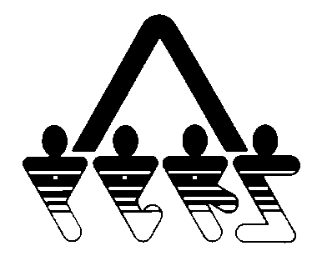

**MUTUAL FUND WINDOW ELECTION**

NORTH DAKOTA PUBLIC EMPLOYEES RETIREMENT SYSTEM

SFN 53082 (Rev. 07-2010)

**NDPERS • PO Box 1657 • Bismarck • North Dakota 58502-1657**

**(701) 328-3900 • 1-800-803-7377 • Fax 701-328-3920**

|  |  |
| --- | --- |
| **PART A MEMBER INFORMATION** | |
| Name (Last, First, Middle) {stdMbrFullNameLFM} | NDPERS Member ID {stdMbrPERSLinkID} |
| Last Four Digits of Social Security Number {stdMbrLastFourDigitsOfSSN} | Date of Birth {stdMbrDateOfBirth} |
| Organization Name {stdCurrentEmployerOrgName} | NDPERS Organization ID {stdCurrentEmployerOrgCodeID} |
| **PART B NDPERS PLAN ELECTION** | |
| This Mutual Fund Window election pertains to the NDPERS:  457 Deferred Compensation Plan  Defined Contribution Retirement Plan | |
| **PART C MEMBER AUTHORIZATION** | |
| I understand that mutual funds purchased through the Mutual Fund Window are not bank deposits, debts or obligations of, and are not insured or guaranteed by, any federal or state entity, including the FDIC, NDPERS and the state of North Dakota. I am aware that NDPERS neither endorses nor monitors the mutual funds available through the Mutual Fund Window, nor does NDPERS make any representation that the mutual funds available through the Mutual Fund Window are proper investments for retirement monies. I agree it is my responsibility to research the funds available, and that I should review all disclosure statements and available materials for each of the funds I consider prior to investing in them. I understand that mutual funds are subject to investment risk, which includes the possible loss of the principal invested. I accept that risk, and acknowledge I am solely responsible for that risk and the investment results of my account. I release, save and hold harmless NDPERS and the state of North Dakota from any and all liability based on my participation in the Mutual Fund Window*.*  Please allow ten (10) business days from the date the form is received by NDPERS, before utilizing the Mutual Fund Window.  Member’s Signature Date of Signature | |