**53320-****{stdMbrPERSLinkID}**

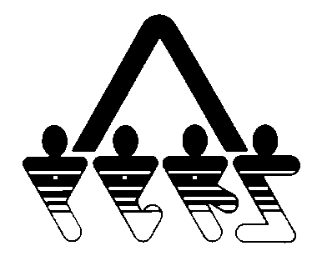

**OUTSTANDING REQUIREMENTS FOR NDPERS GROUP INSURANCE PLAN**

NORTH DAKOTA PUBLIC EMPLOYEES RETIREMENT SYSTEM

SFN 53320 (Rev.01-2014)

**NDPERS • PO Box 1657 • Bismarck, • North Dakota 58502-1657**

**(701) 328- 3900 • 1-800-803-7377 • Fax 701-328-3920**

The following lists what is required for application processing. ***Without the required documentation the application can not be processed***. It is the responsibility of the member requesting coverage to provide all necessary information and the proper documentation. Please be advised that the member has 31 days from the “qualifying event” in which to apply for insurance coverage. If the timeframe is missed employee (or dependent) is a late enrollee and must wait until the annual enrollment period. Waiting periods for pre-existing conditions may be applied.

|  |  |
| --- | --- |
| PART A PARTICIPANT IDENTIFICATION | |
| Name (Last, First, Middle) {stdMbrFullNameLFM} | NDPERS Member ID {stdMbrPERSLinkID} |
| Last Four Digits of Social Security Number {stdMbrLastFourDigitsOfSSN} | Date of Birth {stdMbrDateOfBirth} |
| Organization Name {stdCurrentEmployerOrgName} | NDPERS Organization ID {stdCurrentEmployerOrgCodeID} |
| PART B REQUIRED DOCUMENTATION | |
| Plan: {qu Plan} | |
| Requirement: {qu FreeText} | |
| Due Date: {qu DueDate} | |
| PART C COVERAGE FOR DEPENDENTS | |
| **Step-Child –** MUST provide a copy of the Court Order requiring the member or the member’s spouse to provide health benefits. | |
| **Adopted Child -** MUST provide a copy of the Court Order or placement papers. | |
| **Foster Child(ren) –** MUST provide a copy of the Court Order | |
| **Grandchild(ren) –** MUST provide a copy of the Court Order providing legal guardianship | |
| **Spouse –** MUST provide Certificate of Insurance indicating spouse has lost health coverage under another health plan. | |
| **Adult child –** MUST provide Certificate of Insurance indicating child has lost health coverage under another health plan. | |
| **Child of “Single” Subscriber –** MUST provide a copy of the child’s STATE CERTIFIED Birth Certificate or court order requiring the member to provide health benefits | |
| **Newborn** - MUST provide an updated application adding new dependent to plan. Please include child’s social security number and date of birth on application.  Health Application SFN 60036  Dental/Vision Application SFN 58792 | |

