**NDPERS REQUEST FOR BENEFIT INFORMATION**

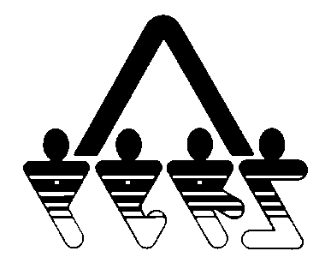

NORTH DAKOTA PUBLIC EMPLOYEES RETIREMENT SYSTEM

SFN 53603 (Rev. 01/2014)

**NDPERS • PO Box 1657 • Bismarck • North Dakota 58502-1657**

**(701) 328- 3900 • 1-800-803-7377 • Fax 701-328-3920**

**COMPLETE AND SEND TO NDPERS TO RECEIVE A BENEFIT ESTIMATE**

|  |
| --- |
| **PART A PARTICIPANT IDENTIFICATION** |
| Name: |
| NDPERS Member ID: |
| Last Four Digits of Social Security Number: |
| Date of Birth: |
| Department/Agency: |
| Daytime Phone: |
| **PART B RETIREMENT PROJECTION** (PLEASE LIMIT TO 2 PROJECTIONS) |
| Age 55  Age 62  Age 65  Earliest Rule of 85/80  Other –Specify Date: _______________ Disability Benefits |
| **PART C SICK LEAVE CONVERSION (PURCHASE)** |
| (LEAVE BLANK IF CONVERSION IS NOT DESIRED)  Number of hours of accumulated unused sick leave ______________ |

