**54119-****{stdOrgCodeId}**

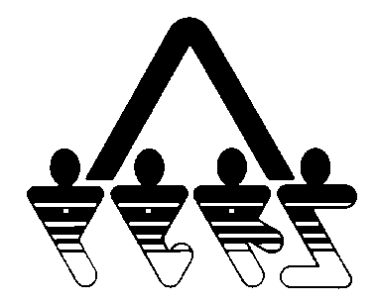

**EMPLOYEE ELIGIBILITY REPORT**

NORTH DAKOTA PUBLIC EMPLOYEES RETIREMENT SYSTEM

SFN 54119 (Rev. 01-2014)

In compliance with the Federal Privacy Act of 1974, the disclosure of the individual's social security number on this form is mandatory pursuant to 26 U.S.C. Section 3402. The individual's social security number will be used for tax reporting and as an identification number.

**Please list the names of all employees who are on the agency’s covered payroll. You must provide the requested information; the Authorized Agent for the agency is required to sign the document. This form must be returned to the NDPERS office along with the required NDPERS enrollment and waiver forms. Former employee(s) currently participating on a COBRA policy, please indicate the COBRA effective date.**

**NDPERS • PO Box 1657 • Bismarck • North Dakota 58502-1657**

**(701) 328- 3900 • 1-800-803-7377 • Fax 701-328-3920**

|  |  |  |  |  |  |  |  |
| --- | --- | --- | --- | --- | --- | --- | --- |
| **Name** | **Social Security Number** | **Date of Hire** | **Employment Status**    **Full-time Part-time** | | **COBRA Effective Date** | **NDPERS USE ONLY**    **Application Waiver** | |
|  |  |  |  |  |  |  |  |
|  |  |  |  |  |  |  |  |
|  |  |  |  |  |  |  |  |
|  |  |  |  |  |  |  |  |
|  |  |  |  |  |  |  |  |
|  |  |  |  |  |  |  |  |
|  |  |  |  |  |  |  |  |
|  |  |  |  |  |  |  |  |
|  |  |  |  |  |  |  |  |
|  |  |  |  |  |  |  |  |
|  |  |  |  |  |  |  |  |
|  |  |  |  |  |  |  |  |
|  |  |  |  |  |  |  |  |

|  |  |
| --- | --- |
| **Organization:** **{stdOrgName}** | **Organization ID:** **{stdOrgCodeId}** |
| **Authorized Agent Signature (required)** | **Date:** |

