Type of Article (Original Article / Review Article / Short Communication) (Size 11)
Instructions to Authors Preparing their Camera Ready Papers for IJRES Journal for A4 Page Size (Size 22)

First Author¹, Second Author², Third Author³ (Size 11)
No abbreviations allowed, No more prefixes like Dr, Prof, Er, etc only name should be mention
¹ Department, University or college Name, State, Country Name. (Size 10 &italic)
² Department, University or college Name, State, Country Name. (Size 10 &italic)
³ Department, University or college Name, State, Country Name. (Size 10 &italic)
Received: Revised: Accepted: Published: (Size9)

Abstract - (Size 10 & Italic) This document gives formatting instructions for authors preparing papers for publication in the Proceedings of an IJRES Journal. The authors must follow the instructions given in the document for the papers to be published. You can use this document as both an instruction set and as a template into which you can type your own text. The abstract must be written in the present tense and clearly state the novelty of the work regarding the journal fields. Ideally it will provide a brief context for the study, before describing the scientific approach and some key results in a qualitative manner. It should finish with a sentence to describe the implications for the field. The abstract must not include references, figures or tables. Do not use more than 250 words in the abstract, as it will be included in the on-line version of the journal and sent for indexing to international databases, in different formats. Very careful wording should be used in the title and in the abstract. Without a proper title and abstract, a great paper might never be downloaded and/or read.
Keywords - (Size 10 & Italic) five keywords or phrases arranged alphabetically and separated by commas. A list of keywords may be found on the website. Use only the keywords defined there. [not capitalized, plural, separated by commas, no full stop]

- Introduction (SIZE 12 &BOLD)
The introduction should be succinct, with no subheadings. Limited figures may be included only if they are truly introductory, and contain no new results. (Size 10 & Normal)
Prospective authors are invited to submit papers that fit within the scope of the journal. Papers should be written in English and submitted in final camera-ready form. All text has to be edited by using the styles defined in this document. Do not use blank lines for spacing. Re-arrange the text in order to fit all the blanks.
It is mandatory to submit your original work in Microsoft Word format (.doc) or (.docx). We will do only minor corrections and the final formatting of your paper. (Size 10 & Normal)
- First-Order Heading (SIZE 12 &BOLD)
2.1. Second-Order Heading (SIZE 10 & BOLD & Italic)
2.1.1. Third-Order Heading (Size 10 & Italic)
Fourth-Order Heading: (Text, no numbering) (Size 10 & Italic)

- Materials and Methods (SIZE 12 &BOLD)
The materials and methods section should contain sufficient detail so that all procedures can be repeated. It may be divided into headed subsections if several methods are described. (Size 10 & Normal)
- Results and Discussion (SIZE 12 &BOLD)
4.1. Subheadings (Size 10 & bold & Italic)
The results and discussion may be presented separately, or in one combined section, and may optionally be divided into headed subsections. (Size 10 & Normal)
((Main Text Paragraphs. Please make the first reference to a display item bold (Figure 1). Do not abbreviate Figure, Equation, etc.; display items are always singular, i.e., Figure 1 and 2. Equations are always singular, i.e., Equation 1 and 2, and should be inserted using the Equation Editor, not as graphics, in the main text. Display items and captions should be inserted in-line within the main text)). ((References should be in the parenthesis and appear after punctuation.[1,2] If you have used reference management software such as EndNote to prepare your manuscript, please convert the fields to plain text by selecting all text with [ctrl]+[A], then [ctrl]+[shift]+[F9]).[3–5] Footnotes should not be used in the text. Instead, additional information can be added to the Reference list.
Your paper must use a page size corresponding to A4 which is 8.5" wide and 11" long. The margins must be set as follows:
  - Top = 1"
  - Bottom = 1"
  - Left = Right = 0.7"
  - Header = Footer = 0.5"

The two-column format in the manuscript must be with a space of 0.25" between columns. The entire document should be in Times New Roman Font. Type other font types may be used if needed for special purposes. Recommended font sizes are shown in Table 2.
Table 1. Title of the table (Size 8 & Bold for the Table Caption)
((Table captions should be placed above the tables.))
(SIZE 10 & Bold) | Table Header | Table Header
Heading | (SIZE 10) | Values
Heading | Values | Values
Heading | Values | Values
Small table or figure must be placed in the double column and positioned either at the top or at the bottom of the page.
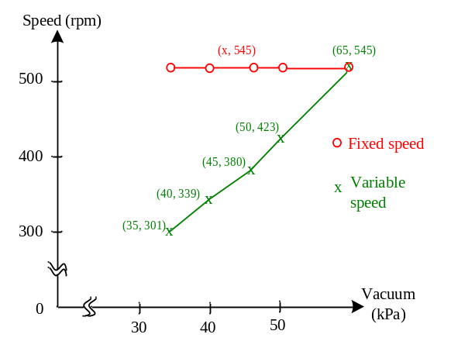
Fig. 1 Example for small figure (Size 8 & Bold for the Fig Caption) ((Figure Caption need to be placed below the figures. Note: Please do not combine figure and caption in a textbox or frame.))
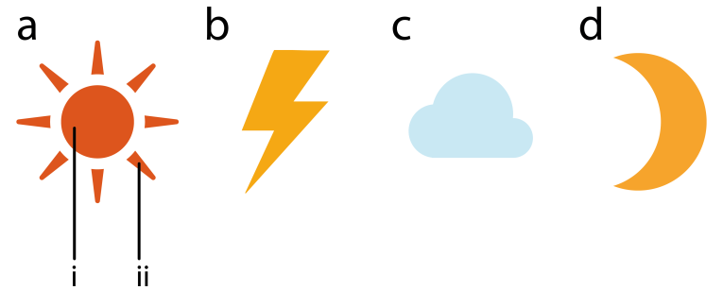
Fig. 2 Example for figure consists of multiple panels: Representations of some common weather symbols. (a) The Sun with (i) core, and (ii) rays. (b) Thunder bolt. (c) Cloud. (d) Moon.

Table 2. Recommended font sizes (Size 8 & Bold for the Table Caption)
Note: Please do not combine table and caption in a textbox or frame and do not submit tables as graphics, please use Word’s “insert table” function.
Heading level  (SIZE 10 & Bold) | Example | Font size and style
Title of the Paper (centered) | Tittle of Research Article | 22 point, normal
1st-level heading | - Introduction | 12 point, bold
2nd-level heading | - Printing Area | 10 point, bold, Italic
3rd-level heading | - Run-in Heading. Text follows | 10 point, italic
4th-level heading | Lowest Level Heading. Text follows | 10 point, italic, no numbering
Figure and Table | Table 1. Caption follows  Fig. 1 Caption follows | 8 point, bold
References | - S. Zhang, C. Zhu, J. K. O. Sin, and P. K. T. Mok, “A novel ultrathin elevated channel low-temperature poly-Si TFT,” IEEE Electron Device Lett., vol. 20, no. 4, pp. 569–571, 1999. | 9 point, normal
^{a)}((Table Footnote)); ^{b)} …(SIZE 8)
Source: Text follows (SIZE 8 Italic)

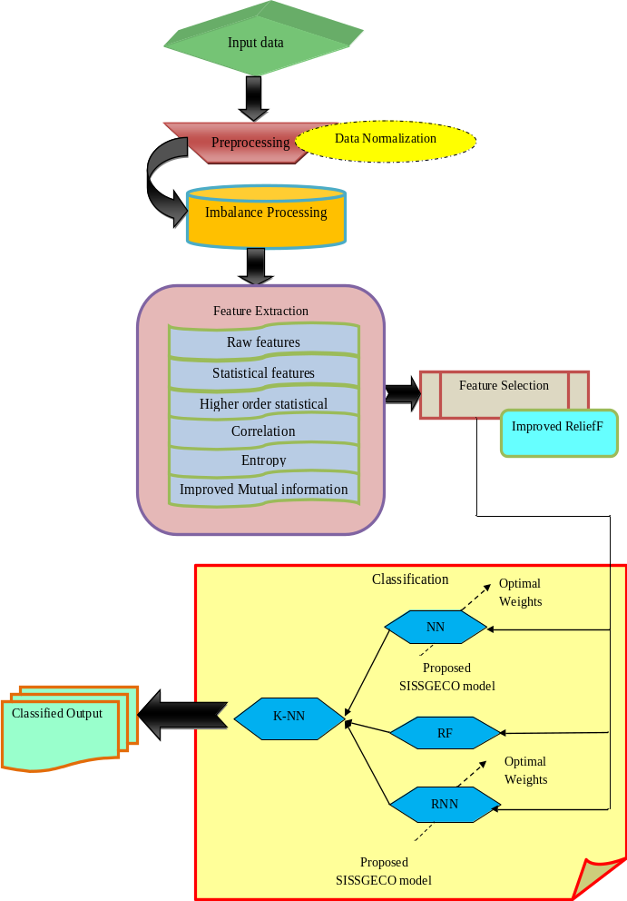
Fig. 3 Example for Large figures (Size 8 & Bold for the Figure Caption)
[Large Figure / tables may span across both columns and must be positioned either at the top or at the bottom of the page.

Figure must be positioned either at the top or at the bottom of the page. They should be referred to as (see Figure 1, etc.) in the main text. Please check all figures in your paper both on screen and on a black-and-white hardcopy. When you check your paper on a black-and-white hardcopy, please ensure that:
- the colors used in each figure contrast well,
- the image used in each figure is clear,
- All text labels in each figure are legible, &
- Reproduced with permission. [Ref.] Copyright Year, Publisher.
((Permission statement required for all figures reproduced or adapted from previously published articles/sources. CC-BY content can be used without asking permission, but the source must be attributed: Reproduced under terms of the CC-BY license. [ref] Copyright Year, The Authors, published by [Publisher]. However, permission must be obtained for reproduction of content published under CC-BY-NC/ND/SA licenses; delete if not applicable.))
If a figure consists of multiple panels, they should be ordered logically and labelled with lower case roman letters (i.e., a, b, c, etc.). If it is necessary to mark individual features within a panel, this may be done with lowercase Roman numerals, i, ii, iii, iv, etc. All labels should be explained in the caption. Panels should not be contained within boxes unless strictly necessary. (See Figure 2)
Equations
Equations and formulae should be typed in equation plug-in like Microsoft Word’s equation tool, and numbered consecutively with Arabic numerals in parentheses on the right hand side of the page (if referred to explicitly in the text). They should also be separated from the surrounding text by one space. They should be referred to as Equation 1, etc. in the main text.
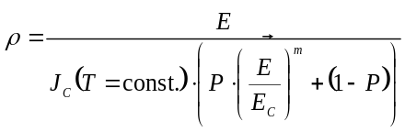 (1)
Displayed equations are centered and set on a separate line. Please avoid rasterized images for equations, tables, flow charts, algorithms, datasets, line-art diagrams and schemas. Whenever possible, use vector graphics instead.
- Conclusion (SIZE 12 &BOLD)
The Conclusions section should clearly explain the main findings and implications of the work, highlighting its importance and relevance. (SIZE 10)
Appendix 1 etc. (SIZE 12 &BOLD)
Appendices, if present, must be marked 1, 2, 3, and placed before the below sections.
Conflicts of Interest (SIZE 12 &BOLD)
This section is compulsory. A competing interest exists when professional judgment concerning the validity of research is influenced by a secondary interest, such as financial gain. We require that our authors reveal any possible conflict of interest in their submitted manuscripts. If there is no conflict of interest, authors should state that “The author(s) declare(s) that there is no conflict of interest regarding the publication of this paper.” (SIZE 10)
Funding Statement (SIZE 12 &BOLD)
Authors should state how the research and publication of their article was funded, by naming financially supporting bodies followed by any associated grant numbers in square brackets. (SIZE 10)
Acknowledgments (SIZE 12 &BOLD)
An Acknowledgements section is optional and may recognise those individuals who provided help during the research and preparation of the manuscript. Other references to the title/authors can also appear here, such as “Author 1 and Author 2 contributed equally to this work. (SIZE 10)

References (FONT SIZE 12 & BOLD)
(Authors are requested to follow the reference format in a strict manner) At least 25 quality Journal references should be cited for research article
Examples of reference items of different categories shown in the References section include:
- example of a journal article in[1]
- example of a conference paper in[2]
- example of a book in[3]
- example of a book in a series in[4]
- example of a patent in[5]
- example of a website in[6]
- example of a web page in[7]
- example of a data book as a manual in[8]
- example of a datasheet in[9]
- example of a master’s thesis in[10]
- example of a technical report in[11]
- (Font Size 9) S. Zhang, C. Zhu, J. K. O. Sin, and P. K. T. Mok, “A novel ultrathin elevated channel low-temperature poly-Si TFT,” IEEE Electron Device Lett., vol. 20, no. 4, pp. 569–571, 1999. [CrossRef] [Google Scholar] [Publisher link]
- M.Wegmuller, J.P.vonder Weid, P.Oberson and N.Gisin, “High-resolution fiber distributed measurements with coherent OFDR,” in Proc. ECOC’00, vol. 11, no. 3, pp. 109-125, 2000. [CrossRef] [Google Scholar] [Publisher link]
- S. M. Metevand V. P. Veiko, Laser Assisted Microtechnology, 2nd ed., R. M. Osgood, Jr., Ed. Berlin, Germany: Springer-Verlag, vol. 5, no. 3, pp. 300-320, 1998. [CrossRef] [Google Scholar] [Publisher link]
- J. Breckling, Ed., The Analysis of Directional Time Series: Applications to Wind Speed and Direction, ser. Lecture Notes in Statistics. Berlin, Germany: Springer, vol. 61, no. 1, pp. 200-220, 1989. [CrossRef] [Google Scholar] [Publisher link]
- R. E. Sorace, V. S. Reinhardt, and S. A. Vaughn, “High-speed digital-to-RF converter,” U.S. Patent5668842, vol. 20, no. 2, pp. 300-325, 1997.
- The IEEE website, 2002. [Online]. Available: http://www.ieee.org/
- FLEX Chip Signal Processor (MC68175/D), Motorola, vol. 15, no. 3, pp. 250-275, 1996.
- PDCA12-70 data sheet, OptoSpeedSA, Mezzovico, Switzerland.
- A. Karnik, “Performance of TCP congestion control with rate feedback: TCP/ABR and rate-adaptive TCP/IP,” M. Eng. thesis, Indian Institute of Science, Bangalore, India, 1999.
- J. Padhye, V. Firoiu, and D. Towsley, “A stochastic model of TCP Reno congestion avoidance and control,” Univ. of Massachusetts, Amherst, MA, CMPSCI Tech. Rep.,1999.
- Wireless LAN Medium Access Control (MAC) and Physical Layer (PHY) Specification, IEEE Std., vol.12, no. 11, pp. 260-280, 1997.

