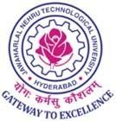
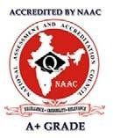
UNIVERSITY COLLEGE OF ENGINEERING JAGITAL
JAWAHARLAL NEHRU TECHNOLOGICAL UNIVERSITY HYDERABAD
(UGC AUTONOMUS)
(Accredited With NAAC A+ Grade)
Nachupally (Kondagattu), Jagtial Dist,Telangana -505501,
DEPARTMENT OF INFORMATION TECHNOLOGY

CERTIFICATE
DATE:

This is to certify that Mr. / Ms. A.Rakesh bearing roll no 25JJ1DA302 of M. Tech I year I semester Cyber Security branch of Information Technology department has satisfactorily completed Information Security Lab (Course Code: D9A301) during the academic year 2025-2026.

------------------------- ---------------------------------
Faculty Head of the Department

------------------------ ---------------------------------
Internal Examiner External Examiner

