23CSE202 DATABASE MANAGEMENT SYSTEMS
S3 B.Tech CSE
Department of Computer Science and Engineering
Amrita School of Computing, Amritapuri Campus

3. Database Design Document

Group No : D12
Team Members :
Roll No | Student Name
AM.SC.U4CSE25322 | Harshita Sanka
AM.SC.U4CSE25362 | Ganga J
AM.SC.U4CSE25326 | Karthikeya S Arun

Project Title : SCHOOL MANAGEMENT SYSTEM

3.1. Detailed description of the project
Project Title: School Management System (SMS)
The School Management System (SMS) is a database application designed to manage the academic records of students in a school. It enables the administrator to maintain student information, record attendance, enter examination marks, and generate academic reports. The system ensures that all student-related data is stored in a structured database, reducing manual paperwork and improving data accuracy.
Users
- Administrator: Manages student records, attendance, marks, and reports.
- Student: Has academic information, attendance records, marks, and generated reports stored in the system.
Entities and Attributes
Entity | Main Attributes
Administrator | AdminID, Username, Password
Student | RegNo, FullName, Class, DateOfBirth, Gender, Phone, Email, HouseNo, City, Pin, AdminID
Marks | MarkID, RegNo, ExamType, FirstLanguage, SecondLanguage, Mathematics, Science, Arts, Others
Attendance | AttendID, RegNo, Date, Status
Report | ReportID, MarkID, RegNo
Relationships
- One Administrator manages many Students (1:N).
- One Student can have many Attendance records (1:N).
- One Student can have many Marks records for different examinations (1:N).
- One Student can generate many Reports (1:N).
- Each report references one student and one marks record through RegNo and MarkID.

Business Rules
- Every student is uniquely identified by RegNo.
- Every administrator has a unique AdminID and Username.
- A student must be managed by one administrator.
- Attendance is recorded once per student for a particular date.
- Marks are stored separately for each examination using MarkID.
- Reports reference the corresponding student and marks record. TotalMarks, Average, and Grade are derived values calculated in the STUDENT_REPORTS view.
- Age is calculated from DateOfBirth and is treated as a derived attribute rather than manually entered.

3.2. ER Diagram
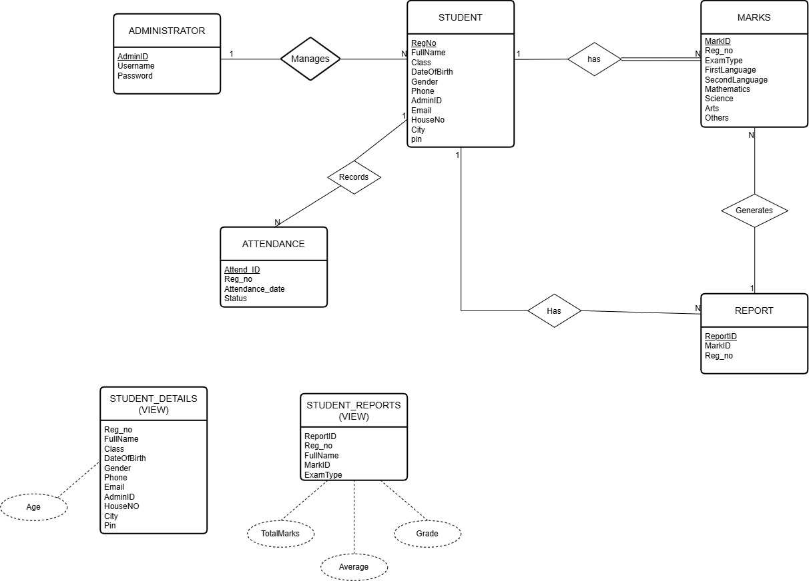
3.3 Relational Schema
ADMINISTRATOR
AdminID | VARCHAR(10) | PK
Username | VARCHAR(50) | UNIQUE, NOT NULL
Password | VARCHAR(255) | NOT NULL

STUDENT
RegNo | VARCHAR(15) | PK
FullName | VARCHAR(100) | NOT NULL
Class | VARCHAR(20) | NOT NULL
DateOfBirth | DATE | NOT NULL
Gender | VARCHAR(10) | NOT NULL, CHECK: Male / Female / Other
Phone | VARCHAR(15) | NOT NULL
AdminID | VARCHAR(10) | FK, NOT NULL
Email | VARCHAR(100) | UNIQUE, NOT NULL
HouseNo | VARCHAR(20) | NOT NULL
City | VARCHAR(50) | NOT NULL
Pin | VARCHAR(10) | NOT NULL

MARKS
MarkID | INTEGER GENERATED ALWAYS AS IDENTITY | PK
RegNo | VARCHAR(15) | FK, NOT NULL
ExamType | VARCHAR(30) | NOT NULL
FirstLanguage | INTEGER | NOT NULL , CHECK: 0–100
SecondLanguage | INTEGER | NOT NULL , CHECK: 0–100
Mathematics | INTEGER | NOT NULL , CHECK: 0–100
Science | INTEGER | NOT NULL , CHECK: 0–100
Arts | INTEGER | NOT NULL , CHECK: 0–100
Others | INTEGER | NOT NULL , CHECK: 0–100

ATTENDANCE
AttendID | INTEGER GENERATED ALWAYS AS IDENTITY | PK
RegNo | VARCHAR(15) | FK, NOT NULL
ATTENDANCE_DATE | DATE | NOT NULL
Status | VARCHAR(10) | NOT NULL, CHECK: Present / Absent

REPORT
ReportID | INTEGER GENERATED ALWAYS AS IDENTITY | PK
MarkID | INTEGER | FK, NOT NULL
RegNo | VARCHAR(15) | FK, NOT NULL

FOREIGN KEY REFERENCES
TABLE | FOREIGN KEY | REFERENCES
STUDENT | AdminID | ADMINISTRATOR(AdminID)
MARKS | RegNo | STUDENT(RegNo)
ATTENDANCE | RegNo | STUDENT(RegNo)
REPORT | MarkID | MARKS(MarkID)
REPORT | RegNo | STUDENT(RegNo)

STUDENT_REPORTS (VIEW)
ReportID | INTEGER GENERATED ALWAYS AS IDENTITY | PK
MarkID | INTEGER | FK, NOT NULL
RegNo | VARCHAR(15) | FK, NOT NULL
TotalMarks | INTEGER | Derived
Average | DECIMAL(5,2) | Derived
Grade | ENUM('A+','A','B','C','D','F') | Derived

STUDENT_DETAILS (VIEW)
RegNo | VARCHAR(15) | —
FullName | VARCHAR(100) | —
Class | VARCHAR(20) | —
DateOfBirth | DATE | —
Gender | VARCHAR(10) | —
Age | INTEGER | Derived
AdminID | VARCHAR(10) | —
Email | VARCHAR(100) | —
Phone | VARCHAR(15) | —
HouseNo | VARCHAR(20) | —
City | VARCHAR(50) | —
Pin | VARCHAR(10) | —

3.4 Normalization and Functional dependency analysis
Functional Dependencies
A functional dependency means that one attribute determines another attribute.
The important functional dependencies in our database are:
- AdminID → Username, Password
Each AdminID identifies one administrator, so it determines the administrator's username and password.
- RegNo → FullName, Class, DateOfBirth, Age, Gender, Phone, AdminID, Email, Address
Each student has a unique registration number. Therefore, RegNo determines the other details of that student.
- MarkID → RegNo, ExamType, FirstLanguage, SecondLanguage, Mathematics, Science, Arts, Others
Each MarkID identifies one marks record, so it determines the marks and exam details.
- AttendID → RegNo, AttendanceDate, Status
Each AttendID identifies one attendance record, so it determines the student's attendance details.
- ReportID → MarkID, RegNo
Each ReportID identifies one report. TotalMarks, Average, and Grade are derived from the marks.

Candidate Key Selection Using Attribute Closure
For the STUDENT table:
RegNo → {RegNo, FullName, Class, DateOfBirth, Gender, Phone, AdminID, Email, HouseNo, City, Pin}
Since the closure of RegNo contains all the attributes of the STUDENT table, RegNo is a candidate key. It is also selected as the primary key.
Similarly:
- AdminID gives all administrator details, so AdminID is a candidate key for ADMINISTRATOR.
- MarkID gives all attributes of a marks record, so MarkID is a candidate key for MARKS.
- AttendID gives all attributes of an attendance record, so AttendID is a candidate key for ATTENDANCE.
- ReportID gives all attributes of a report, so ReportID is a candidate key for REPORT.

Normalization Process
1NF (First Normal Form):
A table is in 1NF when every attribute contains a single value and there are no repeating groups.
Our tables follow 1NF because each field contains one value. For example, in the STUDENT table, FullName, Phone, Gender, and Email contain individual values.
The Address attribute is divided into HouseNo, City, and Pin, so the individual components can be stored separately.

2NF (Second Normal Form):
A table is in 2NF when it is already in 1NF and there is no partial dependency, meaning non-key attributes should depend on the complete primary key.
In our system, the main tables use single-attribute primary keys such as RegNo, MarkID, AttendID, and ReportID. Therefore, partial dependency does not occur because there is no composite primary key.
For example, in STUDENT:
RegNo → FullName, Class, DateOfBirth, Gender, Phone, Email
All these attributes depend completely on RegNo.

3NF (Third Normal Form):
A table is in 3NF when it is in 2NF and there is no transitive dependency, where a non-key attribute depends on another non-key attribute.
To avoid unnecessary dependencies, administrator details are stored separately in the ADMINISTRATOR table, while student details are stored in the STUDENT table.
For example:
Student RegNo → AdminID → Administrator details
Instead of storing administrator username and password repeatedly for every student, we store AdminID as a foreign key in STUDENT and keep the administrator details in the ADMINISTRATOR table.
Similarly, marks and attendance are stored separately using RegNo as a foreign key.
BCNF (Boyce-Codd Normal Form):
A relation is in BCNF when every determinant is a candidate key.
In our database, the main determinants such as AdminID, RegNo, MarkID, AttendID, and ReportID are candidate keys of their respective tables. Therefore, the tables satisfy the BCNF condition based on the identified functional dependencies.

