EV Population Analysis
Name: Karthikeyan P | Batch: DSB04

Chart 1: Correlation Between Numeric Vehicle Attributes
EDA – Section 3.5
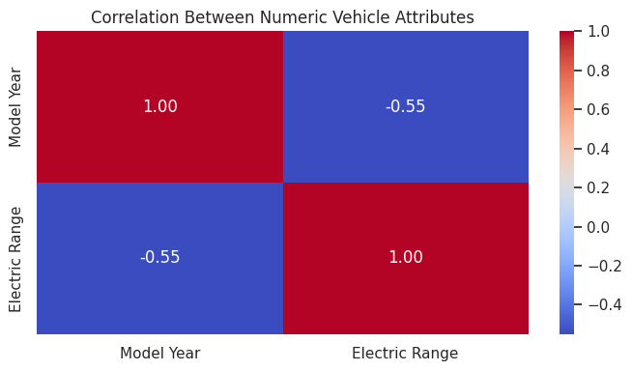
Heatmap of the correlation between Model Year and Electric Range, the only two meaningful numeric variables.

Chart 2: Distribution of Electric Vehicle Types
EDA – Visualization 1 (Bar graph)
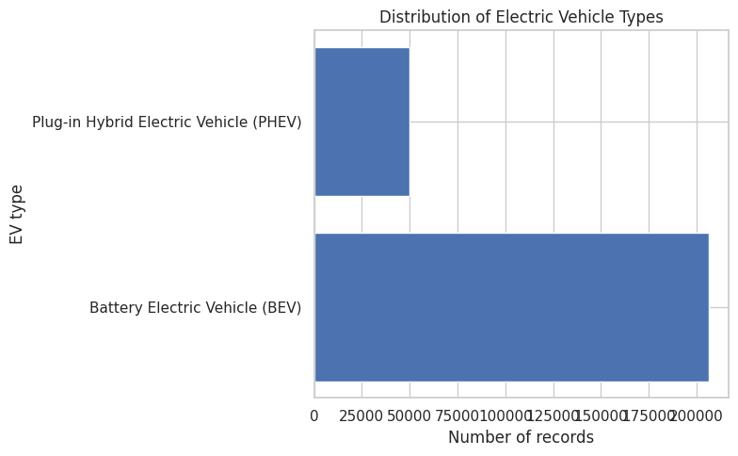
Univariate analysis of the target column, comparing the number of BEV and PHEV records.

Chart 3: Top 10 Manufacturers by Number of Records
EDA – Visualization 2 (Bar graph)
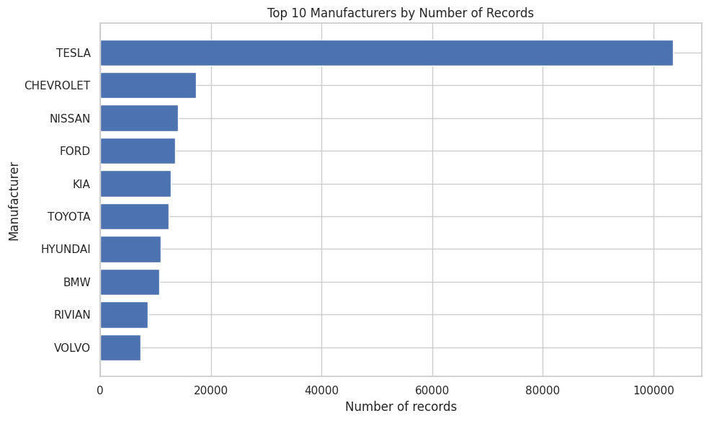
Horizontal bar chart of the ten manufacturers with the most EV records, using value_counts().

Chart 4: EV Records by Model Year
EDA – Visualization 3 (Line plot)
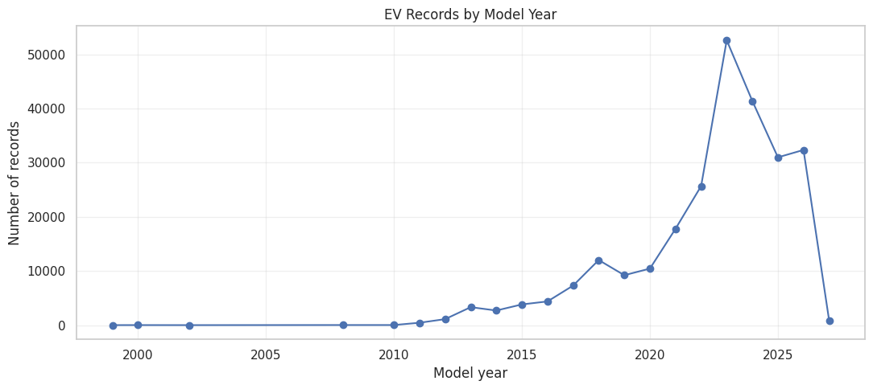
Line plot showing how EV records are distributed across model years.

Chart 5: Distribution of Recorded Electric Range
EDA – Visualization 4 (Histogram)
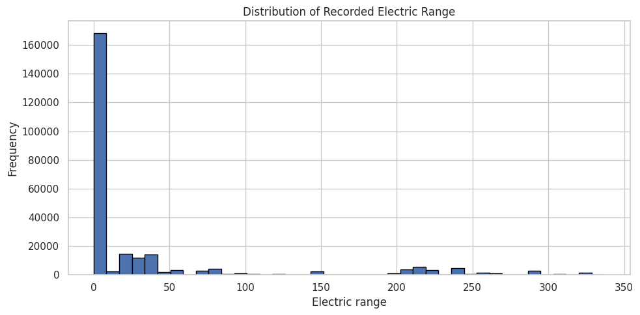
Histogram (40 bins) of electric range values; zero-range records are also checked as a data-quality issue.

Chart 6: Recorded Electric Range by EV Type
EDA – Visualization 5 (Box plot)
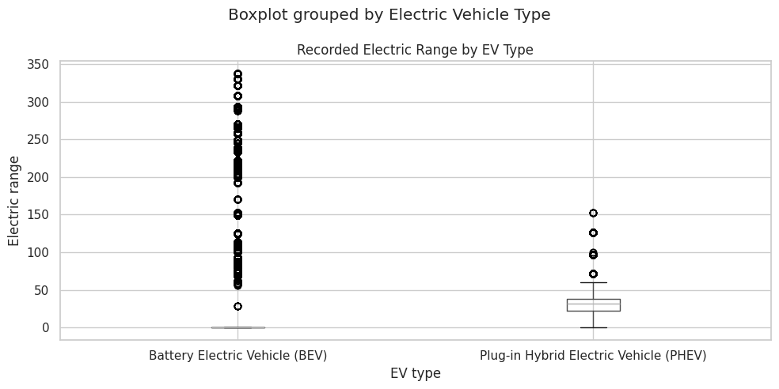
Box plot comparing median, quartiles, spread and outliers of electric range for BEV vs PHEV.

Chart 7: Top 10 Counties by EV Records
EDA – Visualization 6 (Bar graph)
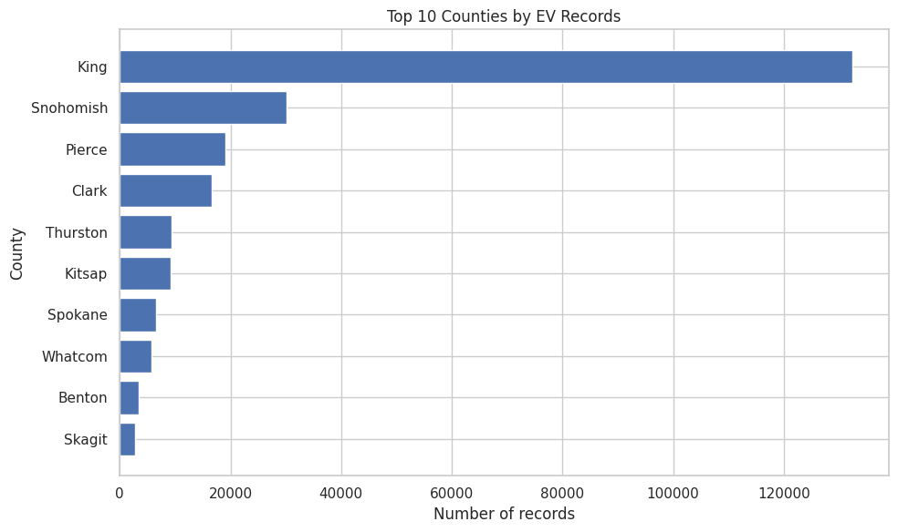
Shows the geographical concentration of EV records across counties.

Chart 8: Top 10 Vehicle Models by Number of Records
EDA – Visualization 7 (Bar graph)
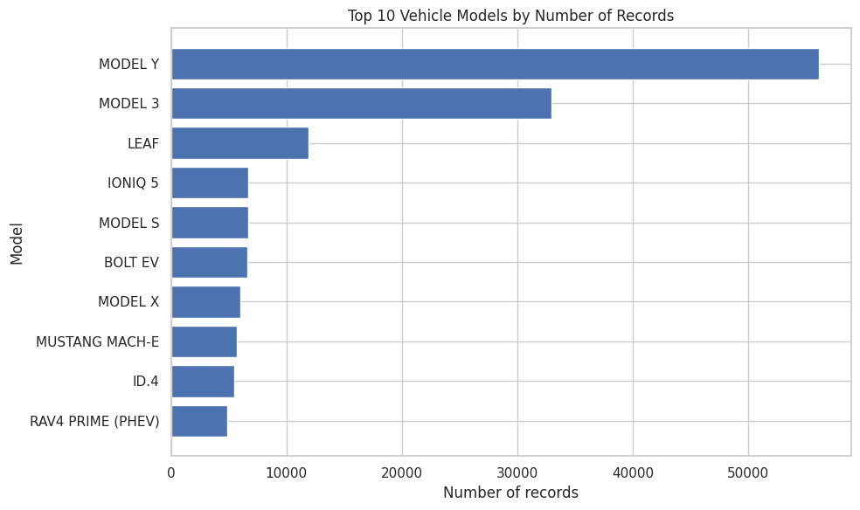
Shows the most frequently recorded EV models.

Chart 9: EV Type Counts for Top Manufacturers
EDA – Visualization 8 (Bar graph)
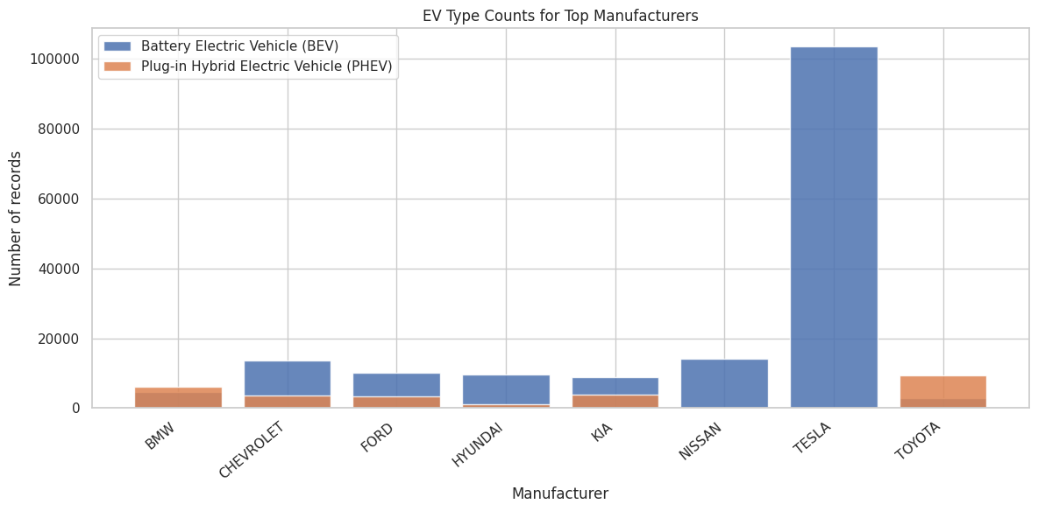
Compares BEV and PHEV counts for the top manufacturers.

Chart 10: Boxplot of Recorded Electric Range
Pre-processing – Outlier detection (Section 4.3)
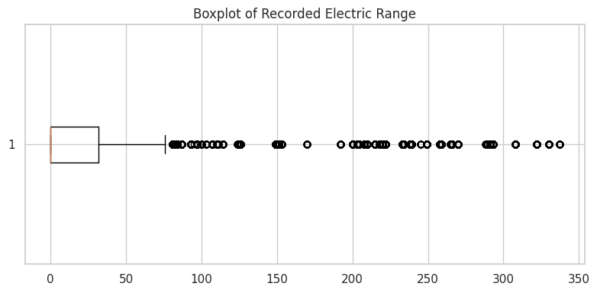
IQR-based.

Chart 11: Log1p-Transformed Electric Range
Pre-processing – Skewness (Section 4.4)
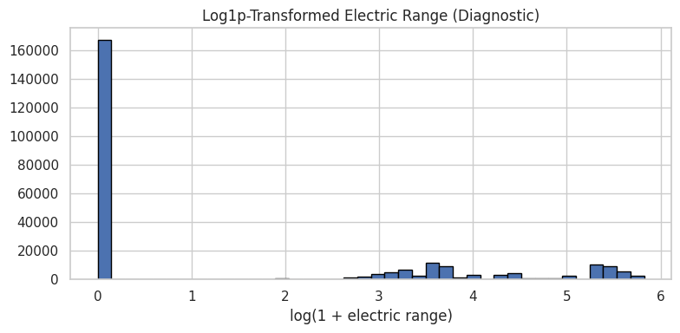
Diagnostic view of the log-transformed range (skewness of the original ≈ 2.26); the original values are kept for modelling.

Chart 12: Confusion Matrix – Logistic Regression
Model building
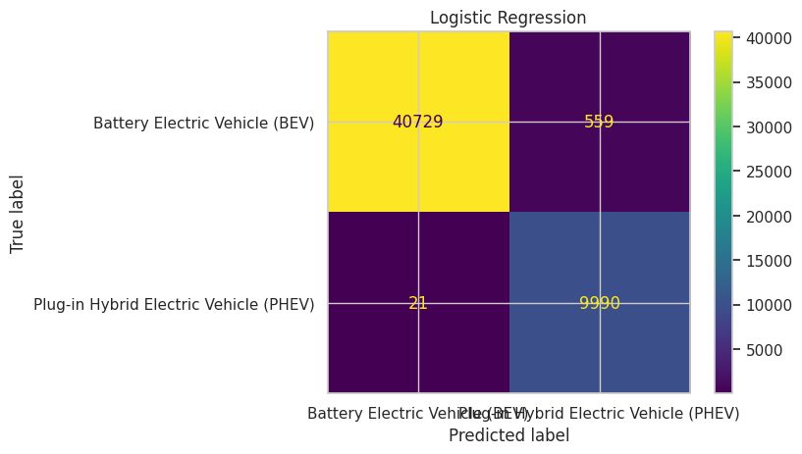
Test accuracy ≈ 98.87%, weighted F1 ≈ 0.9888.

Chart 13: Confusion Matrix – Decision Tree
Model building
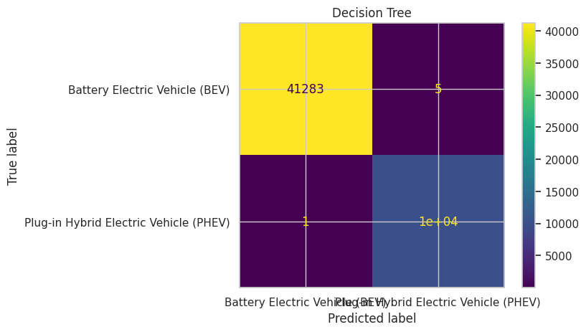
Test accuracy ≈ 99.99%, weighted F1 ≈ 0.9999.

Chart 14: Confusion Matrix – Random Forest
Model building
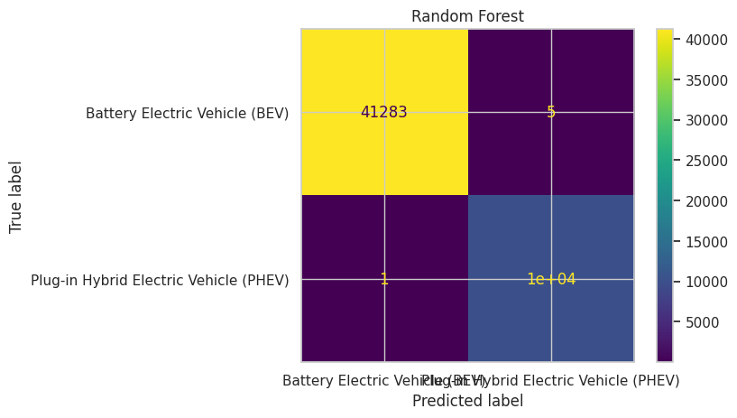
Test accuracy ≈ 99.99%, weighted F1 ≈ 0.9999.

Chart 15: Confusion Matrix – Linear SVM
Model building
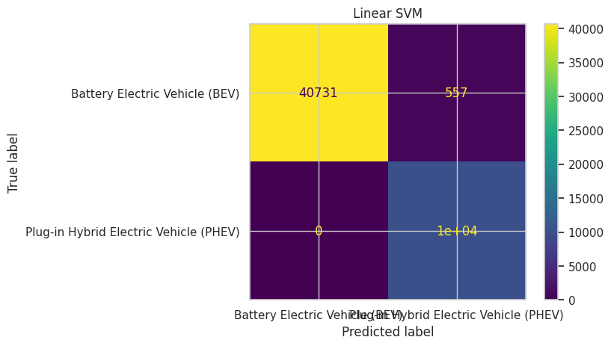
Test accuracy ≈ 98.91%, weighted F1 ≈ 0.9893.

Chart 16: Confusion Matrix – Best Model (Decision Tree)
Model evaluation & comparison
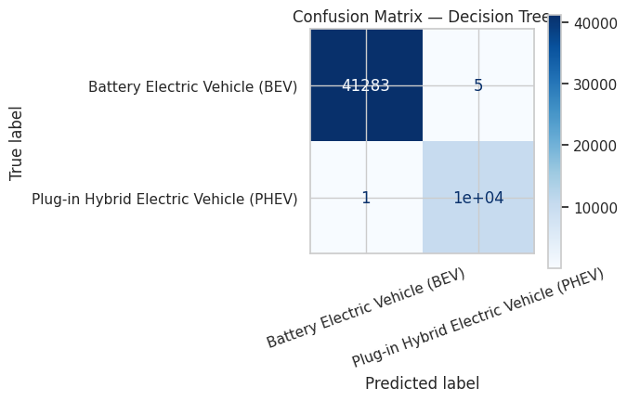
Best model by weighted F1-score; train-test accuracy gap ≈ 0.0001.

