**SYSTEM DESIGN**

**Table Design:**

**Table : admins**

Primary Key : Admin_id

|  |  |  |  |
| --- | --- | --- | --- |
| **S.No.** | **Column** | **Datatype** | **Description** |
| 1 | Admin_id | Int(11) | Id of the admin |
| 2 | Adminname | Varchar(100) | Name of the admin |
| 3 | Email | Varchar(255) | Email of the admin |
| 4 | Password | Varchar(255) | Hashed Password of admin |
| 5 | Mobile_number | Varchar(15) | Mobile number of the admin |
| 6 | Role | Enum | Role of admin |
| 7 | Created_by | Int(11) | Denotes the admin created by Superadmin |
| 8 | CreatedDate | Datetime | Admin created date and time |
| 9 | LastLogin | Datetime | Admin’s recent login date and time |
| 10 | Status | Enum | Status of Admin (active/inactive) |
| 11 | Otp | Varchar(6) | Otp if admin tried to login |
| 12 | Otp_Expiry | Datetime | Otp expiring date and time |
| 13 | Is_email_verified | Tinyint(1) | Is the admin loggedIn and verified |

**Table : usersretailers**

Primary Key : User_id

|  |  |  |  |
| --- | --- | --- | --- |
| **S.No.** | **Columns** | **Datatype** | **Description** |
| 1 | User_id | Int(11) | Id of the user |
| 2 | Username | Varchar(100) | Name of the user |
| 3 | Password | Varchar(255) | Hashed password of the user |
| 4 | Shop_name | Varchar(255) | User’s Shop name |
| 5 | Shop_address | Text | Shop’s Address |
| 6 | Email | Varchar(100) | Email of the user |
| 7 | Mobile_number | Varchar(15) | Mobile number of the user |
| 8 | Otp | Varchar(6) | Otp if user tried to login |
| 9 | Otp_expiry | Datetime | Otp expiring date and time |
| 10 | Is_email_verified | Tinyint(1) | Is the user loggedIn and verified |
| 11 | Owner_name | Varchar(255) | Owner of the shop |
| 12 | userCreationDate | Datetime | User’s created date and time |
| 13 | LastLogin | Datetime | User’s recent login date and time |
| 14 | userType | Enum | Type of user (Regular/Frequent/VIP) |
| 15 | Status | Enum | User’s Status (Active/Inactive) |

**Table : brands**

Primary Key : id

|  |  |  |  |
| --- | --- | --- | --- |
| **S.No.** | **Columns** | **Datatype** | **Description** |
| 1 | Id | Int(11) | Id of the Brand |
| 2 | Main_brand | Varchar(255) | Main Brand Name |
| 3 | Image_file | Varchar(255) | Brand image file location/Path |
| 4 | Catalogue_file | Varchar(255) | Brand Catalogue file location/path |
| 5 | Created_at | Datetime | Brand added date and time |
| 6 | Sub_brand | Varchar(255) | Sub brand name |

**Table : footwear_models**

Primary Key : Model_id

|  |  |  |  |
| --- | --- | --- | --- |
| **S.No.** | **Columns** | **Datatype** | **Description** |
| 1 | Model_id | Int(11) | Id of the model |
| 2 | Main_brand | Varchar(255) | Main brand of the model |
| 3 | Sub_brand | Varchar(255) | Sub brand of the model |
| 4 | Commodity | Varchar(50) | Commodity of the model |
| 5 | Article | Varchar(50) | Article of the model |
| 6 | Color | Varchar(50) | Color of the model |
| 7 | Price | Decimal(10,2) | Price of the model |
| 8 | Type | Varchar(50) | Type of the model |
| 9 | Material | Varchar(50) | Material of the model |
| 10 | Stock_available | Varchar(50) | Availability of the model |
| 11 | Image_name | Varchar(255) | Image name of the model |
| 12 | Image_type | Varchar(100) | Type of the image |
| 13 | Image_data | Longblob | Image data |

**Table : footwear_stock**

Primary Key : Stock_id

Foreign Key : Model_id(footwear_models)

|  |  |  |  |
| --- | --- | --- | --- |
| **S.No** | **Columns** | **Datatype** | **Description** |
| 1 | Stock_id | Int(11) | Id of the stock |
| 2 | Model_id | Int(11) | Id of the model |
| 3 | Description | Varchar(255) | Description about the model |
| 4 | Article | Varchar(50) | Article of the model |
| 5 | Color | Varchar(50) | Color of the model |
| 6 | Size_variation | Varchar(25) | Size variation of the model |
| 7 | Custom_size | Int(11) | Custom size stock |
| 8 | Stock | Int(11) | NOS available |

**Table : Orders**

Primary Key: Order_id

Foreign Key: User_id(usersretailers),Packaged_by(admins – admin_id)

|  |  |  |  |
| --- | --- | --- | --- |
| **S.No.** | **Columns** | **Datatype** | **Description** |
| 1 | Order_id | Int(11) | Id of the Order |
| 2 | User_id | Int(11) | User’s id who placed the order |
| 3 | Order_placed_time | Datetime | Order placed time |
| 4 | Order_updated_time | Datetime | Order Updated time |
| 5 | Order_packaged_time | Datetime | Order Packaged time |
| 6 | Packaged_by | Int(11) | Admin’s id who packaged the order |
| 7 | Bill_amount | Decimal(10,2) | Amount of the bill |
| 8 | Bill_file | Varchar(255) | Path to the Bill’s PDF File |
| 9 | Delivery_status | Enum | Status of the Delivery |
| 10 | Delivered_time | Datetime | Order Delivered time |
| 11 | Estimated_delivery_date | Datetime | Estimated_delivery_time |

**Table : user_cart**

Primary Key : Cart_id

Foreign Key : Model_id (footwear_models), User_id(usersretailers), Stock_id(footwear_stock

|  |  |  |  |
| --- | --- | --- | --- |
| **S.No.** | **Columns** | **Datatype** | **Description** |
| 1 | Cart_id | Int(11) | The ID of the Cart |
| 2 | Model_id | Int(11) | The ID of the model from footwear_models table |
| 3 | User_id | Int(11) | The ID of the Cart Holder User from the Usersretailers table |
| 4 | Quantity | Int(11) | The Amount of Quantity Added in the Cart for the model |

**Dataflow Diagram:**

**Level 0:**



**Level 1:**

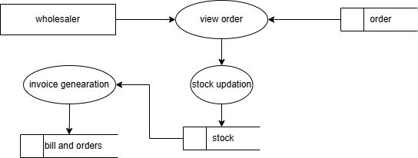

**Level 2:**

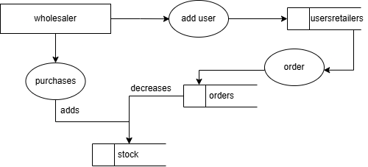

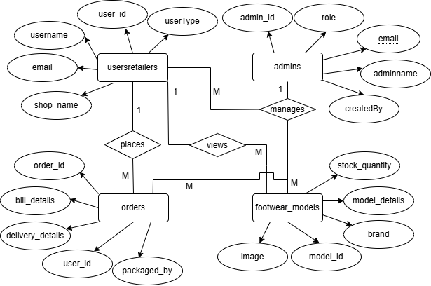**ER Diagram:**