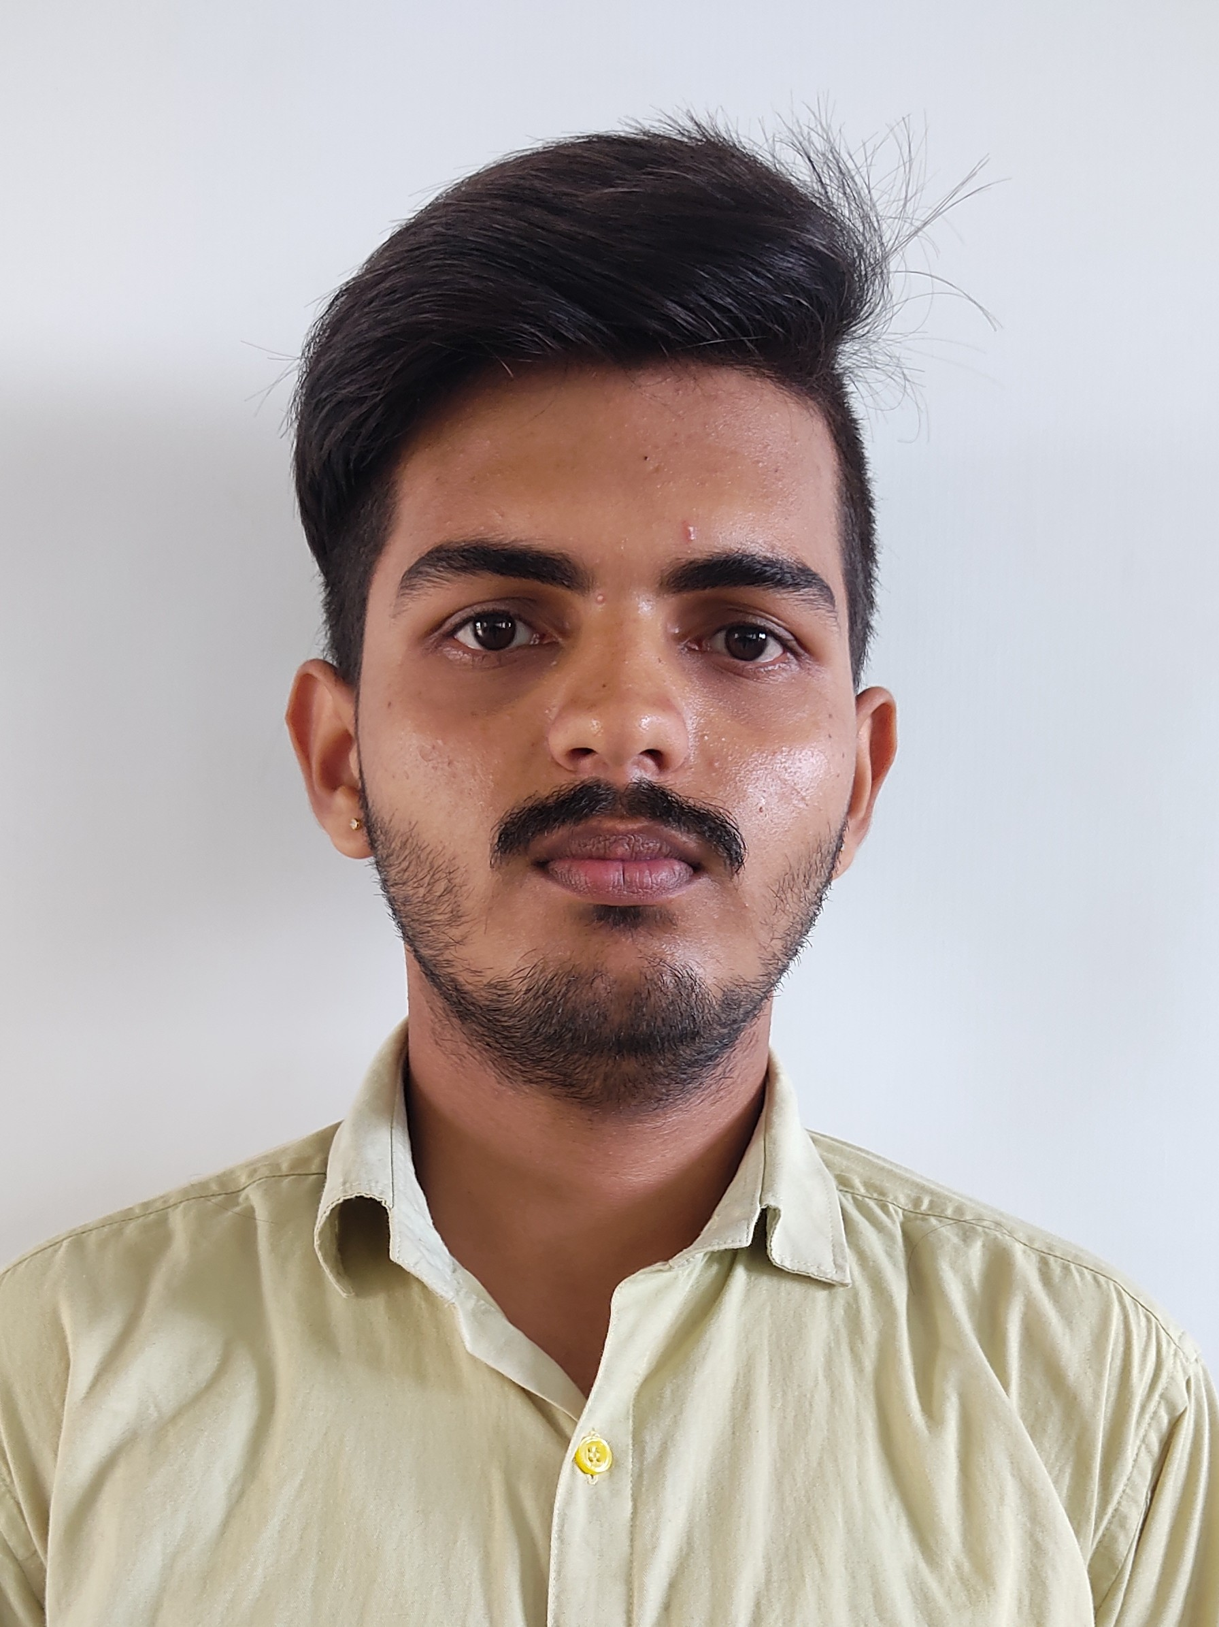

**KARTHI .L**

Address : 38/4, Baba Complex, Sethumadai Main Road, Vettaikaranpudur 642129

Phone : 9442685754 Email ID: [karthi9442685754@gmail.com](mailto:karthi9442685754@gmail.com)

 LinkedIn Profile: [www.linkedin.com/in/karthi-l](http://www.linkedin.com/in/karthi-l) . GitHub Profile: [www.github.com/karthi-l](http://www.github.com/karthi-l)

**Objective:**

Adaptable and fast-learning IT professional with a strong foundation in web development and backend programming. Passionate about learning new technologies and contributing to dynamic teams.

**Education:**

* **HSC** - Palaniyammal Hr.Sec School | 72.3% | 2021 – 2022
* **B.Sc. Information Technology** – Nallamuthu Gounder Mahalingam College (Aug 2022 – May 2025) – 78.2%

**Technical Skills:**

* Programming Languages: Java, Python, C/C++, C#.
* Web Technologies: HTML, CSS, JS, PHP.
* Database Management: Oracle Database, MySQL.
* Tools & Technologies: Git, Excel, Powerpoint, Word, Photoshop, Eclipse IDE, VS Code, Anaconda, Pycharm, Visual Studio, Libre Office.
* Operating System: Windows, Ubuntu Linux.

**Soft Skills:**

Communication, Adaptability, Time Management, Critical and Logical thinking and analysing , Fast and accurate typing speed of 90 WPM.

**Certificates:**

* IIT Bombay’s Course completion of C/C++ and Java Script.
* Value Added Course by the Dept of Computer Technology (Web Development).
* Completed Introduction to C, Intermediate C, Introduction to HTML, CSS in Sololearn.
* Completed Networking Foundations: Networking Basics, Learning Subnetting and Learn IP Addressing in LinkedIn Learning.
* Ongoing : Full Stack Web Development Bootcamp by Colt Steele in Udemy.

**Additional Skills :**

* Excellent communication and teamwork skills.
* Strong problem-solving abilities.
* Fast and Accurate typing speed of 90-100 WPM.

**Extra Curricular Activities:**

* Won second place in college level carrom board competition (Duo)
* Won Debugging competition conducted Computer Science Department(Duo)
* IT Department Secretary at College (2024-Present)
* Participated in VOX POPULI (An English Voicing Forum) – 2/2024

**Communication Languages:** English, Hindi, Tamil

**Projects :**

**Step-upWholesale:** A web-based wholesale footwear management system where retail shop owners can order footwear for their shops. The admin manages stock, users, orders, and delivery status.

* **Tech Stack:** PHP, MySQL, HTML/CSS(Bootstrap), JavaScript.
* **Github Repo:** <https://www.github.com/karthi-l/step-upWholesale>
* **Live in Infintyfreeapp:** <http://karthi-l.infinityfreeapp.com/?i=1>