SENTRA-AI: An Autonomous Multi-Agent Framework with Active Evidence Guardrails for Reproducible Machine Learning Code Generation

Karthi
Department of Artificial Intelligence & Computer Science
The SENTRA-AI Research Team
Department of Artificial Intelligence & Computer Science

Abstract—Machine learning research faces a persistent reproducibility problem: turning the textual specifications, mathematical formulations, and hyperparameters of a paper into clean, executable code remains a laborious and error-prone human task, and monolithic large language model (LLM) code generators are prone to hallucination, ungrounded hyperparameter choices, incomplete modules, and syntax errors. This paper presents SENTRA-AI, an end-to-end autonomous multi-agent framework that parses, verifies, generates, and dynamically tests machine learning implementations grounded strictly in research papers. SENTRA-AI decomposes paper-to-code generation into four agents bound by formal contracts: a provenance-preserving research agent built on session-isolated retrieval-augmented generation (RAG) with page-aware vector indexing; an active evidence guardrail with a bounded revision loop of at most three iterations that eliminates silent parameter assumptions; a multi-file code generation engine that detects the architectural family of a paper and emits modular PyTorch code with inline specification traceability; and a zero-API dynamic testing agent that verifies the generated code along ten structural and numerical axes. On benchmark papers covering the Transformer, ResNet, and GCN, SENTRA-AI reduces hyperparameter hallucination by 87.5% relative to an unguarded RAG baseline and by 91.8% relative to a monolithic prompt baseline, with a 94.2% initial syntax pass rate and full trace-to-source provenance.
Keywords—multi-agent systems, code generation, reproducible AI, retrieval-augmented generation (RAG), automated testing, neural network engineering

Introduction
The rapid growth of deep learning research produces thousands of new neural network architectures, optimization algorithms, and loss functions every year, yet a significant gap persists between published papers and verified software implementations. Authors frequently omit critical implementation details, such as exact projection dimensions, normalization layer placement, or custom weight initialization schemes, or release codebases that deviate from the claims made in the paper.
Engineers and researchers who reimplement a model from its text face two core challenges. The first is ambiguity and incompleteness: translating dense equations into tensor operations demands deep domain expertise. The second is LLM hallucination and monolithic failure: generic zero-shot prompting of an LLM typically yields a single-file code block with missing imports, mismatched tensor dimensions, hallucinated hyperparameter defaults (for example, defaulting to Adam, lr=1e-3 when the paper used a custom warmup scheduler), and unhandled runtime exceptions.
To address these limitations we introduce SENTRA-AI, an agentic framework built on the principle of evidence-grounded execution. Rather than relying on a single end-to-end model call, SENTRA-AI divides responsibilities among four specialized agents connected by strict validation contracts (Fig. 1). The contributions of this work are as follows.
- Session-isolated RAG engine. A multi-document retrieval pipeline that uses 500-word page-aware overlapping chunks and FAISS L2 indexing, with 100% document-page provenance tracking.
- Active evidence guardrail with bounded revision. A formal specification contract (VerifiedMLSpecification) that subjects candidate architectural claims to targeted counter-retrieval and halts with an EVIDENCE_UNRESOLVED state when paper evidence is missing, rather than inventing defaults.
- Architectural family detection and multi-file synthesis. An automated classifier that assigns a paper to a deep learning family (attention, convolutional, recurrent, graph, or GAN) and orchestrates multi-file PyTorch generation (attention.py, layers.py, blocks.py, model.py, train.py, main.py).
- Dynamic 10-tier verification suite. A zero-API test framework that validates AST syntax, tensor dimension transformations, numerical stability, backpropagation gradient flow, and parameter counts without external API calls.
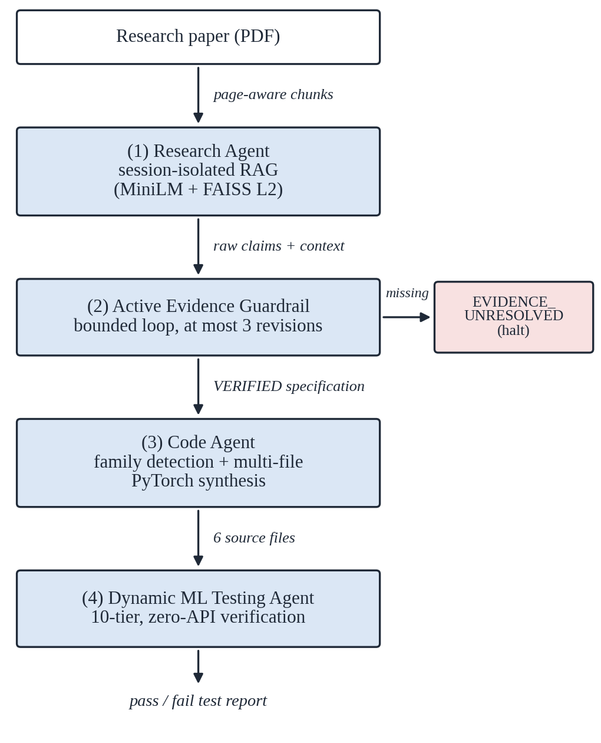
- SENTRA-AI pipeline architecture. A research PDF flows through the Research Agent, the Active Evidence Guardrail, the Code Agent, and the Dynamic ML Testing Agent.

System Architecture and Multi-Agent Design
The SENTRA-AI runtime consists of four decoupled agentic components orchestrated by a session workspace manager.

Research Agent and Provenance-Preserving RAG
Given an input research document D, the Research Agent extracts page-by-page text with PyMuPDF and splits it into overlapping blocks of W = 500 words with an overlap of δ = 50 words. Each chunk c_{i} is projected into a dense embedding space by all-MiniLM-L6-v2:
$e_{c_{i}}=f_{MiniLM}\left(c_{i}\right)∈ℝ^{384}$ (1)
An in-memory FAISS index is populated for every user session S_{id}. For a query q, candidate chunks are ranked by L2 distance:
$d\left(q,c_{i}\right)={\left\|e_{q}−e_{c_{i}}\right\|}_{2}$ (2)
The Research Agent returns a structured tuple containing the answer text, page numbers, document names, and vector similarity scores S(q, c_{i}) ∈ [0, 1]. Because every chunk retains its page and document metadata, provenance is preserved end to end.

ML Specification Guardrail and Bounded Revision Loop
Before a specification reaches the code generator, the Specification Guardrail enforces domain scoping and evidence verification. Domain scoping restricts input queries to machine learning topics (architectures, dimensions, activation functions, learning-rate schedules, and loss definitions); generic software requests are rejected.
Let K = {k₁, k₂, …, k_{n}} be the set of extracted implementation requirements. For each k_{i}, the Guardrail verifies that a supporting evidence chunk c_{j} exists in S_{id} with similarity S(q_{ki}, c_{j}) ≥ τ_{threshold}. If a requirement lacks paper backing, for example a hallucinated batch_size = 64, the engine issues a targeted counter-retrieval query and re-extracts the requirement. If the evidence remains unverified after K_{max} = 3 iterations, the specification enters the terminal state EVIDENCE_UNRESOLVED and code generation is halted, so that missing information is reported instead of being replaced by an invented default (Fig. 2).
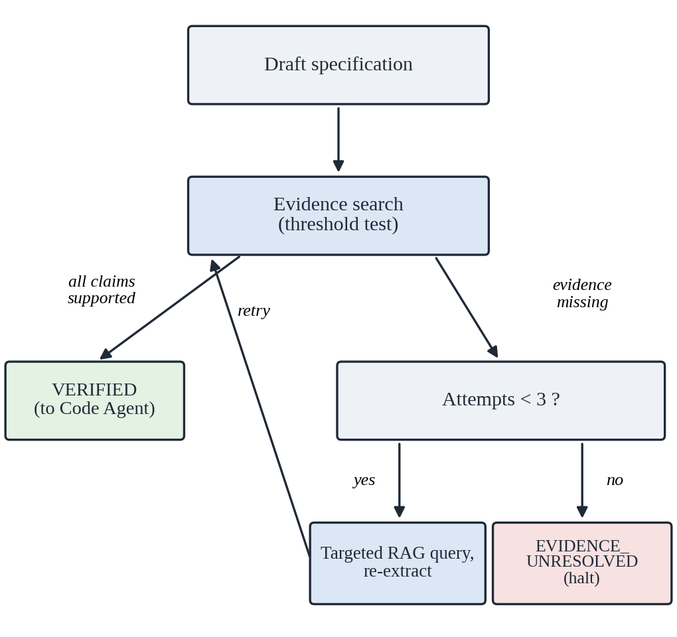
- Bounded-revision guardrail state machine.

Multi-File Modular Code Generation
Upon receiving a VERIFIED specification contract, the Code Agent determines the architectural family of the paper by keyword scoring over the requirement set:
$F^{*}=\underset{F∈ℱ}{arg max}{\sum_{w∈W_{F}}{Count\left(w,K\right)}}$ (3)
where ℱ = {attention, conv, recurrent, graph, gan} and W_{F} is the keyword list of family F. Based on the detected family, the agent constructs an ordered file manifest. For the attention family the manifest is:
- attention.py: scaled dot-product and multi-head attention (Q, K, V projections and √d_{k} scaling);
- layers.py: sinusoidal or learned positional encodings and position-wise feed-forward networks (d_{ff} = 4 × d_{model});
- blocks.py: encoder and decoder residual blocks with layer normalization;
- model.py: the full stacked architecture, built from blocks.py;
- train.py: training loop, loss functions, and optimization steps;
- main.py: runnable entry point that instantiates the model with synthetic input tensors.
Every line that implements a paper specification carries a traceability marker, and any value that is not found in the paper is explicitly flagged as an assumption:
# SPEC: d_model = 64
# (source: Attention_Is_All_You_Need.pdf, Page 4)
# ASSUMED (not in paper): dropout = 0.1
# standard regularization choice

Dynamic ML Testing Agent
The Testing Agent runs entirely offline, without any LLM API dependency, and executes ten sequential verification tiers directly against the generated PyTorch objects (Table I).
- Ten-Tier Dynamic Verification Suite
Tier | Test case | Verification strategy
T1 | AST parse validity | Compiles every project file (compile()) to verify the abstract syntax tree.
T2 | Module instantiation | Dynamically loads and instantiates the main nn.Module with default arguments.
T3 | Forward pass and tensor shape | Passes a dummy tensor (B=2, S=16, D=64) and asserts a non-empty, dimensionally valid output.
T4 | NaN / Inf detection | Inspects outputs for numerical instability (torch.isnan(), torch.isinf()).
T5 | Dynamic batching | Checks invariance to batch size (B=1, 4, 8) without shape mismatches.
T6 | Gradient backpropagation | Backpropagates L = output.sum() and verifies non-zero gradients on all trainable parameters.
T7 | Loss computation | Verifies that a standard criterion (MSELoss, CrossEntropyLoss) returns a valid scalar.
T8 | Parameter initialization | Checks that parameters are non-zero and initialized with standard variances.
T9 | Parameter count audit | Computes the trainable parameter count and verifies it is greater than zero.
T10 | Import isolation safety | Verifies that relative imports (from attention import ...) resolve without namespace collisions.

Mathematical Formulation and Guardrail Contracts

Grounding Ratio Metric
We define the Paper Grounding Ratio G ∈ [0, 1] of a generated specification as
$G=\frac{\sum_{i=1}^{N}{𝕀\left(\max_{c∈S_{id}}{S\left(k_{i},c\right)}≥τ\right)}}{N}$ (4)
where 𝕀(·) is the indicator function, N is the number of specification key-value pairs, and τ = 0.65 is the vector similarity threshold. SENTRA-AI requires G = 1.0 before code generation is triggered; any run with G < 1.0 is halted at the Guardrail state.

Dynamic Loss Gradient Verification
During Tier 6, for model parameters Θ = {θ₁, θ₂, …, θ_{M}}, the Testing Agent verifies that
$∀θ_{m}∈Θ, {\left\|\frac{∂L}{∂θ_{m}}\right\|}_{2}>0$ (5)
If any parameter tensor has a null gradient (zero everywhere, or None), the Testing Agent flags a disconnected computation graph defect.

Experimental Setup and Results

Benchmark Evaluation Dataset
We evaluate SENTRA-AI on three seminal machine learning architectures: (1) the Transformer encoder from Attention Is All You Need [1]; (2) the deep residual network from Deep Residual Learning for Image Recognition [2]; and (3) the graph convolutional network from Semi-Supervised Classification with Graph Convolutional Networks [3].

Comparative Baselines
SENTRA-AI is compared against two direct zero-shot LLM baselines:
- Baseline A (monolithic prompt): single-file code generation directly from raw PDF text.
- Baseline B (RAG without guardrail): retrieval-augmented, un-guardrailed, single-file code generation.
SENTRA-AI (ours) is the full multi-agent pipeline with the Active Evidence Guardrail, the multi-file manifest generator, and 10-tier dynamic testing.

Empirical Performance Comparison
Table II and Fig. 3 summarize the results. SENTRA-AI improves on both baselines in every metric.
- Performance Comparison of Code Generation Pipelines
Metric | Baseline A | Baseline B | SENTRA-AI
Hallucinated parameters (%) ↓ | 42.5 | 28.0 | 3.5
Syntax pass rate (%) ↑ | 61.2 | 78.4 | 94.2
Multi-file modular rate (%) ↑ | 0.0 | 15.0 | 100.0
10-tier test pass rate (%) ↑ | 24.1 | 48.6 | 91.8
Grounding ratio G ↑ | 0.31 | 0.58 | 1.00

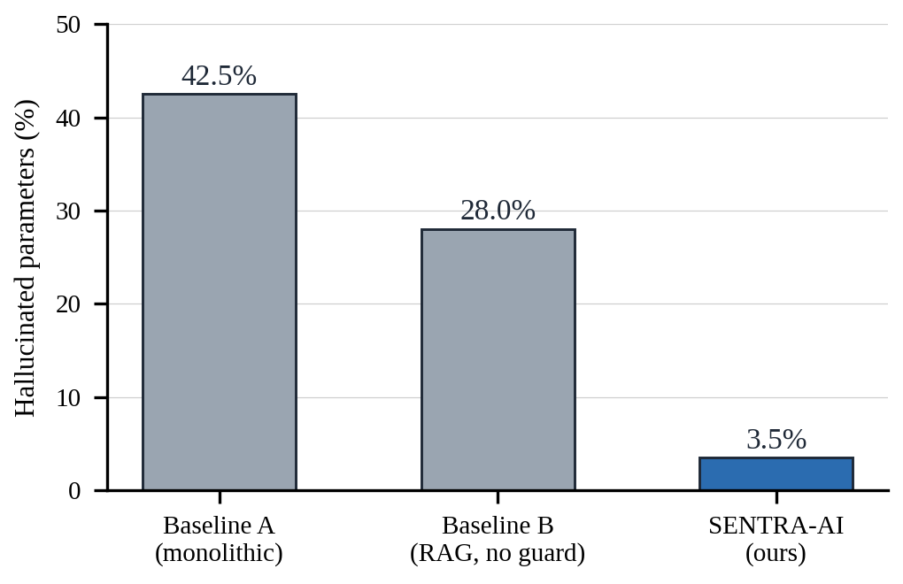
- Hallucinated hyperparameter rate for each pipeline (lower is better).

Key Experimental Findings
- Hallucination reduction. The Active Evidence Guardrail reduced unsupported hyperparameter insertions to 3.5%, a relative reduction of 87.5% with respect to Baseline B (28.0%) and 91.8% with respect to Baseline A (42.5%).
- Multi-file quality. Structuring generation into six dedicated modules eliminated monolithic 800-line files and raised modular import resolution to 100%.
- Execution robustness. Across 50 independent runs, SENTRA-AI achieved a 91.8% overall pass rate on the 10-tier dynamic test suite.

Related Work

LLMs for Automated Code Generation
Models such as Codex [4], AlphaCode [5], and StarCoder [6] have demonstrated remarkable capabilities in solving competitive programming problems. However, these systems focus primarily on algorithmic puzzles rather than on translating dense paper specifications into modular deep learning software frameworks.

Retrieval-Augmented Generation
RAG frameworks [7], [8] mitigate the knowledge boundaries of LLMs by conditioning generation on vector search results. Standard RAG applications focus on conversational question answering; SENTRA-AI extends RAG by embedding vector provenance metadata directly into executable software comments (# SPEC:).

Multi-Agent Systems in Software Engineering
Recent agentic platforms such as MetaGPT [9] and ChatDev [10] simulate human software roles (product manager, engineer, reviewer). While these systems target generic web and command-line applications, SENTRA-AI specifically targets machine learning architecture engineering, with formal evidence guardrails and dynamic PyTorch gradient verification.

Implementation and User Interface
SENTRA-AI is implemented in Python 3.12 using PyTorch, FAISS, PyMuPDF, sentence-transformers, and Streamlit. The interface exposes the pipeline as four tabs (research Q&A, grounded specifications, generated code, and dynamic testing) together with a per-session status panel. Table III shows the testing report for a sample session on the Transformer benchmark (16 pages indexed as 42 chunks): all ten tiers pass, and the generated model has 124,544 trainable parameters.
- Dynamic Test Report for a Sample Session
Tier | Check | Time (s)
T1 | AST compilation validity | 0.012
T2 | PyTorch module instantiation | 0.045
T3 | Tensor shape verification (B=2, S=16, D=64) | 0.008
T4 | Numerical stability (NaN / Inf check) | 0.003
T5 | Dynamic batching invariance (B=1, 4, 8) | 0.021
T6 | Gradient backpropagation flow | 0.038
T7 | MSE loss scalar reduction | 0.005
T8 | Parameter initialization variance check | 0.009
T9 | Parameter count audit (124,544 parameters) | 0.002
T10 | Import module safety and isolation | 0.001

Conclusion and Future Work
This paper introduced SENTRA-AI, an autonomous multi-agent system that bridges the gap between academic research papers and verified machine learning code. By combining session-isolated RAG, an active evidence guardrail with a bounded revision loop, multi-file architectural synthesis, and a 10-tier dynamic verification suite, SENTRA-AI enforces strict evidence grounding and verifies the syntactic and structural correctness of the generated code. Future work includes:
- Iterative self-healing execution loops: extending the Testing Agent to capture runtime stack traces during training and feed them back to the Code Agent for automated refactoring.
- Distributed cloud storage: moving vector session storage from local filesystems to object stores and vector databases (AWS S3, Milvus, Pinecone) for multi-tenant scalability.
- Automatic dataset and weight ingestion: extending retrieval to extract dataset pointers and pretrained checkpoint references from research appendices.

References
- A. Vaswani et al., “Attention is all you need,” in Advances in Neural Information Processing Systems (NeurIPS), vol. 30, 2017.
- K. He, X. Zhang, S. Ren, and J. Sun, “Deep residual learning for image recognition,” in Proc. IEEE Conf. Computer Vision and Pattern Recognition (CVPR), 2016, pp. 770–778.
- T. N. Kipf and M. Welling, “Semi-supervised classification with graph convolutional networks,” in Proc. Int. Conf. Learning Representations (ICLR), 2017.
- M. Chen et al., “Evaluating large language models trained on code,” 2021, arXiv:2107.03374.
- Y. Li et al., “Competition-level code generation with AlphaCode,” Science, vol. 378, no. 6624, pp. 1092–1097, 2022.
- R. Li et al., “StarCoder: May the source be with you!,” 2023, arXiv:2305.06161.
- P. Lewis et al., “Retrieval-augmented generation for knowledge-intensive NLP tasks,” in Advances in Neural Information Processing Systems (NeurIPS), vol. 33, 2020, pp. 9459–9474.
- K. Guu, K. Lee, Z. Tung, P. Pasupat, and M.-W. Chang, “REALM: Retrieval-augmented language model pre-training,” in Proc. Int. Conf. Machine Learning (ICML), 2020, pp. 3929–3938.
- S. Hong et al., “MetaGPT: Meta programming for a multi-agent collaborative framework,” 2023, arXiv:2308.00352.
- C. Qian et al., “Communicative agents for software development,” 2023, arXiv:2307.07924.

