**EduReka Project Report**

Introduction:

This project report helps us to understand how the project was completed. The project was done with following specifications

Tools Used : Spring MVC , Spring JDBC, Java8, Jsp, Bootstrap, Javascript, Css, Maven.

IDE Used : Eclipse.

Project Details:

Using the following commands Database tables were Created :

CREATE TABLE `user_accounts` (

`id` int(45) NOT NULL,

`username` varchar(45) DEFAULT NULL,

`password` varchar(45) DEFAULT NULL,

PRIMARY KEY (`id`)

) ENGINE=InnoDB DEFAULT CHARSET=latin1;

CREATE TABLE `user_profile` (

`id` int(11) NOT NULL AUTO_INCREMENT,

`firstname` varchar(45) DEFAULT NULL,

`lastname` varchar(45) DEFAULT NULL,

`address` varchar(45) DEFAULT NULL,

`pnumber` varchar(45) DEFAULT NULL,

`city` varchar(45) DEFAULT NULL,

`state` varchar(45) DEFAULT NULL,

`zipcode` varchar(45) DEFAULT NULL,

`email` varchar(45) DEFAULT NULL,

`accType` varchar(45) DEFAULT NULL,

PRIMARY KEY (`id`)

) ENGINE=InnoDB AUTO_INCREMENT=3 DEFAULT CHARSET=latin1;

CREATE TABLE `user_transcations` (

`id` int(11) NOT NULL AUTO_INCREMENT,

`date` date DEFAULT NULL,

`acc_holder_name` varchar(45) DEFAULT NULL,

`acc_number` int(45) DEFAULT NULL,

`amt_in` int(11) DEFAULT NULL,

`amt_out` int(11) DEFAULT NULL,

`amt_balance` int(11) DEFAULT NULL,

PRIMARY KEY (`id`)

) ENGINE=InnoDB AUTO_INCREMENT=2 DEFAULT CHARSET=latin1;

CREATE TABLE `credit_card` (

`idcredit_card` int(11) NOT NULL AUTO_INCREMENT,

`name` varchar(45) DEFAULT NULL,

`card_number` varchar(45) DEFAULT NULL,

`expiry_month` int(11) DEFAULT NULL,

`expiry_year` year(4) DEFAULT NULL,

`cvv` int(11) DEFAULT NULL,

`amount` int(11) DEFAULT NULL,

PRIMARY KEY (`idcredit_card`)

) ENGINE=InnoDB AUTO_INCREMENT=3 DEFAULT CHARSET=latin1;

Then the following Screenshots shows us the projects

the project can be access at the url http://localhost:8080/login

This is the login page.

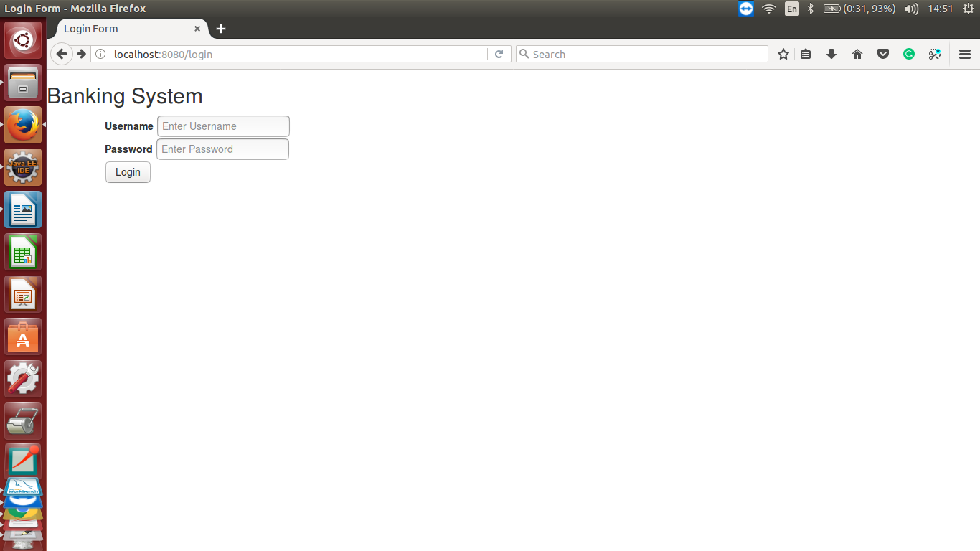

After entering the login button enters to main menu.

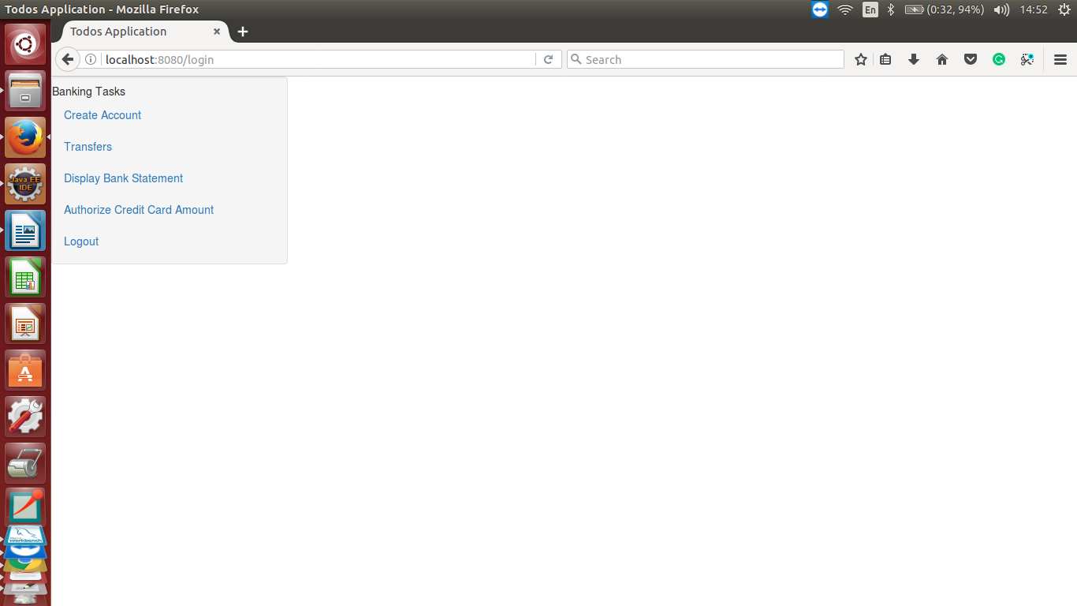

But clicking create account link it takes us to application form.

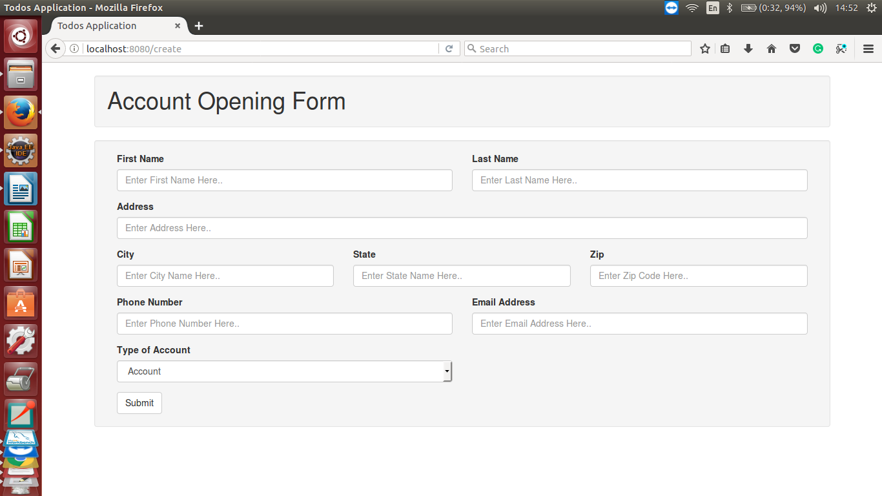

Where the user enters the details and on submit button the form is saved and redirected to main menu.

Now clicking Transfer link the controller takes us to the funds tranfer page

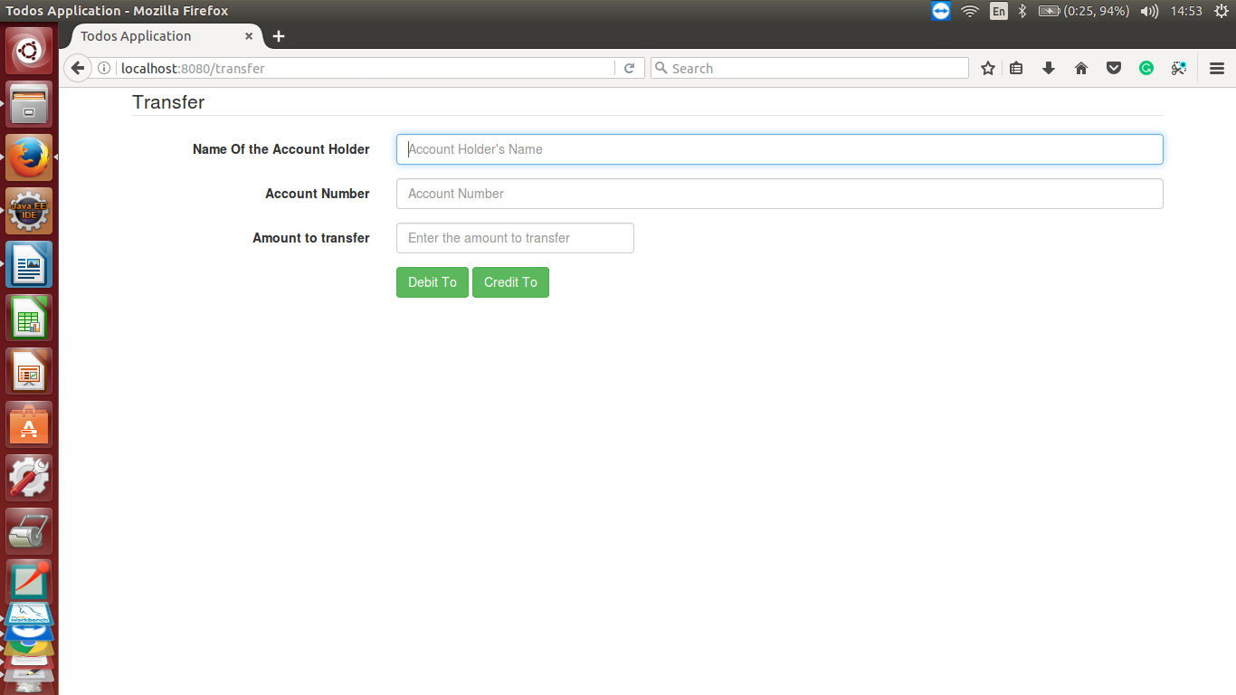

Based on the option I.e debit or credit operation is performed and necessary changes are made in the database.

Now once the debit or credit operation is performed it takes us back to the main menu. And we check the bank statement using bank statement.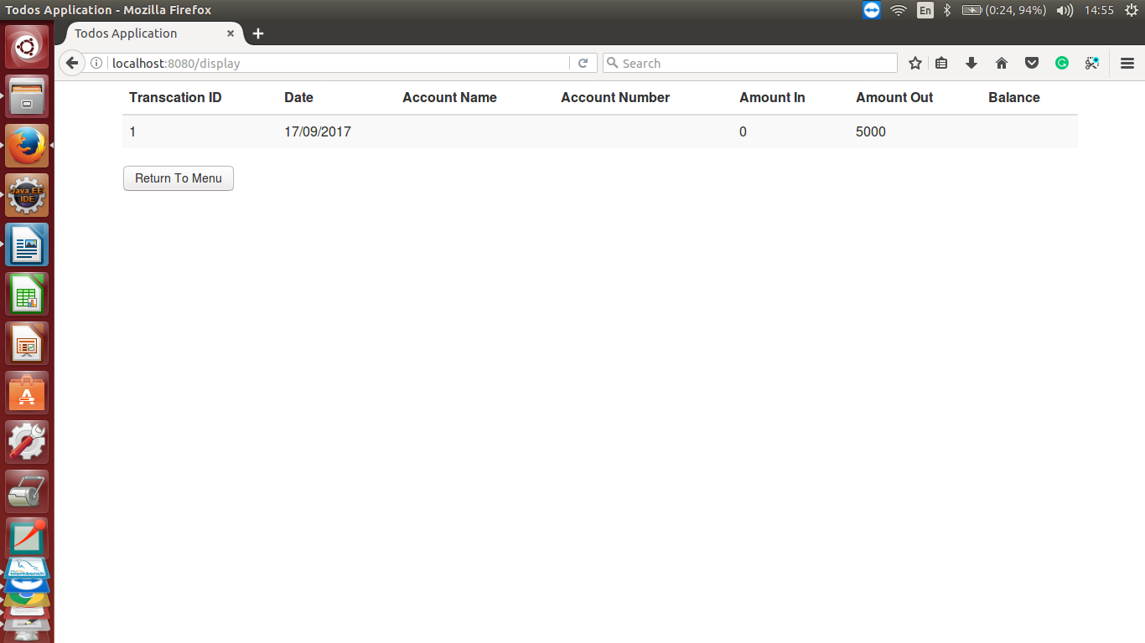

After this credit card authentication page is clicked and shows us,

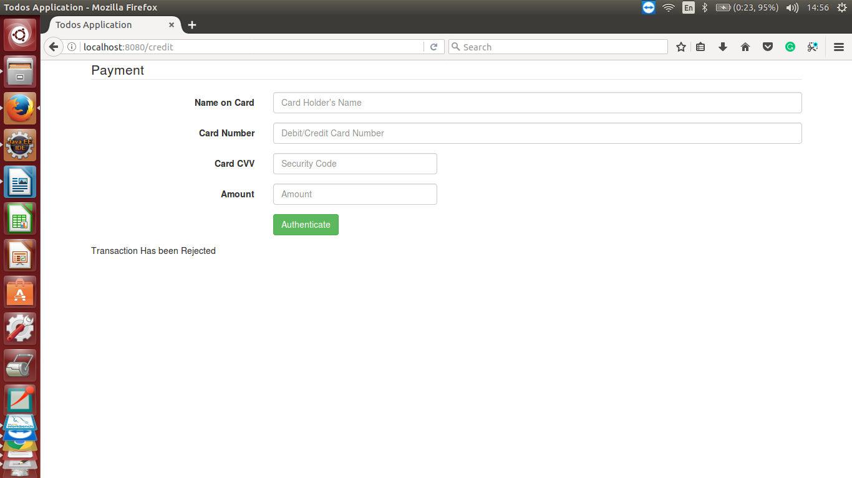

once all the values are entered and authenticate button is pressed then controlle check if it valid or not and displays appropriate result to the screen.

And finally once we press the logout screen it takes us back to the login page.