SOPHOS – VPN Connection
======================

- Login to Sophos Firewall's User Portal by browsing to https://<WAN IP address of Sophos>



- Navigate to SSL VPN

- Click Download Configuration for Other Oss

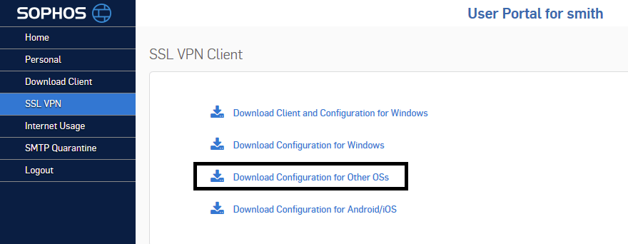
A compressed file named .ovpn is downloaded.
- Navigate to where the ovpn file was downloaded and execute the following command: $ openvpn --config client.ovpn
NOTE : if openvpn is not installed, use the following command to install openvpn
$ sudo apt-get install openvpn -y
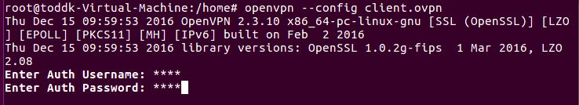
Fill in the username and password
The VPN client will now connect

