Alimerapt – Tasks
=============

Daily Track:
=========
- Take a alimerapt database backup
- Go to MysqlWorkbench, then connect to 192.168.10.148 server database
username : root
password : Gp$U$eR
- Now click connect and then enter into 192.168.10.148 mysql server via mysql workbrnch
- Click the Data Import/Restore section
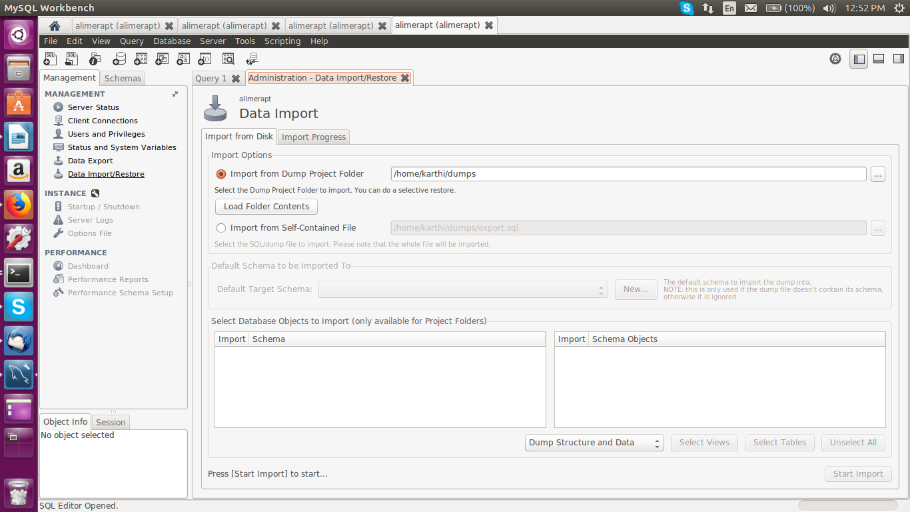

Select Import From Self-contained File and then you have to enter the path that
