AUTOMATION
============
Git - Jenkins – Docker
=================

In this document, we are going to do automatic deployment in docker with the help of Jenkins.

Short - Description:
==============
Developers push their code and create merge request in git, then the project master verify it and merge the code.
If the code is merged by project master, then Jenkins job will trigger.
In Jenkins job, we would do some configuration setting for deployment

GIT
===
First, git for the purpose is to manage project or set of files.

Git commands:
===========
# git branch <local_branch_name> → To create branch.
# git checkout <local_branch_name> → To checkout branch.
# git add . → To add the files to repository.
# git commit -m “MESSAGE” → To commit the changes with message
# git push origin <local_branch_name>:<push_with_branch_changed_tag_name> → push the branch from local branch into master branch. after execute this command, merge request link will display and then hit in browser, fill the fields and submit merge requests

Jenkins configuration with snapshots:
============================

- First create the Item, click Jenkins → New Item → <ENTER_PROJECT_NAME> → Freestyle-Project → OK
- Enter the Project Name, Then go to the Source Code Management Section and enter the project git repository URL. The below screenshot configured with include and exclude region as well.
- Click Add in Additional Behaviours. Choose Force Polling using workspace
- Then choose Polling ignores commits in certain paths and then mention the directory in include and exclude section.
NOTE : The purpose of include section is only to deploy directory mentioned in include region as well as the purpose of exclude section, it wont take an action to deploy directory mentioned in exclude section.

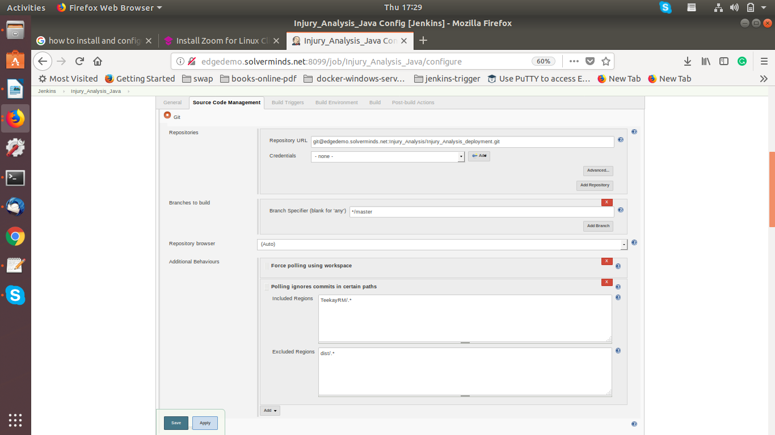

- Next step is to triggering section, we select the option Poll SCM in Build Triggers Section.

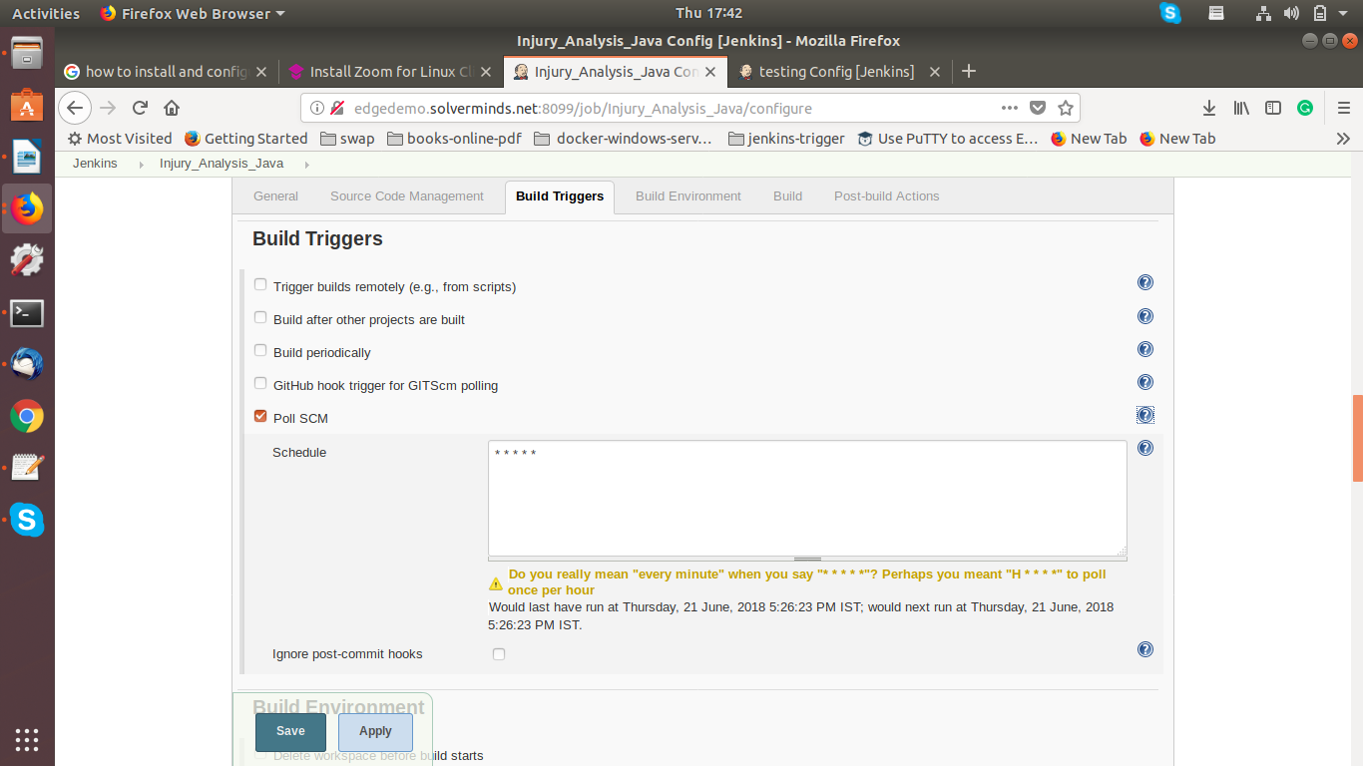
Note: Poll SCM is for the purpose to check git repository every min (as per below screenshot, you can modify as per the requirement). if any changes done in git repository, then the Jenkins trigger the job.

- Next Section is Build Environment, Select the Execute shell script on remote host using ssh and then choose the server to deploy and also enter the commands to execute [Explained in next section] .
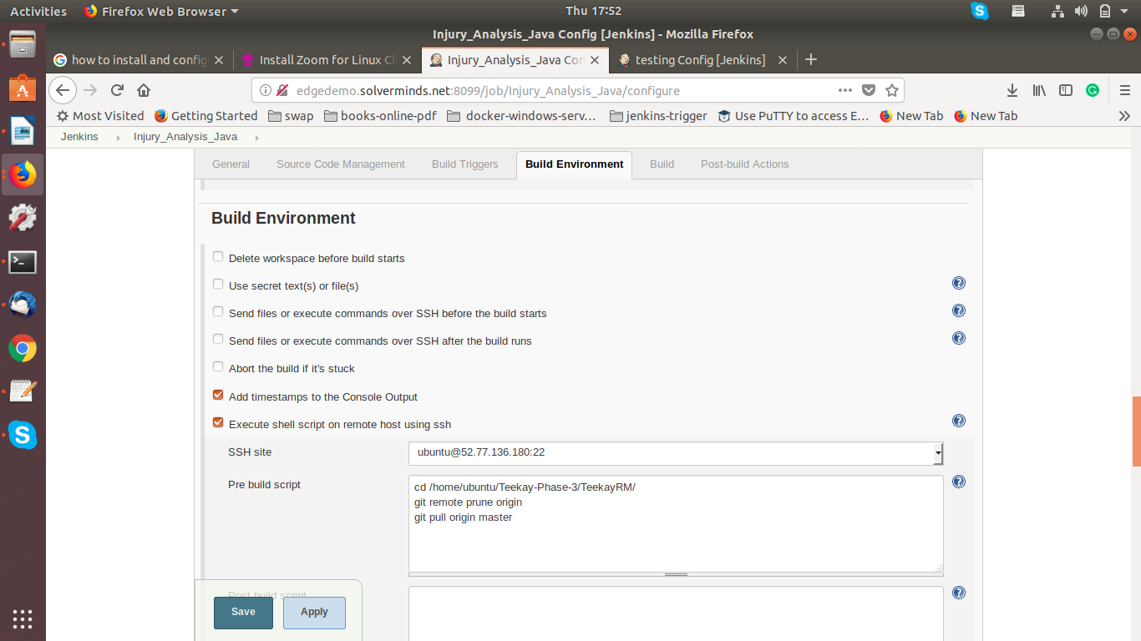

- In Build Section, Logged into the server to deploy and execute commands to deploy or execute scripts to deploy.

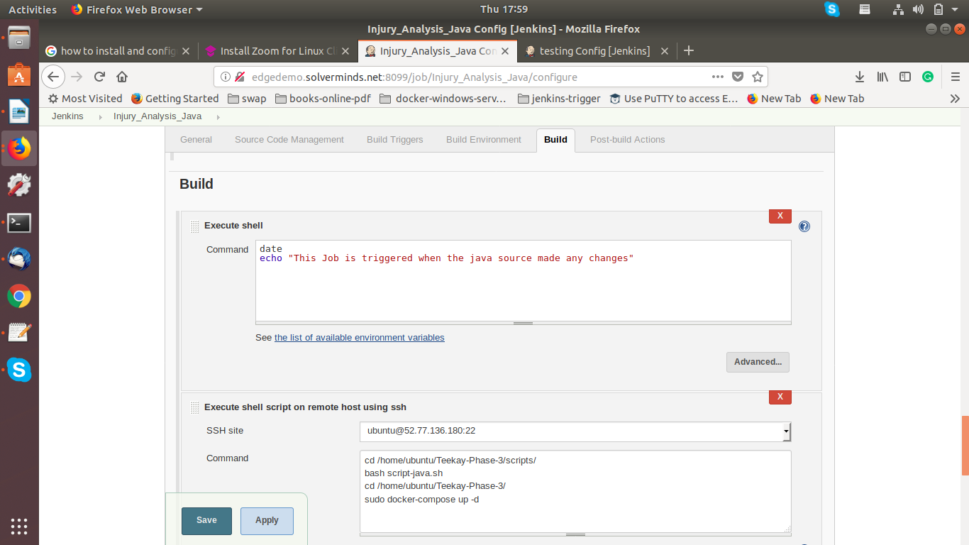

- Post-build Actions, choose the Email-notification option and enter as you.

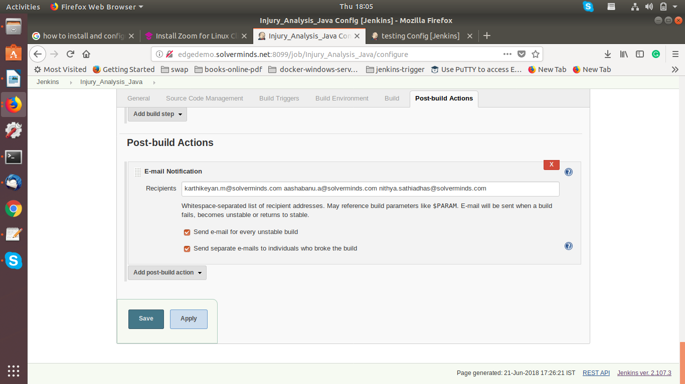

Docker
======

In this section, we are going to see about the commands and scripts entered in the Jenkins section.

script-java.sh
==========

script-java.sh script wrote for the purpose of removing old docker container and then create the docker container with updated files. Script file as follows. (scripts for java source deployment).
Go to the scripts directory and execute the required scripts.

# vim script-java.sh

#!/bin/bash

cp -rf /home/ubuntu/Teekay-Phase-3/docker-files/java/Dockerfile /home/ubuntu/Teekay-Phase-3/TeekayRM/

cd /home/ubuntu/Teekay-Phase-3/TeekayRM

/opt/maven/bin/mvn clean install

if (( $(sudo docker ps | grep injury_java | wc -l) > 0 ))

then

echo "Going to remove the old injury_frontend container"

sudo docker ps | grep injury_java | awk '{print $1}' | xargs sudo docker rm -f

echo "**********REMOVED***********"

echo "Starting Docker build for frontend"

sudo docker build -f /home/ubuntu/Teekay-Phase-3/TeekayRM/Dockerfile -t injury_java .

echo "Build Completed"

else

echo "Starting Docker build for frontend"

sudo docker build -f /home/ubuntu/Teekay-Phase-3/TeekayRM/Dockerfile -t injury_java .

echo "Build completed"

fi

script for front-end (angular) :

# vim script-dist.sh

#!/bin/bash

cp -rf /home/ubuntu/Teekay-Phase-3/docker-files/dist/Dockerfile /home/ubuntu/Teekay-Phase-3/dist/
cp -rf /home/ubuntu/Teekay-Phase-3/docker-files/dist/httpd.conf /home/ubuntu/Teekay-Phase-3/dist/
cp -rf /home/ubuntu/Teekay-Phase-3/docker-files/dist/proxy-html.conf /home/ubuntu/Teekay-Phase-3/dist/

cd /home/ubuntu/Teekay-Phase-3/dist/

if (( $(sudo docker ps | grep injury_frontend | wc -l) > 0 ))

then

echo "Going to remove the old injury_frontend container"

sudo docker ps | grep injury_frontend | awk '{print $1}' | xargs sudo docker rm -f

echo "**********REMOVED***********"

echo "Starting Docker build for frontend"

sudo docker build -f /home/ubuntu/Teekay-Phase-3/dist/Dockerfile -t injury_frontend .

echo "Build Completed"

else

echo "Starting Docker build for frontend"

sudo docker build -f /home/ubuntu/Teekay-Phase-3/dist/Dockerfile -t injury_frontend .

echo "Build completed"

fi

Finally we need to run the docker image by using docker-compose. Go to the project directory and execute the following command.

# sudo docker-compose up -d

NOTE :

docker-compose.yml file like follows.

# vim docker-compose.yml

version: '2'
services:
mysql:
image: mysql/mysql-server:5.7.20
restart: always
environment:
- MYSQL_ROOT_PASSWORD=Solver@01
# ports:
# - "3306:3306"
networks:
static_network:
ipv4_address: 10.5.0.5

injury_java:
image: injury_java
ports:
- "8000:8000"
restart: always
networks:
static_network:
ipv4_address: 10.5.0.6
volumes:
- "/home/Injury_analysis:/home/Injury_analysis"

injury_frontend:
image: injury_frontend
ports:
- "8061:8061"
restart: always
networks:
static_network:
ipv4_address: 10.5.0.7

networks:
static_network:
driver: bridge
ipam:
config:
- subnet: 10.5.0.0/16
gateway: 10.5.0.1

