JENKINS-DOCUMENTATION
=========================

INDEX :
1. To Create and Manage Users in jenkins
2. To add SSH-Hosts in jenkins
3. To Configure Email – notification (SMTP-CONFIGURATION)
4. Log Rotation

1. To Create and Manage User
=======================

To Create User :
===============

Go to Manage Jenkins > Manage Users and Create User.

Manage User (with specified action alone) :
================================

Go to Manage Jenkins > Configure Global Security

i) check the Enable Security
ii) check the Jenkin’s own user database
iii) check the Matrix-based security in Authorization Section for the purpose of specified action to particular user
iv) Finally we just add the user and give the recommanded access to user.

Another way to read the job globally without login (Not Recommanded)
=======================================================

One simple way: Go to Manage Jenkins > Configure Global Security and checked Allow anonymous read access.
Now any body who doesn't have credentials can view the jobs.

2. To add ssh hosts in jenkins
=======================

Go to Manage Jenkins > Configure System and then add SSH sites

Hostname : <REMOTE-SSH-HOST-IP>
Port : 22 (ssh-port)
Credentials : <choose the remote ssh creditials>
ServerAliveInterval : 0
timeout : 0

Note : if didnt added ur credentials previously .. u can add it by simply click ADD button at the right of the credentials sections.

After completing fill up’s. just click check connection, if the connection sucessfully status appears ... then click save

3. Configure Email notification (SMTP Configuration) :
===========================================

SMTP SERVER : mail.solverminds.com

After that Click the Advanced button and then continue to configure

Checked the Use SMTP Authentication

User Name : karthikeyan.m@solverminds.com
Password : <MAIL-PASSWORD>
Use SSL SELECT [TICK MARK]
SMTP PORT : 465
Reply-To Address : karthikeyan.m@solverminds.com
Charset : UTF-8

Then checked Test configuration by sending test e-mail

4. LOG ROTATION :
=================

Configure how many old jobs should be retained
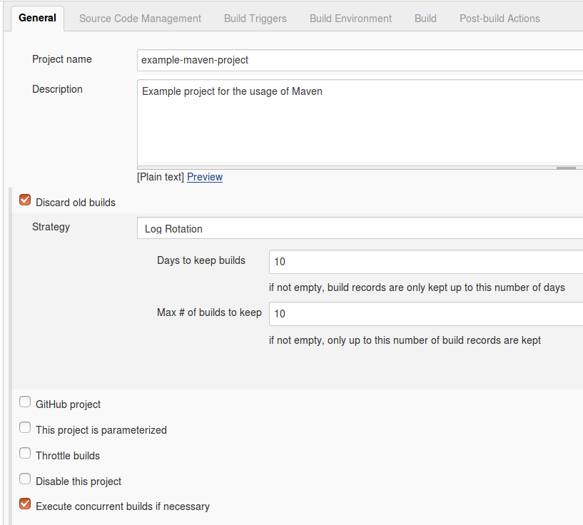

Reference : http://www.vogella.com/tutorials/Jenkins/article.html

